STAFF REPORT IN SUPPORT OF A BASIN PLAN AMENDMENT TO THE WATER QUALITY CONTROL PLAN FOR THE CALIFORNIA REGIONAL WATER QUALITY CONTROL BOARD, COLORADO RIVER BASIN REGION TO PROHIBIT THE DISCHARGE OF WASTE FROM INDIVIDUAL DISPOSAL SYSTEMS ON PARCELS LESS THAN ONE-HALF ACRE THAT OVERLIE THE MISSION CREEK AQUIFER OR THE DESERT HOT SPRINGS AQUIFER IN RIVERSIDE COUNTY, CALIFORNIA, IF A SEWER SYSTEM IS AVAILABLE

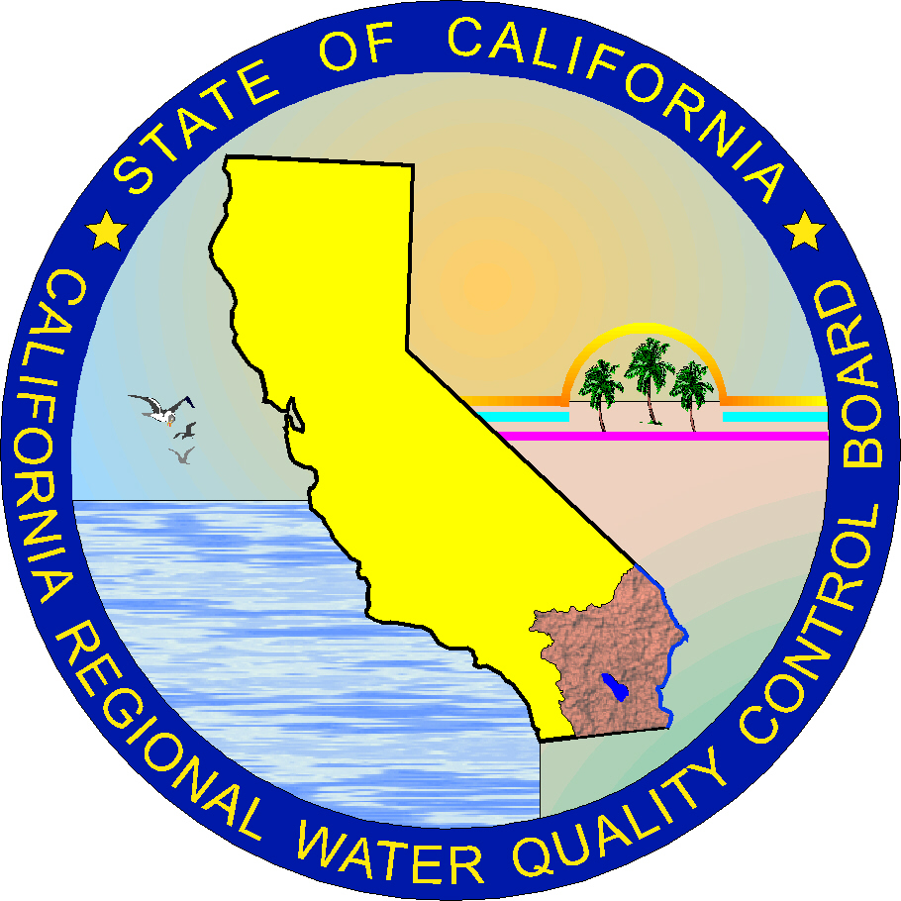

California Regional Water Quality Control Board

Colorado River Basin Region

January, 2004

STAFF REPORT IN SUPPORT OF A BASIN PLAN AMENDMENT TO THE WATER QUALITY CONTROL PLAN FOR THE CALIFORNIA REGIONAL WATER QUALITY CONTROL BOARD, COLORADO RIVER BASIN REGION TO PROHIBIT THE DISCHARGE OF WASTE FROM INDIVIDUAL DISPOSAL SYSTEMS ON PARCELS LESS THAN ONE-HALF ACRE THAT OVERLIE THE MISSION CREEK AQUIFER OR THE DESERT HOT SPRINGS AQUIFER IN RIVERSIDE COUNTY, CALIFORNIA, IF A SEWER SYSTEM IS AVAILABLE

INTRODUCTION

The California Regional Water Quality Control Board, Colorado River Basin Region (Regional Board) is charged by the California Water Code (CWC) with protecting the quality of ground and surface waters of the State within the region. Each Regional Board adopts regulations to carry out its powers and duties pursuant to guidelines established by the State Water Resources Control Board (SWRCB, CWC § 13222).

A Basin Plan is a regulatory instrument that designates beneficial uses for water bodies, and establishes water quality objectives and implementation plans to protect those beneficial uses. Regional Boards are empowered to develop and amend Basin Plans as necessary to protect the waters of the region (CWC §13225 and §13240).

The current Basin Plan for the Colorado Basin Region was edited in 1994, and last updated in July 2003. The most recent Basin Plan amendment was approved by the Office of Administrative Law on July 15, 2003 and concerns a prohibition of discharge from individual wastewater disposal systems in Cathedral City Cove in Riverside County, California.

The Basin Plan for the Colorado River Basin Region uses guidelines adopted in 1974 and revised in 1979 to establish regulations and construction requirements for subsurface wastewater disposal systems (Resolution No. 79-42: Guidelines for Sewage Disposal from Land Development). The guidelines identify: (a) types of systems that need discharge requirements, (b) setback distances, and (c) soil conditions (distance to ground water, slope, and percolation rate). The guidelines do not restrict wastewater discharges from these systems in any part of the region.

Section 13281 of the CWC was amended in 1998 and requires that the Regional Board

prohibit discharges from subsurface wastewater disposal systems on parcels less than one-half acre that overlie the Mission Creek Aquifer or the Desert Hot Springs Aquifer in Riverside County.
The background of CWC § 13281 can be found in Senate Bill 1852, Kelley.

Section 13281 (b)(1) states:

“To the extent that [RB] resources are available for that purpose, the regional board shall prohibit the discharge of waste from existing or new individual disposal systems on parcels of less than one-half acre that overlie the Mission Creek Aquifer or the Desert Hot Springs Aquifer in Riverside County, if a sewer system is available.”

Section 13281 (b)(2) states:

“For parcels of one-half acre or greater that overlie the aquifers described in paragraph (1), the maximum number of equivalent dwelling units with individual disposal systems shall be two per acre. For the purpose of this paragraph, the term “equivalent dwelling unit” means a single family dwelling as defined in Section 221.0 of the 1997 edition of the Uniform Plumbing Code of the International Association of Plumbing and Mechanical Officials.”

Section 13281 (b)(3) states:

“For the purposes of this subdivision, a sewer system is available if a sewer system, or a building connected to a sewer system, is within 200 feet of the existing or proposed dwelling unit, in accordance with Section 713.4 of the 1997 edition of the Uniform Plumbing Code of the International Association of Plumbing and Mechanical Officials.”

Section 13281 (b)(4) states:

“To the extent that resources are available for the purposes of this subdivision, the regional board shall achieve compliance with this subdivision on or before January 1, 2004.”

The purpose of this action is to protect the health and safety of residents consuming the ground water of the Upper Coachella Valley Ground Water Basin and to achieve applicable water quality objectives, and protect beneficial uses.

DESCRIPTION OF THE STUDY AREA

The Coachella Valley is located mostly in central Riverside County, extending into small parts of San Bernardino County to the north and San Diego and Imperial Counties to the south. The valley is approximately 65 miles long on a northwest-southeast trending axis and includes about 440 square miles. The Coachella Valley Watershed is bound to the north and east by the San Bernardino and Little San Bernardino Mountains, and to the south and west by the San Jacinto and Santa Rosa Mountains. The valley portion of the watershed extends from the drainage divide in the San Gorgonio Pass west of Banning, easterly and southeasterly to the drainage divide connecting into the northwesterly portion of the Salton Sea.

The valley is divided into the Upper Coachella Valley and Lower Coachella Valley by an arbitrary line extending from Point Happy northeasterly across the valley to the San Andres fault (Tyley, 1971; Swain, 1978). This line coincides with the local concept that the upper valley and the lower valley are separated by the northernmost extremity of the Coachella Canal, which is also the location at which ground water elevation approximates sea level. Hence, the water table is above sea level in the upper valley and below sea level in the lower valley (Desert Water Agency and Kriger & Stewart, 1983).

The Upper Coachella Valley covers approximately 300 square miles and has a resort/recreation-based economy, while the Lower Valley is agricultural (CVWD, 2000). Ground water elevations indicate that flow is to the southeast and parallel to the Mission Creek fault in the western part of the basin, and to the south/southwest in the eastern part of the basin (Fig 1).

This prohibition applies to the Mission Creek and Desert Hot Springs aquifers, which are part of the Upper Coachella Valley.

HYDROGEOLOGY

The Coachella Valley Ground Water Basin is divided into four sub-basins defined by faults, and includes: Garnet Hill, Whitewater River, Mission Creek, and Desert Hot Springs (Fig 1).

Garnet Hill Sub-Basin: The Garnet Hill Sub-basin is separated from the Whitewater River to the south by the Garnet Hill fault, and from the Mission Creek sub-basin to the north by the Banning fault. The Garnet Hill fault is an effective ground water barrier along its northwest extent but less restrictive of ground water flow at its southeast extent.

Whitewater River Sub-Basin: The Whitewater River Sub-basin is the largest ground water repository for the Coachella Valley, storing over 20 million acre-feet. The Garnet Hill and San Andreas Faults border the sub-basin to the north and the east respectively, and the San Jacinto and Santa Rosa Mountains border the sub-basin to the south. The sub-basin covers approximately 400 square miles and is divided into four sub-areas: Palm Springs, Thermal, Thousand Palms and Oasis.

Mission Creek Sub-Basin: The Mission Creek Sub-basin stores approximately 2.6 million acre-feet of ground water within 1,000 feet of the water table. The sub-basin is naturally recharged by surface and subsurface flow from the Mission and Morongo Creeks, and surrounding mountains. Irrigation return flow and discharges from individual subsurface wastewater disposal systems also contribute to recharge. The Mission Creek sub-basin supplies very high quality water for domestic use to the City of Desert Hot Springs, and the communities of North Palm Springs, West Palm Springs, Desert Crest, West Garnet, Painted Hills and Mission Lakes.

Desert Hot Springs Sub-Basin: The Desert Hot Springs sub-basin stores approximately 4.1 million acre-feet of ground water within 1,000 feet of the water table. Water-bearing materials consist of coarse-grained, poorly sorted alluvial fan deposits from the Ocotillo conglomerate estimated to be more than 700 feet thick. Ground water is typically hot due to tectonic activity, and used by spa resorts. Mineral content in ground water is high and unsuitable for agricultural and municipal purposes.

The Mission Creek and Desert Hot Springs aquifers are comprised of alluvial fan and stream wash water-bearing deposits, and are the aquifers subject to this prohibition. Lithologic logs indicate permeable sands and silts with no or very little clay.

GROUND WATER MANAGEMENT

Ground water from the Mission Creek and Desert Hot Springs sub-basins are managed by three water purveyors: the Mission Springs Water District (MSWD), Coachella Valley Water District (CVWD), and Desert Water Agency (DWA).

The largest community serviced by MSWD is the City of Desert Hot Springs, an urban community with 16,582 residents (US Census, 2000) located at the northern end of Coachella Valley in Riverside County, approximately 60 miles east of Riverside, and 10 miles north of Palm Springs. The southeastern extent of Desert Hot Springs is a political boundary between the service area of MSWD and CVWD (Geotechnical Consultants, Inc, 1979). Both agencies provide water to the area for domestic use, however only MSWD provides sewer service (Soulliere, J., personal communication, 2003).

GROUND WATER VULNERABILITY TO POLLUTION

The Upper Coachella Valley Ground Water Basin is dominated by unconsolidated deposits with moderate to high permeability, and consequently is at risk to pollution from overlying sediments. Vulnerability to ground water contamination is determined by the susceptibility of the recharge area to infiltration. Areas replenished at a high rate are generally more vulnerable to pollution than those replenished at a slower rate.

The main source of water in the desert is ground water extracted from the subsurface via wells. Wells may provide a direct pathway for pollutants from the land surface to ground water, if improperly installed, damaged, inadequately operated/maintained, or worn from age. Most pollutants are discharged to the ground surface via anthropogenic activities.

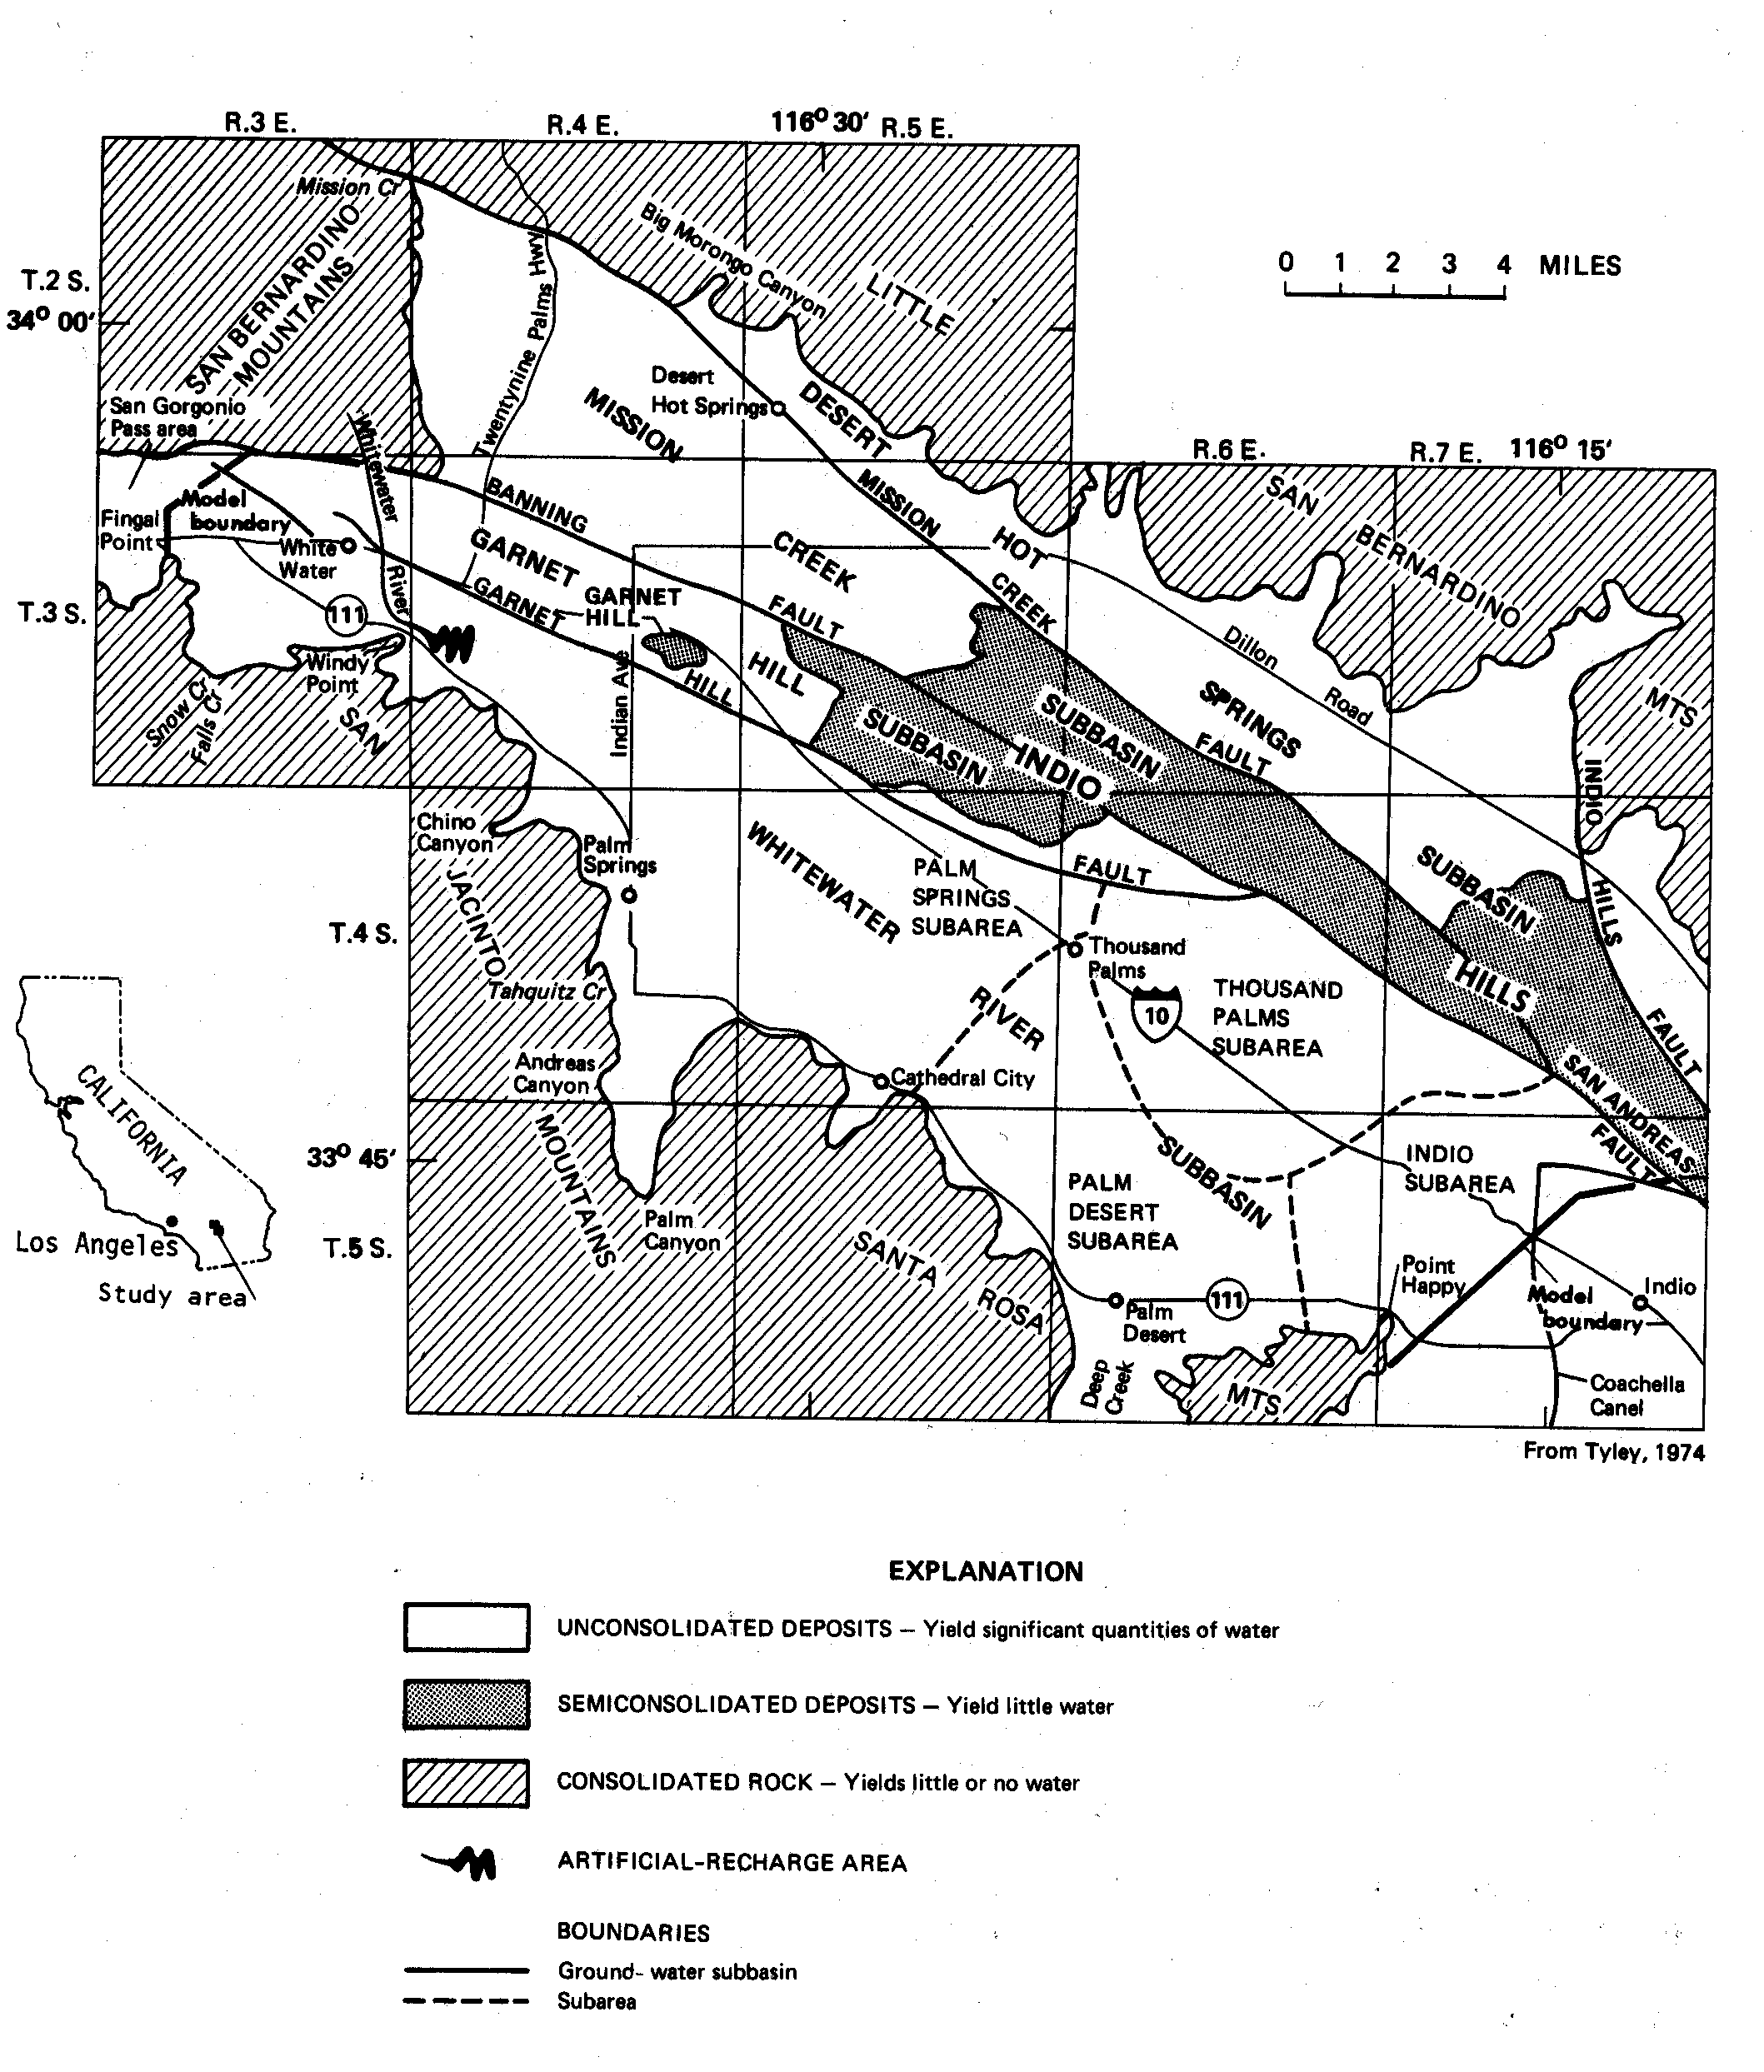

Fig. 1 Upper Coachella Valley, Riverside County California

Large quantities of potential pollutants concentrated in a small area, such as a collection of subsurface septic tanks, may produce a point source for ground water contamination, depending on the depth and type of soil overlying the water table. Overlying soils provide the primary protection against ground water pollution, and may attenuate pollutants through retardation, absorption, adsorption, or chemical reaction, effectively preventing, degrading or reducing pollutant migration to ground water.

Effluents from septic tanks have a high risk of polluting ground and surface water with heavy metals, nutrients, and human-borne pathogens. Nitrate, a water-soluble nutrient and major constituent of septic tank effluent, is a widespread ground water contaminant due largely to releases from septic tanks. Heavy pumping of water supply wells may draw down nitrate-polluted water in the unsaturated zone from septic tank discharges, and contaminate ground water. Likewise, a rising water table may intercept nitrate-rich water in the unsaturated zone.

Nitrate concentrations in drinking water that exceed 2 milligrams per liter (mg/l) are a concern to human health (Nolan, 2002). Nitrate can cause methemoglobinemia in infants, which may lead to death from oxygen deficiency. Nitrate is also a cancer-causing agent, increasing the risk of non-Hodgkin’s lymphoma at concentrations exceeding 4 mg/l (Weyer, 2001; Ward, 1996). To protect the public from the harmful effects of nitrate, the United States Environmental Protection Agency has established a Maximum Contaminant Level for nitrate in drinking water of 10 mg N/l (nitrate as nitrogen).

Discharges from septic tanks are the third leading cause of ground water pollution in the United States (United States Environmental Protection Agency, 2000). Use of subsurface disposal systems is common in areas lacking municipal wastewater treatment infrastructure. The 1999 U.S. Census Bureau indicates more than 1.1 million septic tanks in use in California.

BENEFICIAL USES OF SURFACE WATER

The Coachella Valley Ground Water Basin is the principal source of municipal water for the entire Coachella Valley. Ground water is unconfined and sediments highly porous and permeable, hence ideal for groundwater storage (Reichard and Meadows, 1992; Coachella Valley Water District, 2000; CRWQCB-CRBR, 2003). The amendment to prohibit discharges from subsurface disposal systems on parcels less than one-half acre overlying the Mission Creek or Desert Hot Springs aquifers will protect current and future beneficial uses of Coachella Valley ground water. These beneficial uses include: Municipal and Domestic Supply, Industrial Service Supply, and Agricultural Supply (Table 1). Protecting these aquifers is critical to this region given the superior water quality of the Mission Creek aquifer, and their location in a desert area with no alternative water source for domestic use.

Table 1. Beneficial Uses of Coachella Hydrologic Subunit Groundwater

Designated Beneficial Uses | Description
Municipal and Domestic Supply | Uses of water for community, military, or individual water supply systems including but not limited to drinking water supply
Industrial Service Supply | Uses of water for industrial activities that do not depend primarily on water quality including, but not limited to, mining, cooling water supply, hydraulic conveyance, gravel washing, fire protection, and oil well pressurization
Agricultural Supply | Uses of water for farming, horticulture, or ranching including, but not limited to, irrigation, stock watering, or support of vegetation for range grazing
Source: California Regional Water Quality Control Plan, Colorado River Basin Region
(1994 edition, updated through July 2003)

ACTIONS

The following actions will be implemented to protect water quality and beneficial uses of the Upper Coachella Ground Water Basin:

- Implement CWC § 13281 (b)(1) by amending the Basin Plan to prohibit waste discharges from existing or new individual disposal systems on parcels of less than one-half acre that overlie the Mission Creek Aquifer or Desert Hot Springs Aquifer in Riverside County, if a sewer system is available

- Implement CWC § 13281 (b)(2) which states parcels of one-half acre or greater that overlie the aquifers described in paragraph (1), shall have a maximum number of equivalent dwelling units with individual disposal systems of two per acre.

- Award Proposition 13 grants. Currently the State Water Resources Control Board awarded two Non-Point Source Grants to MSWD. One in August 2002 for $600,000 and a second in 2003 for $2,200,000. These grants will assist with sewer projects in areas affected by this prohibition. MSWD will also seek financial support from other agencies.

BASIN PLAN AMENDMENT PROCESS

Federal and State law require public participation in developing and amending Water Quality Control Plans. Laws governing public participation include:

- Federal Clean Water Act;
- Division 7 of the California Water Code, and
- California Environmental Quality Act (CEQA).

The State and Federal government have developed regulations to ensure compliance with the intent of these laws.

The Regional Board generally utilizes the following procedures to adopt or amend Water Quality Control Plans:

- Proposed plans and amendments are prepared at the direction of the Regional Board Executive Officer;
- An Environmental Checklist (CEQA document) is developed;
- A staff report is prepared that includes: the proposed modifications, reasonable alternatives, and mitigation to minimize significant adverse environmental impacts;
- A Notice of Filing and Notice of Public Hearing is mailed to all interested individuals and parties, (Federal, State, and local), organizations, local newspapers, and libraries at least 45 days before the Regional Board hearing for the proposed plan or amendment;
- Copies of the proposed plan or amendment, environmental checklist and staff report are posted on the Regional Board homepage, or provided upon request to the Regional Board Office;
- Regional Board staff prepares written responses to comments received during the public review period. Comments and responses provided at the Public Hearing are included in the Regional Board meeting minutes.
- Following adoption by the Regional Board, the Executive Officer forwards the plan or amendment to the State Water Resources Control Board for consideration of approval, and
- Following State Board adoption of the plan or amendment, the Regional Board files a Notice of Decision with the Secretary of the Resources Agency for public posting for a period of at least 30 days, and State Board’s Executive Officer forwards the plan or amendment to the Office of Administrative Law
- (OAL) for consideration of approval.

BIBLIOGRAPHY

California Regional Water Quality Control Board--Colorado River Basin Region (CRWQCB-CRBR). 2002. Technical Report prepared for the Basin Planning Amendment, Cathedral City Cove.

California Regional Water Quality Control Board--Colorado River Basin Region (CRWQCB-CRBR). 2003. Water Quality Control Plan for the Colorado River Basin Region. California Regional Water Quality Control Board--Colorado River Basin Region. Palm Desert, CA.

California’s Groundwater Bulletin 118. March, 2003. Hydrologic Region Colorado River, Coachella Valley Groundwater Basin. Desert Hot Springs Sub-basin. http://www.dpla2.water.ca.gov/publications/groundwater/bulletin118/basins/7-21.03_Coachella_Valley_Desert_Hot_Springs_Subbasin.pdf .

California’s Groundwater Bulletin 118. Last update October 1, 2003. Hydrologic Region Colorado River, Coachella Valley Groundwater Basin. Mission Creek Sub-basin. http://www.dpla2.water.ca.gov/publications/groundwater/bulletin118/basins/7-21.02_Coachella_Valley_Mission_Creek_Subbasin.pdf
.

Coachella Valley Water District. 2000. Coachella Valley Draft Water Management Plan. Coachella Valley Water District. Coachella, CA.

Consulting Engineers and Land Surveyors of California (CELSOC). 2002. Water Quality Law, Underground Tank Laws, Environmental Assessor Law, and Urban Water Management Planning Law, p 84.

Desert Water Agency and Krieger and Stewart, Inc, 1983. Volume II Draft Environmental Impact Report on Extension of Time for utilizing Colorado River Water to Recharge the Upper Coachella Valley Ground Water Basins to year 2035. Chapter 3

Geotechnical Consultants, Inc. Hydrogeologic Investigation. 1979. Mission Creek Sub-basin within the Desert Hot Springs County Water District.

Ikehara, Marti. 1996. Short Summary of the Transport of Contaminants from Wastewater Disposal Systems near Mission Creek Sub-basin, Desert Hot Springs, California. U.S. Geological Survey. Study Proposal.

Nolan, B.T., K.J. Hitt, and B.C. Ruddy. 2001. Probability of Nitrate Contamination of Recently Recharged Groundwaters in the Conterminous United States. Environmental Science & Technology 2001, 36, 10, 2138-2145.

Reichard, E.G., and J.K. Meadows. 1992. Evaluation of a Ground-Water Flow and Transport Model of the Upper Coachella Valley, California. Water Resource Investigation Report 91-4142. U.S. Geological Survey. Sacramento, CA.

Schroeder, R.A., P. Martin, and J.K. Bohlke. 1993. Chemical, Isotopic, and Microbiological Evidence for Denitrification During Transport of Domestic Wastewater Through a Thick Unsaturated Zone in the Mojave Desert, San Bernardino County, California. U.S. Geological Survey. Sacramento, CA.

Spalding, R.F and M.E. Exner. 1993. J. Environmental Quality 22: 392-402.

Swain, Lindsay A. 1978. Predicted Water Level and Water Quality Effects of Artificial Recharge in the Upper Coachella Valley, California, Using a Finite-Element Digital Model. Water-Resources Investigations 77-29. U.S. Geological Survey. Menlo Park, CA.

Tyley, Stephen J. 1971. Analog Model Study of the Ground-Water basin of the Upper Coachella Valley California, Open- File 7417-03. U.S. Geological Survey. Menlo Park, California.

U.S. Census Bureau. 2000. Desert Hot Springs City, California Statistics and Demographics Census. http://www.census.gov/deserthotsprings.areaconnect.com/statistics.htm

U.S. Department of Agriculture Soil Conservation Service and University of California Agricultural Experiment Station. 1980. Riverside County, California Coachella Valley Area. U.S. Department of Agriculture. Washington, D.C.

U.S. Environmental Protection Agency. 2002. Onsite Wastewater Treatment Systems Manual. EPA/625/R-00/008. Washington, D.C.

Ward, M.H., S.D. Mark, K.P. Cantor, D. Weisenburger, A. Correa-Villasenor, and S.H. Zahm. 1996. Epidemiolo. 7: 465-471.

Weyer, P.J., J.R. Cerhan, B.C. Kross, G.R. Hallberg, J. Kantamneni, G. Breuer, M.P. Jones, W. Zhenag, C. Lynch. 2001. Epidemiol. 11: 327-338.

In 2003, the Regional Board’s Executive Officer made a determination that resources were available for completing the proposed amendment pursuant to CWC § 13281, and directed staff to proceed.
Source: Water Quality Control Plan, Colorado River Basin Region, Edition 1994
Following OAL approval, Basin Plans and amendments for surface water, are forwarded to the US EPA for consideration of approval. Amendments for ground water are in effect following OAL approval. Basin Plans and amendments for surface water are in effect following US EPA approval.

