#### The City of Fresno

#### Ozone Contact Chamber

#### Tracer Study

For

Surface Water Treatment Plant

Guy Schott, P.E., Associate Sanitary Engineer

Bruce H. Burton, P.E., Senior Engineer

California Department of Health Services

Drinking Water Field Operations Branch

October 2005

**Mendocino District** 50D Street, Suite 200 Santa Rosa, CA 95404

# Background

The City of Fresno (City) has a surface water treatment plant located in the northeast area of the City. The treatment plant provides complete treatment. Ozone is used at the primary disinfectant to achieve the required disinfection inactivation of giardia and viruses. The Department Health Services initially assigned a short circuiting factor to the first four cells of the ozone contact basin of 0.6.

The plant has a design hydraulic capacity of 30 million gallon per day (MGD). The plant consists of a raw water intake structure, a raw water pumping station, chemical pretreatment facilities, two Actiflo ballasted sedimentation basins, two ozone generators, two ozone contact basins, deep bed gravity filters containing nine feet of granular activated carbon, sodium Hypochlorination facilities, corrosion control facilities, a 1.5 MG treated water storage reservoir, and a treated water pumping station. The plant was placed in operation on June 14, 2004.

A test protocol was submitted to the City of Fresno and the Department of Health Services, Merced District Office for review and approval prior to the conduct of the study. This protocol is included as Appendix A.

# Objectives

The objectives of this study were to:

* Evaluate the overall hydraulic performance of one of the two ozone basins,
* Determine t10 (time when 10% of tracer mass has passed each sample station) at the disinfection inactivation compliance monitoring point (Cell 4) and for the entire basin volume so a short circuiting factor, t10/T (where T is the theoretical detention time of the basin) could be determined for each sampling location, and
* Determine the modal time (time when peak concentration is observed) at each sample station.

**Conduct of Tracer Study**

The tracer study was conducted on October 20 & 21, 2005.

The tracer study was conducted on one of two identical ozone contact basins. Each contact basin is baffled with 8 cells, which provide an over and under flow pattern. Each cell is approximately 14 feet wide by 6.7 feet long by 20 feet deep and has a volume of 14,000 gallons. Figure 1 depicts the ozone basin flow regime.

Three tracer tests were conducted at two different flow rates. The high flow was 13.5 million gallons per day (MGD) or 90% of the maximum design flow per basin. The second test was conducted at a flow rate of at 10.6 MGD, which is a typical flow seen during winter plant operations. The third test was conducted at 13.5 MGD. There were two sampling stations for the first two tests and one sampling station for the third test.

The study protocol specified that samples were to be taken from cell 4 just before the water enters cell 5 and from a sample port in the ozone contact basin discharge pipe. Cell 4 is the sampling point being used by the City to demonstrate disinfection inactivation compliance.

During conduct of the tests the treatment plant flow was reduced to the test flow and one ozone contact basin taken off line. This was done because the contact basin discharge pipe (end of basin) receives water from both contact basins.

After conduct of the first two tests, it was discovered that samples from cell 4 had actually been taken from the top of cell 2 just before water entered into cell 3. As a result, a third test was conducted at the 13.5 MGD flow rate. During this third test samples were only taken from cell 4 as originally intended. An additional test was not conducted at the lower flow rate because of lack of tracer.

City personnel reported that the sample lines in each cell (Cells 2 & 4) end approximately six inches out from the sidewall.

# Tracer Chemical

Fluoride, in the form of hydrofluosilicic acid (H2SiF6), was selected as the tracer because it is readily available and easily monitored. Based on the “Certificate of Analysis” the fluoride is 24.07% H2SiF6 with a specific gravity of 1.227. The specific gravity of the delivered tracer was measured on site and found to be 1.215, approximately 1 percent less given on the Certificate of Analysis.

The molecular weight of H2SiF6 is 144.1 grams/mole. By weight, approximately 79.1% is fluoride in H2SiF6 or 19.04% as Fluoride in the total chemical solution. Based on the parameters above, one gallons of solution contains 1.95 pounds (234 g/L) of fluoride.

The weight of the tracer used in each test was measures using a scale that is accurate to 0.01 pounds. The weight of the hydrofluosilicic acid used in each test is given in the table below along with the calculated amount of fluoride.

|  |  |  |  |
| --- | --- | --- | --- |
| Test | Weight of H2SiF6,lbs. | Weight of F, lbs. | Test Flow, MGD |
| 1 | 50.04 | 9.53 | 13.5 |
| 2 | 50.58 | 9.63 | 10.6 |
| 3 | 47.26 | 9.00 | 13.5 |

# Pulse Input Tests and Injection Methods

The pulse input method (also referred to as a slug dose) was used for the three tests conducted. Four inch diameter PVC pipe was used to build a conveyance structure to add the tracer in less than two percent of the theoretical detention time of the first sample station at the beginning of each test. For the test flow of 10.6 MGD, it was desired the tracer be added within 11 seconds. For the test flow of 13.5 MGD, it was desired the tracer be added within 8 seconds.

The conveyance structure consisted of several sections of four inch approximately 20 feet in length. This structure consisted of four inch, schedule 200 PVC pipe, two elbows and one butterfly valve, and a cap with a fitting to allow a two-inch fire hose to be connected to it. One end of the pipe structure was placed into the 36-inch diameter contact chamber inlet pipe. The other end was sticking above the basin access hatch. To add tracer the butterfly valve was closed, tracer was poured into the top of the pipe, the cap was screwed onto the top of the pipe, and the fire hose connected to the top of the pipe. At the beginning of a test the butterfly valve was opened by pulling a rope attached to the valve handle and the hose turned on at the same time. The pictures below show the top of the tracer pipe with the hose connected and the pipe going into the entrance to the contact basin.

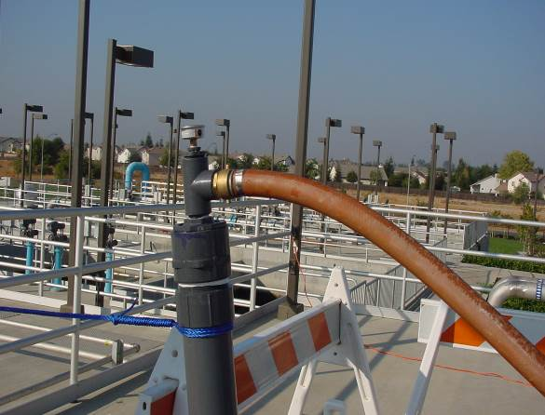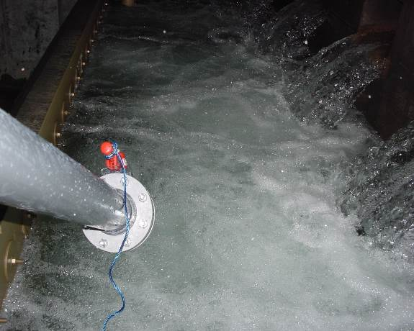

The total volume of the Tracer Pipe was approximately 10 gallons. The flow into the pipe from the hose was approximately 60 gpm. This translates to a period of 10 seconds to get the tracer completely into the entrance pipe.

# Data Collection, Test Duration, and Analysis

At the end of this document is a water sample collection form for each sample station and test flow rate. Each form is prepared to ensure that all water samples are collected during the indicated time and frequency. Approximately 120 milliliters (mL) of water were collected for each sample.

During the three tracer tests, the sample line for each sample station remained on at a constant flow. Two persons per sample station were responsible for collecting and storing samples. City personnel collected samples in all three tests. Department personnel collected samples from the end of the basin or 42-inch ozone outlet pipeline in the 10.6 MGD test. A 12 second delay was used at all sampling stations to account for the time it took water to travel in the sample piping from the sample point to the collection point.

Samples were collected during each test for a period of 4 to 6 theoretical detention times. The table below gives the length of time in minutes and the corresponding number of theoretical detention times samples were collected for each test and sample station.

|  |  |  |  |
| --- | --- | --- | --- |
| **Test** | **Sampling Station** | **Sample Time (minutes)** | **No. Theoretical Detention Times** |
| 1 | Cell 2 | 34 | 9.8 |
| 1 | End of Basin | 74 | 5.3 |
| 2 | Cell 2 | 27 | 6.2 |
| 2 | End of Basin | 81 | 4.5 |
| 3 | Cell 4 | 34 | 5.2 |

The ion selective electrode method was used to measure tracer concentrations in the test samples. A Hach Fluoride Platinum Series Fluoride Combination probe was used to determine the Fluoride concentration in each sample. The probe was calibrated at the beginning of the analysis of each sample set over the 0.2 to 2.0 mg/L concentration range. The probe was recalibrated over the 1.0 to 10 to 100 mg/L range when sample concentrations became greater than 1.0 mg/l. The probe was recalibrated again when the sample concentrations dropped below 1.0 mg/L. Calibration procedures are included in the Tracer Study Protocol in Appendix A.

**Test Results**

The table below represents data collected from each of the three tracer study test.

|  |  |  |  |  |  |
| --- | --- | --- | --- | --- | --- |
| **Flow Rate**  **(MGD)** | **Sample Location** | **Mass Recovery (%)** | **t10**  **(minutes)** | **T**  **(minutes)** | **t10/T** |
| 10.6 | Cell 2 | 117 | 2.44 | 4.39 | 0.56 |
| 10.6 | End of Basin | 89 | 13.35 | 17.82 | 0.75 |
| 13.5 | Cell 2 | 88 | 2.16 | 3.46 | 0.62 |
| 13.5 | End of Basin | 90 | 11.54 | 14.06 | 0.82 |
| 13.5 | Cell 4 | 97 | 4.12 | 6.58 | 0.63 |

Mass recovery ranged from good to excellent with the exception for Cell 2 at the 10.6 MGD flow. Samples collected from Cell 2 had the least amount of time for the tracer to mix completely in the basin. This was evident based on the tracer concentration measured at the end of Cell 2 where the concentration slopes were erratic.

Below are the graphical results for each tracer test.

**Tracer Results**

* Graphical
* Data Sheets
* Ozone Basin Drawing
* Pictures

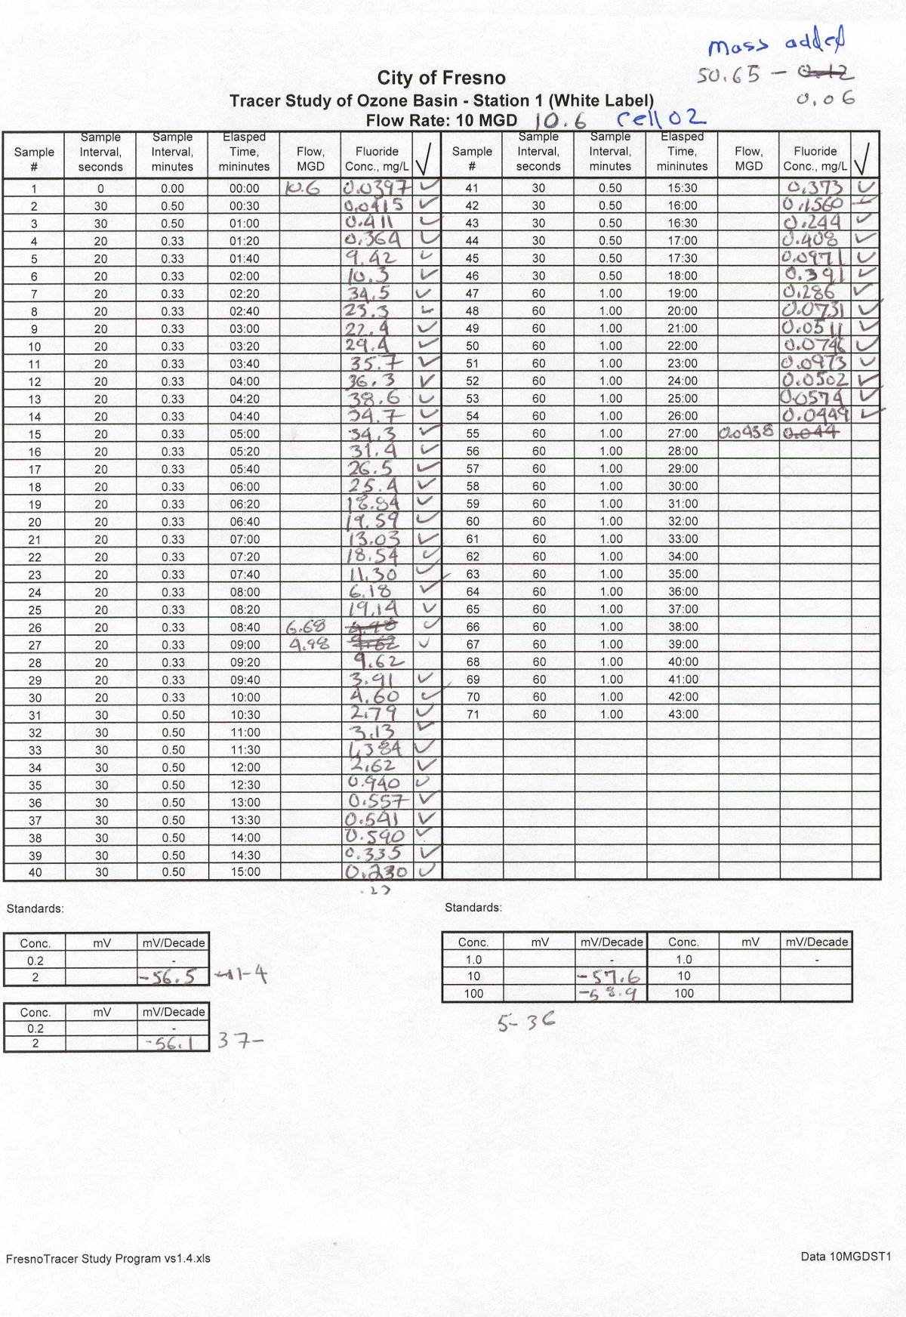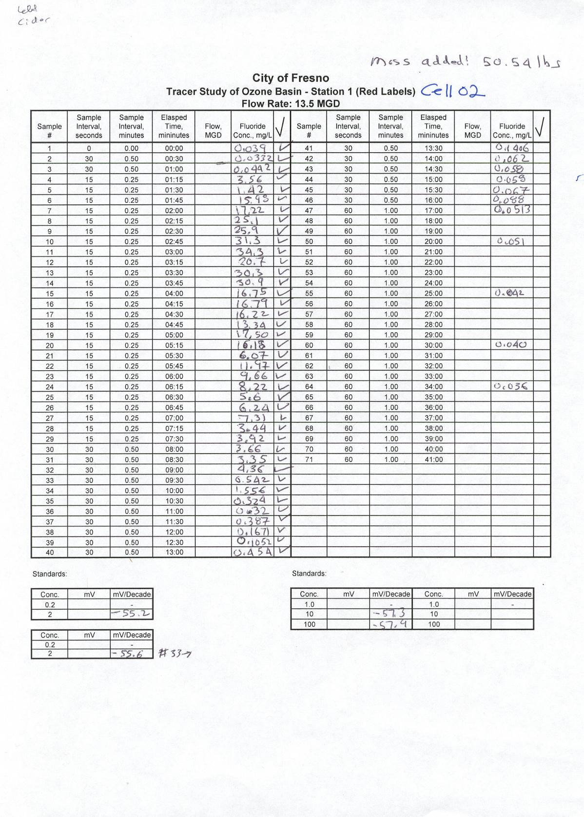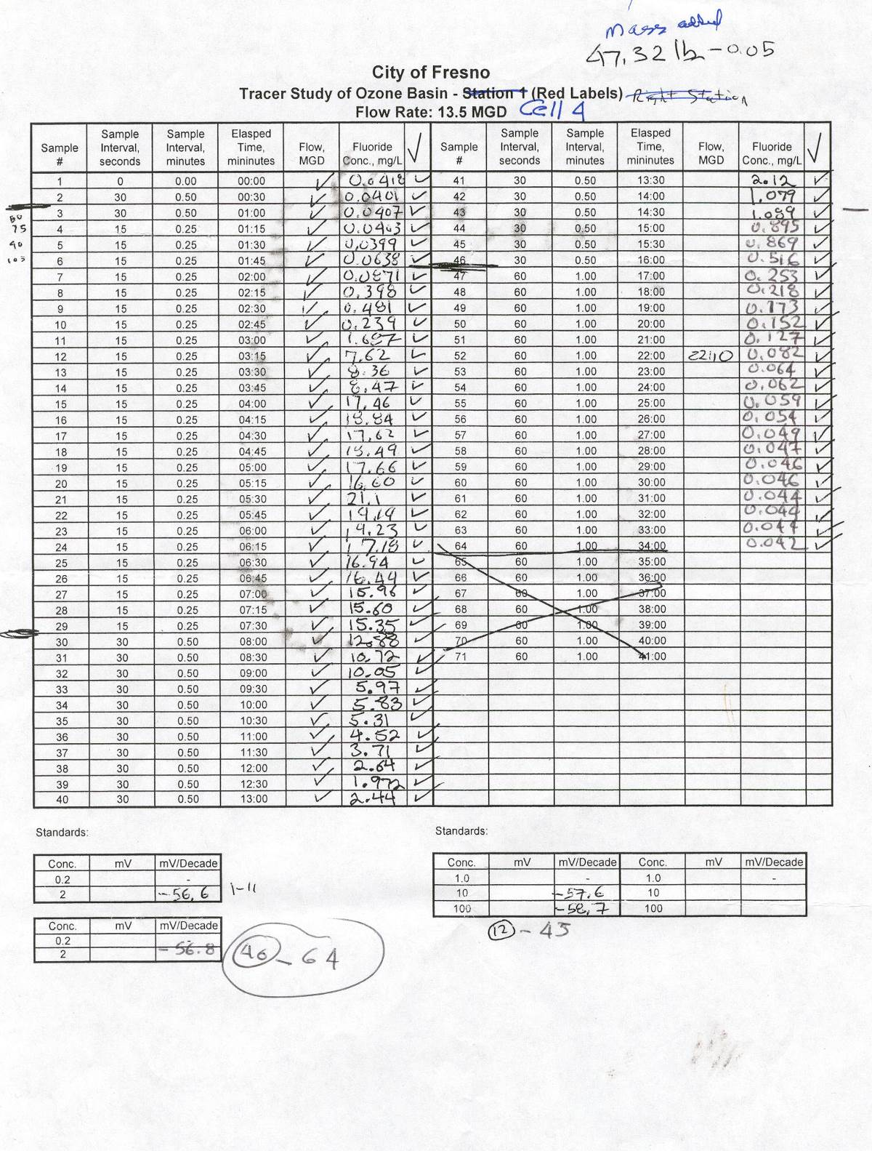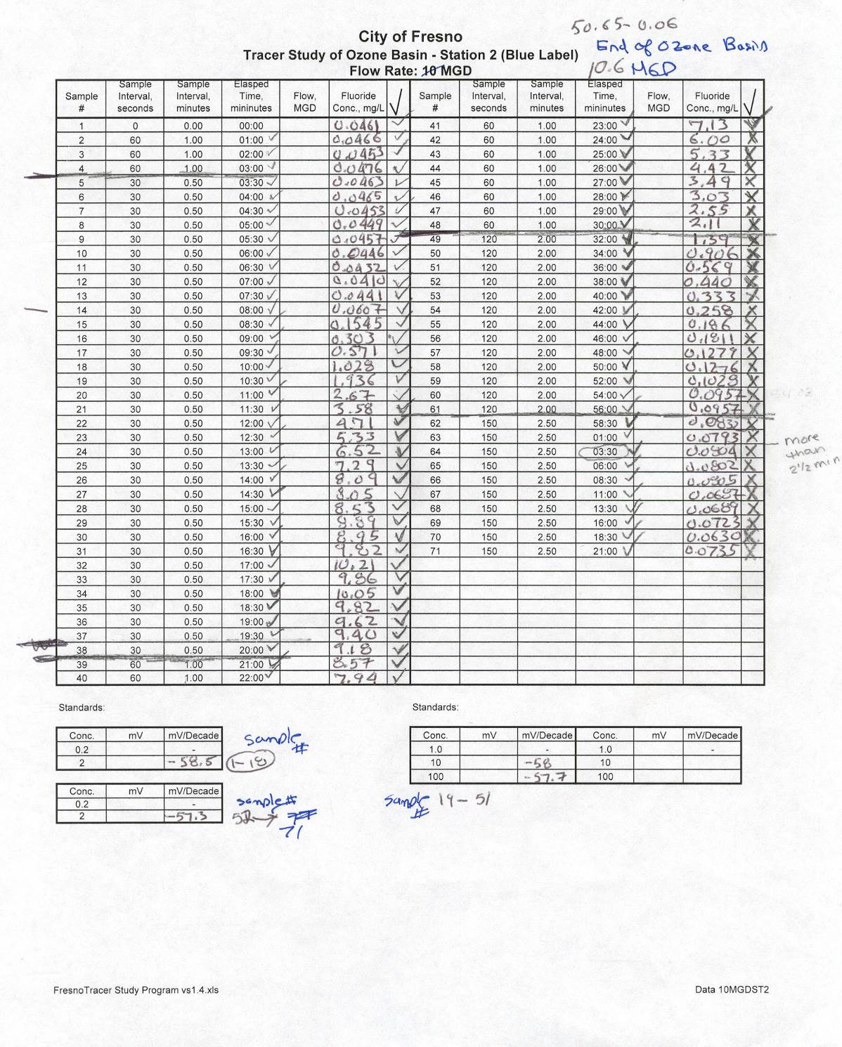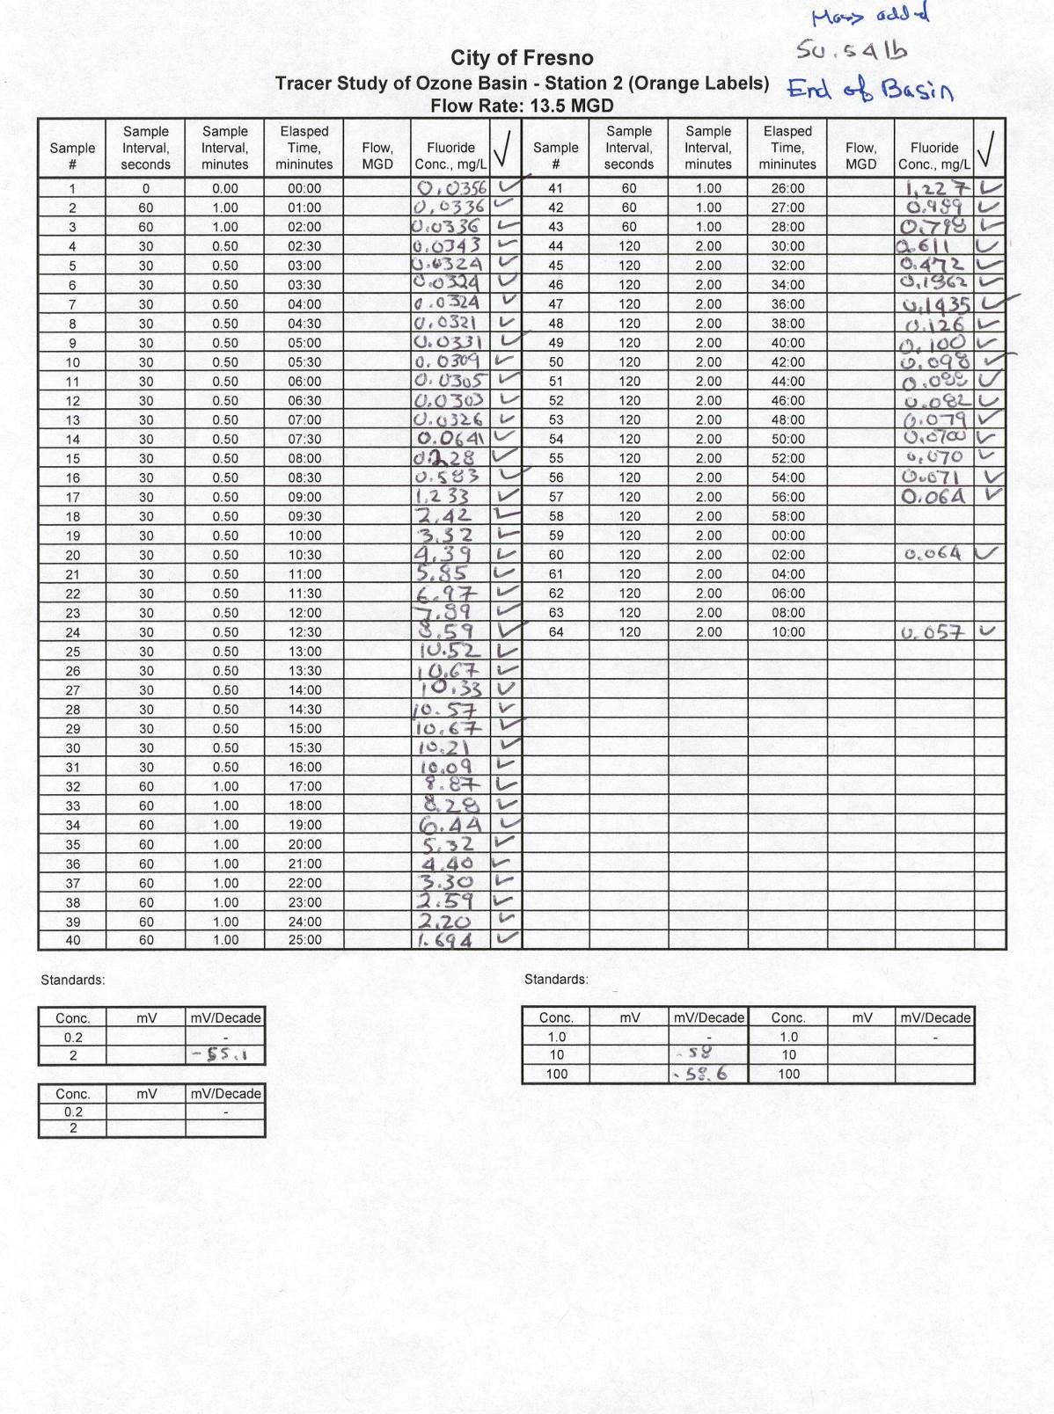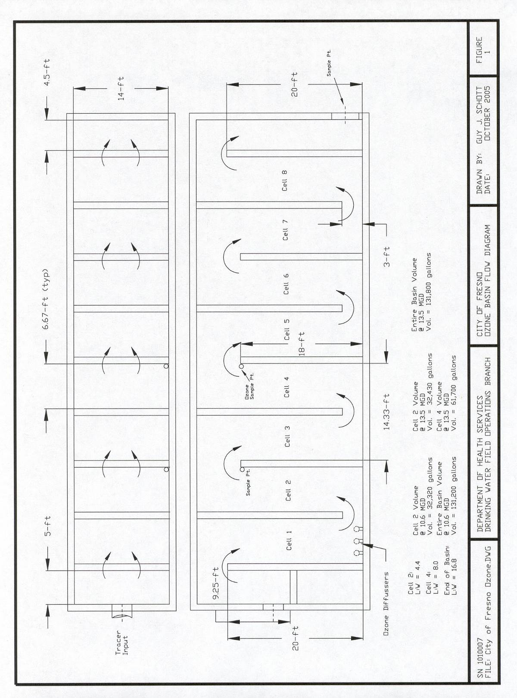

|  |  |
| --- | --- |
|  |  |
| 15 Gallons of H2SiF6 and Scale | Scale and Container |
|  |  |
| Determining Specific Gravity of H2SiF6 | Adding Fluoride into Tracer Pipe |
|  |  |
| Tracer Pipe | Tracer Pipe Valve |

|  |  |
| --- | --- |
|  |  |
| Sample Station for Cells 2 & 4 | Sample Station for End of Ozone Basin |
|  |  |
|  |  |
| Contact Basin Outlet Pipe | Conducting Fluoride Analysis |
|  |  |

File: Fresno_OzoneContactChamberStudyReport

**Appendix A**

* Tracer Protocol

#### Ozone Tracer Study Protocol

For

The City of Fresno

Surface Water Treatment Plant

**City of Fresno**

Robert Moorhead, Chief of Operations, Water Division

Glenn Knapp, P.E., DPU, Water Division

**Mendocino District, Santa Rosa**

Guy Schott, P.E., Associate Sanitary Engineer

Bruce H. Burton, P.E., Senior Engineer

October 2005

**Mendocino District** 50D Street, Suite 200 Santa Rosa, CA 95404

### Ozone Basin Tracer Study Protocol

**For the**

**City of Fresno**

**Surface Water Treatment Plant**

##### Fresno County

**October 4, 2005**

**State Department of Health Services**

**Drinking Water Field Operations Branch**

**Guy J. Schott, P.E., Project Engineer**

# Background

The City of Fresno (City) has a surface water treatment plant located in the northeast area of the City. The treatment plant consists of a conventional gravity filtration plant that uses ozone as its primary disinfectant. The plant has a design hydraulic capacity of 30 million gallon per day (MGD). The plant consists of a raw water intake structure, a raw water pumping station, chemical pretreatment facilities, two Actiflo ballasted sedimentation basins, two ozone generators, two ozone contact basins, six deep bed gravity filters, sodium Hypochlorination facilities, corrosion control facilities, a 1.5 MG treated water storage reservoir, and a treated water pumping station. The plant was placed in operation on June 14, 2004.

# Objectives

A tracer study will be conducted on one of two identical ozone contact basins. Each contact basin is baffled with 8 cells which provide an over and under flow pattern. Each cell is approximately 14 feet wide by 6.7 feet long by 20 feet deep and has a volume of 14,000 gallons. Figure 1 depicts the ozone basin flow regime.

Tracer tests will be conducted at two different flow rates. The high flow will be 13.5 MGD or 90% of the maximum flow per basin. The second test will be conducted at 10 MGD, which is the typical flow seen during winter plant operations. There will be two sampling stations per test. Samples will be taken in cell 4 just before the water enters cell 5. This is currently the sample point used to demonstrate disinfection inactivation compliance. The second sampling station will be at the outlet pipe of the ozone basin. Fluoride in the form of hydrofluosilicic acid (H2SiF6) will be used as the tracer.

The objectives of this study are to:

* Evaluate the overall hydraulic performance of one of the two ozone basins
* Determine t10 (time when 10% of tracer mass has passed each sample station) at the disinfection inactivation compliance monitoring point (Cell 4) and for the entire basin volume
* Determine modal time (time when peak concentration is observed) at each sample station

# Tracer Chemical

Fluoride, in the form of hydrofluosilicic acid (H2SiF6), was selected as the tracer because it is readily available and easily monitored. Fluoride will be conserved in this study due to little or no aluminum interference. Based on the “Certificate of Analysis” the fluoride is 24.07% H2SiF6 with a specific gravity of 1.227. The molecular weight of H2SiF6 is 144.1 grams/mole. By weight, approximately 79.1% is fluoride in H2SiF6 or 19.04% as Fluoride in the total chemical solution. Based on the parameters above, one gallons of solution contains 1.95 pounds (234 g/L) of fluoride.

# Pulse Input Tests and Injection Methods

The pulse input method (also referred to as a slug dose) will be used for this test. The tracer will be added within 1 – 2 percent of the theoretical detention time of the first sample station at the beginning of test. For the test flow of 10 MGD, the tracer must be added within 5 to 10 seconds. For the test flow of 13.5 MGD, the tracer must be added within 4 to 8 seconds.

The City will construct a 4-inch diameter PVC pipe that will have a valve on one end of the pipe. On the opposite end will be a water connection for the fire hose. Approximately 10 gallons of an equal mixer of water and Hydrofluorosilicic acid will be poured into the pipe. The valve will be closed so the liquid is contained in the PVC pipe. One end of the pipeline (with the valve) will be lowered into the overflow basin into the 30-inch diameter inlet pipe to the ozone basin. When the tracer is ready to be injected, the gate valve will be opened. Immediately thereafter, the valve to the fire hose will be opened forcing water into the 4-inch pipe thereby flushing the tracer into the 30-inch inlet pipe.

Approximately 9.74 pounds of fluoride will be added per test. If the fluoride were instantaneous mixed throughout the ozone basin, a dispersion concentration of 8.9 mg/L would be observed.

The liquid fluoride is purchased in 15-gallon carboy containers. The City’s personnel will be responsible for measuring 5 gallons of fluoride for each tracer test. The City will also be responsible for following all safety requirements for handling and storage of the liquid Hydrofluorosilicic acid.

# Data Collection, Bottle Labeling, Test Duration, and Analysis

At the end of this document is a water sample collection form for each sample station and test flow rate. Each form is prepared to ensure that all water samples are collected during the indicated time and frequency.

Sample station 1 will draw from the same location where the ozone residual is collected (cell 4). Station 2 is located on the 42-inch ozone basin outlet pipe.

During the tracer test, the sample line for each station will remain on at a constant flow to avoid any aged water left in the sample line. There must be at least two persons per sample station responsible for collecting and storing samples. The City will supply at least two personnel to assist in the collection and storing of samples during both tracer tests. Before the test, the City is responsible for determining the sample flow rate for each station and the theoretical time it takes for the sample to travel from the sample draw point to the collection point.

For the two test flow rates of 10 and 13.5 MGD through one ozone basin, the following samples and time intervals and number of samples collected are given below:

**Test 1: Flow Rate 10 MGD; T = 8.8 minutes**

**Station 1: Volume 61,360 gallons samples collected from Cell 4.**

|  |  |  |  |  |  |
| --- | --- | --- | --- | --- | --- |
|  | Start  (minutes) | Interval  (seconds) | End  (minutes) | End  (ti/T) | # of Samples |
| Segment 1 | 0.0 | 30 | 1 | 0.11 | 3 |
| Segment 2 | 1 | 20 | 10 | 1.1 | 27 |
| Segment 3 | 10 | 30 | 18 | 2.0 | 16 |
| Segment 4 | 18 | 60 | 43 | 4.9 | 25 |
|  |  |  |  | Total: | 71 |

**Test 1: Flow Rate 10 MGD; T = 18.8 minutes**

**Station 2: Volume 130,900 gallons samples collected on ozone basin outlet.**

|  |  |  |  |  |  |
| --- | --- | --- | --- | --- | --- |
| **Flow: 10MGD** | Start  (minutes) | Interval  (seconds) | End  (minutes) | End  (ti/T) | # of Samples |
| Segment 1 | 0.0 | 60 | 3 | 0.16 | 4 |
| Segment 2 | 3 | 30 | 20 | 1.1 | 34 |
| Segment 3 | 20 | 60 | 30 | 1.6 | 10 |
| Segment 4 | 30 | 120 | 56 | 3.0 | 13 |
| Segment 5 | 56 | 150 | 81 | 4.3 | 10 |
|  |  |  |  | Total: | 71 |

**Test 2: Flow Rate 13.5 MGD; T = 6.6 minutes**

**Station 1: Volume 61,700 gallons samples collected from Cell 4.**

|  |  |  |  |  |  |
| --- | --- | --- | --- | --- | --- |
|  | Start  (minutes) | Interval  (seconds) | End  (minutes) | End  (ti/T) | # of Samples |
| Segment 1 | 0.0 | 30 | 1 | 0.15 | 3 |
| Segment 2 | 1.0 | 15 | 7.5 | 1.1 | 26 |
| Segment 3 | 7.5 | 30 | 16 | 2.4 | 17 |
| Segment 4 | 16 | 60 | 34 | 5.2 | 18 |
|  |  |  |  | Total: | 64 |

**Test 2: Flow Rate 13.5 MGD; T = 14.1 minutes**

**Station 2: Volume 131,800 gallons samples collected on ozone basin outlet.**

|  |  |  |  |  |  |
| --- | --- | --- | --- | --- | --- |
|  | Start  (minutes) | Interval  (seconds) | End  (minutes) | End  (ti/T) | # of Samples |
| Segment 1 | 0.0 | 60 | 2.0 | 0.14 | 3 |
| Segment 2 | 2.0 | 30 | 16.0 | 1.1 | 28 |
| Segment 3 | 16 | 60 | 28.0 | 2.0 | 12 |
| Segment 4 | 28.0 | 120 | 70 | 5.0 | 21 |
|  |  |  |  | Total: | 64 |

T: Theoretical Time

The number of samples and sample intervals for each sample station are based on the length-to-width ratio (L:W) of the ozone contact chamber and conservative model predictions. Based on the model predictions, it is expected that the peak tracer concentration will reach 16 mg/L at station 1 and approximately 10 mg/L as Fluoride at station 2.

Sampling period for each station will have a test run length of at least four theoretical detention times. Continuous flow rate monitoring will be collected via SCADA system.

Before the start of the tracer test, each person will be trained in proper sampling technique for quality assurance and quality control purposes.

All sample bottles will be properly labeled. All fluoride analysis will be conducted using the ion-selective electrode method. The procedures for using the ion-selective electrode method are provided at the end of this document.

## Plant Operation

The plant operators will ensure that plant flow rate is maintained at 10 MGD and 13.5 MGD for tests 1 and 2, respectively. The operators will ensure that no operational interruptions occur during tracer tests such as filter backwash or related system demands. Any auto alarms that could shut the plant operation down will be set to manual to prevent any interruptions due to minor operational adjustments required for this study.

# Roles and Responsibilities of Participants

Roles and responsibility of the participants will be delegated during a pre-test meeting on October 20, 2005. Testing will commence on October 21, 2005.

For any questions, you may contact Guy Schott at 707-576-2732 or email: gschott@dhs.ca.gov.

Guy J. Schott, P.E.

Associate Sanitary Engineer

Department of Health Services

Drinking Water Field Operations Branch

50 D Street, Suite 200

Santa Rosa, CA 95404

**Testing Protocol**

**Materials:**

Fluorosilicic Acid (Tracer)

Specific Gravity: 1.227

H2SiF6: 24.07%

Net Weight: 99.875 pounds

HACH sensIon2 Meter (2)

Docking Station for sensIon2 Meter

Fluoride Combination Electrode (one from DHS and backup from the City of Fresno)

Potassium Chloride Reference Gel Cartridges (4)

Fluoride ISA Powder Pillows (300)

HACH Fluoride Standards (0.2, 1.0, 2.0, 10 & 100 mg/L as Fluoride)

3 mL Syringe

50 mL Polypropylene Beakers (16)

200 mL Polypropylene Beaker (for probe rinsing)

Electrode Stirrer Stand

Stir Bar - polygon (12)

Stir Bar Retriever

DI Water

125 mL Nalgene Sample Bottles (270)

Pulse Input Devise (Constructed by the City of Fresno)

Stopwatch (3)

**Procedures for Fluoride Ion-Selective Electrode Calibration**

**Fluoride Calibration:**

1. Install the electrolyte gel cartridge in the electrode.
2. Prime the electrode by pushing the dispenser button until gel comes out of the reference junction. Rinse excess gel from the tip and the outlet.
3. Connect the combination fluoride electrode to the meter.
4. In 50-mL beakers, prepare two sets of 25 mL standard solutions for each of the following fluoride standards (0.2, 1.0, 2.0, 10 & 100 mg/L).
5. Add the contents of one Fluoride Total Ionic Strength Adjustment Buffer (TISAb) Powder Pillow to each standard. Add stir bar in each prepared standard and place on magnetic stirrer to dissolve buffer.
6. Soak fluoride electrode in the 0.2 mg/L standard for at least 30 minutes
7. Turn on sensION 2 meter by pressing **I/O**.
   1. Press **SETUP**.
   2. Press **ENTER** until BNC appears.
   3. Press **EXIT**.
   4. Press I**SE/mV** until the display shows **mg/L**.
8. Press **CAL**. The display will show **CAL, ?, mg/L** (or other concentration units), and the active keys. The units will be flashing. If necessary, use the arrow keys to select mg/L, then press **ENTER**.
9. Place the beaker with the 0.2 mg/L standard (set 1) on the magnetic stirrer. Stir at a moderate rate.
10. Place the electrode into the standard. **Note:** Stirring at a constant moderately fast rate speeds response and improves accuracy.
11. Give the dispenser button one to two clicks to add gel to the sample.
12. The sensION 2 meter display will show Standard 1? And ___ or the value of standard 1 from the previous calibration.
13. Press **ENTER** to accept to accept the numerical value or use the number pad to edit the display to match the concentration of the 0.2 mg/L standard, then press **ENTER**.
14. The display will show **Stabilizing..** until the reading is stable.
15. The display will show Standard 2? And ___ or the value of standard 2 from the previous calibration.
16. Remove the electrode from the standard solution. Rinse it with deionized water and blot dry.
17. Dip fluoride probe into the next standard to be measured (set 2).
18. Repeat steps 9 – 14 for the 2.0 mg/L standard.
19. After the last standard is measured, press **EXIT**.
20. The display will show **Store?**. Press **ENTER** to store the calibration or EXIT to leave the calibration mode without storing the calibration values.
21. Press REVIEW. Use the up arrow key to scroll to the last slope value. It should be –58 +/- 3 mV/decade. Press EXIT to return to the measurement mode. If the slop does not approximate –58 +/- 3 mV/decade, recalibrate instrument.

**Measuring Samples:**

1. Transfer 25 mL of the sample to a 50 mL beaker. Add a stir bar to the beaker. Add the contents of one TISAB Powder Pillow to the sample. Place the beaker on a magnetic stirrer and stir at a moderate rate.
2. Remove the electrode from the standard solution. Rinse it with deionized water blot dry. Place it into the sample.
3. Give the dispenser button one to two clicks to add gel to the sample.
4. Press **ENTER**. The display will show **Stabilizing…** until the reading is stable. Record value. Repeat steps 22 – 25 for each sample.
5. Remove the electrode after reading the last sample. Rinse the electrode. Store it in a fluoride standard of similar concentration to the sample that will be analyzed next.
6. Once the sample reading is between 1 and 2 mg/L as F, recalibrate the instrument using the 1.0, 10 and 100 mg/L standards. When sample concentrations go below 2 mg/L, recalibrate with 0.2 and 2.0 mg/L standards.
7. After each calibration, measure a standard from the second set of prepared standards that has a similar concentration to the sample that will be analyzed next.
8. When calibrating the sensION2 meter with fluoride standard, rinse the probe with D.I. water and blot with a laboratory Kimwipe. Next dip the fluoride probe into set 2 standard that the probe is to be calibrated at. Remove the probe and blot with a laboratory Kimwipe. Next, lower the probe into the set 1 standard and calibration instrument. Repeat this procedure for each calibration standard.
9. Rinse each 50 mL beaker with the sample to be measured before measuring out 25 mL.

Figure 1:

