State Water Resources Control Board
Division of Drinking Water
364 Knollcrest Drive, Suite 101
Redding, CA 96002
Phone: (530) 224-4800 Fax: (530) 224-4844

Aggressive Well Disinfection with pH Adjustment and Recirculation Procedure
Construct a “water wand”: This can be made out of any tubing that will fit in the access hole on the well seal. ½-inch copper pipe works well. Attach a female garden hose fitting to one end of about a 4-foot section and cap or crimp the other end. Drill a series of small holes in the pipe for the water to spray out. Too many holes will prevent the wand from generating a good spray action. Test the wand before you use it. The idea is that it will thoroughly wet the inside of the well casing with chlorinated water.

1) Plan a time window with little or no water usage for a period of at least 48 hours.

2) Add white vinegar to the well water to achieve a pH between 5.5 and 6. You may be adding ½ to 1 gallon at a time between testing. Depending on water chemistry, plan on having 2 to 3 gallons on hand.

3) Once the desired pH is achieved, add chlorine solution to the well water to achieve approximately 200 ppm free chlorine. mg/L or ppm can be calculated from an estimated volume of water in the well.

4) Attach a garden hose from a bib downstream of the check valve and pressure switch and flush the hose onto the ground to remove potential debris.

5) Attach the garden hose to the water wand and insert the wand into the well through the top seal port. (You will have to remove a plug or the well casing vent to do this.)

6) Turn on the garden hose and allow the well pump to cycle, circulating chlorinated water back into the well for approximately 6 hours.

7) Check that there are still adequate free chlorine levels every 2 hours.

8) Turn off the hose, remove the wand and replace the casing vent.

This procedure will loosen debris in the well. Run the garden hose on the ground until clear to avoid pumping debris into the distribution piping during the next steps. After flushing you may need to add more chlorine to the well to continue.

9) Disinfect the distribution piping by pumping the chlorinated water into the system. Turn on a faucet farthest from the well until significant chlorine can be detected then shut the faucet off. Continue to draw chlorine into the system one or two faucets at a time as described above. Remember hot water taps and toilets too.

10) With no water usage allow the chlorinated water to remain in the pipes for at least twelve hours. More time is better.

11) Flush each faucet one or two at a time until chlorine no longer be detected. Do not turn on so many faucets at a time that the pump cannot keep up and system pressure is lost.

Note: These procedures may need to be modified to be applied to your specific water system.

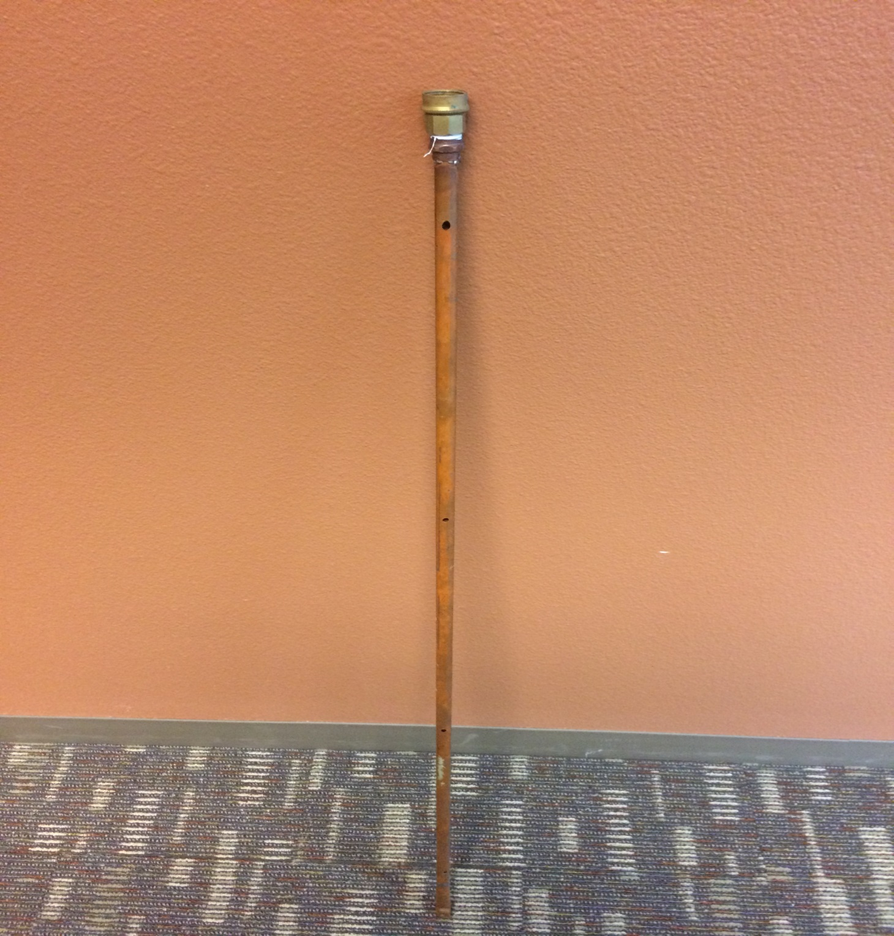
Water Wand: ½-inch copper pipe, several holes drilled in opposing directions, end crimped to fit in well.

