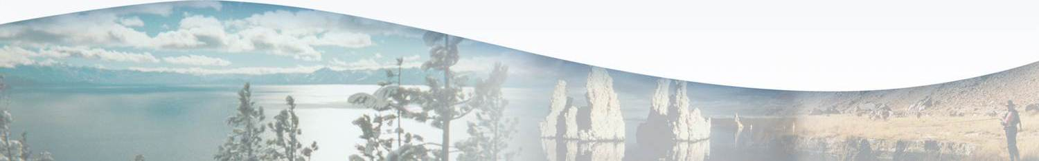
Lahontan Water Board Program Fact Sheet
FY 2017-2018
National Pollutant Discharge Elimination System
Overview
The State of California implements the federal National Pollutant Discharge Elimination System (NPDES) program under authorization by the U.S. EPA, except for the wastewater treatment plant biosolids component. All facilities discharging pollutants (including storm water) from any point source into waters of the United States must obtain a permit. Storm water is covered in a separate Storm Water Program and permits. In the NPDES Program, major permits cover facilities discharging greater than one million gallons per day: Victor Valley Wastewater Reclamation Authority (VVWRA) and Susanville Consolidated Sanitary District (CSD). Eight minor permits cover smaller discharges. General Permits issued by the State and Regional Water Boards cover numerous broad categories of similar discharges in this Program. We have 1.2 PYs in NPDES.
Key Efforts
The Program ensures that:
- Surface water quality objectives are met and beneficial uses are not impaired.
- Numerical and narrative effluent limitations contained in permits are met; violations can be subject to mandatory minimum penalties (fines) that must be assessed.
- Several past aquatic pesticide users are moving to address pesticide methods and provide permit applications seeking to obtain a Basin Plan exemption for prohibitions on the application of aquatic pesticides. Staff is currently working on exemption requests from the Department of Water Resources, the Los Angeles Department of Water and Power and the Tahoe Keys Property Owners Association.
- Assistance is provided to the Planning and Assessment Unit tasked with evaluating surface and groundwater objectives for the Mojave River.
- Permits for discharges that expire after five years are reissued in accordance with priorities, with the goal to maintain 90 percent being updated and reissued on time.
  - Black Rock Fish hatchery permit is to be reissued in April 2018.
  - Work is progressing toward reissuing the Grover Hot Springs permit in 2018.
  - VVWRA permit renewal is scheduled for later in 2018.
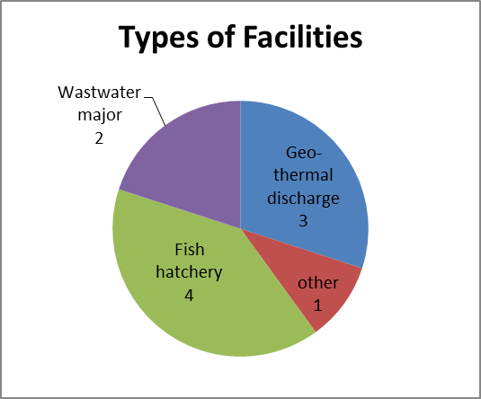
Type of facilities only covers individually permitted facilities not enrollees under general permits.

Performance Targets FY 16 -17
Target Achieved
Major Individual facility inspected 1 3
Minor individual facility permit issued or renewed 2 1
Minor individual facilities inspected 2 2
Minor general facilities inspected 0 0

Of two minor permits scheduled for reissuance last year, Grover Hot Springs is delayed because staff resources were redirected to work on aquatic pesticides issues.
Performance Targets for Fiscal Year 2017-2018 – Progress to Date
Target Progress to Date
Majors Facilities Inspected: 2 1
Minor Facilities Inspected: 1 0
Major Permits Renewed: 0 0
Minor Permits Renewed: 2 0

The Black Rock Fish Hatchery minor permit renewal is scheduled for spring of 2018. Issues surrounding establishing effluent limits for the Grover Hot Springs permit have delayed its reissuance.
Unaddressed Work
- Permit renewal for Hot Creek Hatchery is on hold pending development of Site-Specific Objectives.
- Collaborating with Susanville CSD and stakeholders to evaluate options such as storage and increased recycled water use to reduce discharges while ensuring minimum flows in Susan River for protection of fish habitat; research whether water quality objectives for Susan River may be altered or site-specific objectives should be developed.
- Enforcement actions for unauthorized discharges from sanitary sewer overflows (SSOs) to waters of the U.S. and review of reports and plans required by SSO Permits.
- Work on database and reporting issues, and U.S. EPA requirements for entering Detection Monitoring Reporting reports.
- Notify all drinking water treatment systems operators covered under the State Water Board’s General Permit for waste discharges, that our Basin Plan requirements in the Lake Tahoe Basin are more stringent than the General Permit.

