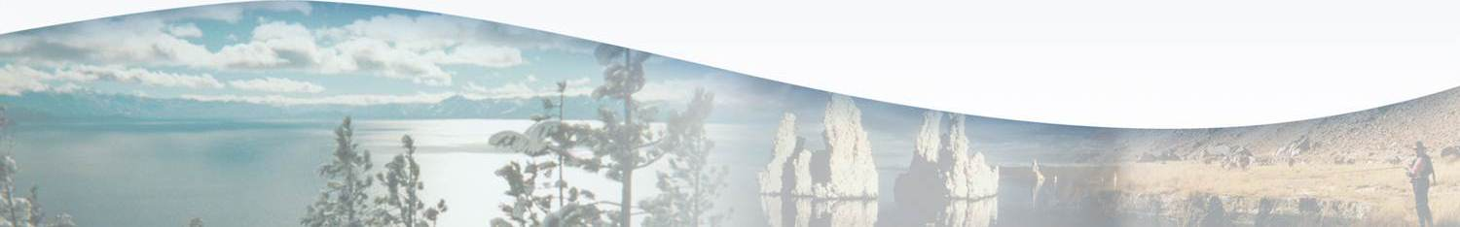
Lahontan Water Board Program Fact Sheet
FY 2017-18
Cannabis Regulatory Program
Overview
The Cannabis Regulatory Program provides a mechanism for the Water Boards to permit the diversion of water and discharge of waste associated with cannabis cultivation activities in a manner that protects water resources. Cannabis cultivation in California has grown exponentially in recent years and is often located in sensitive environmental areas that may significantly impact water quality.

SB 94, signed into law by the Governor in June 2017, combines the requirements of the Medical Cannabis Regulation and Safety Act (MCRSA) and the Adult Use of Marijuana Act (AUMA) into a unified code of regulations. Related legislation established Water Code sections 13149 and 13276, providing the regulatory framework for the Water Boards to regulate medical and commercial cannabis cultivation. In October 2017, the State Water Board adopted the Cannabis Cultivation Policy - Principles and Guidelines for Cannabis Cultivation (Cannabis Policy) and General Waste Discharge Requirements and Waiver of Waste Discharge Requirements for Discharges of Waste Associated with Cannabis Cultivation Activities (Cannabis General Order) which implements the Cannabis Policy. The Cannabis Policy and Cannabis General Order are the backbone of the Region’s Cannabis Regulatory Program.

The keys to developing and implementing an effective program are: (1) a clear and simplified process for permitees; (2) enforcement against cultivators that evade or do not comply with the requirements, and (3) coordination with other agencies. Though cannabis cultivation has been legalized in California, cannabis remains illegal on all federal lands.

The State Water Board developed eight technical units distributed regionally amongst the State Water Board and the nine Regional Water Boards. Regional Water Boards 6 and 7 received one technical team, which is housed within Regional Board 6. Our team is challenged not only with rolling out and implementing a new program in Region 6, but with also learning the regulatory and geographic framework of the Colorado River Basin and implementing the program in Region 7. We have received two PYs this fiscal year, and expect to receive four additional PYs in FY 2018-19.
Key Efforts
The Cannabis Regulatory Program is focused on growing the program from the pilot program areas in Regional Boards 1 and 5 into new geographic areas of the state, and for the program to become fee supported. The program implements measures that help achieve Action 4 (Protect and Restore Important Ecosystems) and Action 6 (Expand Water Storage Capacity and Improve Groundwater Management) of the California Water Action Plan.

Statewide, it is estimated that 2,500 permits will be issued this fiscal year, followed by at least 5,000 in each subsequent year. The communities of Lancaster, California City, Adelanto, Coachella, and Desert Hot Springs have reported a total of approximately 200 permittees (mostly for indoor cultivation) that are waiting for local permits and who will need to apply for coverage under the Cannabis General Order. Inyo and Mono Counties are in the process of finalizing cannabis cultivation requirements, which will likely be in place before the end of this year. Key efforts during the first year of program development will include:
- Continue outreach to local governments and stakeholders.
- Pursue cleanup efforts associated with unauthorized cultivation activities.
- Begin development of a general permit authorizing the onsite disposal of wastewater associated with cannabis cultivation activities in both Regions 6 and 7.
- Expand the Cannabis Identification and Prioritization System (CIPS) throughout Regions 6 and 7.
- Pursue hiring efforts for additional unit staff members.
- Process permit applications.

Accomplishments
- Hired two Water Resource Control Engineers (Senior and staff level).
- Assisted in the California Department of Food and Agriculture’s CalCannabis outreach workshops in Sacramento and Palm Desert areas.
- Initiated coordination efforts with Colorado River Basin Regional Water Board (Region 7).
- Provided outreach on Water Board requirements and onsite waste disposal requirements to Mono County and Inyo Counties, and to the Cities of Adelanto, Lancaster, California City, Desert Hot Springs, Coachella, Palm Springs, Palm Desert, Cathedral City, and Calexico.
No Performance Targets Established
No formal performance targets are established at this time for the Cannabis Program. It is anticipated that such targets will be established in coordination with other State and Regional Water Board efforts once discharger application data and Water Board efforts are evaluated after initial program roll-out and implementation.
Unaddressed Work

None at this time.

