SURFACE WATER AMBIENT MONITORING PROGRAM
(SWAMP)
FINAL WORKPLAN 2002-2003

SAN FRANCISCO BAY REGIONAL WATER QUALITY CONTROL BOARD
JUNE 2002

1. Introduction

In October 1999 the San Francisco Bay Regional Water Quality Control Board (Regional Board) developed a Regional Monitoring and Assessment Strategy (RMAS) in order to develop information for all waterbodies in the Region for the 305b report and for the 303d impaired waterbodies list. The Surface Water Ambient Monitoring Program (SWAMP) is used in this region to implement the RMAS. The three supporting components that make up the SWAMP/RMAS include: 1) funding from the State Water Resources Control Board (SWRCB) for Regional Board lead activities (these activities concentrate on monitoring watersheds, lakes/reservoirs and bays and estuaries other than San Francisco Bay and will include other Regional Board programs such as State Mussel Watch, the Toxic Substances Monitoring Program and the Coastal Fish Contamination Program), 2) partner lead watershed monitoring programs that are being conducted by local agencies/groups and are of similar goals, structure, and scope as the Regional Board lead activities and 3) the San Francisco Estuary Regional Monitoring Program (RMP). Monitoring will be conducted during the fiscal year 2002-2003 on three planning watersheds: Petaluma River watershed, San Mateo Creek watershed and Diablo/Kirker Creek watershed. Under the SWRCB funded site-specific component of SWAMP we will be investigating, monitoring, and assessing “planning watersheds”. These planning watersheds are both area- and drainage-based. The Regional Board has developed this workplan to describe the monitoring to be completed under this component of SWAMP.

The goal of the site-specific portion of the SWAMP in this Region is to monitor and assess all of our waterbodies in order to identify reference sites (clean sites) and/or sites that are impaired. Data developed in this program will be used for evaluating waterbodies in the region and developing comprehensive baseline water quality information for the whole region. Specific objectives of the monitoring program are to: 1) identify reference sites, 2) identify impacted sites or waterbodies in order to determine if beneficial uses are being protected, 3) identify the cause of impacts (i.e. sediment, specific chemical contaminants, temperature), 4) determine if these impacts are associated with specific land uses and 5) evaluate monitoring tools in watersheds in order to develop a program that uses the best environmental indicators to achieve the purposes of the program.

The three watersheds in the 2002-2003 Workplan were chosen for several reasons. These include: 1) spatial distribution, 2) available reference sites, 3) variety of land uses, and 4) priority on the State’s 303d list of impaired water bodies. There are a variety of ecological refuges represented in these three watersheds, including rare habitat that is home to extensive numbers of federally listed species. These include the California black rail, California clapper rail, and the salt marsh harvest mouse in the Petaluma Marsh area; the San Francisco garter snake, the red-legged frog, and the western pond turtle in the upper watershed of San Mateo Creek; and the California tiger salamander, California red-legged frog, and San Joaquin pocket mouse in the diverse habitats of the Kirker Creek and Mt. Diablo Creek watersheds. In addition to this, the upper San Mateo Creek watershed, due to its lack of public use, provides availability of hard to find reference sites. For this reason, this watershed is valuable not only in establishing near reference/historical conditions for the San Mateo Creek watershed, but also for other watersheds with similar geomorphic and hydrologic regimes. The Petaluma River watershed is subject to a massive presence of agricultural land uses, and is therefore a high priority watershed for monitoring of agricultural runoff contaminants (TDS, pesticides, pathogens, and nutrients), and levels of physical habitat degradation. In addition, the San Francisco Estuary Regional Monitoring Program (RMP) has found high levels of contaminants at the mouth of the Petaluma for several years. A special gradient study is planned to investigate potential sources. While potential sites have already been located in these two watersheds, further reconnaissance is necessary in making final site and monitoring selections. The Mt. Diablo/Kirker Creek watersheds both provide contrasting land use and habitat regimes with the upper watersheds showing little land use influences except the historical mining activity, and the lower watersheds highly influenced by urban development.
Beneficial Uses and |  |  |  | Associated Legislative Objectives* for 2002-03 Watersheds
NO. | PLANNING WATERSHED | AREA (SQ. MI) | COUNTY | POTENTIAL PROBLEMS | BENEFICIAL USES AND ASSOCIATED LEGISLATIVE OBJECTIVES | INDICATORS THAT WILL BE USED TO MEET MONITORING OBJECTIVES
1 | Petaluma River | 96.5 | Marin and Sonoma | Dairy Waste Mgt., Rangeland Mgt., Farming, Flood Control, Sensitive Species, Navigability, Landfills, Erosion, Sedimentation, and Recreational Uses. | Is aquatic life protected? Beneficial uses (COLD), (MAR), (MIGR), (SPWN), (WARM), (WILD), (RARE) Legislative objectives- #9, 10, 12, 13, 14 and 15 Is it safe to swim? Beneficial use (REC-1) Legislative objective -#1 Is noncontact recreation protected? Beneficial use (REC- 2) Legislative objective #20 and 21 | Macroinvertebrate bioassessments, water chemistry (metals, organics), ELIZA for diazinon and chlorpyrifos, continuous water quality parameters (temperature, dissolved oxygen, pH, and conductivity), hardness, TSS and TDS, TOC and DOC, turbidity, flow, nutrients, chlorophyll, physical habitat and trash assessment, water toxicity tests, sediments chemistry (metals, organics), grain size, sediment toxicity test, bivalve bioaccumulation, total/fecal coliform bacteria and E.coli bacteria.
2 | San Mateo Creek | 32.8 | San Mateo | Urban Runoff, Dams and Water Releases, Proposed Housing Development, Drinking Water Source, Sensitive Species. | Is aquatic life protected? Beneficial uses (COLD), (SPWN), (WARM), (WILD), (RARE) Legislative objectives- #9, 10, 12, 13, 14 and 15 Is the water safe to drink? Beneficial use (MUN) Legislative objective #2 Is it safe to swim? Beneficial use (REC-1) Legislative objective -#1 Is noncontact recreation protected? Beneficial use (REC- 2) Legislative objective #20 and 21 | Macroinvertebrate bioassessments, water chemistry (metals, organics), ELIZA for diazinon and chlorpyrifos, continuous water quality parameters (temperature, dissolved oxygen, pH, and conductivity), hardness, TSS and TDS, TOC and DOC, turbidity, flow, nutrients, chlorophyll, physical habitat and trash assessment, water toxicity tests, sediments chemistry (metals, organics), grain size, sediment toxicity test, and bivalve bioaccumulation.
3 | Kirker Creek/Mt. Diablo Creek | 61.0 | Contra Costa | Urban Runoff, Proposed Housing Development, Historical Mining, Sensitive Species, Landfill, Ranching, Erosion, Flood Control. | Is aquatic life protected? Beneficial uses (COLD), (SPWN), (WARM), (WILD), (RARE) Legislative objectives- #9, 10, 12, 13, 14 and 15 Is it safe to swim? Beneficial use (REC-1) Legislative objective -#1 Is noncontact recreation protected? Beneficial use (REC- 2) Legislative objective #20 and 21 | Macroinvertebrate bioassessments, water chemistry (metals, organics), ELIZA for diazinon and chlorpyrifos, continuous water quality parameters (temperature, dissolved oxygen, pH, and conductivity), hardness, TSS and TDS, TOC and DOC, turbidity, flow, nutrients, chlorophyll, physical habitat and trash assessment, water toxicity tests, sediments chemistry (metals, organics), grain size, sediment toxicity test, bivalve bioaccumulation, total/fecal coliform bacteria and E.coli bacteria.
* See Appendix E for Legislative Objectives (Site-specific)
2. Description of Watersheds

Petaluma River watershed

Background

Location

The Petaluma River watershed encompasses 96.5 square miles, with 77% located in southern Sonoma County, and 23% in northeastern Marin County. This border is defined by the San Antonio Creek tributary to Petaluma River with Sonoma Co. above and Marin below (see map). The watershed extends approximately 19 miles in length from the Willow Brook, Liberty Creek and Weigand’s Creek headwaters to the Petaluma River mouth in northwestern San Pablo Bay. Both highway 101 and 116 border the southern reach of the Petaluma River, and highway 101 continues alongside the river up into the headwaters near Cotati.

Geologic and Geomorphic Setting

The Petaluma River watershed is located in the southern portion of the northern Coast Ranges of California. Jurassic-Cretaceous Franciscan basement assemblages are overlain by Tertiary and Quaternary deposits, and a cover of soft marine silts, clays, and alluvium resulting from the recent rise in sea level extend from San Pablo Bay up into the City of Petaluma. Folding and faulting from the late Pliocene through the Holocene, have formed the main topographic features seen today; with the Rodgers Creek fault zone running along the eastern edge of the watershed, and the Tolay and Bloomfield faults bordering the City of Petaluma on the east and west, respectively (SSCRCD, 1999].

The headwaters and ephemeral tributaries that feed the Petaluma River drain from the southern slopes of Meacham Hill, the southwest slopes of Sonoma Mountain, and the eastern slopes of Mt. Burdell and Weigand’s Hill. While the Petaluma River is naturally low in gradient for the majority of the watershed, the upper reaches of the tributaries to the Petaluma River have very high erosion potential resulting in landslides and debris flows following storm events [SSCRCD, 1999-APP E]. The Petaluma River itself flows across the Denman Flat area and continues through the City of Petaluma after the confluence with one of its eastern tributaries Lynch Creek. There is debate as to whether the Petaluma River should be titled a river or a tidal slough, as tidal influence extends as far up as the confluence with Lynch Creek. In addition to Lynch Creek, other major tributaries on the eastern side of the Petaluma River include Lichau Creek, the northernmost tributary that flows into Willow Brook, and Adobe and Ellis Creeks, which flow through unincorporated lands before joining with the Petaluma River in the City of Petaluma. On the western side of the Petaluma River, Weigand’s Creek and Marin Creek flow into Liberty Creek at the northern headwaters of the watershed. San Antonio Creek, constituting the largest sub-watershed, flows from just east of Laguna Lake in Chileno Valley to the Petaluma Marsh [SSCRCD, 1999].

Figures A and B: Maps showing upper and lower sections of Petaluma River planning watershed

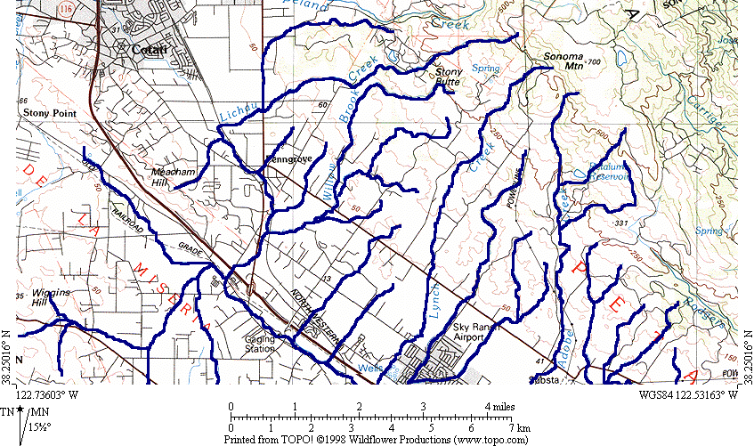

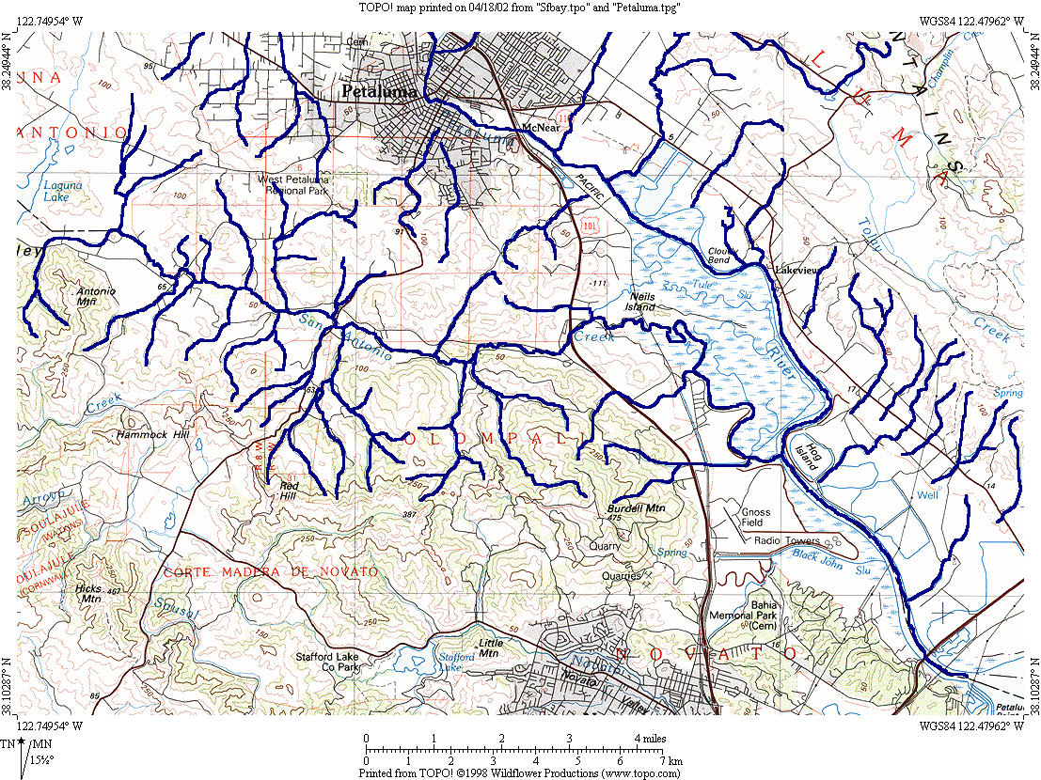

Climate and Vegetation

The Petaluma River watershed generally follows west-coast climatic trends with occasional wind and fog, warm, dry summers, and cool, wet winters. Average annual rainfall ranges from 20 inches near the Petaluma River mouth to approximately 50 inches at the highest elevations in the basin (Sonoma Mountain). Mean temperatures range from 44.7 to 70.6 degrees F [SSCRCD, 1999].

Vegetation along the Petaluma River Watershed has changed dramatically over the last two centuries with the introduction of new agricultural practices in the 1800’s. All that remains of the once extensive two-storied dense riparian canopies are approximately 26 miles of Valley Foothill Riparian habitat (VRI) and scattered narrow patches of remnant riparian corridor [SSCRCD, 1999-APP H]. The upper and few middle reaches of the Petaluma River tributaries are more closely representative of historical conditions than the lower reaches, as their steep slopes and difficult access prevent overgrazing and other land uses from degrading the vegetative cover as dramatically. These areas are found in the upper reaches of Lichau, Lynch, Washington, and Adobe Creeks, and offer the best potential for reference site sampling. Typical overstory of dense riparian canopies throughout the watershed consist of large live oak, black oak, and CA bay trees, with understory typically consisting of buckeye, big leaf maple and willow. Non-native eucalyptus trees are also ubiquitous throughout the lower watershed. Native and non-native shrubs along streambanks include blackberry, snowberry, honeysuckle, fennel, thistle, and poison oak [SSCRCD, 1999-APP H].

Land Uses and Associated Water Quality Issues

Agriculture- Historically, the Petaluma River was used extensively from the mid-1800’s until 1959 for poultry production. It was called the Egg Basket of the World in the early 1900’s, with egg and poultry production in the watershed being the foremost in the industry. An Act of Congress declared the once called tidewater estuary a river in 1959, and coincidentally around this time, the poultry industry began its decline and was replaced by a flourishing dairy industry. Most of these dairies today are found along the San Antonio Creek and Ellis Creek subwatersheds. Vineyards are now beginning to become more prominent throughout the watershed, with most development occurring in the Lakeville area along HWY 101, and in the San Antonio Creek subwatershed [SSCRDD, 1999]. Other agricultural uses include livestock, poultry, emus, llamas, oats, hay, olives, truck crops, Christmas trees, floral nurseries, and greenhouses [SSCRCD, APP A, 1997]. These agricultural uses have been the primary source of water quality degradation in the Petaluma Watershed, as grazing and farming are both associated with increased erosion, increased sedimentation and turbidity, decreased dissolved oxygen, increased temperature from lower vegetative cover, increased chemical runoff of pesticides, herbicides, and fertilizers, and waste runoff high in nutrients and ammonia.

Rural Residential- Large lots or ranchettes are dispersed throughout the watershed. These developments typically cover from 1 to 20 acres and commonly hold horses, sheep, and other livestock. In Sonoma County alone there are approximately 15,000 horses held in rural residential lots, with each horse producing approximately 50 pounds of daily waste [Agricultural Waste Management Field Handbook, 1992]. These ranchettes are most densely located along the Lichau Creek, Lynch Creek and outside the western edge of Petaluma near Liberty Road, Skillman Lane, Rainsville Road, Middle Two Rock Road and Eastman Lane [SSCRCD, 1999]. These ranchettes could contribute high nutrient and ammonia levels from runoff, thus decreasing dissolved oxygen availability, and increasing ammonia toxicity in adjacent streams. Monitoring in these areas may help locate high impact sources, providing useful information for the development of improved land management and layout designs.

Navigability and Flood Control Measures- As industry and populations boomed along the Petaluma Creek in the early 1800’s, increased activity along the creek added more sediment to the streambed, making it less navigable. Demand increased for a wider and deeper channel, and by 1860, Chinese laborers began to address this problem by dredging and straightening segments of the creek. In 1931, the Army Corps of Engineers (ACOE) widened the river to 100-200 feet in width and 8 feet in low-tide depth resulting in its official label as river in 1959 instead of tidewater estuary. Dredging has continued ever since by the ACOE in order to maintain the River’s navigable channel, leading to a total of 3 million cubic yards of dredged material since 1937.

Dredging has also been conducted by the ACOE in conjunction with the City of Petaluma as a protective measure against potential damages to crops and urban areas resulting from the 40-year flood event. These measures include channel widening projects, construction of levees, diversions, and storage alternatives. These flood control measures have had the greatest detrimental effects on increased levels of channel sedimentation, with an estimated 60,000 cubic yards of material deposited in the river per year [SCWA, 1986]. This sedimentation has only been exacerbated by upstream agricultural uses, dumping of dredged material in old stream meanders and construction of land fills in the tidal areas [SSCRCD, 1999]. Channel modification and associated sedimentation can detrimentally effect water quality by decreasing substrate quality and diversity, decreasing DO, and increasing temperature through changes in depth, TDS and riparian community. All of these factors are crucially important to biological integrity, as a healthy community of benthic macroinvertebrates (BMI), and higher trophic levels require a well-oxygenated system with substrate diversity, pools and riffles, and low turbidity water.

Urban Development-The majority of urban development in the Petaluma River watershed is concentrated within the confinements of the city limits. As a result, most of the run-off attributable to urban sources would be found draining into the Petaluma River south of the city and the lower reaches of Adobe and Lynch Creeks. The community of Penngrove also has limited commercial and residential development. The largest concern with urban development is increased imperviousness. High imperviousness leads to increased runoff instead of slow soil infiltration following rain and storm events. This immediate runoff leads to increased erosion, and transport of urban chemicals, heavy metals, sediment, nutrients, and bacteria into the nearby streams.

Open Space and Recreation-A large portion of the watershed (11%) are the lower salt marshes. These areas are split up in management between the California Department of Fish and Game (CDFG), Marin County Open Space District, The State Coastal Conservancy (SCC), U.S. Fish and Wildlife Service (USFWS), The Sonoma Land Trust, and The City of Petaluma. Other open spaces include the Helen Putnam Regional Park (Sonoma County Department of Parks and Recreation), the Burdell Ranch (CDFG), Petaluma Adobe State Historic Park (California Department of Parks and Recreation), Olompali State Historic Park (California Department of Parks and Recreation), and the Fairfield Osborn Preserve (Sonoma State University) [SSCRCD, 1999]. Due to the rare species diversity found in these areas, some areas are protected from farming by agencies such as the California Department of Fish and Game. Other areas, such as the 472 acres of marshland south of Petaluma, which is managed by the Sonoma Land Trust, are leased as farmland, thus contributing to water quality degradation by runoff of waste and further stream bank erosion.

Other Land Uses-

A large rock quarry is located west of HWY 101 and south of Petaluma. This could potentially contribute to downstream increases in TDS, and sedimentation, in addition to alteration of the stream pH.

A privately owned golf course, Adobe Creek Golf Course, is located near the middle reach of Adobe Creek. This site can be accessed off of Adobe Rd., and a site downstream of the Golf Course may yield different pesticide and nutrient characteristics than the surrounding vineyard and dairy laden segments of the Creek. This site was also recommended by Mike Rugg, with the CDFG, as a priority site for monitoring [SSCRCD, 1999].

There are two landfills in the Petaluma River Watershed. The Sonoma County inactive landfill is located off Meacham Hill Road and drains into the upper Petaluma River and Liberty Creek. The active landfill is located near Redwood, and drains into the lower slough and San Antonio Creek [SSCRCD, 1999]. These landfills could be associated with toxic leaching of heavy metals, and other chemicals detrimental to the health of local biota.

Beneficial Uses

The Petaluma River watershed is made up of a variety of upland, flatland and wetland environments which provide homes to an extensive list of federally listed species. The Petaluma Marsh is the largest remaining salt marsh in San Pablo Bay encompassing approximately 5,000 acres in area. It provides rare habitat to many species including the California Clapper Rail, the California Black Rail and the Salt Marsh Harvest Mouse. Other federally listed species found throughout the watershed include the American Peregrine Falcon, Western Snowy Plover, Bald Eagle, California Red-Legged Frog, Delta Smelt, Central California Steelhead, Sacramento Splittail, Soft Bird’s-Beak, Baker’s Stickyseed, Burke’s Goldfields, Showy Indian Clover and Sebastopol Meadowfoam (RARE).

The San Francisco Regional Water Quality Control Board Basin Plan [1995] lists some of the Petaluma River’s beneficial uses as: COLD, MAR, MIGR, SPWN, WARM, and WILD, which indicate that the watershed has potential to be healthy habitat for fish migration and spawning. Bill Cox from the Department of Fish and Game believes that steelhead may have historically lived in Lichau, Adobe, San Antonio, Lynch, Willow Brook, and Thompson Creeks, but this is difficult to predict due to lack of historical data. Many think that the few salmonids that have been found in the watershed were “strays” on their way to Sacramento River [SSCRCD, 1999].

Navigation (NAV) is an important use of the watershed, and is responsible for the major physical changes incurred on the river throughout the last century. The river provides an efficient means for transporting agricultural goods. As mentioned earlier, agricultural use (AGR) is an important beneficial use to many residents, as there exist a great number of agricultural commodities produced throughout the watershed [SSCRCD, 1999].

Contact recreation (REC-1) generally occurs in the lower watershed where a large portion is allotted to open space and recreational areas. Non-contact recreation (REC-2) occurs in a variety of lower watershed parks, as well as a few in the upper watershed.

Overview of Available Information

Previous Studies

The Army Corps of Engineers recorded information on stream flows within the Petaluma River from 1941 to 1946 at a station located approximately 1 mile upstream of the City of Petaluma [ACOE, 1972]. The USGS continued monitoring stream flows with the same gauge approximately 1,000 ft. upstream of Corona Road. They recorded data from this site until 1963 [FEMA, 1991]. This data showed that flows ranged from 0-3,500 cubic feet per second with runoff between 1,600-32,800 acre-feet [COE, 1972]. Water temperatures at these stations ranged from 4-17 degrees Celsius [Blodgett, 1971].

In the mid 1970’s and 1993, the RWQCB collected water samples and measured water quality parameters such as nutrients, dissolved oxygen and coliform bacteria. In the upper watershed, tests showed slightly elevated levels of nutrients and coliform counts. Questa Engineering Inc. collected water quality information in the Petaluma River for the City of Petaluma and the State Coastal Conservancy. In the lower reaches, unacceptable levels of dissolved oxygen, turbidity, sedimentation, ammonia, coliform, algal blooms, eutrophication, and foul odors were noted [Questa Engineering Inc.,1992]. These findings were important in the addition of the Petaluma River watershed to the State’s 303d list of impaired water bodies [SSCRCD, 1999].

Ongoing Studies

Mike Rugg, with the CDFG has been involved with monitoring stations in the Petaluma River Watershed since 1971, but not systematically until 1991 when they developed the Marin-Sonoma Counties Agricultural Runoff Influence Investigation (MSCARII). During this time, the CDFG has monitored 8 stations in the San Antonio Creek subwatershed and more recently they have begun monitoring 2 sites within the Ellis Creek subwatershed, and 2 sites on Wiggin’s Creek near King Road. At these sites, they have regularly (biweekly) measured pH, temperature, ammonia, percent saturation, electrical conductivity, dissolved oxygen, biochemical oxygen demand, and total dissolved solids. Data for the MSCARII monitoring is available for the last 10 years, and shows that levels of toxic ammonia in San Antonio and Ellis Creeks have reached maximum levels within the last year of 0.059 and 0.108 mg/L, respectively, both of which are well above the 0.025 mg/L criteria [Rugg et al, 2002].

The City is currently monitoring discharge effluent on a monthly basis from May 1 to October 20. There are 4-8 sampling sites, which are within 2,000 ft. upstream and downstream of the effluent discharge into Ellis Creek. Parameters include total suspended solids, conductivity, temperature, dissolved oxygen, pH, bacteria and biochemical oxygen demand. In addition, pesticides and metals are occasionally tested. There have been two sampling runs in the lower Petaluma River, where antidegredation studies were conducted, but no sediment studies have been conducted to date [St. George, 2002].

The San Francisco Estuary Regional Monitoring Program monitors a site at the mouth of the Petaluma River. This site has exhibited high levels of trace elements and trace organics [SFEI,1994-2000]. It is unknown whether these high levels are due to the circulation of particulate associated contaminants through San Pablo Bay and deposition and accumulation near the Petaluma River mouth, or if they are primarily coming from the Petaluma River watershed itself. A special study analyzing sediment chemistry, grain size and TOC on a gradient down the Petaluma River would help determine source(s).

Tom Furrer has been working with students from Casa Grande High School since 1983 on monitoring of stream conditions for seven tributaries within the watershed. In additional to monitoring, they have been involved in a variety of successful stream restoration projects.

Students from Grant Elementary School are working with AmeriCorps members to develop a monitoring program for Thompson Creek. Students are monitoring for pH, temperature, ammonia, and dissolved oxygen.

The Sonoma and Marin County Farm Bureaus have developed a water quality monitoring program. This program includes monitoring at four sites within the watershed for parameters such as pH, temperature, ammonia and DO.

The Petaluma Tree Planters (PTP) have been granted funding by the Rose Foundation to conduct diazinon testing in at least eight major tributary confluences along the Petaluma River. Results were available as of July 1999.

Summary and Conclusions

The Petaluma River watershed is listed on the State’s 303(d) list as an impaired water body for having high levels of nutrients, pathogens, and sedimentation; all of which have been produced or exacerbated by overgrazing, agricultural practices, and channel modifications. The Regional Water Quality Control Board plans to develop a Petaluma River watershed TMDL report for nutrients and pathogens by 2003, with TMDL implementation by 2005. There have been many monitoring efforts on different tributaries of the watershed, all of which will ideally be incorporated into the SWAMP database. While reference sites will be difficult to establish in this watershed due to the widespread use of the land adjacent to the waterways, further inspection of the watershed headwaters and the upper reaches of the tributaries should yield at least a few relatively unaffected sites. Water quality monitoring for SWAMP should include:

1) 15-20 monitoring sites in the Petaluma River watershed. This is due to size of the watershed (96.5 square miles), and importance of collecting extensive data on farming and grazing influences, which are the dominant water quality concerns in this watershed. Finding reference sites may be difficult if not impossible, due to the long history of land use and lack of historical water quality data.

2) Monitoring of Tier 1 parameters (continuous monitoring, rapid bioassessment, and physical habitat assessment) in Upper Petaluma River, and Adobe, Ellis, Lynch, and Willow Brook Creeks in order to monitor conditions for potential salmonid habitat and general biological integrity. It is worth noting, however, that the low gradient of the middle and lower reaches of the Petaluma River, and the naturally high sedimentation yields of the upper reaches, make the Petaluma River less than ideal for salmonid migration and spawning, even in the absence of grazing and agricultural influences. Due to the extent and quality of monitoring in San Antonio Creek conducted by Mike Rugg and his staff at the CDFG, the data from MSCARII may be utilized for Tier 1 information, with only supplemental work done by SWAMP.

3) San Antonio, Adobe, and Ellis Creeks are the most highly impacted tributaries in the Petaluma River watershed, due to the influences of agricultural uses and high levels of grazing. Sites along these creeks should be monitored for Tier 2 parameters such as NH₃, nutrients, turbidity, BOD, TDS, and pathogens.

4) There are two landfills in the Petaluma River watershed. One is an inactive landfill near the lower reach of Liberty Creek at Meacham Hill Road. The other is an active landfill close to San Antonio Creek near Redwood Road, just above Olompali State Park. These landfills may be leaching toxic contaminants and should be included in the Tier 2 monitoring. One or both of these may be one of the primary sources for the elevated levels of trace organics and metals found at the mouth of Petaluma River by the RWQCB RMP.

5) In order to determine the sources of the elevated levels of organic contaminants and heavy metals found by the RMP at the Petaluma River mouth, a special study should be performed in which sediment is collected on a gradient down the Petaluma River. Sediment chemistry, grain size and TOC should be measured. This study would be independent of the Tier 1 and Tier 2 monitoring and would require a special study design.

6) Privately owned Adobe Creek Golf Course near Adobe Road should be a priority site, so that differences in stream bank erosion and Tier 2 parameters such as water chemistry and nutrients can be compared between this site and surrounding agricultural areas.

7) Two integrator sites should be monitored in this watershed due to the extensive tidal influence. One should be the lowest point along the Petaluma River unaffected by tidal influence which is located past the railroad in Petaluma, upstream of the Lynch Creek and Petaluma River confluence. The second integrator site could be at the lowest point on San Antonio Creek before tidal influence, a usable site being the MSCARII Station 1 on San Antonio Road, which is sampled regularly by the CDFG. Due to the difference in orders, distance up the watershed, and upstream land uses, it would be expected that these two integrator sites would show significantly different results.

References

Blodgett, J.C., 1971, Water Temperatures of California Streams, San Francisco Bay Subregion, U.S. Geological Survey, Menlo Park, Ca.

Federal Emergency Management Agency, 1991, Flood Insurance Study-Sonoma County California, Unincorporated Areas, Washington D.C.

Goff, Gina, Department of Fish and Game, February 20, 2002, Personal Communication.

Leidy, Robert, 2002, Fish Query Results www.stgeorgeconsulting.com/FishQueryResults

Questa Engineering Inc., 1992. Existing Conditions Report: Petaluma River Access and Enhancement Plan. For the City of Petaluma and State Coastal Conservancy. Point Richmond, Ca.

Rugg, Mike; and Goff, Gina, Department of Fish and Game, 2002, Marin-Sonoma Counties Agricultural Runoff Influence Investigation 2000-2001 Summary.

San Francisco Estuary Institute. Annual Reports. 1995-2000.

Sonoma County Water Agency, 1986, Petaluma River Watershed Master Drainage Plan.

Southern Sonoma County Resource Conservation District, 1999, Petaluma Watershed Enhancement Plan (PWEP).

St. George, Mike, March 14, 2002, Personal Communication.

U.S. Army Corps of Engineers, San Francisco District, 1972, Survey Report for Flood Control and Allied Purposes, Petaluma River Basin, Sonoma and Marin Counties, San Francisco, CA.

USDA Soil Conservation Service, 1992, Agricultural Waste Management Field Handbook.

San Mateo Creek Watershed

Background

Location

The San Mateo Creek “Planning Watershed” encompasses an area of 32.8 square miles, which includes the San Andreas Reservoir, Upper and Lower Crystal Springs Reservoirs, and San Mateo Creek (see map). The reservoirs are situated parallel to the San Andreas Fault, with the San Andreas Reservoir being the furthest north, the Lower Crystal Springs Reservoir in the center, and the Upper Crystal Springs Reservoir furthest south. The San Mateo Creek headwaters begin near Sweeney Ridge, and continue southeast until the Lower Crystal Springs Reservoir. Post-dam, the river continues through the cities of Hillsborough and San Mateo before draining into the San Francisco Bay at Ryder Park, just south of Coyote Point.

Geologic and Geomorphic Setting

The upper watershed is topographically characterized by northwest trending faults, rift valleys, and mountain ranges (see maps). The northwestern area of the watershed is bordered by Montara Mountain and the southwestern area of the watershed is marked by Kings Mountain. The gradients range from 3:1 to 1:1 in the northern parts of the watershed, whereas the southern upper watershed areas display gradients from 5:1 to 3:1. Resulting from this high relief environment, the erosion hazard and landslide potential of the upper watershed is severe. Drainage headwaters begin in the steep ridges of the coastal mountain ranges, and flow into the San Mateo, Pilarcitos and San Andreas Creeks. These three creeks subsequently feed the three reservoirs: Crystal Springs, San Andreas, and Pilarcitos. As San Mateo Creek continues downstream of the Lower Crystal Springs Reservoir, it travels through Hillsborough and San Mateo at a much lower gradient with water flow in San Mateo Creek generally depending on regulated dam release [SFPUC, 1998].

Figure C: Map showing San Mateo Creek planning watershed
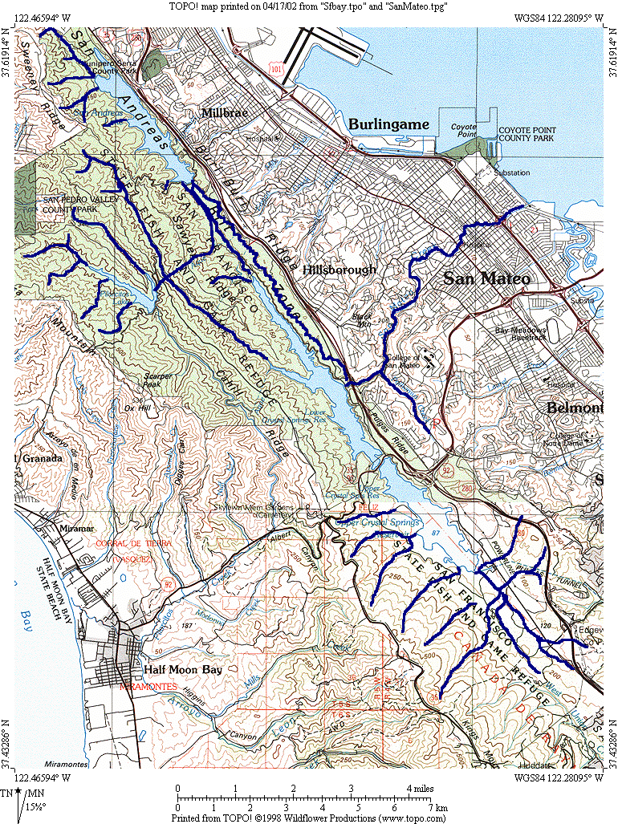

Climate and Biota

Due to its coastal proximity, the San Mateo Creek Watershed has a diversity of climate conditions. These support a variety of vegetation habitats including mixed evergreen forests (coast oak woodland), dense riparian areas, serpentine grasslands, douglas fir forests, chaparral, and wetlands. Resulting from stringent protection of the drinking water reservoirs by the San Francisco Public Utility Commission (SFPUC), this area has the greatest concentration of rare, threatened, and endangered species in the Bay Area region. Some of these species include the San Francisco garter snake, red-legged frog, and the western pond turtle [SFPUC, 1998]. A study conducted in 1995 by Tom Taylor while he was working with Trihey and Associates, found rainbow trout and sculpin in the upper watershed [Taylor, 02]. A study by Rob Leidy of the US EPA found these same species, in addition to threespine stickleback in the lower watershed [Leidy, 1993].

Land Uses and Associated Water Quality Issues

Rural and urban residential-San Mateo Creek directly below the reservoir suffers relatively low influence from adjacent urbanization. This area is characterized as moderate to highly vegetated, with steep canyon riparian corridors. As the creek passes from Hillsborough into San Mateo, the residential and commercial uses increase dramatically, with the area east of El Camino Real showing the densest urbanization. Due to the high imperviousness of the San Mateo Creek basin below the reservoir (~38%), adjacent areas are subject to substantial sheet and stream bank erosion from high surface runoff following storm events [STOPPP, 2002]. This imperviousness also leads to decreased groundwater recharge through infiltration, with increased runoff potentially carrying pollutants such as heavy metals, pesticides, nutrients, bacteria, and sediment. San Mateo Creek is on the State’s 303d list of impaired water bodies because of high levels of urban chemicals such as diazinon from urban runoff and storm sewers. Sources could include either residential areas in Hillsborough, urbanized areas in San Mateo, or a combination of both [SFPUC, 1998]. In addition to urban and residential runoff, the Mosquito Abatement District in Hillsborough annually applies pesticides to the San Mateo Creek in Hillsborough to kill the mosquito larvae in its initial stage of development [Bielski, 2002]. Nine potential monitoring sites have been located along San Mateo Creek, and are presented in the attached spreadsheets.

Reservoirs-The three reservoirs in the planning watershed, as mentioned earlier, are Lower and Upper Crystal Springs Reservoirs, and San Andreas Reservoir; all of which are owned and regulated by the San Francisco Public Utility Commission (SFPUC). While, tributaries in the upper watershed supply approximately 5% of the water in these reservoirs, the primary source of drinking water comes from the Hetch Hetchy Reservoir (~85%). This water is carried through an aqueduct from the Sierra Nevada Mountain Range to the Bay Area by gravity flow [SFPUC, 1998]. The water is then treated at the Tesla Portal chlorination station in Tracy. Approximately 50% of this chlorinated water is sent directly to drinking water recipients in the City and County of San Francisco without further filtration or treatment, with the other 50% subsequently mixed with the water in Upper Crystal Springs Reservoir and eventually the other two reservoirs, through both gravity flow and active pumping. In 1999, the Regional Water Quality Control Board mandated that SFPUC discontinue the mixing of chlorinated Hetch Hetchy water with the Upper Crystal Springs Reservoir water, resulting in the current construction of a de-chlorination unit near the Pulgas Water Temple. Following this change, de-chlorinated water from Hetch Hetchy will be discharged into Upper Crystal Springs Reservoir, and following transport, will be treated at the Harry Tracy Drinking Water Treatment Plant north of the San Andreas Reservoir. In addition to the chlorination, SFPUC has occasionally administered copper sulfate in order to control algae growth resulting from excessive nutrient input, but since this can also have detrimental affects on aquatic toxicity, this has not been a regular practice. Levels of copper in the reservoirs resulting from copper sulfate administration have been monitored by the SFPUC, and have shown to be diluted to acceptable levels with respect to fish toxicity [Bielski, 2002].

Channel Modification-The most impacted area along San Mateo Creek in terms of channel modification occurs between North El Camino Real and North Railroad Avenue near the Caltrans Railroad Depot. This stretch of the creek is completely culverted and potential sampling sites have been located in both pre and post-culvert positions to analyze the effects of this highly modified segment. Upstream of the culverted area in Arroyo Park, the creek is slightly modified by local land users and residents, who have used a variety of methods for erosion control including tires, wood panels, chicken wire, and bricks (see photos). These modifications highly effect water quality by decreasing riparian habitat and increasing siltation, which, resultingly decrease substrate quality, increase temperature, and decrease dissolved oxygen. These changes consequently reduce the habitat potential for biological diversity such as benthic macro-invertebrates and salmonid fish species.

Golf Course-There is one golf course in the San Mateo Creek Watershed, Crystal Springs Golf Course. This is located east of Lower Crystal Springs Reservoir. In addition to this golf course, there is present discussion of a new golf course placement, south of the Upper Crystal Springs Reservoir. Any detrimental effects from the present golf course would show up in the Lower Crystal Springs Reservoir. Since regular studies have been conducted by SFPUC to ensure that the quality of water is maintained according to the Title 22 public drinking water standards, evidence of any pesticide runoff would show up in SFPUC data on Lower Crystal Springs Reservoir.

Beneficial Uses

The SFPUC regulates all the land in the upper watershed. They maintain strict accessibility rules in order to avoid contamination of the drinking water supply for over 2 million people in the City and County of San Francisco and other suburban areas (MUN). While the three reservoirs in this watershed are restricted from contact recreation, limited non-contact recreational activities such as mountain biking and day-hiking are allowed in specified areas (REC-2). These areas include the Sweeny Ridge Trail starting north of San Andreas Reservoir, and an area adjacent to I-280, where San Mateo County Parks and Recreation Department maintains 25 miles of public land under a Scenic and Recreational Easement [SFPUC, 1998].

The diversity of wildlife in the three reservoirs as mentioned earlier, is the most extensive in all the bay area, with many rare and endangered species thriving in its protected environment (RARE, and WILD). The reservoirs and their tributary freshwater streams provide fishery resources for fish such as land locked rainbow trout, Sacramento sucker, tule perch and various sculpin species (COLD, WARM, SPWN, and FRSH). During the depression, bass were introduced to the reservoirs in order to provide greater food supply. This non-native fish has flourished in the reservoirs and has become partially responsible for the demise of other native fish species. The changes that the reservoirs have incurred on the watershed have also yielded detrimental effects on the survival of native fish species, the most obvious of which, the blocking of passage for anadromous species such as steelhead [Bielski, 2002].

Overview of Available Information

Previous Studies

In a study conducted by the San Mateo Countywide Stormwater Pollution Prevention Program, in conjunction with USGS, the imperviousness of San Mateo County watersheds were analyzed. This study found that the estimated cumulative percent imperviousness of the San Mateo Creek watershed below the dam was approximately 38% [STOPPP, 2002]. John Konnan of EOA also has been involved in imperviousness studies in the San Mateo Creek watershed and made available detailed unpublished GIS data which presented the lower San Mateo Creek watershed in terms of land uses [Konnan, 2002]. These studies are helpful in determining locations for potential SWAMP sampling.

Robert Leidy of the US EPA has conducted fish community studies in all Bay Area watersheds and this information is presently being updated. His reports indicate that the common fish species found in the San Mateo Creek watershed include threespine stickleback and steelhead. This information can be found at www.stgeorgeconsulting.com/servlet/FishQueryResults or at the SFEI website under “Bay Area Fish Studies”.

Tom Taylor of Entrix, was involved in a study of the San Mateo Creek watershed in 1995 when he worked for Trihey and Associates. During a personal interview, Taylor stated that during the study, they found both rainbow trout and sculpin in the upper watershed, and suckers and carp in the lower reach of the San Mateo Creek.

Ongoing Studies

SFPUC has been sampling water quality parameters in the reservoirs for about 40 years in order to comply with Title 22 drinking water standards and Harry Tracy Drinking Water Plant requirements. Tested parameters include organics, inorganics, metals, bacteria, pesticides, nutrients and general water quality parameters (DO, pH, temp, and electrical conductivity). SFPUC sampling crews have also taken samples from the reservoir tributaries and lower reach of the San Mateo Creek when specific water quality concerns had been questioned. In a tributary to the San Andreas Reservoir near Sweeny Ridge, where there is a parcel of land in negotiation for development, SFPUC has been collecting data for approximately 1 year in monthly intervals when water levels were favorable. Data is available for all water quality studies conducted on the SFPUC watershed area, in addition to recent sanitary surveys of the reservoirs [Dingman, 2002].

Summary and Conclusions

The nearly pristine conditions of the upper San Mateo Creek watershed present unique potential for close to historical reference sites. While the upper watershed has been unarguably affected by the presence of the reservoirs, there are locations where the streams have been relatively less influenced. San Mateo Creek is listed on the State’s 303(d) for diazinon associated with urban runoff with the highest potential source occurring between the crossing of San Mateo Creek with El Cerrito Avenue and I-101. Five potential reference sites in the upper watershed, and 9 sites in the San Mateo Creek below the dam have already been located (see site map) with final sampling location decisions pending further investigation. SWAMP water quality monitoring of the San Mateo Creek watershed should include:

1) Standard Tier 1 monitoring (continuous monitoring of general water quality parameters, rapid bioassessment, and physical habitat assessment) in sites along lower San Mateo Creek to monitor effects of urbanization on general water quality, and provide data on potential habitat for salmonid species. Also Tier 1 monitoring should be conducted in the upper watershed sites to provide general water quality reference data.

2) Tier 2 monitoring of water chemistry, nutrients, and toxicity, should be monitored in at least 2 sites along the lower San Mateo Creek, in addition to at least 2 sites in the upper watershed for reference data.

3) North of San Andreas Reservoir in Pacifica, there is a parcel of land, (~10 acres) that is in the stages of redevelopment negotiations. This land, if sold to private owners, would be developed with high density housing and the subsequent runoff would drain into the San Andreas Reservoir through associated tributaries. It would be beneficial to gather baseline data on this section of the planning watershed. Monitoring should include Tier 1 general water quality and biodiversity assessment, and possibly Tier 2 parameters such as urban pesticides, sedimentation, turbidity and nutrients so as to have pre-development data on some of the parameters generally exacerbated by urbanization.

4) An appropriate integrator site is located near South Fremont Street and 2nd Street. This site marks the lowest point in the watershed before tidal influence, and will reflect the level of water quality contamination resulting from dense urbanization.

References

Bessey, Verne, Personal Communication, February 6, 2002.

Bielski, Jason, Personal Communication, February 14 and 28, 2002.

Dingman, Dave, Personal Communication, February 4, 2002.

Konnan, John, Personal Communication and Unpublished GIS Data, January 30, 2002.

Leidy, Robert, 2002, Fish Query Results www.stgeorgeconsulting.com/FishQueryResults

Moran, Kelly, Personal Communication, February 6, 2002.

San Francisco Public Utilities Commission (SFPUC), 1998, Peninsula Watershed Management Plan-DRAFT.

San Mateo Countywide Stormwater Pollution Prevention Program (STOPPP), 2002, Characterization of Imperviousness and Creek Channel Modifications for Seventeen Watersheds in San Mateo County.

Taylor, Tom, Personal Communication, February 1, 2002.

Mt Diablo/Kirker Creek Watershed

Background

Location

The Mt. Diablo/Kirker Creek “Planning Watershed” encompasses an area of 61 square miles, and is located in Contra Costa County. The planning watershed consists of two subwatersheds, Mt. Diablo Creek and Kirker Creek. These two watersheds are subdrains of the Suisun Bay watershed, discharging near the confluence of the San Joaquin and Sacramento Rivers in the eastern end of Suisun Bay (see maps). The headwaters of Mt. Diablo Creek originate in the northeastern slopes of Mt. Diablo. Mt. Diablo Creek continues through Clayton and Concord on its way to its discharge point in Hastings Slough (Questa Engineering, 1999). Kirker Creek begins with its headwaters in the foothills of Mt. Diablo, in the Black Diamond Mines Regional Preserve, and continues through the cities of Pittsburg and Antioch before its discharge into New York Slough (CCRCD, 2002). These sloughs are combined and discharge shortly after into Suisun Bay.

Figure D: Map showing Mt. Diablo Creek planning watershed

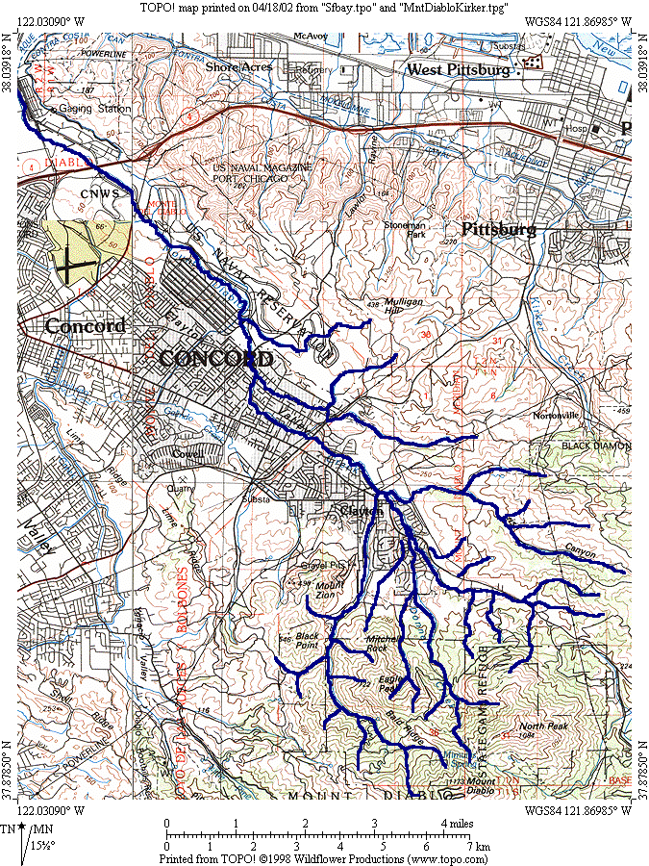

Figure E: Map showing Kirker Creek planning watershed

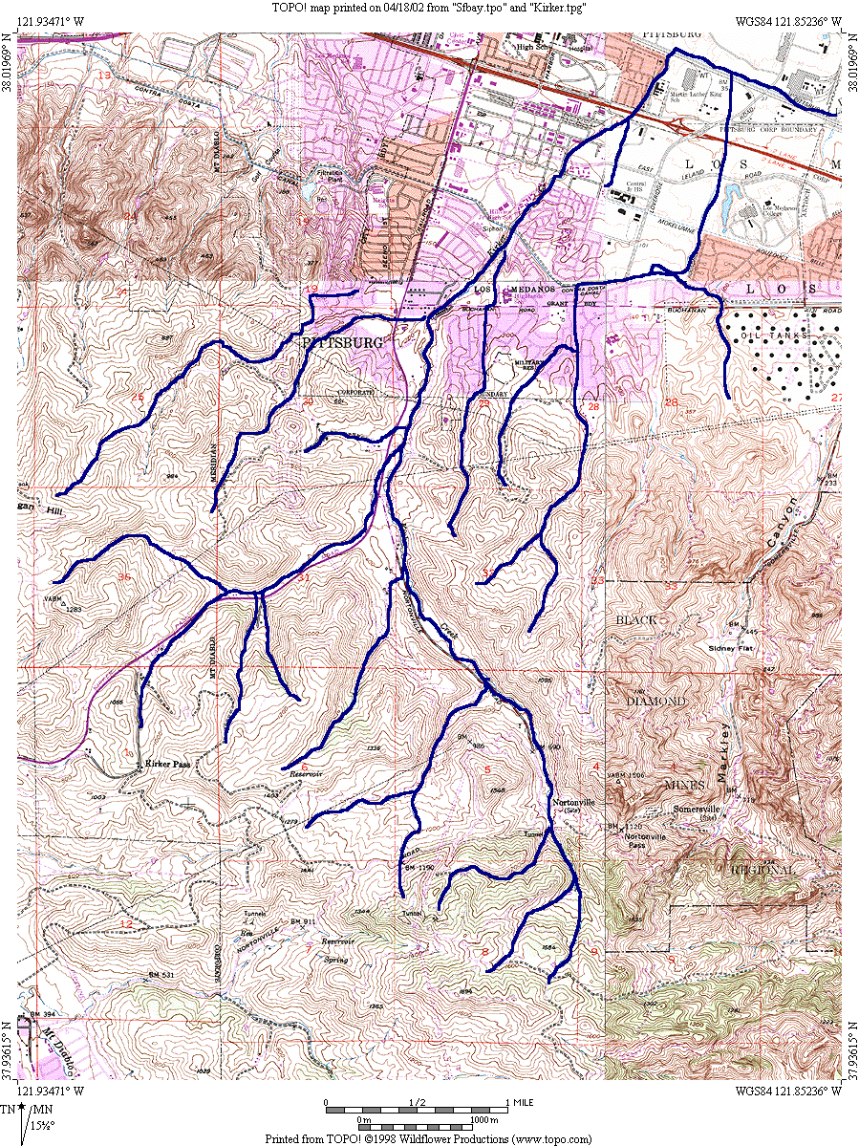
Geologic and Geomorphic Setting

The Mt. Diablo hills and the Black Diamond Mines Regional Preserve in the upper watersheds of Kirker and Mt. Diablo Creeks are composed of the Domengine formation, a white sandstone with interbeds of shale and seams of coal. These were historically mined for coal and white foundry from the mid 1800’s to the mid 1900’s. The coal was extracted from the seams and the white foundry was extracted from the silica-rich sandstone. The upper watershed areas can display very steep gradients, with slopes up to 70% in some locations. Increased velocity, and rapid erosion of the streambed can lead to a significant source of sediment load downstream. Erosion and runoff from Mt. Diablo have led to significant alluvial deposition in the lower Mt. Diablo and Kirker Creek watersheds, where lower stream gradients lead to deposition of eroded material (CCRCD, 2002). Erosion of material can also affect stream pH. Eroded shale can lead to increases in pH, while erosion of the coal seams can lead to decreases in pH. Depending on what type of mine wastes are deposited, significant changes in stream pH can occur through leaching of material and subsequent runoff (EBRPD, 1999).

Climate and Biota

The climate of the northeastern area of Contra Costa County is characterized as subtropical and Mediterranean, having both warm, dry summers and cool, wet winters. Annual precipitation in the area ranges from over 20 inches in the higher elevations, to 12.5 inches in the lower elevations, with over 90% of this generally occurring between November and April. Due to a lack of a continuous source of water, the creeks are often seasonally intermittent, and can dry up during the summer months. (CCRCD, 2002).

Vegetation patterns in the two watersheds differ greatly from historical conditions. In the two watersheds, willow, oak, and cottonwood trees are found in the riparian zones along the creek and tributaries, with scattered patches of mixed deciduous and exotic species. In 1981, Contra Costa County enforced a flood control easement on residents preventing them from building houses near the Mt. Diablo creek. This lead to the preservation of the land adjacent to the stream, with the large lots of the 1940’s subdivision houses preventing dense urbanization in the area. The result of this is a healthy riparian zone in the upper Mt. Diablo watershed areas, such as Clayton (Questa, 1999). Kirker Creek shows similar trends with the upper watershed displaying the densest riparian zones in the Black Diamond Mines Regional Preserve and Mt. Diablo. As Kirker Creek passes through the urban areas of Pittsburg and Antioch, the vegetation is predominantly exotic species planted by private landowners. Below the Preserve area, grasslands are quite common (CCRCD, 2002).

These two watersheds present valuable habitats such as coastal woodlands, grasslands, chapparal, marsh, and valley foothill riparian zones. These habitats provide homes to a variety of special status animal species such as the California tiger salamander, California red-legged frog, vernal pool fairy shrimp, prairie falcon, California coyote, San Juaquin kit fox, San Juaquin pocket mouse, salt-marsh harvest mouse, giant garter snake, Suisun song sparrow, tricolored blackbird, and the horned lark (CCRCD, 2002).

Land Uses and Associated Water Quality Issues

Urbanization- Lower Kirker Creek and Mt. Diablo Creek both suffer from the impacts of urbanization. For this reason, they are listed in the Regional Water Quality Control Board’s 303d list of impaired water bodies for having unacceptable levels of diazinon. All impacting influences include urban residential, commercial, and industrial uses. Mt. Diablo Creek passes through the City of Concord, and the Concord Naval Weapons Station in its lower reach before entering Hastings Slough. Riparian corridors in lower Mt. Diablo Creek are highly degraded, with frequent patches of low canopy and high erosion from low streambank stability and urban runoff. In the Kirker Creek watershed, the majority of the commercial and industrial areas are located along Highway 4, Railroad Avenue, and East Leland Road. Downtown Pittsburg also has a high density of residential and commercial development. While National Pollutant Discharge Elimination System (NPDES) regulations on point source pollution, such as wastewater from industrial centers, have been implemented in both watersheds by the Regional Board, dense urbanization can also lead to high levels of non-point source pollution through urban runoff, sometimes leading to much graver consequences than point source pollution.

Rural Residential-The upper watersheds of Mt. Diablo Creek and Kirker Creek are characterized by large privately owned ranchettes and open spaces. Bordering the south side of the City of Pittsburg, the land is open space district, owned by the East Bay Regional Parks District and private landowners. These areas are largely used for agriculture, allowing for the degradation of water quality through continuous grazing and bank erosion. In addition to the grazing, horses are common in these ranchette areas, and through direct access to the creeks, can influence streambank erosion and increase nutrients and fecal contamination in the creek (CCRCD, 2002).

Landfills-In the Kirker Creek watershed, the Keller Canyon Landfill site is located in the southwest margin of the drainage basin. The area contained within the landfill site is 820 acres. While the active landfill is located outside the watershed, the “Special Buffer Area” and “Primary Project Area” are located within the watershed area. Stock watering ponds and planted trees and shrubs have been established in the buffer area, however, toxic leaching can still potentially be contributing to contamination of Kirker Creek through runoff and slow seepage.

Mining Operations-As mentioned earlier, active mining was historically prevalent in the upper watersheds of both Kirker and Mt. Diablo Creeks. While mining activity halted in the mid 1900’s, the open scours of the mining sites and associated piles of mine waste have continued to present a threat to water quality through acid mine drainage. The East Bay Regional Park District monitored pH conditions near the abandoned mines from March 1998 to July 1999, and found pH levels near the Black Diamond waste piles to range from 3.3-3.8. Levels of pH this low can pose a significant threat to many biological species and should therefore be monitored to ensure that these highly acidic conditions are not draining into the watershed in crucial levels. Monitoring of metals contaminants near the mine conducted by the East Bay Regional Park District showed that metals were not a significant threat to water quality (CCRCD, 2002).

Golf Course-There is one golf course, Oak Hearst Golf Course, outside Clayton near the upper reach of Mt. Diablo Creek. This is a privately owned golf course and may potentially be contributing pesticide and fertilizer contaminants into the watershed. Due to a lack of proper riparian corridor bordering the creek, chemical runoff from the golf course may be contributing to significant degradation of biological integrity in the Mt. Diablo Creek.

Channel Modification-While Kirker Creek is left as an open channel for the majority of its reaches, there are culverts at every road crossing, and at a few locations along the Pittsburg-Antioch Highway. In the 1940’s, U.S. Steel modified the route of Kirker Creek from its straight northward channel going directly into the New York Slough, to a rerouted channel which takes a 90 degree turn north of the Pittsburg-Antioch Highway and flows parallel to the highway east before discharging into the New York Slough via the Dowest Slough and the Los Medanos Wasteway. This lower reach of the creek is completely channelized and contributes to changes in sedimentation, vegetation, and flooding. Flooding is a large problem in the two watersheds, and future channelization and stream widening projects are presently being planned, especially along Kirker Creek crossings with Highway 4 and Loveridge Road (CCRCD, 2002). In the Mt. Diablo Creek watershed, the most prominent forms of channel modification are hardscape features. Erosion is a large problem in the Mt. Diablo Creek, and hardscapes have been placed at all sinuous curves along the creek where erosion could potentially occur. These bank stabilization repairs have been fairly well maintained with about 94% in fair to good condition according to an inspection conducted by Questa Engineering (1999).

Underground Storage Tanks (USTs)- USTs present a potential threat to the quality of groundwater supplies, as sites that require the storage of petroleum and hazardous substances may be neglecting proper maintenance of their tanks, thus leading to contamination of underlying groundwater. This can potentially lead to contamination of surface waters, depending on discharge and depth of aquifers. High-density urban areas, such as the City of Concord and Pittsburg, may have locations where USTs are leaking. The Concord Naval Weapons Station may also be a source of contaminants through USTs. For reference, 57 leaky USTs were found in the cities of Pittsburg and Antioch in 1998, so this can very likely be a source of water quality contamination in the 2 watersheds (CCRCD, 2002).

Beneficial Uses

The beneficial uses in the Kirker Creek/Mt. Diablo Creek watershed, as stated in the San Francisco Bay Regional Water Quality Control Board Basin Plan (1995) are: Cold Freshwater Habitat (COLD), Warm Freshwater Habitat (WARM), Fish Migration (MIGR), Contact Recreation (REC-1), Non-Contact Recreation (REC-2), Fish Spawning (SPWN), and Wildlife Habitat (WILD).

Overview of Available Information

Previous Studies

In 1997, Terry Seward with the Regional Water Quality Control Board completed a cursory investigation of the historically mined areas in the Kirker Creek watershed. He found that the pH levels were well below the surface water objective of 6.5-8.5 pH units near Black Diamond Mines, and requested that further investigation of the site be conducted (EBRPD, 1999).

Questa Engineering conducted a study of Mt. Diablo watershed in 1999, which focused on both historical and existing conditions within the watershed, along with proposed maintenance, repair, and management procedures. They evaluated the watershed using longitudinal bed profiles, different flow regimes, vegetation cover, vegetation type distribution, channel bank stresses, and erosion control techniques. In addition, they designed site-specific streambank stabilization procedures in order to address the more severe erosion problems in the watershed (Questa, 1999).

Ongoing Studies

The East Bay Regional Park District has been monitoring pH levels of acid mine drainage from Black Diamond Mine since March 1998. They have found pH levels as low as 3.3 directly adjacent to the mine waste piles (EBRPD, 1999).

Los Medanos College has been monitoring stream conditions in Kirker Creek Watershed since February, 2002. They have chosen 16 sites along the watershed, which are designed to represent the gradient of conditions evident throughout the watershed, 9 of which they are actively monitoring on a biweekly schedule. A map showing these sites is found in Appendix B as Map F. Parameters measured include dissolved oxygen, ammonia, phosphate, nitrate, sulfate, salinity, conductivity, turbidity, temperature, color, odor, and pH. They are looking to add more sites, and will work with SWAMP in order to provide the most comprehensive monitoring of the watershed possible utilizing both resources (Schweickert, 2002).

The Contra Costa Resource Conservation District is currently involved in the development of a Kirker Creek Watershed Program (KCWP). In collaboration with the City of Pittsburg, Contra Costa County, Contra Costa County Farm Bureau, Contra Costa Clean Water Program, Contra Costa Watershed Forum, Dow Chemical Company, East Bay Regional Park District, Natural Resources Conservation Service, Local Ranchers, and Residential Landowners, the KCWP has been granted $440,345 from CalFed and matching contributions. With these funds, the Contra Costa Resource Conservation District aims to address all sources of water quality contamination in the watershed, consider all beneficial uses of the watershed, and develop a program which protects and improves the overall health of the watershed. A resource inventory has already been collected, with future plans looking at conducting more in depth studies of water quality, riparian corridors, and impacts of land uses (CCRCD, 2002).

Summary and Conclusions

These two watersheds have had very few studies completed throughout their land use history, so it is very important that the SWAMP collect baseline information throughout the watersheds in order to develop an understanding of the relative impacts of different land uses throughout the watersheds. Impacts within the two watersheds are varied, including mining, grazing, urbanization, and waste disposal. Water quality monitoring of the Kirker/Mt. Diablo Creeks planning watershed should include:

1) Standard Tier 1 monitoring (continuous monitoring of general water quality parameters, rapid bioassessment, and physical habitat assessment) in all sites within the two watersheds. Results in the lower watersheds will aid in understanding the effects of urbanization on general water quality, and provide data on potential habitat for salmonid species. Since these creeks have no presence of dams, there are clear runs for fish migration, and it is therefore of crucial importance that we understand the condition of general water quality parameters such as dissolved oxygen, electrical conductivity, pH, and temperature, with which the anadromous species depend on. Tier 1monitoring in the upper watershed sites will help to provide data on the impacts of ranches and grazing, with selected sites showing little or no land use impact and potentially near-reference conditions.

2) Tier 2 parameters should be monitored in a few selected sites throughout the watersheds that display different land use characteristics than their surrounding areas. In the upper Kirker Creek watershed near the Black Diamond Mines Preserve, water and sediment chemistry should be evaluated, in order to determine the impacts of mining on the adjacent creek conditions. In the southwest area of Kirker Creek watershed, toxicity should also be measured to determine if seepage from the Keller Landfill has reached Kirker Creek. In upper Mt. Diablo, toxicity, water chemistry, and nutrients should be measured in a site that represents near reference conditions in order to show what historical levels might have been. In the lower watersheds, toxicity, water chemistry, and nutrients should be measured along highway 4 in Pittsburg, and within the City of Concord. These will represent the impacts of the two largest cities in the planning watershed, including the effects of both urban runoff and downstream accumulation.

3) There needs to be two integrator sites within the planning watershed, one near the mouth of Kirker Creek, and one near the mouth of Mt. Diablo Creek. In Kirker Creek, this would be located around the diversion at Los Medanos Wasteway. In Mt. Diablo Creek, the integrator site should be located below the Concord Naval Weapons Station, but above any tidal influence. This integrator site may pick up increased contaminant loads near the Mt. Diablo mouth, due to potential contamination of the water quality coming from Concord Naval Weapons Station.

References

Alvarez, Jeff 1994. Wildlife Inventory along Kirker Creek at Buchanan Park, Pittsburg, California. Environmental Impact Services. Report prepared for The Friends of the San Francisco Bay Estuary and the City of Pittsburg. 9 pp.

Contra Costa County Resource Conservation District. United States Department of Agriculture, Natural Resources Conservation Service, Elk Grove Service Center 2002. Kirker Creek Watershed Resources Inventory.

East Bay Regional Park District 1999. “Black Diamond Mines Regional Preserve Coal Mine Waste Pile pH Investigation Technical Report.” Planning/Stewardship Dept.

Lake, Dianne 1995. Plant Survey to Determine Native vs. Exotic Plants, Kirker Creek, Buchanan Park, Pittsburg, CA. Report prepared for the City of Pittsburg. 6 pp.

Schweickert, Mitch, May 15, 2002. Los Medanos College, Personal Interview.

Questa Engineering Corporation 1999. Stream Corridor Study, Management and Enhancement Program for Galindo and Mt. Diablo Creeks.

3. General Study Design

In order to fully understand a watershed, it is necessary to consider all environmental factors, such as biodiversity, general water quality, physical habitat, geographic location, and forms of stream degredation that may be incurred by specific land uses. While the overall goal of SWAMP is to develop a general picture of watershed health in the SF Bay Region, a directed sampling design is used to: 1) evaluate the influence of tributaries, 2) determine if beneficial uses are being protected at specific locations, 3) follow-up on previous data indicating potential impacts, 4) determine if specific land uses are having an impact on water quality and 5) identify reference sites.

In determining sites, SWAMP considers the prominent water quality concerns in the watershed first. By hypothesizing where the sources of these problems may be, potential sites are considered in those areas, depending of course on factors such as site accessibility, access permission, and project funding. By monitoring sites in locations both upstream and downstream of high impact areas, it is possible to make inferences, directly related to specific land uses. Establishing reference sites is of utmost importance. Criteria for establishing reference sites is a long debated issue, but general requirements are that they are accessible, are found in geographic and geologic conditions similar to those of impacted sites, and are as unaffected by land uses, and as close to historical conditions as is available in the watershed. Integrator sites are established at the lowest, non-tidally influenced point in the watershed. These sites allow for a cumulative analysis of all contaminant sources and land use impacts in the watershed and help to determine the relative contribution of contaminants to receiving waters.

The strategy used for Regional Board lead studies under SWAMP focuses on three sampling events based on three hydrologic cycles. The three hydrologic cycles are the wet season (January-March), decreasing hydrograph/spring (April-May) and the dry season (June-October), although sampling time is primarily decided by water patterns than by month. Monitoring involves: 1) a 2 tiered watershed monitoring design to assess water quality impacts and establish regional reference sites, 2) monitoring of fish in reservoirs and coastal areas where people catch and consume fish.

“Tier 1” is the set of monitoring parameters that addresses the general health of the watershed. These include: 1) a California rapid bioassessment that takes place in spring synoptically with a physical habitat assessment and the measurement of basic water quality parameters and 2) continuous monitoring of water quality parameters throughout the watersheds. The continuous monitoring devices are YSI 6600 sondes, which are deployed for 2-week intervals and take measurements continuously every 15 minutes. Measured parameters include: pH, dissolved oxygen, temperature, and electrical conductivity. Three sondes are deployed by Regional Board field crew in two watersheds at a time. This is done to allow for both intra-and inter-watershed analysis for a given 2 week monitoring period. A more extensive physical habitat assessment is also done by Regional Board field crew during reconnaissance and again at the time of sonde deployment, characterizing factors such as vegetation, depth of stream, flow, visual turbidity, occurrence of pools and riffles, and substrate quality.

Tier 2 monitoring provides an opportunity to answer basic questions concerning protection of beneficial uses and potential impacts of land use and water management. Parameters monitored are nutrients, sediment and water toxicity, contaminants, pathogens, chlorophyll, ammonia, nitrate/nitrite, total nitrogen (by TKN), phosphate, alkalinity, hardness and total and dissolved solids (TDS-salinity). These parameters are monitored at sites where there are potential impacts from land uses, or in reference sites to provide background levels. Toxicity/chemistry samples will be collected during 3 hydrologic cycles, the wet season, decreasing hydrograph (spring) and dry season, at the same time that conventional water quality samples are being collected. At the bottom of each watershed, or the lowest point before tidal influence, there will be an integrator station, which will measure the cumulative contaminant concentrations, in addition to determining which contaminants from the watershed are flowing into the receiving waters. At these stations, Corbicula will be deployed for bioaccumulation measurements, sediment samples will be collected for toxicity analysis, using Hyalella, grain size analysis and sediment chemistry.

The data collected through the SWAMP will be used in the development of watershed characterization outlines for the whole San Francisco Bay Region, thus providing one of the first comprehensive and systematic analyses of the health the entire Region’s water bodies. This information will make possible cross comparisons between different watershed basins, in addition to providing a database of information which can be accessed by all members of the public sector enabling a greater awareness and communication among all stakeholders and interest groups alike.

4. Specific Study Design and Planned Activities

Number of Stations per Watershed/Waterbody

See Appendix A. In the Petaluma River watershed (PET & SAN) there will be 27 stations, 9 are for the gradient study. In the San Mateo Creek watershed (SMA) there will be 10 stations. In the Mt. Diablo/Kirker Cr. watershed (MTD, WLW & KRK) there will be 15 stations.

Types and Numbers of Samples/Analyses

See Appendix A.

In general:
43 Tier 1 sites (bioassessment, visual phys. assess., candidates for continuous WQ)
15 Nutrient/Conventional Chemistry Sites
9 Water Metals/Organics/Toxicity Sites
6 Integrator Sites (Mt Diablo, Kirker, Willow (small creek b/w Mt. Diablo and Kirker), Petaluma, San Antonio, San Mateo)
15 Sediment Chem. Sites (6 integrators plus 9 additional Petaluma sites)

Designation of Stations

Stations will be individually designated by storing GPS coordinates at the location of sonde deployment, taking digital cross referenced photographs (both upstream and downstream), and making a site map of the area. All of these will enable future reference for site locations. GPS coordinates will be uploaded into a TOPO! program and placed on a common map. Photos will be stored in the SWAMP database and will be labeled according to their site identification number (e.g. SPA200).

Quality Assurance of Sampling and Analysis

Sample collections and subsequent processing and testing will be performed according to the most recent version of the SWAMP Quality Assurance Project Plan (QAPP) and SWAMP Laboratory Standard Operating Procedures (SOPs). RWQCB staff will be sampling bacteriological analysis, conducting continuous monitoring of basic water quality parameters, and performing quantitative physical habitat assessments and trash assessments at selected sites in each watershed. The Department of Fish and Game will collect bioassessment samples according to the California Stream Bioassessment Procedure Protocols as described in section 3. They will perform qualitative physical habitat assessments in the field, collect all required samples and measurements, and analyze data in the DFG water quality laboratory according to QAPP and SOP speculations. Moss Landing water quality specialists will collect samples from Tier 2 and integrator sites, including total and dissolved metals and organics, toxicity, nutrients, salinity, TDS, and general water quality parameters. These samples will be analyzed by the Dept. of Fish and Game for chemical parameters and U.C. Davis for toxicity. Toxicity test data will include test mean, standard deviation, and a determination of whether or not a sample is toxic at a statistically significant level of difference from the laboratory control samples and a value less than 80% of the lab control value. Chemistry data will include the analytical result, method detection limit, reporting limit, and relevant quality assurance (QA) information on surrogate recovery, duplicate relative percent difference (RPD), matrix spike percent recovery and RPD, and blank spike percent recovery and RPD. The State Mussel Watch, Toxic Substances Monitoring, and the Coastal Fish Contamination Programs are included in SWAMP. All sampling and analysis techniques used by these organizations have their own QA requirements. No data will be incorporated into the official SWAMP database, unless QA has been investigated and has passed all SWAMP QA requirements. Data collected by independent research groups and organizations will be entered into a common database, but will be provided solely as unofficial information unless a complete QA inspection has taken place by Regional Board staff members. Any deviations from QA goals established in the QAPP will be noted. Data will be made available in electronic format unless otherwise requested.

5. Description of Deliverable Products

Sampling Event Reports- The bioassessment information collected by DFG is presented in a California Stream Habitat Characterization Form for each site. This report will be provided to the Regional Board, with an additional copy provided to the State Board (one copy to each). The report will include a reach/transect diagram, GPS coordinates, a brief description of each station, all field measurements and data collected during the sampling event including: flow, temperature, electrical conductivity, dissolved oxygen, pH, turbidity, any physical assessments completed and any unusual circumstances or deviations from protocols or task order. Results will also be analyzed using regression analysis to determine significant correlations between parameters and biodiversity. All of this information will ultimately be entered into the delineated electronic file. A report from Moss Landing of each sampling event including water quality data and the success of sampling, including any unusual events, at each site will be compiled.

Final Data Report- A final data report will be prepared for the year’s work. All data will be reported in an electric file in an agreed upon format, as well as in hard copy (three one-sided originals for copying, and three bound copies). One of each type, electronic file, one-sided hardcopy original, and bound hardcopy shall go to the State Board, the Regional Board, and DFG. QA/QC evaluation reports and verification that data met QA criteria set forth in QAPP must be provided with the hardcopy data report. The final data report will include where applicable, but shall not necessarily be limited to the following items: all station data including project number, station number, sample number, sample collection date, sample station longitude and latitude, sample GPS coordinates, sample station flow and water quality data, and sample location characteristics. Specific QA/QC data may be included in the QA/QC report or appendices. QA/QC evaluation ranking by each analytical laboratory will be provided in the database. In addition, appendices will include replicate data for toxicity tests, a database description and file structure description. A QA/QC report will also be included in the final data report, containing an evaluation of how the data complied with actually QA/QC parameters.

6. Anticipated Milestones

All samples will be collected within the 3 hydrologic cycles specified in the sample design. The field report should be made available within a month of finishing the collection. Data from the analyses of the samples should be submitted within 6 months of collection. A final data report should be made within 6 months after the final sample collection. Exact sampling dates are still in the process of being negotiated between the Regional Board and all affiliated groups.

7. Budget

The preliminary budget is included in Appendix A. This budget has quite a few uncertainties. Currently, the budget is $28,403 over the current $272,565 allocated for SWAMP. However, two products/studies may be deleted from the budget: 1) since the State Board agreed that an interpretative report is due every other year and we included a report in 01-02, the 02-03 report will probably not be needed, this would save $15,000, 2) the Clean Estuary Partnership (CEP) may fund the gradient study in the Petaluma River, this would save $21,942. In addition, there may be funding from MW/TSM that could be used for some of these activities. A detailed budget will be included with the 02-03 task order.

8. Working Relationships
9. Appendices:

Appendix A - Preliminary Budget
Appendix B - Maps of preliminary RWQCB SWAMP Stations for 2002-2003
Appendix C – Station descriptions
Appendix D – Contacts
Appendix E – Beneficial uses and associated legislative objectives

Appendix A - Preliminary Budget

See excel spreadsheet

Appendix B - Maps of RWQCB SWAMP Stations for 2002-2003

Map A-MSCARII sites in Petaluma River watershed established and sampled by CDFG.
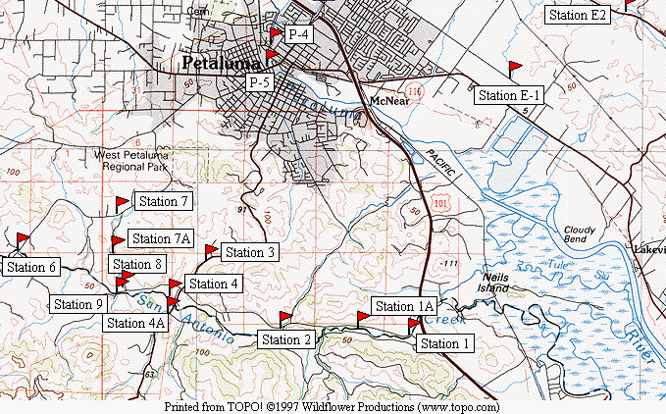

Map B-Site near Sweeney Ridge in upper San Mateo Creek watershed

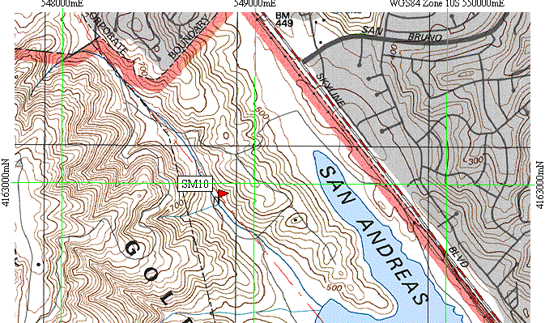

Map C-Potential sites established in the lower San Mateo Creek watershed.

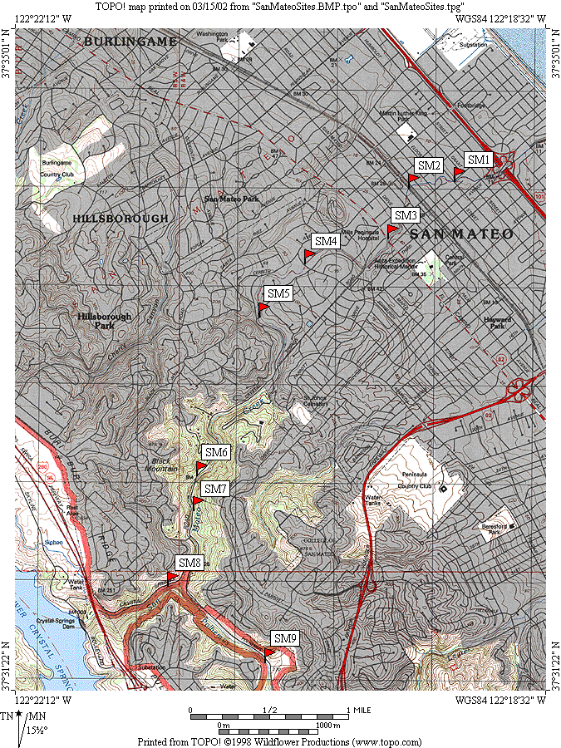

Map D-Sites along upper San Mateo Creek.

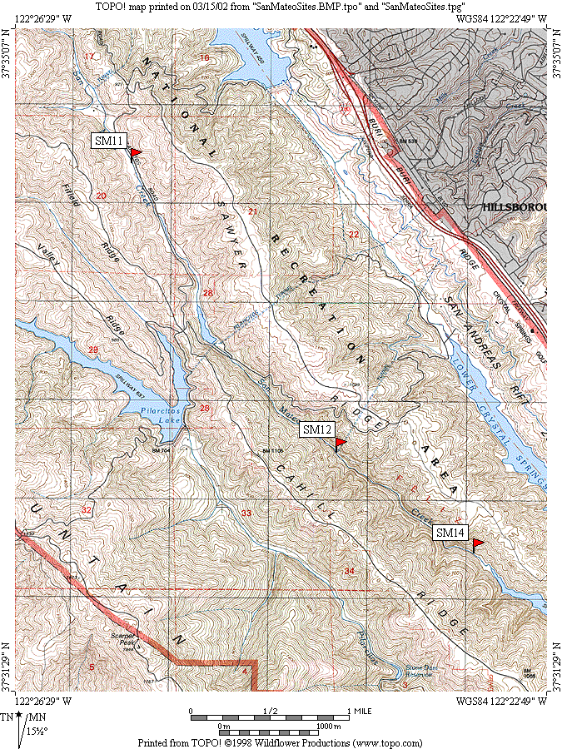

Map E-Pre-Hetch Hetchy tributary site below Upper Crystal Springs Reservoir.

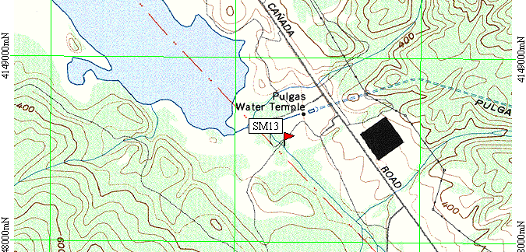

Map F- Sites established by Los Medanos College in Kirker Creek watershed.
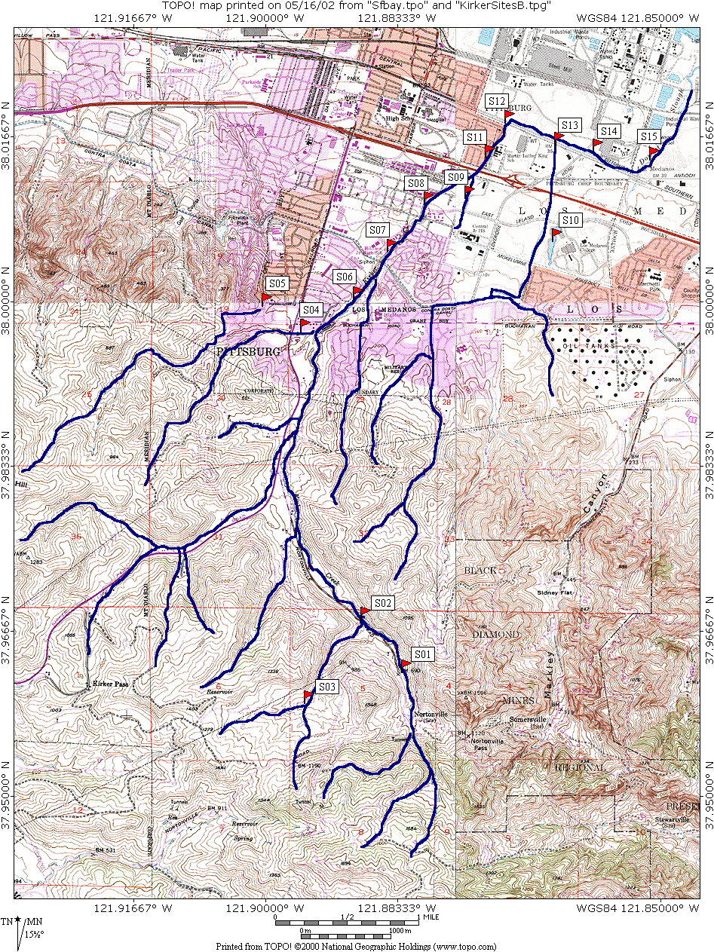
Appendix C- Site descriptions for Petaluma River and San Mateo Creek

Appendix D - Watershed Specific Contact Sheets

Appendix E – Legislative Objectives (Site-specific)

section vi. SITE-specific monitoring

The overall goal of this activity of SWAMP is to develop site-specific information on sites that are (1) known or suspected to have water quality problems and (2) known or suspected to be clean. It is intended that this portion of SWAMP will be targeted at specific locations in each region. This portion of SWAMP is focused on collecting information from sites in water bodies of the State that could be potentially listed or delisted under CWA Section 303(d). The RWQCBs are given significant flexibility to select the specific locations to be monitored. The RWQCBs at their discretion may perform monitoring at clean sites to determine baseline conditions (for assessments related to antidegradation requirements) or if this information is needed to place problem sites into perspective with cleaner sites in the Region.

Monitoring Objectives
In developing the SWAMP monitoring objectives, the SWRCB used a modified version of the model for developing clear monitoring objectives proposed by Bernstein et al. (1993). The model makes explicit the assumptions and/or expectations that are often embedded in less detailed statements of objectives (as presented in SWRCB, 2000). This section is organized by each major question posed in the SWRCB report to the Legislature on comprehensive monitoring (SWRCB, 2000).

Is it safe to swim?

Beneficial Use: Water Contact Recreation

- At sites influenced by point sources (e.g., storm drains, publicly owned treatment works, etc.) or nonpoint sources of pathogenic contaminants, estimate the concentration of bacteria or pathogens above screening values, health standards, or adopted water quality objectives.

Is it safe to drink the water?

Beneficial Use: Municipal and Domestic Water Supply

- At specific locations in lakes, rivers and streams that are sources of drinking water and suspected to be contaminated, estimate the concentration of microbial and chemical contaminants above screening values, drinking water standards, or adopted water quality objectives used to protect drinking water quality.

- At specific locations in lakes, rivers and streams that are sources of drinking water and suspected to be contaminated, verify previous estimates of the concentration of microbial and chemical contaminants above screening values, drinking water standards, or adopted water quality objectives used to protect drinking water quality.

Is it safe to eat fish and other aquatic resources?

Beneficial Uses: Commercial and Sport Fishing, Shellfish Harvesting

- At specific sites influenced by sources of bacterial contaminants, estimate the concentration of bacterial contaminants above health standards or adopted water quality objectives to protect shellfish harvesting areas.

- At specific sites influenced by sources of chemical contaminants, estimate the concentration of chemical contaminants in edible aquatic life tissues above advisory levels and critical thresholds of potential human health risk.

- At frequently fished sites, estimate the concentration of chemical contaminants in commonly consumed fish and shellfish target species above advisory levels and critical thresholds of potential human health risk (Adapted from USEPA, 1995).

- At frequently fished sites, verify previous estimates of the concentration of chemical contaminants in commonly consumed fish and shellfish target species above advisory levels and critical thresholds of potential human health risk (Adapted from USEPA, 1995).
- Throughout water bodies (streams, rivers, lakes, nearshore waters, enclosed bays and estuaries), estimate the concentration of chemical contaminants in fish and aquatic resources from year to year using several critical threshold values of potential human impact (advisory or action levels).

Are aquatic populations, communities, and habitats protected?

Beneficial Uses: Cold Freshwater Habitat; Estuarine Habitat; Inland Saline Water Habitats; Marine Habitat; Preservation of Biological Habitats; Rare, Threatened or Endangered Species; Warm Freshwater Habitat; Wildlife Habitat

- At sites influenced by point sources (e.g., storm drains, publicly owned treatment works, etc.) or nonpoint sources of pollutants, identify specific locations of degraded water or sediments in rivers, lakes, nearshore waters, enclosed bays, or estuaries using several critical threshold values of toxicity, water column or epibenthic community analysis, habitat condition, and chemical concentration.

- At sites influenced by point sources (e.g., storm drains, publicly owned treatment works, etc.) or nonpoint sources of pollutants, identify specific locations of degraded sediment in rivers, lakes, nearshore waters, enclosed bays, or estuaries using several critical threshold values of toxicity, benthic community analysis, habitat condition, and chemical concentration.

- Identify the areal extent of degraded sediment locations in rivers, lakes, nearshore waters, enclosed bays, and estuaries using several critical threshold values of toxicity, benthic community analysis, habitat condition, and chemical concentration.

Beneficial Use: Spawning, Reproduction and/or Early Development

- At sites influenced by point sources (e.g., storm drains, publicly owned treatment works, etc.) or nonpoint sources of pollutants, identify specific locations of degraded water or sediment in rivers, lakes, nearshore waters, enclosed bays, and estuaries using several critical threshold values of early life-stage toxicity, chemical concentration, and physical characteristics.

- At sites influenced by point sources (e.g., storm drains, publicly owned treatment works, etc.) or nonpoint sources of pollutants, verify previous measurements identifying specific locations of degraded water or sediment in rivers, lakes, nearshore waters, enclosed bays, and estuaries using several critical threshold values of early life-stage toxicity, chemical concentration, and physical characteristics.

Is water flow sufficient to protect fisheries?

Beneficial Use: Migration of Aquatic Organisms; Rare, Threatened or Endangered Species; Wildlife Habitat

- At specific sites influenced by pollution, estimate the presence of conditions necessary for the migration and survival of aquatic organisms, such as anadromous fish, using measures of habitat condition including water flow, watercourse geomorphology, sedimentation, temperature, and biological communities.

- At specific sites influenced by pollution, verify previous estimates of the presence of conditions necessary for the migration and survival of aquatic organisms, such as anadromous fish, using measures of habitat condition including water flow, watercourse geomorphology, sedimentation, temperature, and biological communities.

Is water safe for agricultural use?

Beneficial Use: Agricultural supply

- At specific locations in lakes, rivers and streams that are used for agricultural purposes, estimate the concentration of chemical pollutants above screening values or adopted water quality objectives used to protect agricultural use.

- At specific locations in lakes, rivers and streams that are used for agricultural purposes, verify previous estimates of the concentration of chemical pollutants above screening values or adopted water quality objectives used to protect agricultural uses.

Is water safe for industrial use?

Beneficial Use: Industrial Source Supply; Industrial Process Supply

- At specific locations in coastal waters, enclosed bays, estuaries, lakes, rivers and streams that are used for industrial purposes, estimate the concentration of chemical pollutants above screening values or adopted water quality objectives used to protect industrial use.

- At specific locations in coastal waters, enclosed bays, estuaries, lakes, rivers and streams that are used for industrial purposes, verify previous estimates of the concentration of chemical pollutants above screening values or adopted water quality objectives used to protect industrial uses.

Are aesthetic conditions of the water protected?

Beneficial Use: Non-Contact Water Recreation

- At specific locations in coastal waters, enclosed bays, estuaries, lakes, rivers and streams, estimate the aesthetic condition above screening values or adopted water quality objectives used to protect non-contact water recreation.

- At specific locations in coastal waters, enclosed bays, estuaries, lakes, rivers and streams, verify previous estimates of the aesthetic condition above screening values or adopted water quality objectives used to protect non-contact water recreation.
List of Indicators
Monitoring programs sponsored by the SWRCB and the RWQCBs have used a variety of environmental indicators. Indicators that have been used in ambient monitoring efforts and meet the requirements of the general criteria are presented in Table 3. These indicators are considered a starting point for the indicators which should be used in the State’s ambient monitoring efforts.

Table 3: List of indicators for Site-Specific and Regional Monitoring
Beneficial Use | Monitoring Objectives |  | Category | Indicator
 | Regional | Site-Specific
Water Contact | 1, 2, and 3 | 1 | Contaminant exposure | Total coliform bacteria  Fecal coliform bacteria  Enterococcus bacteria  Enteric viruses
Drinking Water | 4 and 5 | 2 and 3 | Contaminant exposure | Inorganic water  chemistry  Nutrients  Organic water chemistry  Total coliform bacteria  Cryptosporidum  Giardia
Fish and Shellfish Contamin-ation | 6, 7, 8, 9 and 10 | 4, 5, 6, 7, and 8 | Contaminant exposure | Fish tissue chemistry  Shellfish tissue  chemistry  Coliform bacteria in  shellfish  Fecal coliform bacteria  in water
Aquatic Life | 11, 12, 13, 14, 15, 16, and 17 | 9, 10, 11, 12,  and 13 | Biological response2 | Phytoplankton  Chlorophyll-a  Benthic infauna  (Animals that live in  sediment.)  Fish assemblage  Fish pathology  Recruitment of sensitive  life stages  Interstitial water toxicity Macroinvertebrate  assemblage  Periphyton  Sediment toxicity  Water toxicity
 |  |  | Pollutant exposure | Acid volatile  sulfides/simultaneously  extracted metals  Debris  Interstitial water metal  chemistry  Reporter Gene System  (RGS 450)  Organic and inorganic  sediment chemistry  Total organic carbon  Shellfish or fish tissue  chemistry  Nutrients  Turbidity  Inorganic and organic  water chemistry
 |  |  | Habitat | Dissolved oxygen  Sediment grain size and  gradations  Sediment organic carbon  Water flow  Water temperature  Channel morphology  Residual pool volume  Instream structure  Substrate composition  Wetland vegetation  Riparian vegetation  Electrical conductivity  Salinity  Hydrogen sulfide  Ammonia
Sufficient Flow | 18 and 19 | 14 and 15 | Habitat | Water flow  Suspended solids  Channel morphology  Water temperature
 |  |  | Biological response | Fish assemblage  and populations  Macroinvertebrate  assemblage and  populations  Periphyton  Wetland habitat  Riparian habitat
Agricultural Supply | 20 and 21 | 16 and 17 | Pollutant Exposure | Organic and inorganic  chemistry
Industrial Supply | 22 and 23 | 18 and 19 | Pollutant Exposure | Organic and inorganic  chemistry  Total organic carbon  Temperature  Electrical conductivity
Aesthetic Condition | 24 and 25 | 20 and 21 | Pollutant Exposure | Taste and odor  Debris and trash

Adapted from: SWRCB, 1993; SPARC, 1997; SCCWRP, 1998; Stephenson et al., 1994; CalEPA, 1998; CABW, 1998; CDFG, 1998; Noble et al., 1999; AB 982 Scientific Advisory Group, personal communication, August, 2000

The number refers to the monitoring objective discussed previously under regional and site-specific monitoring approaches.
2 While the assessment of invasive species is not a focus of SWAMP, these organisms will very likely be identified when biological community measurements are made.

