ATTACHMENT D.1
RISK DETERMINATION WORKSHEET
NATIONAL POLLUTANT DISCHARGE ELIMINATION SYSTEM (NPDES)
GENERAL PERMIT FOR STORMWATER DISCHARGES ASSOCIATED
WITH CONSTRUCTION AND LAND DISTURBANCE ACTIVITIES
(GENERAL PERMIT)

The Risk Determination Worksheet in this Attachment serves as guidance for construction stormwater dischargers and may be used to manually calculate the site-specific risk of a construction project. Dischargers are required to submit risk information using the Stormwater Multiple Application and Report Tracking System (SMARTS) as part of filing a Notice of Intent for coverage under the Construction Stormwater General Permit.
Dischargers may use SMARTS to auto-populate values for the soil erodibility factor (K factor), length-slope factor (LS factor), and the receiving water risk (the risk sediment poses to receiving waters) based on the provided latitude and longitude coordinates for the project. SMARTS relies on the same data as the GIS map method, which dischargers can use to confirm the auto-populated values. Dischargers may alternatively use the individual method, a site-specific analysis, to determine the K factor, LS factor, and receiving water risk where GIS data may not accurately reflect the site’s characteristics.
Dischargers may use a combination of the GIS map method or individual method to calculate the K factor, LS factor, sediment risk, and receiving water risk in steps 1 and 2, depending on which method is judged to be the most accurate for the site.
SMARTS will automatically determine the combined Risk Level based on the entered information.

Instructions:
Step 1 – Determine sediment risk via one of the following options:
- GIS Map Method - EPA Rainfall Erosivity Calculator & GIS Map
- Individual Method - EPA Rainfall Erosivity Calculator & Individual Data
Step 2 – Determine receiving water risk via one of the following options:
- GIS Map Method - GIS Map of Sediment-Sensitive Watersheds
- Individual Method - Provided Sediment Impaired Water Bodies
Step 3 – Determine combined Risk Level

Step 1 – Sediment Risk Worksheet
The Construction Stormwater General Permit requires dischargers to calculate sediment risk by multiplying the rainfall erosivity (R), soil erodibility (K), and length-slope (LS) factors. Determine the values for each of the factors and use the table below to assess the site-specific sediment risk for the construction project.

a. Rainfall Erosivity (R) Factor
Analyses of data indicated that when factors other than rainfall are held constant, soil loss is directly proportional to a rainfall factor composed of total storm kinetic energy (E) times the maximum 30-minute intensity (I30) (Wischmeier and Smith, 1958). The numerical value of R is the average annual sum of EI30 for storm events during a rainfall record of at least 22 years. "Isoerodent" maps were developed based on R values calculated for more than 1000 locations in the Western U.S.
A guide for the U.S. EPA Rainfall Erosivity Factor Calculator (https://www.waterboards.ca.gov/water_issues/programs/stormwater/smarts/construction/docs/rfactor_guide.pdf) is available to dischargers to assist with calculating the site-specific R factor.
R Factor Value = ______________

b. Soil Erodibility (K) Factor
The soil erodibility (K) factor represents: (1) susceptibility of soil or surface material to erosion, (2) transportability of the sediment, and (3) the amount and rate of runoff given a particular rainfall input, as measured under a standard condition. Fine-textured soils that are high in clay have low K values (about 0.05 to 0.15) because the particles are resistant to detachment. Coarse-textured soils, such as sandy soils, also have low K values (about 0.05 to 0.2) because of high infiltration resulting in low runoff even though these particles are easily detached. Medium-textured soils, such as a silt loam, have moderate K values (about 0.25 to 0.45) because they are moderately susceptible to particle detachment and they produce runoff at moderate rates. Soils having a high silt content are especially susceptible to erosion and have high K values, which can exceed 0.45 and can be as large as 0.65. Silt-size particles are easily detached and tend to crust, producing high rates and large volumes of runoff.
A soil erodibility nomograph is provided on page 4 to assist the discharger with determining the site-specific K factor.
K Factor Value = _____________

c. Length-Slope (LS) Factor
The effect of topography on erosion is accounted for by the LS factor, which combines the effects of a hillslope-length factor, L, and a hillslope-gradient factor, S. Generally speaking, as hillslope length and/or hillslope gradient increase, soil loss increases. As hillslope length increases, total soil loss and soil loss per unit area increase due to the progressive accumulation of runoff in the downslope direction. As the hillslope gradient increases, the velocity and erosivity of runoff increases.
A length-slope table is provided on page 5 to assist the discharger with estimating the weighted LS factor for the site prior to construction.
LS Factor Value = ____________

d. Watershed Erosion Estimate
Estimate watershed erosion by multiplying the R, K, and LS factors, then use the table below to determine the site-specific sediment risk for the project.
Watershed Erosion Estimate (tons/acre) = R x K x LS = ____________
Watershed Erosion Estimate (tons/acre) | Site-Specific Sediment Risk
Less than 15 tons/acre | Low
Greater than or equal to 15 tons/acre and less than 75 tons/acre | Medium
Greater than or equal to 75 tons/acre | High
Site-specific Sediment Risk (High, Medium, or Low) = ____________

e. Sediment Risk GIS Map Method
In addition to the U.S. EPA Rainfall Erosivity Factor Calculator, State Water Board staff has prepared map tools to assist dischargers with estimating site-specific K and LS factors. Dischargers may use the map tools instead of manually determining the K and LS factors using the nomograph on page 4 and tables on page 5. Additionally, SMARTS is equipped with an auto-populate feature that can generate K and LS factors given the project latitude and longitude coordinates.
K Factor Map
(https://www.waterboards.ca.gov/water_issues/programs/stormwater/docs/constpermits/guidance/k_factor_map.pdf)
LS Factor Map
(https://www.waterboards.ca.gov/water_issues/programs/stormwater/docs/constpermits/guidance/ls_factor_map.pdf)

Soil Erodibility (K) Factor Nomograph

The K factor can be determined by using the nomograph method, which requires that a particle size analysis (ASTM D-422), be conducted to determine the percentages of sand, very fine sand, silt, and clay. Use the figure below to determine the appropriate K factor value.
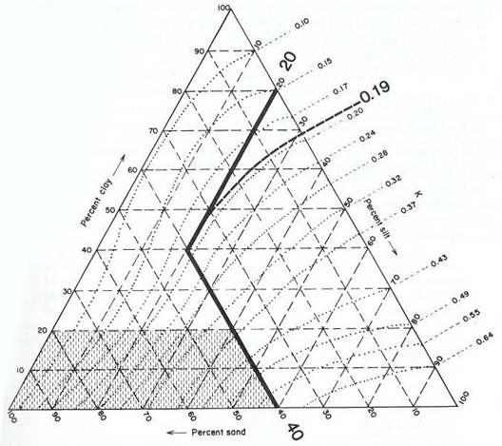
The figure above is the Erickson triangular nomograph used by the USDA to determine the K factor for a soil based on its texture (percent silt plus very fine sand, percent sand, percent organic matter, soil structure, and permeability).
Nomograph from Erickson 1977, as referenced in Goldman et. al., 1986.

Length-Slope (LS) Factor Table for Construction Sites
To determine a construction site's specific LS factor locate the intercept of the site's Sheet Flow Length (ft) and Average Watershed Slope (percent). Table from Renard et. al., 1997.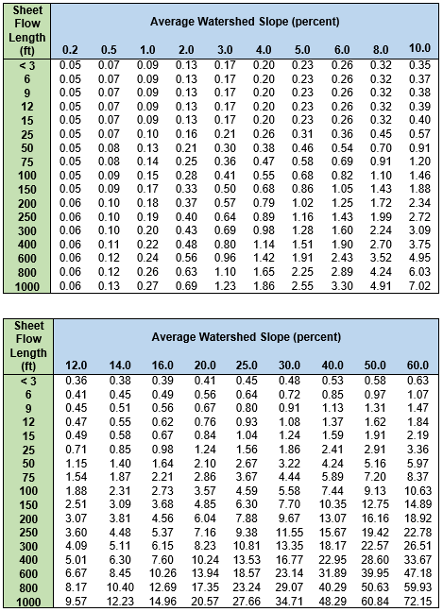

Step 2 – Receiving Water Risk Worksheet
Receiving water risk is based on whether a project drains to a water body or watershed that is sediment-sensitive. If the answer to either question below is “yes”, the project is considered a high receiving water risk. If the answer to both questions below is “no”, the project is considered a low receiving water risk.
- Does the disturbed area discharge (either directly or indirectly) to a 303(d)-listed water body impaired by sediment? For help with identifying impaired water bodies, please refer to the 2020 – 2022 California Integrated Report (Clean Water Act Section 303(d) - 305(b) Report) (https://www.waterboards.ca.gov/water_issues/programs/water_quality_assessment/2020_2022_integrated_report.html).
OR
- Does the disturbed area discharge (either directly or indirectly) to a water body with designated beneficial uses of COLD, SPAWN, and MIGRATORY? For help with identifying designated beneficial uses, please refer to the appropriate Regional Water Quality Control Board Basin Plan below.
Region 1 – North Coast Basin Plan (https://www.waterboards.ca.gov/northcoast/water_issues/programs/basin_plan/)
Region 2 – San Francisco Bay Basin Plan (https://www.waterboards.ca.gov/sanfranciscobay/basin_planning.html#2010basinplan)
Region 3 – Central Coast Basin Plan (https://www.waterboards.ca.gov/centralcoast/publications_forms/publications/basin_plan/index.html)
Region 4 – Los Angeles Basin Plan (https://www.waterboards.ca.gov/losangeles/water_issues/programs/basin_plan/)
Region 5 – Central Valley Basin Plan (https://www.waterboards.ca.gov/centralvalley/water_issues/basin_plans/index.html)
Region 6 – Lahontan Basin Plan (https://www.waterboards.ca.gov/lahontan/water_issues/programs/basin_plan/index.html)
Region 7 – Colorado River Basin Plan (https://www.waterboards.ca.gov/coloradoriver/water_issues/programs/basin_planning/)
Region 8 – Santa Ana Basin Plan (https://www.waterboards.ca.gov/santaana/water_issues/programs/basin_plan/index.html)
Region 9 – San Diego Basin Plan (https://www.waterboards.ca.gov/sandiego/water_issues/programs/basin_plan/index.html)

Sediment-Sensitive Watershed GIS Map Method
State Water Board staff has prepared a High-Risk Receiving Watershed Map tool (https://www.waterboards.ca.gov/water_issues/programs/stormwater/docs/constpermits/guidance/receivingwaterrisk.pdf) to assist dischargers with determining site-specific receiving water risk. Additionally, SMARTS is equipped with an auto-populate feature that can determine the receiving water risk based on the project latitude and longitude coordinates. Projects located in the watersheds highlighted in red are considered high-risk. Please note that the map option may not reflect the correct receiving watershed, lacking site-specific drainage information.
The discharger is responsible for identifying the appropriate receiving water. If the project does not discharge to the watershed as depicted on the High-Risk Receiving Watershed Map, please contact the appropriate Regional Water Quality Control Board.
Site-Specific Receiving Water Risk (High or Low) = __________

Step 3 – Combined Risk Level Matrix
The below matrix is used to determine the combined Risk Level of the project, factoring in both sediment risk and receiving water risk.
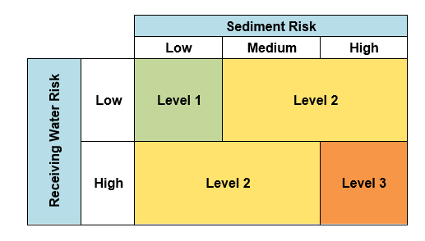
Combined Risk Level (1, 2, or 3) = _____________

ASTM D-422 is the standard test method used for the quantitative determination of the distribution of particle sizes in soils.
Environmental Protection Agency, American Society for Testing and Materials (ASTM) Standards, <https://www.epa.gov/sites/default/files/2020-01/documents/sedc_2004-2005_append.pdf> [as of June 22, 2022]
The Central Valley Basin Plan lists the COLD beneficial use designation as part of the SPAWN and MIGRATORY beneficial uses. Waterbodies will be considered high-risk receiving waters if listed as SPAWN (COLD) and MIGRATORY (COLD).

