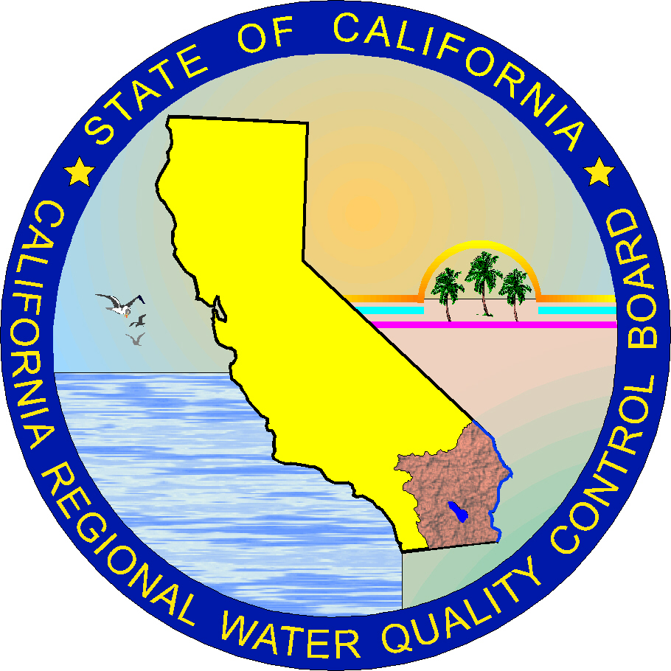

Quality Assurance Project Plan
For sampling volatile organic compounds in the NEW River FOR tmdl development

November 2004

Prepared by and for
State of California Regional Water Quality Control Board
Colorado River Basin Region
Staff

This page is intentionally left blank

Quality Assurance Project Plan
For New River Volatile Organic Compounds TMDL Development

APPROVALS:

California Regional Water Quality Control Board

____________________________________________ __________________________ Jose Angel, PE, Supervising WRC Engineer Date
Watershed Protection Division Chief
Quality Assurance Officer

____________________________________________ __________________________
Doug Wylie, PE, Senior WRC Engineer Date
NPS/TMDL Implementation Unit Chief
Project Manager

____________________________________________ __________________________
Joan Stormo, RG, Senior Engineering Geologist Date
Water Quality Policy Unit Chief

Table of Contents
Approvals ii

List of Tables and Figures v
1. Project Management 1
1.1 Introduction 1
1.2 Distribution List 1
1.3 Project/Task Organization 1
1.4 Problem Definition/Background 2
1.5 Project/Task Description 3
1.6 Quality Objectives and Criteria 3
1.6.1 Data Quality Indicators (Acceptance Criteria) 4
1.7 Special Training s/Certification 5
1.8 Documentation and Records 5
1.8.1 Project Working File 5
1.8.2 Field Datasheets 6
1.8.3 Quality Control Log Notebook 6
1.8.4 Calibration Log Notebook 6
1.8.5 Laboratory Analytical Summaries 7
1.8.6 Quality Assurance Reports 7
2. DATA Measurement/Data AcquisitIon 8
2.1 Sampling process Design 8
2.2 Sampling Methods 9
2.3 Sample Handling and Custody 9
2.4 Analytical Methods 10
2.5 Quality Control 10
2.6 Instrument/Equipment Testing, Inspection, & Maintenance 11
2.7 Instrument Calibration and frequency 11
2.8 Inspection/Acceptance for Supplies/Consumables 12
2.9 Data Acquisition (Non-Direct Methods) 12
2.10 Data Management 12
3. Assessment and Oversight 12
3.1 Assessment and Response Actions 12
3.2 Reports to Management 13
4. Data Validation and Usability 14
4.1 Data Review, Verification and Validation 14
4.1.1 Technical Systems Audit 14
4.1.2 Performance Evaluation of Laboratories 14
4.1.3 Data Quality Assessment 15
5. Health and Safety Plan 16
5.1 Contamination Containment Zones 16
5.2 Personal Protective Equipment 16
5.3 Personnel Decontamination Procedures 17
5.3.1 Emergency Numbers and Facilities 17
5.3.2 After Sampling 17
6. References 18
Appendix I, Project Organization Chart 19
Appendix II, Sample Chain of Custody Form 21
Appendix III, Decontamination Procedures 23

List of Tables
Table 1: QA Objectives for Analytical Laboratory Analysis 4
Table 2: Monitoring Stations 8
Table 3: Required Containers, Preservatives, Techniques, and Holding Times 9
Table 4: Sampling Constituents and Methods for VOCs 10
Table 5: Quality Control Sample 11
Table 6: Specifications for the YSI 6600 Sonde or YSI 600 XML 12
Table 7: Nearest Hospitals to Sampling Locations 17

Project Management

Introduction
Volatile organic compounds (VOCs) are among the more difficult and expensive contaminants to monitor in water. Because VOCs easily move between air and water, environmental samples can either lose VOCs by volatilization or become contaminated when VOCs in air partition into the sample during sample collection, processing, or analysis. Thus, this Quality Assurance Project Plan (QAPP) describes the quality assurance (QA) and quality control (QC) procedures associated with the sampling activities to characterize the VOCs in the New River. These activities are scheduled in response to requirements of the California Regional Water Quality Control Board, Colorado River Basin (Regional Board) to address the impairment of the New River by VOCs.

This QAPP follows the format that the United States Environmental Protection Agency (USEPA) established in its Requirements for Quality Assurance Project Plans, EPA QA/R-5, 2001. Further, it also complies with the QA/QC requirements specified in the State Water Resources Control Board Quality Assurance Program Plan, June 2001.

The Project Supervisor and the QA Officer/Division Chief may, upon mutual concurrence, request modification of this QAPP to achieve the objectives of the project. The process for QAPP modification consists of incorporating the necessary changes into the QAPP document, obtaining approval signatures, and distributing the revised document to project personnel.

Distribution List
The following individuals will receive copies of the approved QAPP and subsequent revisions:

- Jose Angel, PE, Supervising WRCE, Watershed Protection Division Chief/ QA Officer*
- Doug Wylie, PE, Sr. WRCE, NPS/TMDL Implementation Unit Chief*
- Joan Stormo, RG, Sr. EG, Water Quality Policy Unit Chief, Project Supervisor*
- Jennie Snyder, PE, WRCE, TMDL Development Unit, Project Manager
- Phan Le, WRCE, Lab Director
* Indicates approving authority

Project/Task Organization
Specific responsibilities of the Regional Board staff are outlined below. A project organization chart is provided as Appendix 1.

Jose L. Angel, P.E., Supervising WRC Engineer, Watershed Protection Division Chief/QA Officer, (760) 776-8932
- Reviews and approves the QAPP and subsequent revisions.
- Ensures that the QAPP is implemented and followed to meet the project objectives.
- Oversees validation activities for field and lab data.

Doug Wylie, PE, Senior WRC Engineer, (760) 346-6585
- Reviews and approves the QAPP and subsequent revisions.
- Ensures that the QAPP is implemented and followed to meet the project objectives.
- Ensures that field personnel have appropriate training and certification for field activities.
- Reviews field reports.
- Ensures plans are implemented according to schedule.
- Prepares final reports.
- Manages sampling data.
- Performs field sampling as necessary.
- Conducts Health and Safety briefing for field samplers prior to each sampling event.
- Coordinates field and laboratory activities.
- Reports project status to the QA Officer and Division Chief.
- Responsible for evaluating data to ensure TMDL compliance.

Joan Stormo, RG, Senior Engineering Geologist, Water Quality Policy Unit Chief, Project Supervisor, (760) 776-8982
- Reviews and approves QAPP and subsequent revisions.
- Coordinates TMDL development.

Phan Le, WRC Engineer, Region 7 Lab Director, (760) 346-7491
- Prepares Quality Assurance Project Plan (QAPP)
- Calibrates equipment prior to sampling event.
- Performs water quality analyses.
- Assists with sampling activities.

Jennie Snyder, PE, WRC Engineer, Project Manager
- Reviews Quality Assurance Project Plan (QAPP)
- Coordinates field activities and ensures they are consistent with the QAPP
- Conducts assignment briefing for field samplers prior to each sampling event.
- Ensures that sample containers have no defects and have been prepared properly.
- Conducts sampling activities as required.
- Coordinates delivery of samples to the laboratory.
- Coordinates decontamination of equipment.
- Prepares summary field report

Field Samplers
- Assists with sampling activities as required.

Problem Definition/Background
Pursuant to State Board’s Clean Water Act (CWA), Section 303(d) 2002 list, the Regional Board is required to develop a VOCs Total Maximum Daily Load (TMDL) for the New River. This TMDL is being developed because VOC concentrations in the River violate the Water Quality Objectives (WQO) established by the Regional Board to protect the River’s beneficial uses. This QAPP is for collecting data for TMDL development and for the monitoring and tracking of VOCs. More specifically, this QAPP details the sampling, handling and analysis of water samples for the following seven (7) VOCs: Chloroform, Toluene, p-Cymene, 1,2,4-trimethylbenzene, m,p,-Xylenes, o-Xylenes, and 1,4-Dichlorobenzene (p-DCB). VOCs are chemical compounds that contain organic carbon and have a minimum vapor pressure of 0.13 kPa at 20 ºC at sea level. VOCs have low molecular weights, high vapor pressures, and low-to-medium-water solubilities, properties that allow the compounds to move freely between water and air.

Development and implementation of the New River VOC TMDL will require determining the location, concentration, and sources of VOCs throughout the River. The data collection activities outlined in this QAPP are being undertaken to insure that reliable information is available to develop and implement the TMDL.

Project/Task Description
The overall objective of this project is to obtain valid data of known and documented quality, which can be utilized in determining compliance with the water quality objectives as set forth in the Basin Plan. Specifically, the purpose of this project is to:

- Collect representative water samples for VOC analysis from the New River at the sampling locations identified in Table No. 2, below; and
- Record field measurements (physical parameters) including pH, temperature (air and water), dissolved oxygen (DO), and electrical conductivity (EC).

This project consists of monthly sampling events for six consecutive months, in which water samples will be collected and field measurements taken at varies sampling stations. The sampling events will start in December 2004 and continue through May 2005. Sampling events may include alternative sampling locations on the New River as necessary to pinpoint sources of contamination and determine the extend and location of VOC impairment. Sampling locations are described in detail in Section 2.1.

Data Quality Objectives AND CRITERIA
Valid data of known and documented quality are needed to meet the objectives of this project. The constituents of concern for this project are VOCs. Only data that meets project quality assurance (QA) criteria will be considered valid. The specific data quality objectives of this project are:

- Analitical results for VOCs must be of sufficient quality to be used in development of the New River VOCs TMDL.
- Data obtained should be of sufficient quality to determine the contributions of VOCs from possible sources and the resulting VOC concentrations within the New River, at the time of sampling.

- The data generated for this project meets the States Surface Water Ambient Monitoring Program (SWAMP) QA requirements.

Table No. 1, below, summarizes the analytical precision, accuracy, and completeness criteria.

Table 1: QA Objectives for Analytical Laboratory Analysis
Analyte | Matrix | Units | Precision  (RPD) | Accuracy  (% Recovery) | Completeness¹  (% Cmp)
VOCs | Water | ppb (μg/L) | 10 | 85-115^{(2,3)} | < 95
Field Measurement
Temperature | Water | ⁰C | 0.01 | +/- 0.15 | N/A
pH | Water | pH units | 0.01 | +/-0.2 | N/A
DO | Water | mg/L | N/A | +/- 2% of reading or 0.2 mg/L⁽⁴⁾ | N/A
EC | Water | μmhos/cm | N/A | +/- 0.5% of reading + 0.001 mS/cm | N/A
¹ Completeness criteria will not be applied to results from QC samples.
²For blanks, the average of all VOCs measurements must be below 0.2μg/L.
³All projects requiring submittal of spike samples will be coordinated in a manner such that one set of spikes will be submitted to the laboratory for all projects.
⁴Whichever is greater.

Data Quality Indicators (Acceptance Criteria)
The following data quality indicators will be utilized to assess whether data generated are useable and meet the data quality objectives stated above:

Precision
Precision is defined as the degree of refinement of a measurement. Precision of the data generated will be assessed as the relative percent difference (RPD) for field and laboratory duplicates.

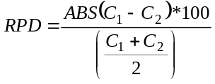
RPD = Relative Percent Difference
C₁ = Results for sample 1
C₂ = Results for sample 2
ABS = Absolute value

Accuracy
Accuracy is defined as the degree of refinement of a measurement to the actual value or standard. Accuracy for VOCs will be determined by calculating percent recovery for spike samples and field blanks. For field blanks, the average of measurements must be below 0.2 (μg/L) in order for this data quality objective to be met. All projects requiring submittal of spike samples will be coordinated in a manner such that one set of spikes will be submitted to the laboratory for all projects.
%R = Percent recovery
C_{M} = Measured concentration of reference material (RM).
C_{R} = Actual concentration of reference material (RM).
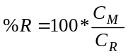

Completeness
Completeness is defined as a measure of how many collected samples actually yield valid and useable data. A minimum of 95% completeness is expected for this project. This will result in a sufficient amount of data to meet the previously stated requirements.
%C = Percent complete
V = Total number of measurements or laboratory results judged valid
T = Total number of measurements or laboratory results

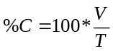

Special Training Requirements/Certification
The Project Manager will ensure that all of the field samplers have valid and current training for their field activities, as required by OSHA regulations. Currently, all sampling personnel have completed the required OSHA training for the sampling activities described herein. There are no other specialized training/certification requirements needed to accomplish the Project’s QA objectives.

Documentation and Records

Project Working File
The Project Manager will establish and maintain a Project Working File for maintaining sampling records. The Lead Field Sampler and Lab Director will ensure that all received/generated data (e.g., field notes, chain-of-custody forms, lab analyses) are delivered to the Project Manager. The file will contain, but need not be limited to:

- Field data sheets
- Calibration logs
- Laboratory reports
- Data reports summarizing field activity and quality control for each sampling event
- Data spreadsheets
- Correspondence
- Quality control reports
- Validation reports
- Final Reports

Field Datasheets
The designated Lead Field Sampler for each sampling event will use field datasheets to document field activities and data for each sampling event. Each field datasheet will be dated and signed by a sampling team member at each sampling station. At the time of sampling, the following information will be recorded in the field datasheet:

- Weather observations
- Sampling station latitude and longitude, using a global positioning system (GPS) unit, if not previously recorded
- Sample identification code and sampling method for all samples taken
- In-situ measurements for temperature (air and water), pH, DO, and EC
- Sample identification code, and time and location of preparation, for all quality control samples prepared in the field
- Any deviations from the QAPP
- Any noteworthy observations (take pictures if necessary)

Quality Control Log Notebook
The QA Officer will use a bound quality control log notebook with pre-numbered pages to document the QC samples submitted to the laboratory and the analysis results. For each QC sample, the quality control log notebook will contain the:

- Sample identification code
- Supplier of the QC sample
- Value reported by the supplier
- Date of preparation and submission
- Name and signature of the person submitting the QC sample
- Laboratory performing the analysis
- Analysis method
- Reported value from the laboratory

Calibration Log Notebook
The Regional Board Lab Director will use a calibration log notebook to document calibration activities performed on sampling equipment prior to each sampling event. The calibration log notebook for each piece of equipment will be bound and will have pre-numbered pages. For each calibration event, the calibration log notebook will contain:

- Date and time of calibration
- Person(s) performing the calibration
- Signature of one of the persons performing the calibration
- All standard solutions used in calibration, including the source and date of preparation of the standard solution
- The initial reading of the YSI 6600 multiprobe sonde or YSI 600 MXL when tested against each standard solution, and the temperature of each standard solution at the time of calibration
- Any problems encountered and how the problems were addressed

Laboratory Analytical Summaries
The Division Chief will request that the contracted analytical laboratory prepare and submit to the Project Manager a laboratory analytical summary for each sampling event upon completion of the laboratory’s analysis of samples. This summary will include analytical results, analytical methods, problems encountered, QC results, and chain of custody forms. The lab summary reports should be given in electronic format.

Quality Assurance Reports
The QA Officer will prepare quality assurance reports, including a technical systems audit for each sampling event, performance evaluations of laboratories, and a final data quality assessment. These reports are described in more detail in Section 4.1.

Measurement/Data Acquisiton

Sampling process Design
The project objectives are to produce data of known quality that can be used to evaluate the VOCs concentrations in the New River at several sampling stations along its length. This project will be used to identify sources of VOCs and determine the extent of impairment. This may require modifying sampling locations as necessary within the New River watershed. Because accurate VOC data is necessary for TMDL development, VOC concentrations are considered critical measurements for this project, and the temperature (air and water), EC, pH and DO, are considered the field measurements.

The New River sampling stations were selected to characterize the changes in water quality in flows downstream of the International Boundary. Sampling locations will be adapted in response to previous monthly data results to isolate the area of impairment and concentrate sampling efforts in that area. Table 2 lists the sampling stations that will be used to initially establish areas of impairment. Subsequent sampling may include additional or alternative sampling stations

At each of the locations listed in Table 2 below, water samples will be taken as described, and a YSI multi-parameter sonde will be used to take in-stream measurements of temperature, DO, EC and pH.
Table 2: Monitoring Stations
Sampling Location | Description*
NR-B | Monitoring station for Mexico’s VOCs contribution to the New River at the Boundary, to be located at the intersection of the New River and the International Boundary.
AACB | Monitoring station at the All American Canal Siphon Crossing to be located at the intersection of the New River and the All American Canal Siphon Crossing.
NR-H98 | Monitoring Station at Highway 98, to be located at the intersection of the New River and the Highway 98 Bridge.
NR-LR | Monitoring Station at Lyon’s Road, to be located at the intersection of Lyon’s Road Crossing and the New River.
NR-EH | Monitoring station for the Lower New River to be located at the Evan Hewes Road Bridge and the New River.
NR-D2 | Monitoring station for the Middle New River to be located at Drop Structure #2 of the New River.
NR-O | Monitoring station for the Upper New River drainshed, to be located at the USGS sampling station downstream of Lack Road Bridge.

*A location may be changed provided the prescribed location is inaccessible or a haphazard, as documented by field observations.

Sampling Methods
All samples for VOC analysis shall be collected in accordance with SWAMP sampling requirements. The sample containers for VOC water samples are 40-mL amber glass volatile organic analysis (VOA) vials that contain hydrochloric acid as a preservative.

Water samples will be collected using a swing sampler with a clean VOA vial attached to grab the sample at a depth of 1 foot below the surface at midstream.
Because the VOA vials are pre-acidified with HCl for sample preservation, they are not to be rinsed with ambient water before being filled. To avoid leaving any air bubbles in the sample, the VOA vial should have a meniscus and no air bubbles before being capped. If there is any headspace remaining in the VOA vial, a small amount of ambient New River water should be poured into it to create a meniscus. Then the sample shall be capped with a Teflon septum. Turn the vial upside down and check for air bubbles. Tap the bottom of the VOA vials to dislodge any bubbles that may have formed around the cap or sides. If bubbles are present, discard vial and re-sample using new VOA .

A YSI multi-parameter water quality sonde will be used to collect field measurements for the following parameters: DO, pH, temperature and EC. Measurements will be collected mid-stream at each sampling location, about 1-foot below the water surface. Where hazardous conditions prevent midstream sampling, YSI measurements will be collected at the riverbank. After at least two minutes or when the readings have reached equilibrium, the values for these parameters will be manually recorded in the field data sheet.

Sample Handling and Custody
Sample-holding times will be adhered to, as prescribed by the USEPA and 40 CFR 136. VOC preservation techniques and holding times are provided in Table 3, below.

Table 3: Required Containers, Preservatives, Techniques, and Holding Times
Constituent | Container | Preservation Technique | Holding Time
VOCs | 3 *VOA vials (120 ml) | Cool 4 ⁰C, HCL | 14 days
VOA = volatile organic analysis

Each sample container will be labeled with a unique sample identification code. All samples (including QC samples) for laboratory analyses will be stored in an ice chest, and will remain in custody of Regional Board staff until the samples are delivered to the analytical contract lab. The ice chest will contain sufficient ice to maintain the samples at a temperature below 4°C at all times until they are relinquished to lab staff. All samples will be delivered with chain of custody forms. A sample chain of custody form to be used for this project is included in Appendix II. Any violation of holding times or other sample handling and custody requirements will be documented in the quality control records and reported to the Project Manager and the QA Officer. Any violations thereof will be taken into account when evaluating the data.

Analytical Methods
As described by the State Water Resources Control Board’s “Quality Assurance Program Plan”, each analytical laboratory used for sample analysis must have a written QA Laboratory Manual describing the analytical method requirements. The lab must use USEPA approved methods as outlined in Table No. 4, or a suitable substitute. The analytical methods, and reporting limits provided serve as a guide, and will vary with sample dilution and lab capabilities. Consultation with the project manager should occur prior to sample analysis to ensure that the analytical methods and reporting limits meet project requirements.

Table 4: Sampling Constituents and Methods for VOCs
Constituent | USEPA Method | Detection Limit | Reporting Limit | Units
VOCs | 524.2 | 0.05 | 0.2 | µg/L

Quality Control
A number of quality control checks will be implemented to assess whether data quality requirements are being met. The calibration and maintenance of Regional Board Laboratory instruments and the general operation of the Regional Board laboratory are subject to the requirements of the State Board Quality Assurance Program Plan and the Regional Board Quality Assurance Program for the Laboratory.

All QC samples will be placed in an ice chest, for transport to the lab. Five types of QC samples will be collected: trip blanks, field duplicates, field blanks, spiked samples, and temperature blanks.

Trip Blanks

Each ice chest of field samples shipped to the analytical contract laboratory will contain two 40 ml trip blanks filled with special purged water. The trip blanks will be prepared prior to the sampling event and placed in the ice chest before transport to the field. Field staff will contact the laboratory in advance of the sampling event to inquire about an appropriate VOA trip blank. Trip blank vials are never opened during the trip/sampling event (i.e., from the time they are placed into the ice chest prior to the sampling event, until they arrive at the laboratory), and used to determine if the containers and sample handling introduce contamination.

Field duplicate
F
ield duplicates are collected at a rate of 10 percent of all samples every three months. Field duplicates are collected in the same manner as "real" surface water samples (i.e., using two-40 ml VOA vials).

Field blank

Field blanks will also be collected during sample collection every three months to check for field contamination. 40 ml VOA sample containers will be used, and filled in the field with organic free water obtained from vendors or the contract laboratory.

Spiked Samples

One spiked sample with a known concentration of VOCs will be submitted to the analytical contract laboratory every three months along with other QC and field samples. Spiked samples assess for laboratory contamination, and are ordered from a list of approved vendors provided by Department of Health Services.

Temperature Blanks

A small plastic temperature blank filled with water will be placed in the ice chest with the field samples. The temperature of the field samples will be determined at the laboratory by measuring the temperature of the temperature blank. The sample temperate should not exceed 4 degrees Celsius (ºC).

Immediately after sample collection, samples will be placed into ice chests containing wet ice. At the end of the sampling event, field and QC samples will be transported to the Regional Board Laboratory and then shipped to the analytical contract laboratory.

The contract lab will not be informed in any way as to which samples are control samples and which samples are field, surface water samples. A summary of Quality Control Sample Requirements is provided in Table 5.

Table 5: Quality Control Sample
Quality Control Samples | Number of Sample | Frequency
Trip Blank | 1 | Per ice chest
Duplicate Sample | 10% | Every 3 months
Field Blank | 1 | Every 3 months
Spike Sample | 1 | Every 3 months
Temperature Blank | 1 | Per ice chest

Instrument/Equipment Testing, Inspection, & Maintenance
All Regional Board staff participating in the field-sampling event will be trained in the operation, calibration, and maintenance of field instruments. Manufacturer’s instruction manuals will be readily available for field personnel. The instruments will be maintained and calibrated in accordance with the manufacturer’s instructions and recommendations. Laboratory personnel will calibrate, inspect, and maintain field instruments prior to all sampling events.

Instrument Calibration and frequency
YSI multi-parameter sondes will be calibrated in the Regional Board laboratory prior to each sampling event. Dissolved oxygen will be calibrated before each sample collection, using ambient air. Pre and post sampling dissolved oxygen calibration checks will be performed at each sampling site by field personnel. This process involves checking and recording the % DO output. If it is greater than 2 % of saturation (102-98 % DO), recalibration of DO is required. The pre and post calibration check data (% DO output) will be recorded on the field datasheet. If recalibration is required, recalibration will be noted in the field notebook. A post-calibration for all parameters will be performed when the sonde is returned to the office, or as soon as practical. Results of calibration measurements will be documented in the field log notebook and submitted to the QA Officer. Table 6, below illustrates the YSI 6600 sonde or YSI 600 XML, the instruments currently/commonly used for TMDL implementation sampling.

Table 6: Specifications for the YSI 6600 Sonde or YSI 600 XML
Parameter | Operating Range | Accuracy | Resolution | Calibration  Standard
pH | 0 to 14 units | ± 0.2 units | 0.01 units | 2-pt, with pH buffered solutions
Temperature | − 5 to 45 ºC | ± 0.15 ºC | 0.01 ºC | not required
DO | 0 to 20 mg/L | ± 0.2 mg/L | 0.01 mg/L | saturated air
EC | 0 to 100 mS/cm | ± 0.5% of reading | .001 mS/cm | KCl

Inspection/Acceptance for Supplies/Consumables
The Lead Field Sampler will:

- Ensure that the sample bottles have no defects, and are properly prepared.

- Contact the contract laboratory to order sample bottles and organic free water two weeks before the sampling event.

- Submit a list of sampling supplies to Region 7 Lab Director as needed.

Data Acquisition Requirements (Non-Direct Methods)
Only data collected from this project and historical data from the TMDL development program that has passed QC criteria, will be used. Data from other sources will not be used unless it satisfies the QA requirements set herein.

Data Management
The Project Manager will maintain field datasheets and chain of custody forms in the project file. Field measurement data will be transferred from the field notebook to an electronic data file. The Project Manager will submit all data in MS Excel format to the QA Officer. After verification and approval by the QA Officer, the Project Manager will download the data into the project database (MS Excel format) and store it on the Regional Board’s local area network (LAN).

Assessment and Oversight

Assessment and Response Actions
Surveillance of the records and overall status of the project will be conducted by the QA Officer to ensure that all of the requirements of the QAPP are being met. Surveillance will be conducted for each sampling event, after all laboratory results have been received for that sampling event. A technical systems audit will also be performed by the QA Officer, as discussed in Section 4.1.1. Also, an annual data quality assessment of the applicability of the data will be performed to assess the handling of all data and to correct any errors found in the project database (see Section 4.1.3).

Reports to Management
The Project Manager will prepare quarterly and final project reports. The quarterly project reports will summarize activities, field and lab data, data quality, field/lab problems and solutions, and identify samples that violate Water Quality Standards. The final project report will include a statistical analysis and indicate drainshed loading, decrease or increase in loading at drainshed boundaries, drainsheds out of compliance, and recommendations for TMDL modification.

Data Validation and Usability

Data REVIEW, VERIFICATION AND Validation
Independent data validation is not mandated for this project. However, all records will be available for independent evaluation should the need arise. Data is considered legally defensible when obtained through procedures discussed in this QAPP.

Technical Systems Audit
The QA Officer will prepare or oversee a technical systems audit for each sampling event, after all laboratory results are received. Data will be validated to determine if the collection and analyses procedure conformed to the QAPP. The review will consider: field notes, field datasheets, chain of custody forms, laboratory analysis forms and calibration assessment to determine potential error in field measurements. Documentation of results will occur within 15 days, and will describe data reviewed, review criteria, and data usability.

Unacceptable departures from sample collection procedures include the use of contaminated sampling bottles, the lack of critical sample collection information, or any other activity which would result in the cross contamination or incorrect identification of samples.

Departures from the sample handling and custody procedures contained in Section 2.3 of this report will be determined through the review of chain of custody forms and laboratory analysis forms. In order for data to be considered valid for meeting the data quality objectives of this study, all chain of custody forms must be in the possession of the Project Manager, and strict adherence to holding times and temperatures must be followed. Data generated from samples that do not meet these requirements will not be considered valid for use in this study.

Verification of proper calibration of the YSI sonde will be performed during the audit of data quality through a review of the quality control records. Calibration values will also be assessed to determine the potential error in field measurements. If calibration values have errors that exceed acceptable error tolerances, the measurements obtained prior to that calibration, but after the previous calibration, will be labeled suspect and further investigated to determine if they are valid for use in this study.

The QA Officer will then ensure that data are entered into the database. It is conceivable, however, that errors could occur in entering the data (e.g., transposing the decimal point for a particular result or keying in the wrong Sample ID). Therefore, once a data set has been entered into the database, all records will be checked to ensure accuracy.

Performance Evaluation of Laboratories
Validation of laboratory data will be performed in the Audit of Data Quality by assessing the results of QC sample analyses. Lab data will be validated for precision, accuracy, and completeness according to the criteria specified in Section 1.6.

In the event that QC analyses do not meet the specified criteria, the data will be labeled as “suspect”, the lab will be notified, and the field notes will be re-evaluated. Data sets corresponding to any value that cannot be confirmed, based on the acceptable criteria in Table 1, will be rejected.

The QA Officer will contact the contract lab if data is missing. In some cases, missing data will be denoted as missing in reports. For all missing data, and any other data requiring special explanation, qualifiers will be included in the database and in data reports. Missing data will be designated as ”NR”, meaning Not Reported.

Data Quality Assessment
The QA Officer will conduct annual audits of data quality reports that include: Technical Systems Audits; verification of calibration and instrument drift results for the YSI multi-parameter sonde, and results of laboratory QC samples, including precision, accuracy, and completeness results. The reports will also assess whether the total error in the data is tolerable, and if significant departures from the QAPP reduce data set completeness (and thus reduce data set usability for drawing conclusions).

Significant departures from the QAPP will be noted in these reports, and the resulting data will not be validated. Unacceptable departures include, but are not limited to:
- Cross-contamination
- Lack of critical sample collection information
- Violation of sample holding times and temperatures

Health and Safety Plan

Contamination Containment Zones
The contaminated areas for this project consist of and cover the entire waterways for the aforementioned waters, their banks, the area within 2 feet of the banks, and the bridge at the Outlet. Decontamination zones will be set at least 10 feet away from the banks of the surface waters. The decontamination zone will be used for personnel decontamination and will include wash water, soap, paper towels, and trash bags. All contaminated solid waste material will be placed in trash bags for proper disposal. Only biodegradable antibacterial soap will be used at the site. The clean area will be set at least 20 feet away from the banks of the surface water.

Personal Protective Equipment
The general concerns at the sampling sites are the potential exposure to toxicants present in the waters being sampled, risk of sunburn, excessive heat exposure, insect bite, and possibly snakebites. In addition, the sampling crew should be aware of the risk of falling into the waterways. No less than two experienced samplers will be in the field at one time. The sampling crew will also have a cellular phone in one of the vehicles.

- Any member of the sampling team has the authority to stop the sampling event when he/she determines that conditions at the site (e.g., rain, dust, local emergency, etc.) preclude safe sampling. A Hazard Evaluation Plan (HEP) will be done for each sampling site. The lead field sampler will be responsible for reviewing the HEP.

- To reduce the risk of exposure while collecting/transporting samples, latex examination gloves must be worn. The contaminated zone must not be entered without the aforementioned Personal Protective Equipment (PPE).

- To reduce the risk of heat exposure and sunburn, samplers should wear sunscreen and carry in their vehicle cold drinking water. If any of the samplers begin to experience symptoms of heat exhaustion, such as cramps or dizziness, he or she will immediately be removed from the sun and given plenty of cool liquids. If these symptoms persist, he or she will be taken to the nearest hospital.

- Extra caution should be used when working near or around the agricultural drains to reduce the risk of falling in.

- To reduce the risk of insect bites, samplers should use insect repellent.

- To reduce the possibility of snakebite, samplers will check areas for snakes prior to entering the area. If snakebite occurs, ice will be placed on the bite. The sampler will be immediately transported to the nearest medical facility.

Personnel Decontamination Procedures
The Clean Zone must not be entered with contaminated Personnel Protective Equipment (PPE). All team members exiting Contaminated Zones must immediately proceed to the Decontamination Zone, and use the following decontamination procedures before proceeding to Clean Zone:

- Remove latex gloves carefully to avoid contact with bare skin and dispose of them in the trash bag. Thoroughly wash hands with antibacterial soap; and

- Dispose of wash water into surface water just sampled.

Note: everything that is touched (pens, pencils, rinse water bottles, probes, etc.) with dirty gloves could be contaminated. Avoid touching these items with bare skin.

Emergency Numbers and Facilities
All sampling personnel will have access to a cellular phone to call 911 in case of an emergency. The hospital nearest the sampling locations are listed in Table 8 below:

Table 7: Nearest Hospitals to Sampling Locations
Sampling Location | Medical Facility | Address | Phone #
NR-B | EL Centro Regional Medical Center | Imperial and Ross Ave., El Centro | (760) 339-7100
AACB | EL Centro Regional Medical Center | Imperial and Ross Ave., El Centro | (760) 339-7100
NR-H98 | EL Centro Regional Medical Center | Imperial and Ross Ave., El Centro | (760) 339-7100
NR-LR | EL Centro Regional Medical Center | Imperial and Ross Ave., El Centro | (760) 339-7100
NR-EH | Pioneers Memorial Hospital | 207 West Legion, Brawley | (760) 351-3333
NR-D2 | Pioneers Memorial Hospital | 207 West Legion, Brawley | (760) 351-3333
NR-O | Pioneers Memorial Hospital | 207 West Legion, Brawley | (760) 351-3333

In case of an emergency, sampling personnel should also contact the Regional Board Safety Officer, Doug Wylie, as soon as practical at 760-346-6585 or 760-341-7491.

After Sampling
Place field and QC samples into Regional Board lab refrigerator or keep in an ice chest filled with wet ice; keep water drained from ice chests to avoid soaking container labels. Give field notes to lead field sampler to place in the project working file. Contaminated equipment should be decontaminated and placed in the storage room. Decontaminate and properly clean ALL items, which were exposed in the field in accordance with USGS National Field Manual for the Collection of Water-Quality Data, Chapter A3. Cleaning of Equipment for Water Sampling (See Attachment III).
- References
U.S. Environmental Protection Agency. 2001. EPA Requirements for Quality Assurance Project Plans, EPA QA/R5. EPA Publication number 240/B-01/003. U.S. Environmental Protection Agency, Washington, D.C.

State Water Resources Control Board (State of California), 2001. Quality Assurance Program Plan.

Surface Water Ambient Monitoring Program (SWAMP) Quality Assurance Management Plan, version 2003

Robert F. Lundgren and Thomas J. Lopes, 1999, Occurrence, Distribution, and Trends of Volatile Organic Compounds in the Ohio River and its Major Tributaries: U.S. Geological Survey Water-Resources Investigations Report 99-4257

Appendix I, Project Organization Chart

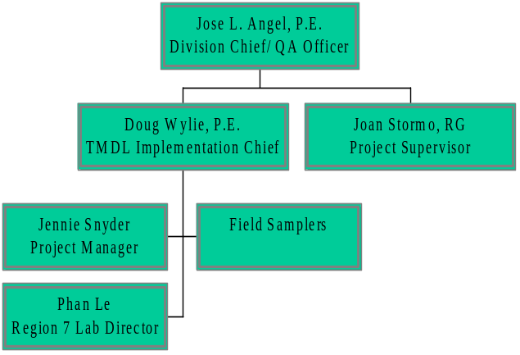

This page is intentionally left blank
Appendix II, Sample Chain of Custody Form
This page is intentionally left blank

Appendix III, Decontamination Procedures
This page is intentionally left blank

