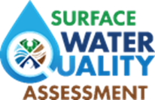

This is an empty reference added to the system to allow past cycle LOEs to be moved to an updated water body using an LOE moving tool.

For more information please contact the Surface Water Quality Assessment Unit staff at WQAssessment@waterboards.ca.gov

