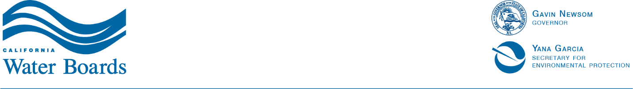

State Water Resources Control Board
LEGAL INTERNSHIPS WITH THE
STATE WATER RESOURCES CONTROL BOARD
OFFICE OF ENFORCEMENT

Background:
The State Water Resources Control Board oversees water quality, water rights, and drinking water in California. Our role is to ensure that violations of orders and permits result in firm, fair, and consistent enforcement through direct actions, the development of policies and guidance, and the identification of metrics for decision-making on enforcement issues.

We are comprised of legal and investigative staff. The attorneys provide legal representation to the State Water Board and nine Regional Water Quality Control Boards in prosecuting enforcement actions involving significant water quality and water rights issues. The investigative staff is divided into five units: the Special Investigation Unit, Stormwater and Advanced Technology Unit, Underground Storage Tank Enforcement Unit, Cannabis Enforcement Unit, and the Fraud, Waste and Abuse Prevention Unit. For more information, please visit: www.waterboards.ca.gov/water_issues/programs/enforcement/.

Job Description:
The Office of Enforcement seeks unpaid legal interns for Fall 2026, Spring 2027, and/or Summer 2027. Legal interns will conduct legal research and writing related to water quality, water rights, and drinking water related enforcement matters, interpret statutes and regulations, and prepare legal documents such as subpoenas, memoranda, reports, summaries, etc. The position is expected to be hybrid in Sacramento, CA. Any telework must occur within the state of California. Academic credit is usually available through law schools for Fall 2026 and Spring 2027 internships.
Prerequisite: Only accepting applications from students currently attending law school.
Application: To apply for an unpaid legal internship with the Office of Enforcement, submit the following to kailyn.ellison@waterboards.ca.gov:
- A cover letter,
- A resume,
- An unofficial transcript, and
- A writing sample.
Applications must be received by July 1, 2026. Applications for Fall 2026 internships may be reviewed on a rolling basis before the July 1st deadline.

