Double L Mobile Ranch Park
Updated on February 28, 2020

County: Fresno
Population: 80
Challenges: Uranium & 1,2,3-TCP MCL Drinking Water Violations
Consolidation date: January 31, 2020

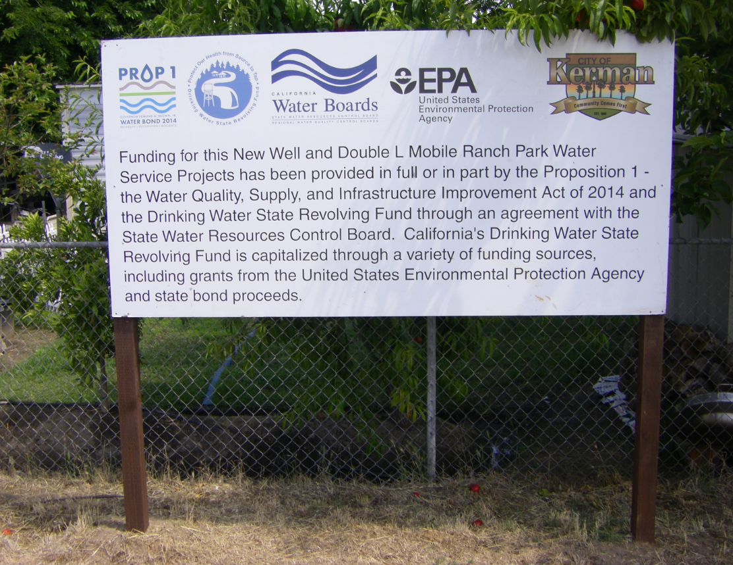
Figure 1. Project Signage

Double L Mobile Ranch Park is a severely disadvantaged community located in Fresno County approximately three miles outside of the City of Kerman. The Double L Mobile Ranch Park water system (Water System) is comprised of 37 residential connections, and services a population of approximately 80 people. The legal owner of the Water System is Mr. Carl Hunt. The Water System has one active well (Well 02) and one inactive well (Well 01) which has been physically disconnected from the Water System’s distribution system.

The Water System was issued Compliance Order No. 03-23-11O-004 in 2011 for non-compliance with the Uranium maximum contaminant level (MCL) at Well 02. Well 02 is the Water System’s sole source of supply. In early 2018, Compliance Order No. 03_23_18R_005 was issued for non-compliance with the 1,2,3-Trichloropropane (1,2,3-TCP) MCL.

The City of Kerman (City) was awarded funding in 2016 for a construction project though the Proposition 1–Water Quality, Supply and Infrastructure Improvement Act of 2014 and the Drinking Water State Revolving Fund. The project consolidates Double L Mobile Ranch Park water system into the City’s system. As part of the construction project, the City would be able to drill and develop a new well (Well 18), install a transmission main to connect the Water System to the City’s distribution system, install a master meter, and install a chlorination station. The City was awarded $3,230,000 for the total project.

At the end of January 2020, the Water System was tied into the City’s distribution system and began receiving City water. As part of the project, the Water System’s two wells (Well 01-Inactive and Well 02-Active) are to be destroyed. The City will be responsible for operation and maintenance of the transmission main and the new chlorination station to maintain a free chlorine residual at the service connection.

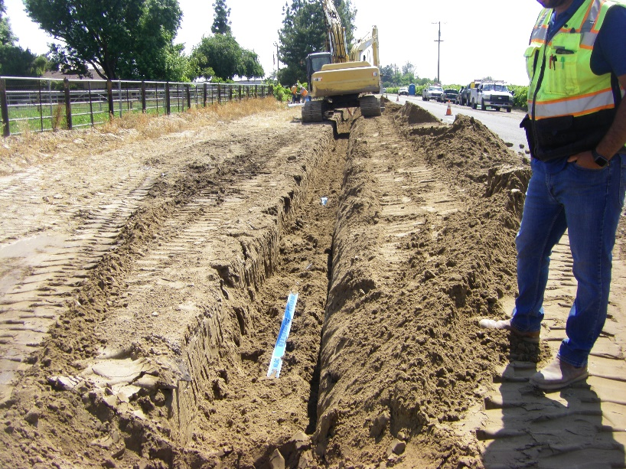
Figure 2. Trench for Transmission Line Installation

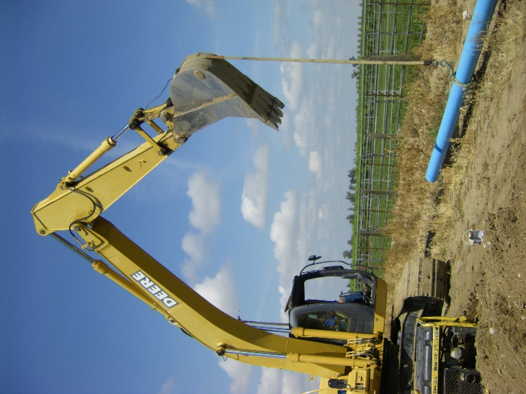
Figure 3. Installation of Transmission Main

