State of California—Health and Human Services Agency
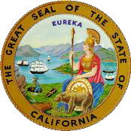

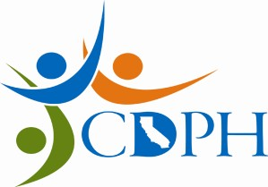

California Department of Public Health

RON CHAPMAN, MD, MPH EDMUND G. BROWN JR.
Director & State Health Officer Governor

EXAM SCHEDULES – Grade D1 – D5

WATER DISTRIBUTION OPERATOR CERTIFICATION PROGRAM DRINKING WATER TECHNICAL PROGRAMS BRANCH

Final Filing Date Test Dates

January 2, 2014 March 15, 2014

July 1, 2014 September 20, 2014

January 2, 2015 March 21, 2015

July 1, 2015 September 19, 2015

January 2, 2016 March 19, 2016

July 1, 2016 September 17, 2016

Exam dates are subject to Department approval.

Applications for all grades D1-D5 must be POSTMARKED ON OR BEFORE the final filing date to be considered for the current examination period. All minimum education qualification must be met by the final filing date of the exam you wish to participate in. Incomplete or illegible applications will result in a delay in the evaluation of your qualifications and scheduling examination.

PROPOSED EXAM SITES (Grade D1 – D5)

Fresno | Sacramento | San Jose
Los Angeles | San Bernardino
Redding | San Diego

Exit sites are in the general vicinity of the cities listed and are subject to change.

Rev. 10/15/2013

Division of Drinking Water and Environmental Management P.O. Box 997377, MS 7417 Sacramento, CA 95899-7377 (916) 449-5611 (916) 449-5654 Fax
Internet Address: http://www.cdph.ca.gov/certlic/occupations/Pages/dwopcert.aspx

