State of California—Health and Human Services Agency
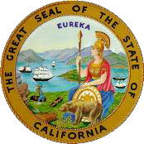

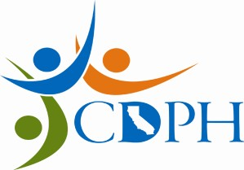

California Department of Public Health

RON CHAPMAN, MD, MPH EDMUND G. BROWN JR.
Director & State Health Officer Governor

EXAM SCHEDULES Grade T1 – T5

WATER TREATMENT
OPERATOR CERTIFICATION PROGRAM

Final Filing Date | T1-T4 Test Dates | T5 Test Dates
March 1, 2014  September 1, 2014 | May 17, 2014  November 15, 2014 | June 2014*  December 2014*
March 1, 2015 | May 16, 2015 | June 2015*
September 1, 2015 | November 21, 2015 | December 2015*

Exam dates are subject to Department approval.

Applications must be POSTMARKED ON OR BEFORE the final filing date to be considered for the current examination period. All minimum education qualifications must be met by the final filing date of the exam in which you wish to participate. Incomplete or illegible applications will result in a delay in the evaluation of your qualifications and scheduling of examination.

* Grade 5 oral exams will be held in two locations ONLY – Northern California and Southern California
(usually Sacramento and Lakewood)

PROPOSED EXAM SITES (Grade T1 – T4)

Fresno | Sacramento | San Diego
Los Angeles | San Bernardino/Riverside Area | San Jose
Redding

Exam sites are in the general vicinity of the cities listed above and are subject to change.

Rev. 10/15/2013

Division of Drinking Water and Environmental Management P.O. Box 997377, MS 7417 Sacramento, CA 95899-7377 (916) 449-5611 (916) 449-5654 Fax
Internet Address: http://www.cdph.ca.gov/certlic/occupations/Pages/dwopcert.aspx

