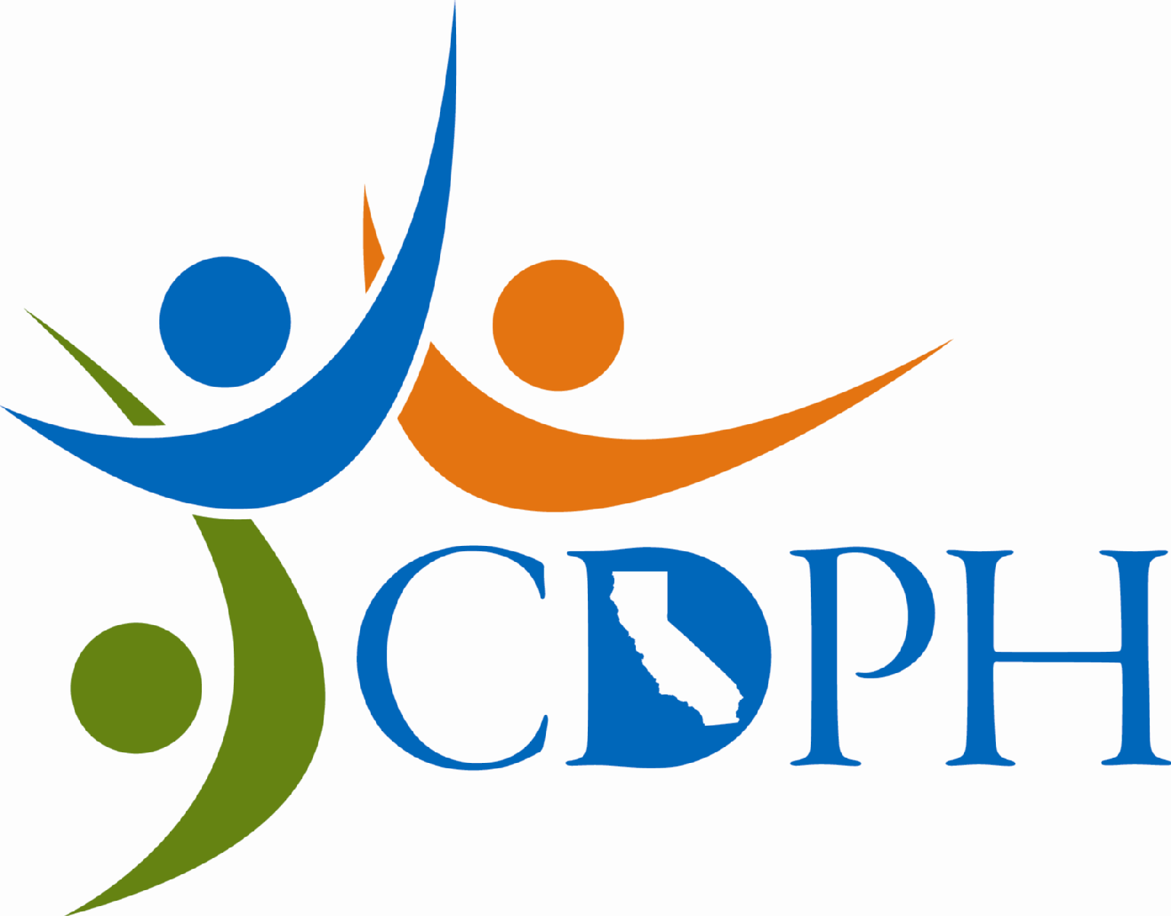
SDWSRF Enhancing Project Impact
9

Loan Funds for

* * System Security * Water Conservation *

* Energy Conservation / Reliability *

Safe Drinking Water State Revolving Fund project applications may include requests for loan funds to support water system security, water conservation, and energy conservation/reliability infrastructure.

The California Department of Public Health (CDPH), Drinking Water Program encourages water systems to examine the overall operation of their system through technical, managerial, and financial (TMF) assessments to ensure the safety and reliability of public water supply. In conjunction with the application process for SDWSRF funding, systems conduct a review of these areas, identify gaps in their present TMF capability, and establish schedules for addressing critical elements.

The SDWSRF can provide loan funds for security measures incorporated into projects to correct existing or threatened public health related problems. Systems invited to apply for SDWSRF funding are encouraged to include appropriate security measures in their proposed projects, consistent with the guidelines of the USEPA for increasing security of public water system components which could be vulnerable to tampering.

In addition, CDPH encourages projects involving the replacement of distribution lines to include a request for funding to provide for water meter installation. Through appropriate measurement of water production and use, water systems can reduce unaccounted water lost to leaks. By lowering water demand, public water systems may be able to accommodate more customers without increasing water production capacity. Increasing water conservation saves the expense and energy needed to produce and distribute water, and ultimately saves on wastewater collection and treatment costs as well. Further information on metering as a component of a comprehensive water conservation plan can be obtained from the California Urban Water Conservation Council.

Applicants for SDWSRF funding are required to meet a number of TMF requirements including development of an operations plan for their system. Planning provides a systematic process for addressing efficient system operation and can contribute to saving both water and power. Water distribution is one of the largest components of energy use by many local governments. SDWSRF loan funds can be used for energy efficiency measures such as enhancing SCADA (Supervisory Control and Data Acquisition) systems, in conjunction with a funded project. SCADA systems can allow public water systems to save energy (and expenses) by optimizing pump operation to respond to shifting demand within the distribution system. SDWSRF loan funds can also be used to ensure energy reliability, such as standby power generators and alternative power supplies for use during power disruption. For further information on incorporating security and conservation elements into your project, contact the Drinking Water Program District Office for your county.

