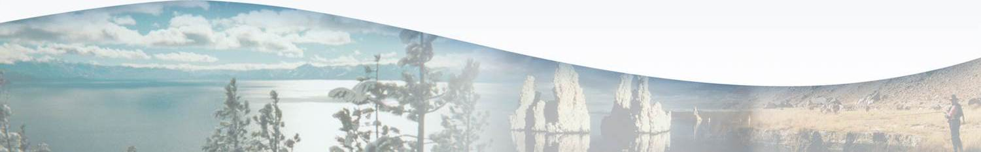
Lahontan Water Board Program Fact Sheet
FY 2017-18
Nonpoint Source Pollution Control
Overview
The purpose of the Nonpoint Source Pollution Control Program (NPS Program) is to protect unimpaired waterbodies and restore waters impacted by NPS pollution. Restoration on forested lands and grazing management are high priorities in the NPS Program. The Federal Clean Water Act Section 319(h) allocation this fiscal year is 1.6 PYs with an additional $2,202,277 in grant support to local technical assistance projects. The Region’s NPS Program implements the statewide California Nonpoint Source Program Implementation Plan 2014-2020, and is consistent with the statewide Policy for Implementation and Enforcement of the Nonpoint Source Pollution Control Program.
Key Efforts
The NPS Program focuses on implementing grants and regulatory actions to prevent adverse impacts due to livestock grazing; supporting watershed restoration efforts and interacting with stakeholders.

Federal Lands Management Activities
- Review and comment on project NEPA documents.
- Work with stakeholders in developing a draft Federal Lands Nonpoint Source Permit.
Grazing Operation & Other Activities in the East Walker River Watershed
- Monitor compliance with Bridgeport Valley Grazing Waiver.
- Engage with ranchers and other stakeholders to develop watershed-based approach.
Grazing Activities on Los Angeles Department of Water and Power (LADWP) Lands
- Engage and receive input from stakeholders.
- Engage with LADWP to focus on addressing grazing activities to reduce bacteria in surface waters.
- Begin to draft permit to cover grazing activities while protecting water quality.
Identifying and Protecting Healthy Watersheds
- Support Total Maximum Daily Load (TMDL) implementation activities.
- Conduct environmental education and outreach activities to help stakeholders better understand their role in protecting the state’s water resources.

Accomplishments
- Managed eight technical assistance grant projects that implement adopted TMDLs; three projects were completed during the past year and two new projects were funded.
- Provided oversight and inspections of major stream restoration and stabilization projects implemented by the USFS and the California Tahoe Conservancy at the Upper Truckee River
- Issued water quality certification orders for forest, meadow, and stream restoration projects.
- Acted as CEQA lead agency for two restoration projects to expedite project permitting.

East Walker River Grazing
- Renewed the Bridgeport Valley Grazing Waiver in July 2017 for another five years.
- Commenced collaborative meetings to develop a new watershed-based approach for the next permit.

LADWP Lands
- Met with LADWP representatives in October to kick-off the process of a permit for land owned by LADWP and leased to ranchers for grazing in the Owens Valley Area.
- Continued with developing general WDRs specific for LADWP maintenance activities in Inyo and Mono counties to include sediment removal, vegetation management, and replacement of existing structures. Circulated the draft CEQA document for public comment December 2017.

Federal Lands Nonpoint Source Permit
- Partnered with Central Valley Regional Water Quality Board to conduct six joint public outreach meetings in Susanville, Redding, Rancho Cordova, Bishop, Clovis, and Apple Valley to inform local federal agency staff and interested stakeholders about the proposed permit and to solicit feedback from meeting attendees to inform permit development.
- Developed a “frequently asked questions” document to aid public outreach.
No Performance Targets Established
Though no formal performance targets are established for the NPS Program, each Region and the State Water Board are required to submit an annual report and two semi-annual reports to US EPA to report on activities funded from the federal Clean Water Act 319(h) program.
Unaddressed Work

- Development of a regulatory mechanism for grazing activities on private lands.
- Development of a regulatory mechanism for native surface road maintenance, closure and repair.
- Active and completion inspections for all forest health and stream restoration projects.

