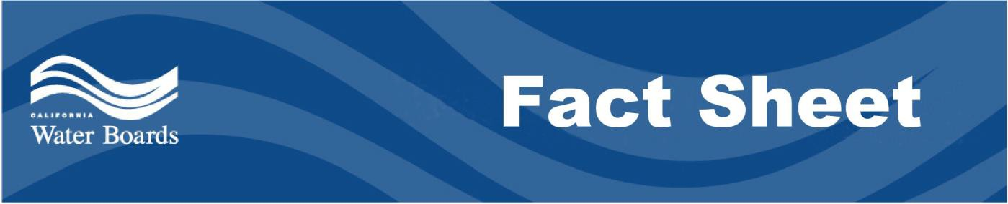

San Francisco Bay Regional Water Quality Control Board Working Together with Federal, State, and Local Officials on Public Health, Stormwater, Flood, and Erosion Issues Following Wildfires

Agency Response to Fire Cleanup
- The primary focus of the response to the catastrophic fires in the North Bay Area has been the protection of human life and property. Since the fires have been contained and efforts are underway to aid those who have lost their homes and businesses, State and local agencies have turned their attention to the cleanup of fire debris and minimizing damage to natural resources as the rainy season approaches.
- The goals of the San Francisco Bay Regional Water Quality Control Board (SF Bay Water Board) in responding to the fires are the protection of human health, critical infrastructure (bridges, roads, culverts, and flood protection facilities), wildlife, and the natural environment, including our streams and waterways.
- CAL FIRE and the California Geologic Survey have convened a Water Emergency Response Team (WERT) to rapidly assess the risks of landslides and flooding posed by fire-impacted zones throughout the San Francisco Bay Region. SF Bay Water Board staff have participated on the team and are relying on the assessments to guide water quality protection efforts.
- Multiple local agencies are also working together, independently and in collaboration with CAL FIRE’s WERT, to assess and reduce the risk of flooding and to prevent fire-related debris, pollutants, and sediment from burned areas from being carried into our storm drains, creeks, rivers, and the Bay.

- Agency partners include the U.S. Forest Service; U.S. EPA; the State Department of Water Resources; the State Water Resources Control Board; the North Coast Regional Water Quality Control Board; the cities of Santa Rosa, Sonoma, and Napa; the counties of Sonoma, Napa, and Solano; the Sonoma County Water Agency; the Sonoma County Agricultural Preservation and Open Space District; the Napa County Flood Control and Water Conservation District; the Natural Resources Conservation Service; and the local Resource Conservation Districts, as well as many non-profit organizations and private partners.
- There are multiple streams and watershed lands in the areas affected by fire in Sonoma, Napa, and Solano counties. Given that our natural watersheds filter our drinking water and provide sensitive natural habitat, it is critically important that ash, debris, and other pollutants are prevented from entering stream systems to the maximum extent possible.
- County and municipal staff are assessing burned areas around drinking water reservoirs in order to implement effective erosion control, hillslope stabilization, and chemical management to protect and insure safe drinking water. These agencies are coordinating with the SF Bay Water Board, the North Coast Regional Water Board, and the State Water Board’s Department of Drinking Water in these efforts.

Actions to Prevent Runoff Contamination
- The SF Bay Water Board is establishing safe and efficient protocols and opportunities for disposal of fire debris at landfills in the SF Bay Region. The SF Bay Water Board is expediting establishment of a permit to provide more opportunities and safe protocols for removal of fire debris. A draft is available for review at: https://www.waterboards.ca.gov/sanfranciscobay/board_info/agendas/2017/December/DisasterReateddWastes/Tentative_Order.pdf
- SF Bay Water Board staff are conducting watershed field visits, coordinating with other agencies, and conducting water quality monitoring to assess risks and identify high impact areas and sensitive resources to target technical and financial assistance to land managers and property owners for debris removal and containment, erosion control, stormwater runoff management, flood prevention, and stream and habitat restoration.

- The SF Bay Water Board will exercise its enforcement discretion with respect to deadlines and tasks in existing permits and regulatory orders to account for emergency fire response (e.g., debris removal and containment), best practices for post-fire erosion control, potential need for revised timeframes, etc., as needed and appropriate. If you have concerns about permit compliance as a result of the recent fires, please contact the SF Bay Water Board staff member listed as a contact in your permit.

For Residents
- Residents should not wash ash down into streets or drains.
- A fact sheet with debris removal questions and answers developed by Cal OES and FEMA is available at wildfirerecovery.org- http://wildfirerecovery.org/debris-removal/ debris-removal-faqs/.
- Actions taken by rural property owners can significantly reduce erosion on their properties and help prevent downstream flooding. The Natural Resource Conservation Service and the local Resource Conservation Districts can provide tips for best management practices. See these webpages: http://sonomarcd.org/resources/fire-recovery/ and http://naparcd.org/after-the-fire-rcd-and-nrcs-can-help/
- The U.S. Army Corps of Engineers is taking the lead for Debris Removal operations. They have hired two prime contractors who will use local contractors for their work. The prime contractors are Ashbritt and Environmental Chemical Corporation. Local contractors can register as subcontractors at the prime contractors’ websites: http://www.ashbritt.com/ and http://www.ecc.net

(This Fact Sheet was last updated on Nov. 7, 2017)

