ATTACHMENT J

FIGURES

CALIFORNIA REGIONAL WATER QUALITY CONTROL BOARD
SAN FRANCISCO BAY REGION

For the General Waste Discharge Requirements for
Discharges of Winery Waste to Land Within the San Francisco Bay Region
Order No. R2-2017-XXXX

Figure 1: San Francisco Bay Regional Water Quality Control Board Boundary

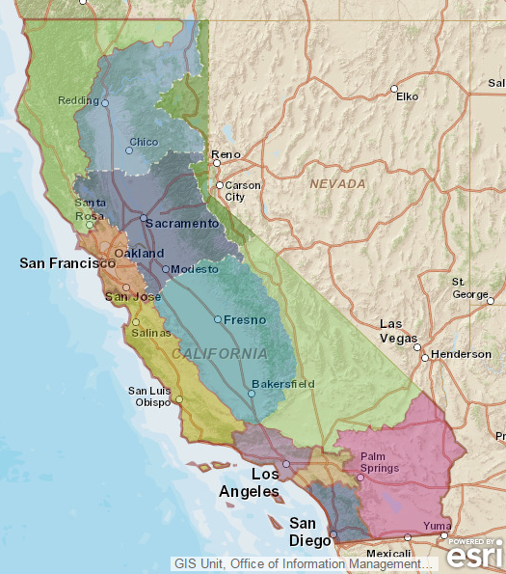

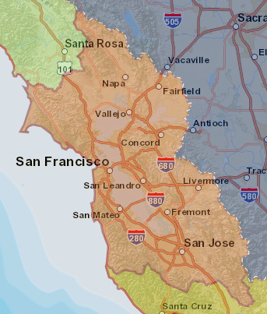

Figure 2-1: Groundwater Basins in the Water Board’s San Francisco Bay Region

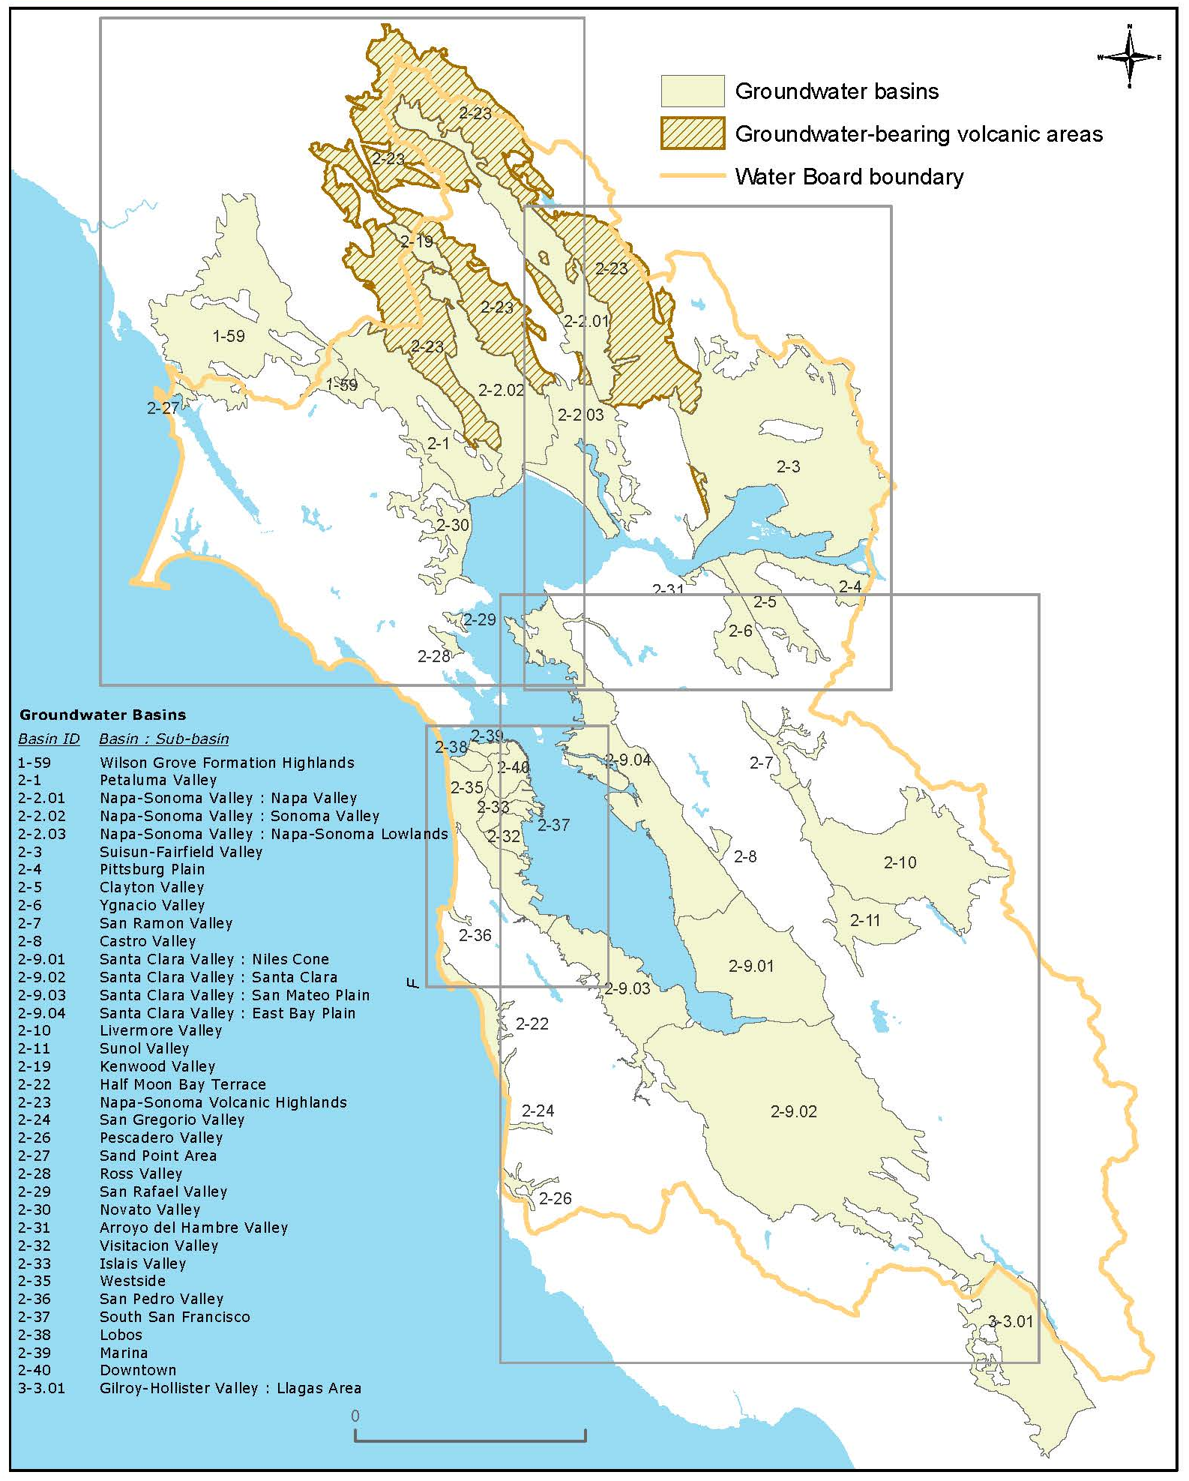
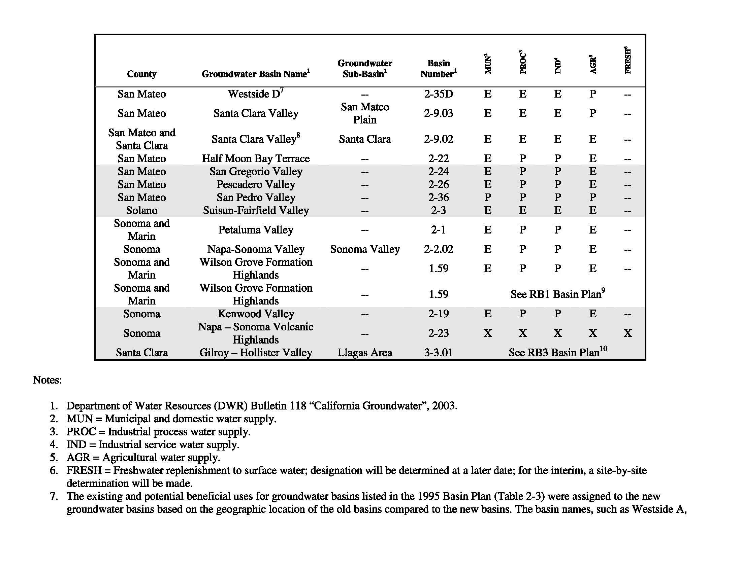
Figure 2-2: Existing and Potential Beneficial Uses in Groundwater in Identified Basins

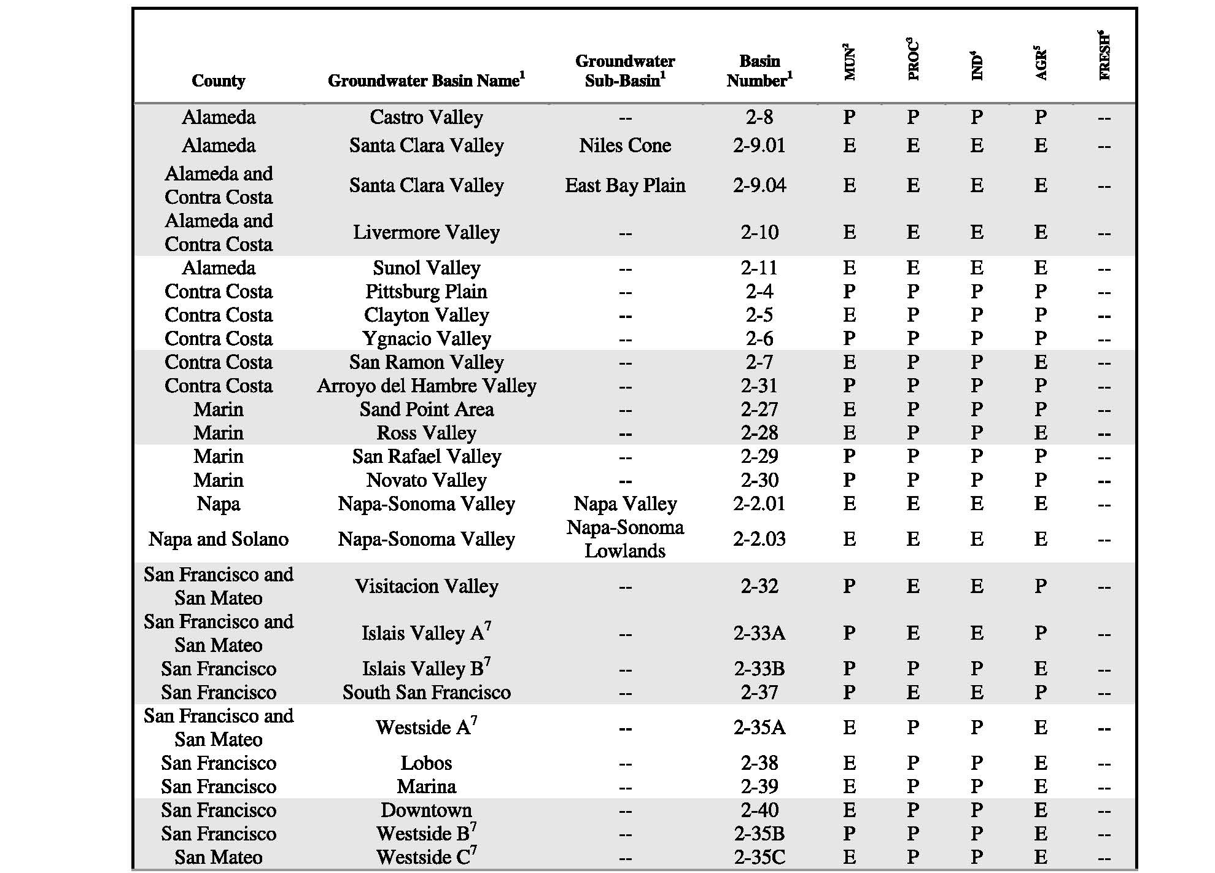

Figure 3: Zone 7 Water Agency Identified Nitrate-Impacted Groundwater Areas

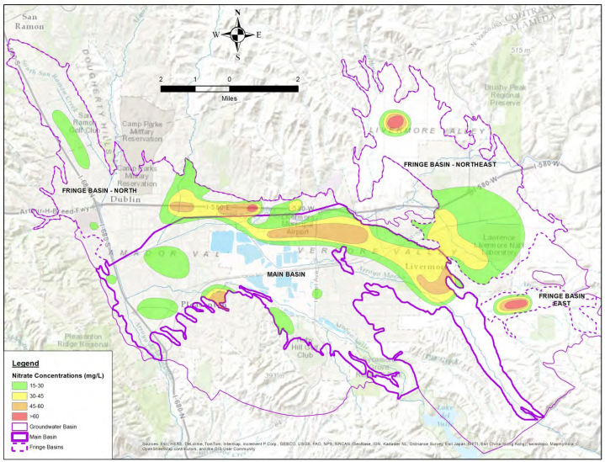

This figure was current at the time this Order was adopted but is subject to change as additional data are collected. Refer to the Groundwater section of the Zone 7 Water Agency Reports and Planning Documents website for the most recent version of the Nutrient Management Plan, http://www.zone7water.com/index.php/reports-a-planning-documents.

Figure 4: Elevated Nitrate Groundwater Areas in Petaluma, Sonoma County
Figure will be updated following consultation with Sonoma County.
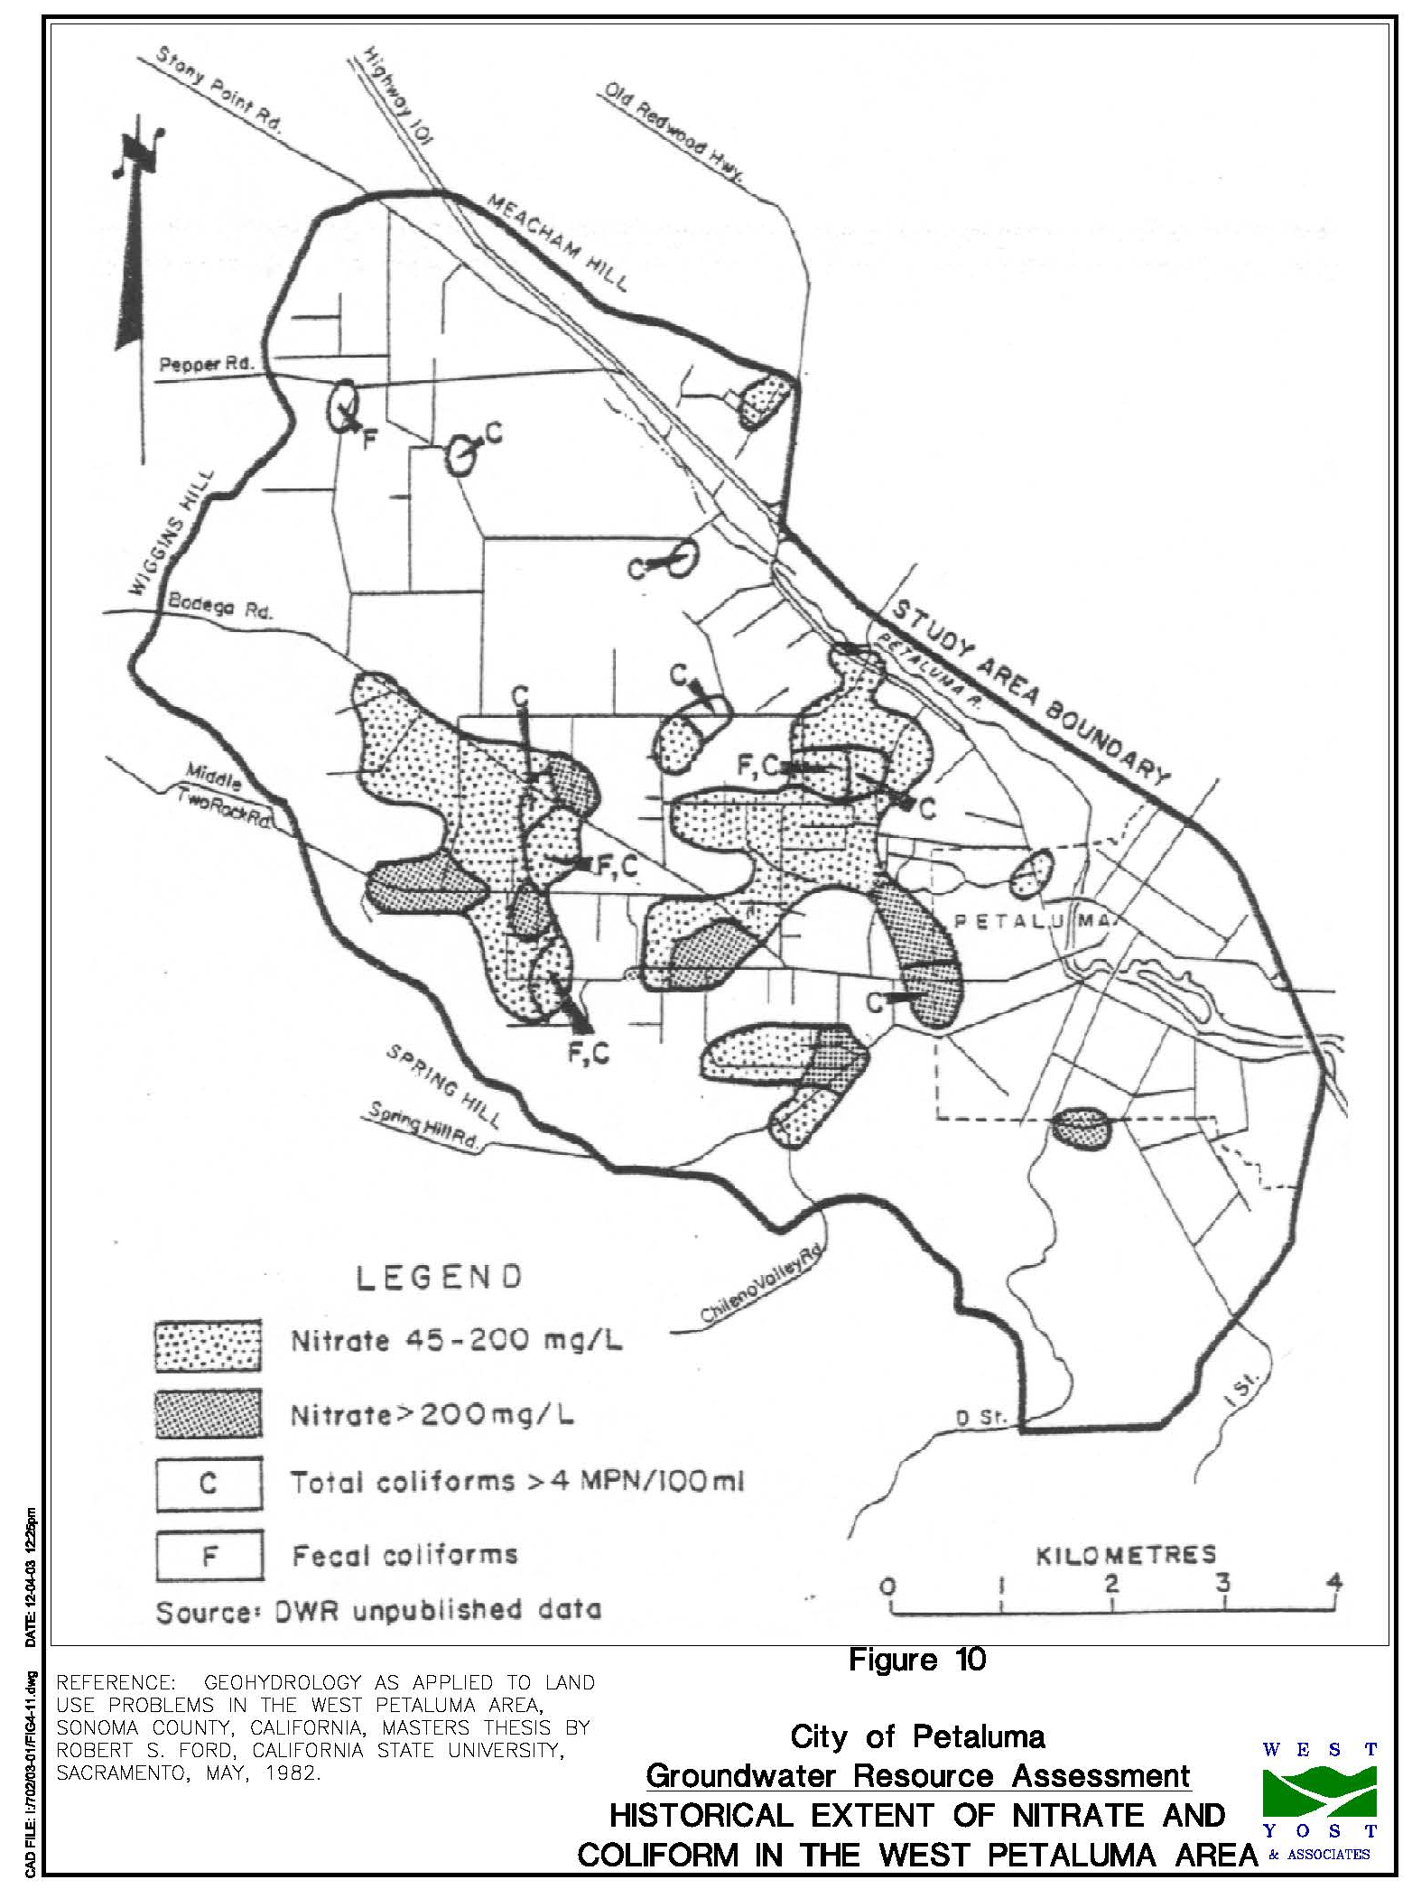
Figure 5: Elevated Nitrate Groundwater Areas in Pescadero, San Mateo County
Figure will be updated following consultation with San Mateo County.
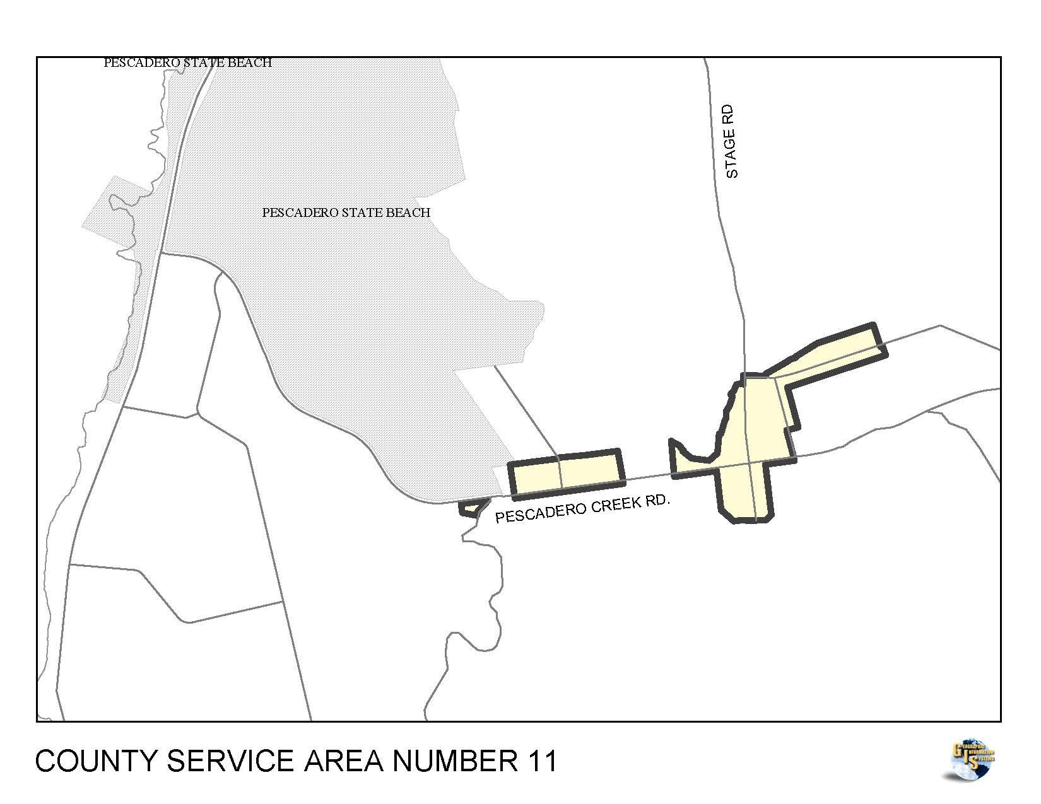

Source: State Water Resources Control Board, http://www.waterboards.ca.gov/waterboards_map.shtml.
Source: Water Quality Control Plan for the San Francisco Bay Basin, Chapter 2, Figure 2-10 Groundwater Basins http://www.waterboards.ca.gov/sanfranciscobay/water_issues/programs/planningtmdls/basinplan/web/fig/fig_2-10.pdf.
Source: Zone 7 Water Agency July 2015 Nutrient Management Plan, Figure 2-15 Nitrate Areas of Concern, page 27, http://www.zone7water.com/images/pdf_docs/groundwater/nmp-2015_final.pdf.
Source: West Yost and Associates. 2004. Technical Memorandum No. 4 Groundwater Feasibility Study. Accessible online at http://cityofpetaluma.net/cdd/pdf/riverfront/West-Groundwater-Feasibility-Study.pdf.
Source: City of San Mateo Public Works. CSA 11 County Service Area 11. Accessible online at http://publicworks.smcgov.org/csa-11-county-service-area-11.

