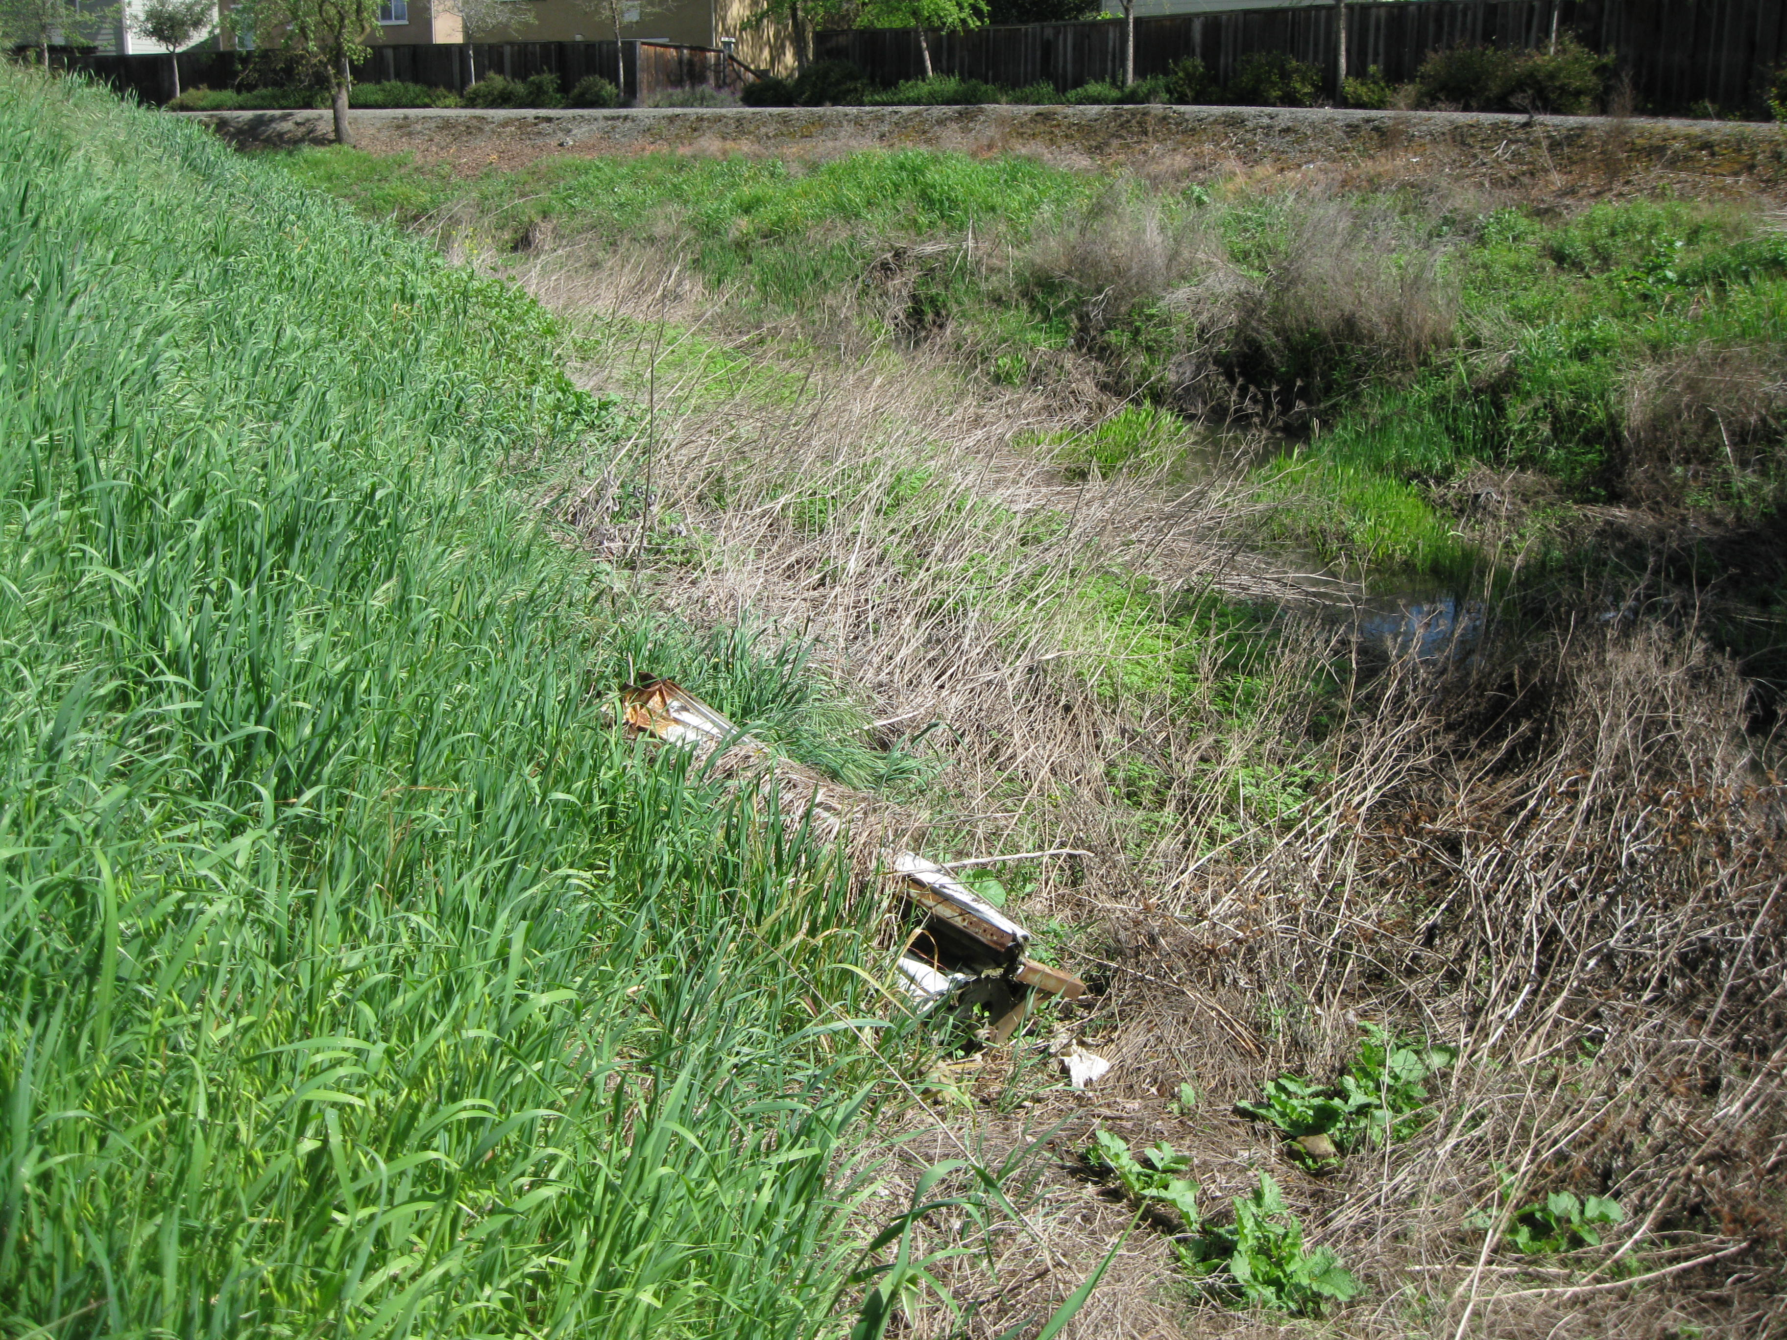

Dan Wilson Creek location #3 “before”

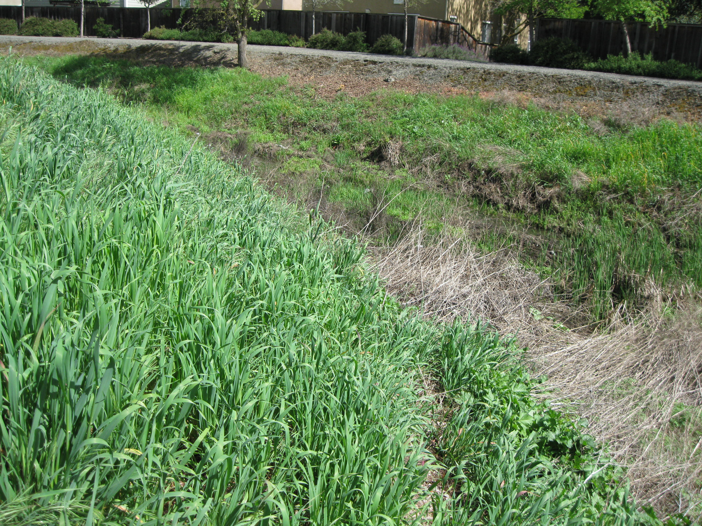

Dan Wilson Creek location #3 “after”

