Lewiston Community Services District

County: Trinity
Population: 150
Challenges: Failing water infrastructure with arsenic contamination

A
unique cooperative effort by local, state and federal agencies on behalf of a disadvantaged community of approximately 150 near the Trinity Dam led to an upgraded water system that now provides a reliable and safe supply of drinking water.

Constructed in 1957 as part of a temporary community used to house those working on the new Trinity Dam, key components of this water system were failing. Known previously as the Lewiston Valley Water Company, the system was also supplying water that violated the drinking water standard for arsenic.

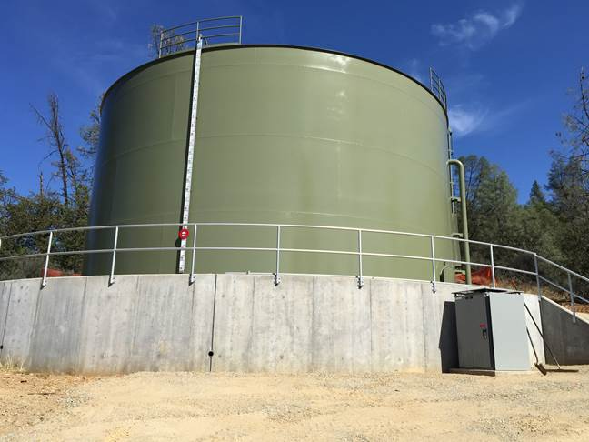
Lewiston’s upgrade included relocating its surface water intake pipe and constructing a new pump station, raw water main, filter plant and storage tank. With completion of the project, leaks along the raw water main were greatly reduced. The upgrades also brought Lewiston into compliance with the arsenic drinking water standard and the surface water treatment rule.

Updating Lewiston Community Services District’s water system was team effort as it took the involvement of the California Public Utilities Commission, the U.S. National Park Service, U.S. Department of Health and Human Services, Trinity County and the State Water Board to complete it. Some of the issues included the system being located on federal land near a federally designated Wild and Scenic River that is home to Coho salmon, as well as completing new pump station construction on land that was originally deemed for recreational use only.
One of the many upgrades at the Lewiston Community Services District was the installation of this new water storage tank.

The $3.2 million project, issued in the form of grants to the disadvantaged community, was paid for through a combination of Proposition 50 and 84 funding, as well as financing from the Drinking Water State Revolving Fund.

