Speaker Biographies:

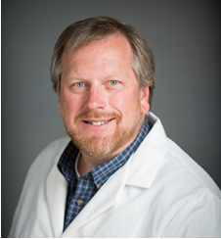  Shane Snyder University of Arizona | Dr. Shane Snyder is a Professor of Chemical & Environmental Engineering, and holds joint appointments in the College of Agriculture and School of Public Health, at the University of Arizona. He also co-directs the Arizona Laboratory for Emerging Contaminants (ALEC) and the Water & Energy Sustainable Technology (WEST) Center. For nearly 20 years, Dr. Snyder’s research has focused on the identification, fate, and health relevance of emerging water pollutants. Dr. Snyder and his teams have published over 175 manuscripts and book chapters on emerging contaminant analysis, treatment, and toxicology (H-index = 55 as of September 2015). He currently serves as an editor-in-chief for the international journal Chemosphere. Dr. Snyder has been invited to brief the Congress of the United States on three occasions on emerging issues in water quality. He has served on several U.S. EPA expert panels and is currently a member of the EPA’s Science Advisory Board drinking water committee. He was recently appointed to the World Health Organization’s Drinking Water Advisory Panel and was a member of the US National Academy of Science’s National Research Council Committee on Water Reuse. Dr. Snyder also is a Visiting Professor at the National University of Singapore and an Adjunct Professor at the Gwangju Institute of Science and Technology in South Korea.
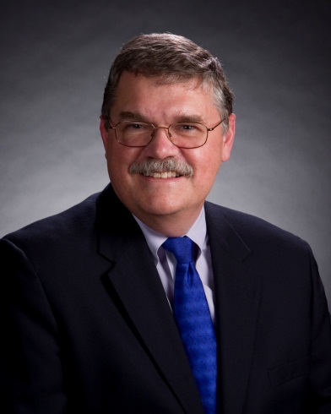  Mike Wehner  Orange County  Water District | Mr. Mike Wehner is the Assistant General Manager at Orange County Water District (OCWD) and directly manages Water Quality and Technology programs at the District. Prior to joining OCWD in 1991, he spent 20 years with Orange County Environmental Health where he was Water Quality Program Chief. Mr. Wehner is an internationally recognized expert in water quality, public health and advanced water purification technology and has served on advisory panels for the National Water Research Institute, WaterRF, the WateReuse Research Foundation, the NRC, US EPA, CDPH, the California State Water Resources Control Board, UK Water Industry Research, Thames Water, CSIRO in Australia and the PUB in Singapore. Mr. Wehner received a Masters of Public Administration from California State University Long Beach and a B.S. in Biological Sciences from the University of California, Irvine.
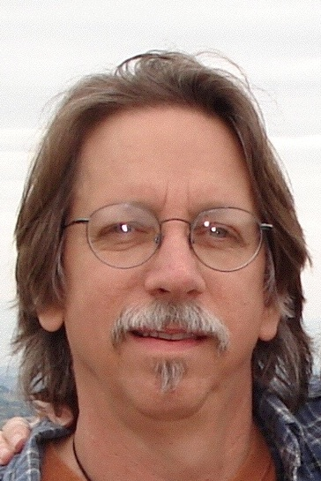  Mike Denison  University of California, Davis | Dr. Mike Denison received a B.S. degree in Marine Biology from St. Francis College, a M.S. degree in Animal Physiology from Mississippi State University and a Ph.D. in Environmental Toxicology from Cornell University. After postdoctoral research in the Clinical Pharmacology Department at the Hospital For Sick Children in Toronto and the Molecular Pharmacology Department at Stanford University, he joined the Department of Biochemistry at Michigan State University as an Assistant Professor and relocated UC to Davis where he is currently a professor in the Department of Environmental Toxicology. Dr. Denison’s overall research focus for the past 35 years has been directed toward understanding the molecular mechanisms by which the Ah receptor mediates the biological/toxicological actions of dioxins and related chemicals and nuclear hormone (steroid) receptors mediate the action of endocrine disrupting chemicals. In addition to his work on the biochemical and molecular analysis of the Ah receptor and steroid hormone receptors, his laboratory has a major emphasis in the development of receptor-based bioassay systems for the detection and quantitation of dioxin-like chemicals and environmental hormones (endocrine disruptors) in environmental, biological, food and commercial and consumer products. He has more than 200 publications in these areas.
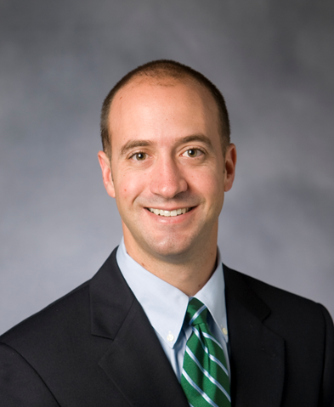  Lee Ferguson  Duke University | Dr. P. Lee Ferguson is an Associate Professor of Environmental Science and Chemistry at Duke University in Durham, NC. Research in the Ferguson laboratory is focused on Environmental Analytical Chemistry. Specifically, his research group develops novel methods for trace analysis of organic and nanoparticulate contaminants in the aquatic environment. Specifically, a major thrust of research in the lab involves the application of high resolution, accurate mass (HRAM) mass spectrometry coupled with multidimensional chromatographic separations, bioaffinity isolation techniques, and online sample preparation methods to detect, identify, and quantify emerging contaminants (including endocrine disruptors, pharmaceuticals, and surfactants) in wastewater and drinking water. Another significant research thrust involves the development of sensitive trace analytical techniques for quantifying and characterizing carbon based nanoparticles in natural and engineered systems. The analytical methods developed in the Ferguson laboratory (for both nanoparticles and organic contaminants) are applied to both process-oriented environmental chemistry experiments in the field and laboratory as well as to toxicity bioassays (including whole-organism assays and molecular endpoints). The overarching goal is to gain an increased understanding of how emerging contaminants are transported, transformed and induce deleterious effects within aquatic ecosystems.
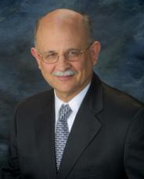  Rhodes Trussell  Trussell Technologies | The founder of Trussell Technologies, Inc., R. Rhodes Trussell, has a B.S., M.S., and Ph.D. in Environmental Engineering from University of California at Berkeley. Dr. Trussell is a registered Civil and Corrosion Engineer in the State of California with more than 40 years of experience who has authored more than 200 publications. He is recognized, worldwide, as an authority in methods and Criteria for Water Quality and in the development of advanced processes for treating water or wastewater to achieve the highest standards. He has worked on the process design for dozens of treatment plants, ranging from less than one to more than 900 mgd in capacity and has experience with virtually every physiochemical process and most biological processes as well. Dr. Trussell is available to review and advise on any complex water quality problem. He has a special interest in emerging water quality problems and reuse.  Dr. Trussell served for more than ten years on EPA’s Science Advisory Board, on several committees for the National Academies, including as Chair of their Water Science and Technology Board. For the International Water Association, Dr. Trussell has served on the Scientific and Technical Council, Editorial Boards, and on the Program Committee.
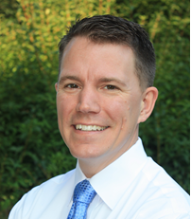  Ben Stanford  Hazen and Sawyer | Dr. Ben Stanford is the Director of Applied Research at Hazen and Sawyer in Raleigh, NC where he manages a portfolio that has spanned over 50 research grants and also leads the company’s water reuse practice group. Dr. Stanford earned his Ph.D. in Environmental Sciences and Engineering from UNC Chapel Hill and has conducted a range of studies spanning science, engineering, and public health protection for water, water reuse, and wastewater. His current work includes numerous direct and indirect potable water reuse studies and projects. He also serves as an expert advisor to AWWA, NSF, municipalities, and several other groups on emerging contaminants, cyanotoxins, chlorate/perchlorate, disinfection byproducts, and control of legionella in premise plumbing systems. Dr. Stanford has over 30 peer-reviewed publications, and was awarded the 2012 Publications Award by the American Water Works Association.
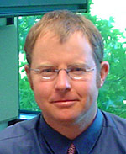  Andy Salveson  Carollo Engineers | Mr. Andy Salveson is the Vice President, Water Reuse Chief Technologist, and Disinfection Principal at Carollo Engineers in Walnut Creek, CA. Mr. Salveson has 19 years of environmental consulting experience serving public and private-sector clients in the research and design of water and wastewater treatment systems. He is a nationally recognized expert in water reuse and disinfection, and provides Carollo’s clients with guidance and expertise on the latest industry issues and technology regarding reuse. Mr. Salveson has led numerous planning, design, and research projects for various organizations, utilities, and corporations, and was honored with the 2007 WateReuse Person of the Year Award for bringing innovative technologies to market. Mr. Salveson specializes in water reuse and disinfection, treatment technology development, and water treatment technology research and investigations, including innovations in UV disinfection and new approaches to ozone treatment. Mr. Salveson is currently working on design efforts for indirect and direct potable water reuse projects in Oregon, California, New Mexico, and Texas.
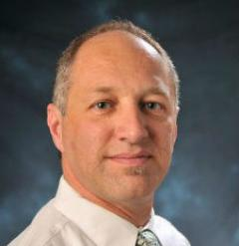  Karl Linden  University of  Colorado Boulder | Dr. Karl G. Linden is a Professor of Environmental Engineering and the Mortenson Professor in Sustainable Development at the University of Colorado Boulder, USA. He has a BS from Cornell University in Agricultural and Biological Engineering and an MS and PhD from University of California at Davis in Environmental Engineering. He teaches classes on UV Processes in Environmental Systems, Sustainable Water Reuse, and Water Sanitation and Hygiene. Dr. Linden’s research has investigated novel water and wastewater treatment systems, including advanced and innovative UV systems; the efficacy of UV and ozone disinfection for inactivation of pathogens; and the use of UV and advanced oxidation processes for the degradation of organic and other emerging contaminants in water and wastewater. Dr. Linden is an associate editor of Journal of Environmental Engineering and Journal of the American Water Works Association. He serves as Trustee of the Water Science and Research Division of the AWWA, and is 2013-2016 President of the International Ultraviolet Association (IUVA). He was named a 2013-2014 Fellow of the Australian Water Recycling Centre of Excellence, received the 2013 Pioneer Award in Disinfection and Public Health from the Water Environment Federation and was the WateReuse Association’s 2014 WateReuse Person of the Year. Professor Linden Co-Directs the Mortenson Center in Engineering for Developing Communities at CU Boulder.
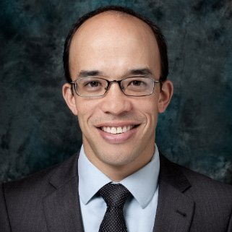  Brian Pecson  Trussell Technologies | Dr. Brian M. Pecson has a B.S. and B.A. from the University of Notre Dame, and an M.S. and Ph.D. in Civil and Environmental Engineering from the University of California at Berkeley. Dr. Pecson is a registered engineer in the state of California. Dr. Pecson has 9 years of environmental engineering experience and has authored 7 research papers. His professional experiences have focused on the reuse of wastewater and sludges, the analysis of alternative treatment processes, and the impact of treatment decisions on greenhouse gas emissions. His interests in the field of water reuse include the treatment and management of brine residuals, the suitability of recycled water for agriculture, and the development of technologies for indirect potable reuse. In addition to analyzing alternative treatment processes based on water quality criteria, Dr. Pecson is interested in understanding how these decisions affect the carbon footprint of treatment facilities. His past research experience focused on the disinfection of wastewater and sludges, with an emphasis on viruses and helminth eggs, two of the most resistant pathogen classes. These studies provided a wide breadth of experience, from low-tech treatment options (constructed wetlands, alkaline sludge stabilization) to the development of molecular detection methods.

