# Appendix F: Generalized Flow Chart for Tissue Mercury Assessments for the California Integrated Report

This flowchart is a generalized guide illustrating how staff assessed fish tissue mercury data for the California Integrated Report to make listing or delisting decisions, per sections 3.4, 3.5 or 3.11 of the Listing Policy.

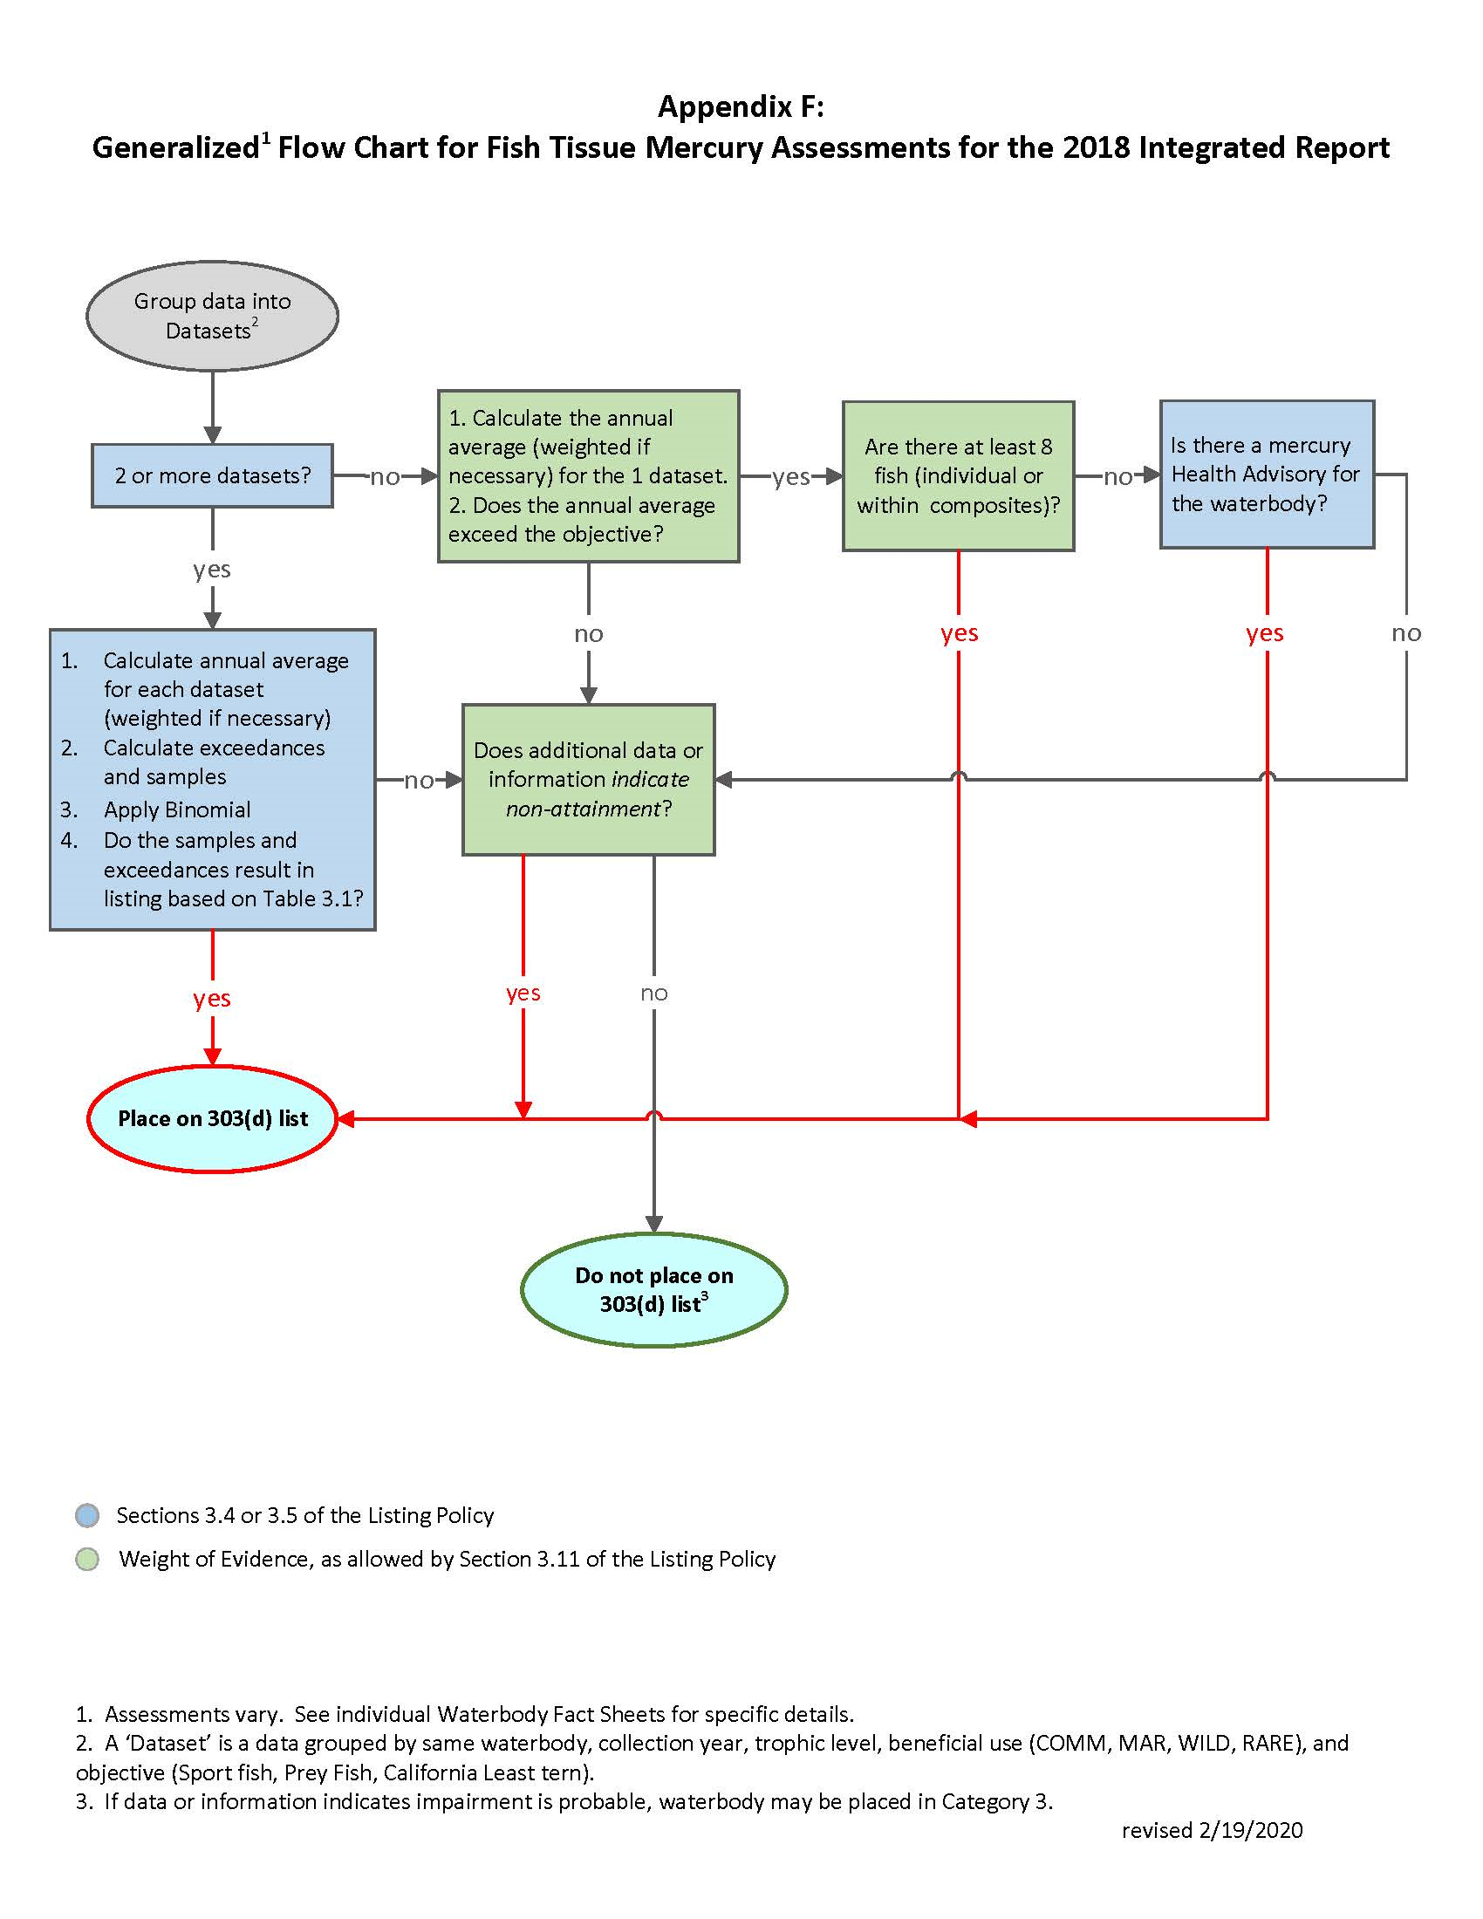

1. This diagram shows the typical assessment process for mercury fish tissue objectives. Procedures used for assessments specific to individual waterbodies may vary. See individual Waterbody Fact Sheets for specific details.
2. A “dataset” is defined as data representing the same waterbody, collection year, trophic level, beneficial use (COMM, MAR, WILD, or RARE) and objective (the sport fish objective, the prey fish objective, or the California Least Tern objective).
3. If data or information indicates impairment is probable, waterbody may be placed in Category 3.