April 24, 2015

Ms. Jane Diamond, Director
Water Division (WTR-1)
U.S. Environmental Protection Agency,
Region 9
75 Hawthorne Street
San Francisco, CA 94105

Dear Ms. Diamond:

TRANSMITTAL OF THE 2012 CALIFORNIA INTEGRATED REPORT [CLEAN WATER ACT SECTIONS 303(d) AND 305(b)]

On April 8, 2012, by Resolution No. 2015-0021, the State Water Resources Control Board (State Water Board) approved the Clean Water Act section 303(d) List of water quality limited segments (303(d) List) portion of the 2012 California Integrated Report. Pursuant to Clean Water Act section 303(d)(2), the State Water Board is submitting to the U.S. Environmental Protection Agency (U.S. EPA) the Clean Water Act section 303(d) List and supporting documentation for review and approval. The 2012 California Integrated Report contains five categories consistent with U.S. EPA guidance. Consistent with Section 2 of the Water Quality Control Policy for Developing California’s Clean Water Act Section 303(d) List, the Clean Water Act section 303(d) List portion of the California Integrated Report is comprised of Integrated Report categories 4a, 4b, and 5.

The complete 2012 California Integrated Report and supporting documentation listed below are being sent separately to Mr. Terrence Fleming of your office:

- The State Water Board Staff Report which contains the listing methodology used; summaries of the proposed additions, deletions, and area changes (Table 3); and the 2010 California 303(d) List;
- 2012 California Integrated Report category reports;
- Fact sheets supporting recommendations for listing, delisting, and area changes;
- Miscellaneous Changes Report;
- State Water Board Summary of Comments and Responses;
- State Water Board Resolution; and
- A DVD copy of the April 8, 2015 State Water Board Meeting.

The complete 2012 California Integrated Report, including the Clean Water Act 303(d) List portion approved by the State Water Board, is available online at http://www.waterboards.ca.gov/water_issues/programs/tmdl/integrated2012.shtml.

We look forward to receiving your approval of the Clean Water Act 303(d) List portion of the 2012 California Integrated Report. If you have any questions on this subject, please contact me at (916) 341-5615 (Tom.Howard@waterboards.ca.gov). You may also contact
Mr. Nick Martorano, Chief of the Water Quality Assessment Unit, who is the lead staff person on this matter, at (916) 341-5290 (Nicholas.Martorano@waterboard.ca.gov).

Sincerely,
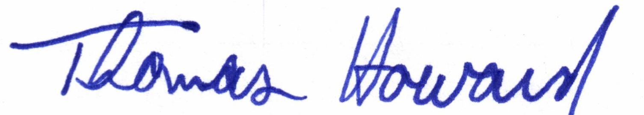

Thomas Howard
Executive Director

Enclosure

cc: | (with attachments)  Mr. Terrence Fleming, WTR-2  Fleming.Terrence@epa.gov  U.S. Environmental Protection Agency,  75 Hawthorne Street  San Francisco, CA 94105

cc: (without attachments)  Ms. Janet Hashimoto, WTR-2  Hashimoto.Janet@epa.gov  U.S. Environmental Protection Agency,  75 Hawthorne Street  San Francisco, CA 94105 | Nick Martorano (DWQ)
Mr. Nick Martorano (DWQ)

