YUROK TRIBE ENVIRONMENTAL PROGRAM
PO Box 1027
Klamath, California 95548
(707) 954-1523
(707) 482-1356 (FAX)
kfetcho@yuroktribe.nsn.us

MEMORANDUM

TO: Klamath River BGA workgroup
FROM: Ken Fetcho
DATE: September 16, 2008
RE: September 3, 2008 phytoplankton results

YTEP has received phytoplankton identification and enumeration results for water samples collected on September 3, 2008 in the Klamath River at Weitchpec and the Lower Klamath River Estuary. Samples were collected at additional sampling sites within the Yurok Reservation boundaries and those results will be released once they are received and reviewed. Both samples that are reported below were collected from 1 foot below the surface of the water using a churn sampler. Both sites reported levels of Microcystis aeruginosa and Aphanizomenon flos-aquae and are detailed in the table below.

Communication with the Karuk Tribe has indicated that the blooms in Iron Gate Reservoir and Copco Lake are very heavy with visible surface scums. Karuk Tribe staff have also recently released information that edge water in the vicinity of Klamath River below Iron Gate Dam and at Seiad Valley have high levels of microcystis aeruginosa and the toxin microcystin. To date, these conditions have not extended down to Orleans or the Weitchpec area.

Date | Station | Depth  (feet) | Microcystis aeruginosa  (cells/ml) | Planktothrix  (Oscillatoria) sp. (cells/ml) | Anabaena sp.  (cells/ml) | Aphanizomenon  flos-aquae  (cells/ml)
8/7/08 | LES | 1 | 0 | 0 | 0 | 0
8/7/08 | WE | 1 | 1,149 | 0 | 0 | 0
8/21/08 | LES | 1 | 379 | 0 | 0 | 0
8/21/08 | WE | 1 | 739 | 22 | 0 | 0
9/3/08 | LES | 1 | 4,707 | 0 | 0 | 48
9/3/08 | WE | 1 | 4,066 | 0 | 0 | 312
LES = Lower Estuary Surface WE= Klamath River at Weitchpec (above Trinity River confluence)

Preserved water samples will be sent to the Region 9 USEPA lab in Richmond, CA to be analyzed for microcystin (a toxin commonly produced by BGA) and these results will be made available once they are received and validated.

YTEP’s real-time water quality monitoring equipment on the Klamath River have BGA probes that are designed to detect the presence of phycocyanin that is present in some forms of toxic cyanobacteria including microcystis. The data from these sites continue to show a presence of phycocyanin containing cyanobacteria such as microcystis, (see graphs below on following pages). These probes are being used to track changes in between water sampling events, which occur twice a month. This data is provisional and is subject to change.

This information can be viewed at http://exchange.yuroktribe.nsn.us/lrgsclient/stations/stations.html

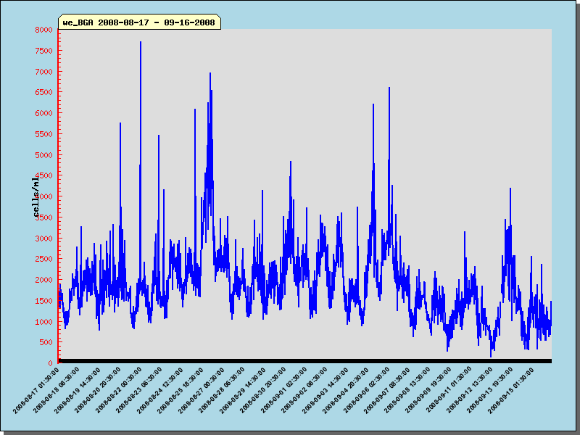
Figure 1. Graph of “average number of cells of cyanobacteria containing phycocyanin” at the Klamath River at Weitchpec sampling site from August 17 to September 16, 2008.
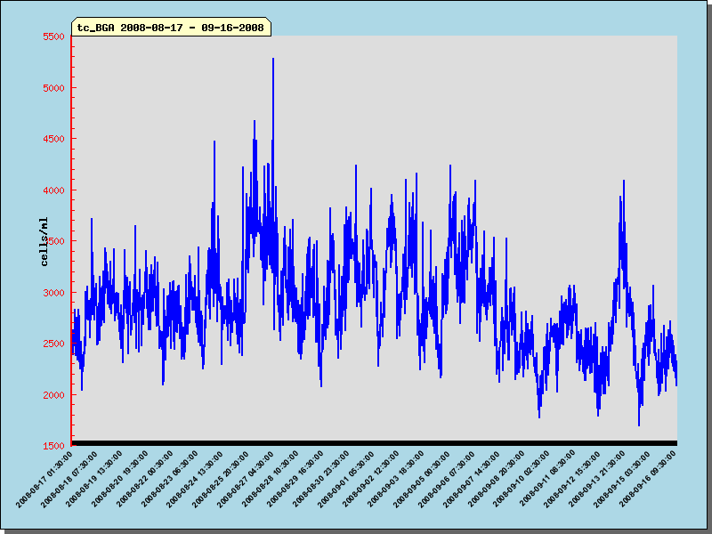
Figure 2. Graph of “average number of cells of cyanobacteria containing phycocyanin” at the Klamath River above Tully Creek sampling site from August 17 to September 16, 2008.

If you have questions about the BGA monitoring from Weitchpec to the mouth of the Klamath River, please contact Ken Fetcho with the Yurok Tribe Environmental Program at (707) 954-1523.

Questions about BGA monitoring in the Klamath Basin in general can be directed to Trina Mackie, the coordinator for the Klamath BGA Work Group, at KlamathBGA@gmail.com.

