Exhibit 11.II
Santa Ana Region Water Quality Monitoring Program

Errata Sheet
P. iii, List of Figures: insert “Figure 3-13 Land Use Correlations Sites”

P. iii, List of Figures: Change “Figure 3-13 Monitoring Design for Land Use Correlations” to “Figure 3-14 Monitoring Design for Land Use Correlations”

Footer: deleted “June 1” and inserted “August 12”

P. 3, Section 1.2, 1st sentence: inserted “elements” after “monitoring program’s”

P. 5, Section 1.3.2, 5th bullet: inserted space between “values” and “occurring”

P. 10, Section 3.1, 2nd to last paragraph: deleted “With the agreement of the Board, this adaptive toxicity testing component will be substituted for the permit requirement for priority pollutant scans.”

P. 20, Section 3.2.1.1, list of parameters, inserted superscript “1” after “Chloride” and “Sulfate”

P. 21, Section 3.2.1.1, list of parameters, inserted superscript “2” after “selenium”

P. 21, Section 3.2.1.1, footnote #1, deleted “estuaries” and inserted “channels”

P. 21, Section 3.2.1.1, footnote #6: inserted “using methods described in the Region SWAMP Field Operations Manual” after “Once per year”

P. 28, Section 3.3, 2nd paragraph, 4th sentence: deleted “high” and inserted “that exceed AB411 receiving water standards”

P. 29. Section 3.3.1.2, 1st paragraph following 1st bulleted list: delete “HB3a, BH3b” and insert “HB3”

P. 29, Section 3.3.1.2, bulleted list of stations: deleted “Los Trancos” and “ El Moro Creek” and inserted “Pelican Creek (discharges at coastline)” and “Muddy Creek (discharges at coastline)”

P. 32, Section 3.4.1.1, 1st paragraph, 2nd sentence: deleted “in flux at the moment, but are expected to be resolved by Fish and Game in the near future” and inserted “being reevaluated by Fish and Game and the SMC at the moment. This program element will adjust sampling methods as necessary to follow the approved Fish and Game method. In the event of any short-term uncertainty about the revised approach, the sampling method used in 2004-2005 will be employed.”

P. 33-34, Section 3.4.1.2, bulleted list: replace “BCW-BB” with “BCWG04”, “BON-CN” with “BCF04”, “SDC-IRWD” with “TWF05”, “PCW-BP” with “BPF06”, “SDC-HV” with “”UHAF05”, “SD-133” with “TWF05”, “SR-BP” with “UBPF19”, “BKG-OB” with “BGH01”, “SC-VIC” with “VICE08”

P. 37, Section 3.5.1.2, 1st paragraph, last sentence: deleted “Sites for the cities of Cypress, Yorba Linda, and Westminster are being finalized in June 2005.”

P. 38, Section 3.5.1.2, 1st paragraph following bulleted list, 1st sentence: inserted “and Regional Board staff”

P. 38, Section 3.5.1.2, 1st paragraph following bulleted list, 2nd sentence: inserted “and Regional Board staff will be”

P. 38, Section 3.5.1.2, 2nd to last paragraph on page: inserted “and Regional Board staff”

P. 39, Section 3.5.1.2, bulleted list: inserted “There is concurrence by Regional board staff.”

P. 40, Section 3.6.1: insert “(Figure 3-13)” prior to bulleted list

P. 40, Section 3.6.1, last line: change “Figure 3-13” to “Figure 3-14”

P. 85: insert map of mass emissions sites

P. 87: insert map of estuary / wetlands sites

P. 91: insert map of bacteriology / pathogen sites

P. 93: insert map of bioassessment sites

P. 94: insert map of reconnaissance sites

P. 96: insert Figure 13, map of land use correlation sites

P. 97: change “Figure 3-13” to “Figure 3-14”

Table of Contents
Executive Summary 1
1.0 Introduction 3
1.1 Introduction 3
1.2 Report Overview 3
1.3 Permit and Monitoring Background 3
1.3.1 Permit history 3
1.3.2 Past monitoring programs and findings 4
2.0 Program Overview 5
2.1 Approach to Monitoring Design and Implementation 5
2.2 Objectives and Program Overview 6
2.3 Implementation Schedule 8
3.0 receiving waters monitoring program elements 9
3.1 Mass Emissions Monitoring 9
3.1.1 Core monitoring 10
3.1.2 Regional monitoring 15
3.1.3 Special studies 15
3.2 Estuary / Wetlands Monitoring 19
3.2.1 Core monitoring 20
3.2.2 Regional monitoring 23
3.2.3 Special studies 24
3.3 Bacteriological / Pathogen Monitoring 27
3.3.1 Core monitoring 28
3.3.2 Regional monitoring 30
3.3.3 Special studies 30
3.4 Bioassessment 32
3.4.1 Core monitoring 32
3.4.2 Regional monitoring 34
3.4.3 Special studies 34
3.5 Reconnaissance 35
3.5.1 Core Monitoring 36
3.5.2 Regional monitoring 39
3.5.3 Special studies 39
3.6 Land Use Correlations 39
3.6.1 Core monitoring 40
3.6.2 Regional monitoring 41
3.6.3 Special studies 41
3.7 TMDL/303(d) Listed Waterbody Monitoring – Nutrient TMDL 41
3.8 TMDL/303(d) Listed Waterbody Monitoring – Toxics TMDL 41
3.9 Relationship to Regional Monitoring Efforts 42
4.0 summary 43
4.1 Program Philosophy 43
4.2 Program Structure 43
4.3 Specific Program Elements 44
Appendix 1: SMC TIE Prioritization Metric 45
Appendix 2: San Diego Region Dry Weather Reconnaissance 48
Appendix 3: San Diego Region Dry Weather Analysis Methods 64

List of Tables

Table 2-1 | Distribution of Monitoring Types Across Program Elements
Table 2-2 | Summary Monitoring Program Overview
Table 2-3 | Relationship of Permit Objectives to Monitoring Program Elements
Table 2-4 | Specific Monitoring Objectives of the Program Elements
Table 3-1 | Decision Framework for Interpreting Triad Results
Table 3-2 | Dry-Weather Targeted Reconnaissance Sites
Table 3-3 | Dry-Weather Random Reconnaissance Sites

List of Figures

Figure 2-1 | Role of Monitoring in the Program’s Decision Making
Figure 3-1 | Relationship of Mass Emissions Monitoring to Other Management Efforts
Figure 3-2 | Mass Emissions Monitoring Sites
Figure 3-3 | Adaptive Toxicity Testing Protocol
Figure 3-4 | Estuary/Wetlands Monitoring Sites
Figure 3-5 | Conceptual Model Underlying Estuary/Wetlands Assessment
Figure 3-6 | Stormdrain Prioritization Framework
Figure 3-7 | Coastal Stormdrain Site Selection Process
Figure 3-87 | Bacteriology/Pathogen Monitoring Sites
Figure 3-9 | Structure of the “Triad” Approach to Bioassessment
Figure 3-10 | Bioassessment Monitoring Sites
Figure 3-11 | Reconnaissance Sites
Figure 3-12 | Process for Determining Basis of Comparison for Reconnaissance Sites
Figure 3-14 | Monitoring Design for Land Use Correlations
Figure 4-1 | Receiving Waters Program Evolution

Executive Summary

This report fulfills the requirements of NPDES Permit No. CAS618030, Order No. R8-2002-0010, from the Santa Ana Regional Water Quality Control Board to the Orange County Stormwater Program Permittees for a receiving waters monitoring program (the Monitoring Program) to be implemented beginning in 2003. This report documents that the Monitoring Program fulfills all the requirements of the permit. It describes program elements focused on:

- Mass emissions monitoring
- Estuary/wetlands monitoring
- Bacteriological/pathogen monitoring
- Bioassessment
- Reconnaissance (dry-weather) monitoring
- Land use correlations
- TMDL/303(d) listed waterbody monitoring (Nutrient TMDL)
- TMDL/303(d) listed waterbody monitoring (Toxics TMDL).

This sequence of program elements mirrors that laid out in the permit. Thereare, however, two exceptions. First, Item III.2.C., Water Column Toxicity Monitoring, is incorporated into the long-term mass emissions element because Item C is defined to occur on the mass emissions samples. Second, monitoring required under the Toxics TMDL that is of County-wide importance is integrated into the mass emissions and estuary / wetlands elements. This integration is because the Toxics TMDL monitoring effort had not been fully defined at the time the permit was written.

The design of each program element follows a structure defined in both the POTW and stormwater model monitoring programs developed through SCCWRP and the Stormwater Monitoring Coalition that splits monitoring efforts into:

- Core monitoring of routine measurements
- Regional monitoring related to periodic regional assessments (as in the Bight ’03 study) and the development of regionally coordinated approaches and methods for stormwater monitoring and management
- Special studies that focus on answering specific questions and/or following up on potential problems identified by the results of core and/or regional monitoring.

In addition to these specific program elements, the Permittees’ Monitoring Program also complies with Items III.3.A and II.3.B of the permit. The monitoring program not also uses EPA approved methods, but has actively participated in a laboratory intercalibration study managed by SCCWRP intended to set common performance standards for stormwater chemical analyses across the region. The Orange County Stormwater Program was also an active participant in Stormwater Monitoring Coalition’s model stormwater monitoring program project. The goal of this project was to identify a core set of key management questions and then develop common monitoring approaches to these questions that would provide a framework for monitoring program design throughout southern California. As part of that project, the Monitoring Program has provided data that are being used to characterize the variability of various types of stormwater data, in order to develop more rigorous monitoring design guidance.

Overall, the Permittees’ Monitoring Program is characterized by the extensive use of adaptive features such as explicit triggers for follow-on studies that focus on particular potential problems in greater depth. For example, toxicity identification evaluations (TIEs) will be triggered where toxicity impacts cross certain thresholds and upstream source identification studies will be triggered where routine chemical and/or toxicity monitoring data cross other defined thresholds. In addition, the Monitoring Program identifies a number of additional adaptive special studies that focus on the needs of the Toxics TMDL.

The Monitoring Program described here also builds, to the greatest extent possible, on knowledge gained from past monitoring efforts throughout the County, and in other Counties as well. The specific elements of this program thus represent a significant evolutionary step in terms of how management questions will be addressed through monitoring. Finally, we expect that certain aspects of the monitoring program will continue to evolve, particularly as more specific guidance becomes available from the SMC model stormwater monitoring project.

1.0 Introduction

1.1 Introduction
The Permittees’ Receiving Waters Monitoring Program under Order No R8-2002-0010, NPDES Permit No. CAS618030, consists of eight main elements:

- Mass emissions monitoring
- Estuary / wetlands monitoring
- Bacteriological / pathogen monitoring
- Bioassessment
- Dry weather reconnaissance
- Land use correlations
- TMDL/303(d) listed waterbody monitoring (nutrient TMDL)
- TMDO/303(d) listed waterbody monitoring (toxics TMDL).

Each of these program elements addresses a different aspect of characterizing urban stormwater runoff and its impact on the environment. The dry weather reconnaissance, mass loading, estuary / wetlands, and nutrient TMDL monitoring elements build on previous efforts in the First and Second Term Permit periods, while the bioassessment, bacteriological / pathogen, land use correlations, and Toxics TMDL elements are relatively new efforts. The following sections describe the Permittees’ overall approach to implementing these elements, relate them to the permit objectives, and describe their measurement and data analysis designs.

It is important to recognize that the Permittees’ overall Stormwater Management Program (the Management Program) includes a wide range of elements that involve activities such as public education, inspections, and a variety of best management practices (BMPs). The Receiving Waters Monitoring Program described in this section will provide important feedback on the ultimate effects of such actions on receiving water quality. Combined with special studies and focused BMP evaluations, the Receiving Waters Monitoring Program will enhance the Program’s ability to continually adapt its management approach as knowledge improves.

1.2 Report Overview

This report describes the Orange County Stormwater Program’s overall approach to the design and implementation of receiving water monitoring (Section 2.1) and then explicitly states the Monitoring Program’s objectives (Section 2.2). Section 3 and its subsections detail each of the monitoring program’s elements in turn. For each program element, the report states the underlying objective and then describes its core monitoring, regional monitoring, and special studies elements.

1.3 Permit and Monitoring Background

1.3.1 Permit history

In response to the First Term Permits (1990-1995), the Permittees developed and implemented a water quality monitoring program to aid in the detection and control of illicit connections and illegal discharges to the municipal storm drain systems and to meet other program performance objectives. The monitoring program estimated pollutant loads in urban stormwater runoff, tracked compliance with water quality objectives, searched for sources of pollutants, and addressed impacts on areas of special concern.

In response to the Second Term Permits (1996-2002), the Permittees conducted a two-year re-evaluation and revision of the water quality monitoring program. The purpose of this review was to (1) re-focus the efforts to determine the role, if any, of urban stormwater discharges to the impairment of beneficial uses and (2) to provide technical information to support an effective urban stormwater management program to reduce the beneficial use impairments associated with urban stormwater.

The Pemittees also initiated several water quality planning efforts, conducted additional water quality evaluations in response to technical requests from the Regional Boards, and participated in various regional research and monitoring programs. The combination of these efforts will aid the Permittees in determining the extent and degree of the relationship between urban stormwater runoff and impairment of beneficial uses within the aquatic resources of Orange County.

With the Third Term Permits (2002-2006), this evolution has continued with the third-term permit monitoring program described below. It expands further on previous efforts to identify pollutant sources, measure impacts, and gauge effectiveness of stormwater control efforts.

1.3.2 Past monitoring programs and findings

Past monitoring programs have helped to characterize spatial and temporal patterns of contamination in creeks, channels, and coastal bays and estuaries, as well as laying the groundwork for long-term tracking of trends. In addition, monitoring data have helped to increase understanding of the dynamics and patterns of stormwater pollution, thereby contributing to improved monitoring and management strategies. Specific representative findings include the following:

- The first flush of a storm typically has higher concentrations of trace metals and greater organic-based turbidity than any other part of a storm. The first flush of the first storm of the season typically has the highest levels of the year.
- The concentration of total and dissolved metals is greater in storm runoff than in dry weather runoff.
- Water hardness appears to be the dominant factor in the assessment of compliance with CTR standards for dissolved metals. Stormwater in a concrete-lined channel is more likely to have a lower hardness than in an earthen channel. Stormwater in a concrete-lined channel will therefore exceed CTR standards for dissolved metals more often than stormwater in an earthern channel, assuming similar land uses in the respective watersheds.
- The Management Program has met the 2002 total nitrogen target and is substantially below the 2007 target for this constituent.
- The nitrogen concentration in San Diego Creek at Campus Drive is seasonal, with the greater dry-weather values occurring during late wet season. The higher concentrations during the winter months may be a function of greater groundwater inputs and the decreased nitrate removal efficiency of IRWD’s constructed wetlands.

- Groundwater seepage into the stormdrain system appears to be a significant source of nitrate in the San Diego Creek watershed.
- Benthic sediments collected from the harbors and bays typically have higher concentrations of trace metals than sediments collected from channels. Harbor and bay sediments also tend to have greater concentrations of silts and clays.
- Reconnaissance of the Construction Circle Drain in Irvine showed that many businesses in that drainage area were violating the County’s water pollution ordinance.

2.0 Program Overview

2.1 Approach to Monitoring Design and Implementation

The Permittees’ approach to the development of the Receiving Waters Monitoring Program is based on several widely recognized and fundamental principles of monitoring design. Monitoring should be:

- Focused on specific, answerable questions that are relevant to management concerns
- Based on the most current scientific and technological understanding
- Cost effective and statistically efficient
- Designed with adaptive feedback mechanisms that allow for appropriate adjustments to the program.

Periodically assessing the eight main program elements against these principles ensures that the program, and the information it produces, remain relevant and effective. To help accomplish this outcome, the Permittees have considered each program element in terms of three kinds of monitoring activities, each with different implications for implementation and for the analysis and evaluation of resulting data:

- Core monitoring – routine, ongoing measurements, analyzed with well-defined methods, that address clearly defined questions related to small-scale or site-specific problems and processes
- Regional monitoring – periodic, collaborative, and larger-scale surveys, e.g., the Bight Study carried out through SCCWRP, that use standardized sampling methods to collect a wide range of data across the entire region in both impacted and reference areas. Regional data can be analyzed with a variety of descriptive, hypothesis testing, and pattern analysis methods, as well as with indices designed to place sites on regional pollution or disturbance gradients.
- Special studies – tightly focused and relatively short-term studies, e.g., those carried out through the Stormwater Monitoring Coalition (SMC), often using exploratory data analysis methods, to investigate new measurement methods, improve basic understanding, characterize problems, or provide one-time measurements of important parameters or processes.

The monitoring design principles, along with the three-part framework, have been accepted by the Stormwater Monitoring Coalition (SMC) as a template for the design of a regional model stormwater monitoring program. They will help ensure that each program element utilizes appropriate methods for sampling, data analysis, standardization, and flexibility by directing the design of specific monitoring studies (e.g., whether a long-term trend monitoring or a shorter-term experimental approach is used, the selection of parameters, the number and location of sites) to the particular questions being asked and/or problems being addressed. Table 2-1 illustrates how these three kinds of monitoring were used in organizing more detailed designs for each program element.

Figure 2-1 provides an overall depiction of the role of monitoring information in the Program’s decision making. A key aspect of this framework is the set of feedbacks that use information developed during the design and implementation of the monitoring program to refine not only technical study strategies but also more fundamental management expectations and goals.

These feedbacks occur in large part through the Management Program’s existing reporting processes and management structure which provide ample opportunities for the dissemination of information about patterns of pollution and discussion regarding their implications for the Management and Monitoring Program objectives.

2.2 Objectives and Program Overview

The objectives of the Receiving Waters Monitoring Program, as stated in the Third Term Permit, are to:

- Develop and support an effective municipal urban runoff and non-point source control program
- Define water quality status, trends, and pollutants of concern associated with urban storm water and non-storm water discharges and their impact on the beneficial uses of the receiving waters
- Characterize pollutants associated with urban storm water and non-storm water discharges and to assess the influence of urban land uses on water quality and the beneficial uses of receiving waters
- Identify significant water quality problems related to urban storm water and nonstorm water discharges
- Identify other sources of pollutants in storm water and non-storm water runoff to the maximum extent possible (e.g., atmospheric deposition, contaminated sediments, other non-point sources, etc.)
- Identify and prohibit illicit discharges
- Identify those waters, which without additional action to control pollution from urban stormwater discharges, cannot reasonably be expected to attain or maintain applicable water quality standards required to sustain the beneficial uses in the Basin Plan (TMDL monitoring)
- Evaluate the effectiveness of existing municipal storm water quality management programs, including an estimate of pollutant reductions achieved by the structural and nonstructural BMPs implemented by the permittees
- Evaluate costs and benefits of proposed municipal storm water quality control programs to the stakeholders, including the public.

The monitoring program described in the following section (see Table 2-2 for summary overview) meets these objectives (with the proviso that evaluating the overall effectiveness and cost-benefit relationships of municipal stormwater programs, including specific BMPs, requires further effort beyond the scope of the water quality monitoring program outlined in the Permit and detailed in the following section). Table 2-3 illustrates the direct relationship between the specific permit objectives and the eight monitoring program elements.

The Monitoring Program continues and expands the previous monitoring program’s emphasis on assessing impacts on aquatic resources, documenting long-term trends in water quality, targeting problematic discharge sites for more focused investigations, and adding additional monitoring elements. Table 2-4 briefly summarizes the specific objectives of the program elements in terms of management goals, monitoring strategies, and other aspects of monitoring program design used as a design framework in the SMC’s Model Stormwater Monitoring project. Table 2-4 results in the following more detailed objectives for each program element:

Mass emissions monitoring: | Using measurements of a range of urban contaminants, loads, as well as exceedances of relevant standards, shall decline over a time frame of years to decades, as compared with past and present levels.
Estuary / wetlands monitoring: | Using measurements of key pollutants, loads, and biological community parameters, describe impacts on estuarine and wetlands ecosystems and the relationship of any impacts to runoff, based on theoretical and empirical expectations about the structure and function of healthy communities.
Bacteriological / pathogen monitoring: | Using measurements of a suite of bacterial indicators, identify spatial and temporal patterns of elevated level in order to prioritize problem areas.
Bioassessment: | Using a “triad” of indicators (bioassessment, chemistry, toxicity), describe impacts on stream communities and the relationship of any impacts to runoff, based on comparisons with reference locations and a regional IBI on a year-to-year timeframe.
Reconnaissance: | Using measurements of key pollutants, identify potential illegal discharges and illicit connections, based on comparison with historical data and available estimates of background levels.
Land use correlations: | Using an experimental, “before-after,” design, identify changes in runoff associated with the urbanization of previously agricultural land.
TMDL/303(d) listed waterbody monitoring – nutrient TMDL: | Using measurements of nutrients, track progress of nutrient control measures over time, based on comparison with TMDL targets.
TMDL/303(d) listed waterbody monitoring - toxics TMDL | Using measurements of key pollutants, identify potential sources and pathways of toxic compounds and track progress of control measures over time, based on comparison with TMDL targets.

The Monitoring Program will reflect the Management Program’s continued evolution toward watershed management and toward addressing a more complex set of questions that integrate multiple Program elements. For example, the inclusion of an adaptive toxicity testing component in the mass emissions program element provides the ability to more fully characterize toxicity and then track its upstream source(s) on a watershed scale. As another example, the reconnaissance program (focused on identifying illegal discharges and illicit connections) will make use of the growing databases of commercial and industrial facilities resulting from the cities’ ongoing inventories of such facilities. Further, the inclusion of bioassessment and estuary/wetlands program elements enables the Monitoring Program to investigate the relationship of important biological endpoints to chemical contamination and physical changes in habitat. Overall, the monitoring program described in the following sections has expanded its focus on identifying the sources of problems, while continuing important historical data collection on trends at key sites.

Finally, the receiving water quality monitoring program responds explicitly to Section 3.3.1, Item 2, of the DAMP, which states that water quality problems will be identified through a Countywide monitoring program and other assessments.

2.3 Implementation Schedule

The new Monitoring Program is schedule to start in July 2005, which is part of the way into the dry season. This will affect the implementation schedule for some of the program elements, which will be implemented as follows:

- Mass emissions
- Wet weather: no impact
- Dry weather: begin with summer quarter
- Estuary/wetlands
- Wet weather: no impact
- Dry weather: begin with summer quarter
- Bacteriological/pathogen: no impact
- Bioassessment: begin with fall sampling
- Reconnaissance
- Summer 2005: complete detailed site reconnaissance and setup
- Summer 2006: begin routine sampling
- Land use correlations: no impact
- Nutrient TMDL: no impact
- Toxics TMDL: no impact

3.0 receiving waters monitoring program elements

Table 2-2 summarizes the monitoring program elements that have been designed to address the objectives described above. Each element is then described in fuller detail in the following sections. Data processing and analysis methods are as described in the most recent Annual Status Report, unless otherwise noted.

In addition to meeting the basic permit objectives, these data will be useful in helping to assess the effectiveness, in a general sense, of urban runoff management programs. More specifically, they will be helpful in measuring the performance of existing site-specific TMDLs (e.g, Newport Bay) and in generating the requirements for new TMDLs (e.g., Huntington Harbour). Nutrient TMDL monitoring is addressed in Section 3.7. Toxics TMDL monitoring is integrated, where possible, into the mass emissions (Section 3.1) and estuary / wetlands (Section 3.2) program elements. Additional TMDL monitoring elements that do not integrate well with the NPDES permit requirements are summarized in Section 3.8.

The Monitoring Program includes a large number of special studies. Some of these (e.g., toxicity tests at higher dilutions, TIEs) are relatively straightforward and have well-defined methods. However, others (e.g., investigations of sediment / pollutant links and impacts around marinas in Newport Bay) do not yet have detailed study designs. The Monitoring Program will work with Regional Board staff and SCCWRP to develop and implement a consistent process for defining study designs. This process will focus on coherence among a clear definition of questions and hypotheses, the location and timing of sampling, and the statistical methods used to analyze the data. Some special studies will therefore necessarily be phased in as their study designs are finalized.

3.1 Mass Emissions Monitoring

The goal of the mass emissions element of the program is to:

- Estimate the total mass emissions from the MS4
- Assess trends in mass emissions over time
- Determine if the MS4 is contributing to exceedances of water quality objectives or beneficial uses, by comparing results to the California Toxics Rule (CTR), Basin Plan, and/or other relevant standards.

These objectives will be addressed with a trend monitoring design that focuses on sites at or near the outlets of key watersheds, and includes sampling in both wet and dry weather for toxicity as well as for a broad range of pollutants. The trend monitoring is supplemented by routine toxicity testing, and by special studies for TIEs (Toxicity Identification Evaluations), upstream source identification, and expanded characterization of the spatial and temporal distribution of key pollutants.

Some components of the Toxics TMDL for the Newport Bay watershed have been integrated into the mass emissions monitoring design, including:

- Addition of a fourth dry-weather sampling event for all constituents (except toxicity) to standardize dry-weather monitoring on a quarterly schedule
- Addition of organochlorines pesticides and PCBs to quarterly dry-weather benthic sediment samples at all earthen channel stations, in order to better characterize patterns of these legacy pollutants
- Addition of mercury and selenium to the list of constituents at stations that are part of the Toxics TMDL
- Addition of eight (for a total of 12) monthly dry weather sampling events at four stations to better characterize inputs of organophosphate pesticides
- Addition of the fathead minnow (Pimephales promelas) to the suite of freshwater toxicity test organisms as a screening test (no sample dilutions) during the first year of the permit
- Use of mass emissions stations in the Newport Bay watershed as “trigger” sites in an adaptive monitoring approach that may initiate further sampling at upstream Toxics TMDL stations
- Special studies to better characterize the sediment / contaminant relationship in channel outflows, levels of the legacy organochlorine pesticides and PCBs in water, and potential upstream sources of metals.

The inclusion of toxicity testing in this element will not only help identify where biological impacts may be occurring, but will also improve the ability to assess potential impacts on coastal receiving waters (in coordination with data from the periodic Bight studies). Where called for, toxicity tests at higher dilutions and TIEs, carried out as special studies, will provide additional information for further upstream source identification and / or source control efforts.

Figure 3-1 shows the flow of information, and the relationships, among the NPDES mass emissions and TMDL monitoring programs.

3.1.1 Core monitoring

The core monitoring aspects of this program element include chemical and toxicity monitoring, for both aqueous and sediment samples, collected in both wet and dry seasons. This element is based on a trends monitoring design. However, mass emissions data may also be used in combination with data from other program elements to improve understanding of patterns in urban runoff and their potential relationship to other aspects of the environment.

Mass emissions monitoring is targeted at important inputs to Huntington Harbor and Newport Bay, as well as at key coastal sites, and areas of north Orange County where surface flows have not yet been well characterized (Figure 3-2).

3.1.1.1 Monitored parameters

The parameters to be sampled will depend on the season (3 storm events including the first storm of the year, 4 dry weather samples per year), whether a storm is the first storm of the year, and on whether the sample is an aqueous or a sediment sample, as illustrated below. Dry weather sampling has been increased from three times per year, as specified in the permit, to four times per year (quarterly), except for toxicity testing, to accommodate requirements of the Toxics TMDL and to standardize and simplify program logistics.

Parameter | Wet Season  Storms | Dry Season  Aqueous | Dry Season  Sediment
- Nutrients
- nitrate plus nitrite | X | X
- total ammonia | X | X
- total Kjeldahl nitrogen (TKN) | X | X
- total phosphate | X | X
- orthophosphate | X | X
- Dissolved organic carbon (DOC) | X
- Total organic carbon (TOC) | X | X | X
- Total suspended solids (TSS) | X | X
- Volatile suspended solids | X | X
- Chloride | X | X | X
- Sulfate | X | X | X
- Turbidity | X | X
- pH | X | X | X
- Oil and grease |  | X
- Temperature | X | X
- Dissolved oxygen | X | X
- Electrical conductivity | X | X
- Hardness | X | X
- Particle size |  |  | X
- Total and dissolved heavy metals
  - arsenic
- cadmium | X | X | X
- chromium | X | X | X
- copper | X | X | X
- lead | X | X | X
- mercury | X | X | X
- nickel | X | X | X
- selenium | X | X | X
- silver | X | X | X
- zinc | X | X | X
- Organochlorine pesticides & PCBs¹ |  |  | X
- Organophosphate pesticides
- diazinon | X | X²
- chlorpyrifos | X | X²
- malathion | X | X²
- dimethoate | X | X²
- Bacterial indicators
- total coliform | X | X
- fecal coliform | X | X
- Enterococcus | X | X
- Toxicity | X³ | X⁴
- Priority pollutant scan | X⁵
- Glyphosate (herbicide) | X | X⁶
- Others⁷

¹ To be sampled only at the six stations that are also part of the Toxics TMDL program
² To be sampled monthly, only at four of the six Toxics TMDL stations (Peters Canyon Wash, San Diego Creek at Harvard, Santa Ana Delhi Channel, and San Diego Creek at Campus)
³ During two storms per year with Ceriodaphnia, sea urchin fertilization, mysid survival and growth; fathead minnow to be used in addition during the first two years at the six stations that are also part of the Toxics TMDL in the Newport Bay watershed
⁴ Two times during dry weather at all stations except for quarterly during dry weather at Peters Canyon Wash, San Diego Creek at Harvard, Santa Ana Delhi Channel, and San Diego Creek at Campus. With freshwater test organisms; fathead minnow to be used in addition to Ceriodaphnia, Selenastrum, and Hyallela azteca during the first two years at the six stations that are also part of the Toxics TMDL in the Newport Bay watershed
⁵ For first storm of each year only
⁶ To be targeted at channels dominated by urban runoff, as opposed to groundwater
⁷ Additional constituents, determined on a case by case basis, found to have contributed to the impairment of local receiving waters.

3.1.1.2 Monitoring sites and analyses

Monitoring will be conducted at the mass emissions sites shown on Figure 3-2. Samples will be collected for three storm events per season, including the first storm of the year, with three to four samples collected per storm event, and four times during the dry season. The sites target:

- Coyote Creek (CCBA01) (in north Orange County)
- Fullerton Creek (FULA03) (in north Orange County)
- Carbon Creek (CARB01) (in north Orange County)
- Santa Ana Delhi Channel (SADF01) (Newport Bay Toxics and Nutrient TMDL) *
- Peters Canyon Wash (BARSED) (Newport Bay Toxics and Nutrient TMDL) *
- San Diego Creek at Campus (SDMF05) (Newport Bay Toxics and Nutrient TMDL) *
- Central Irvine Channel (CICF25) (Newport Bay Toxics TMDL)
- San Diego Creek at Harvard (WYLSED) (Newport Bay Toxics and Nutrient TMDL) *
- Costa Mesa Channel (CMCG02) (Newport Bay Toxics and Nutrient TMDL) *
- Bolsa Chica Channel (BCC02) (Huntington Harbour) *
- East Garden Grove-Wintersburg Channel (EGWC05) (Bolsa Bay) *.

Sites in the above list followed by an asterisk (*) are ones for which there is historical data that will be useful in providing a context for tracking trends into the future. In addition, six sites will contribute data to both the Toxics and Nutrient TMDLs for the Newport Bay watershed.

Sampling on the three northern County creeks will be phased in over a three-year period, to reflect the somewhat lower priority given this area in Section 3 of the DAMP. The sampling schedule will be:

- Year 1: Time-weighted composite samples from three storm events per year and 24-hr composite samples from three dry-weather periods per year
- Year 2: Continue automatic sampling of three storms and three dry-weather periods; install stream gauges and define the rating curves for each site
- Year 3: install automatic samplers and move to routine mass emissions monitoring
- Year 4: continue monitoring.

Analytical methods will remain as in the current 99-04 plan. Sampling equipment and methods will be modified to enable determinations of aqueous concentrations of organic compounds (diazinon, chlorpyrifos, malathion, dimethoate, TOC) and aquatic toxicity. Calculation of both loads and event mean concentrations will be performed as in the previous program.

Loads and event mean concentrations will be analyzed for historical patterns and trends, both at individual sites and across the north County region as a whole. These analyses will use statistical techniques such as plotting and regression analysis (for identifying trends), and cluster analysis (for identifying patterns among sites). In addition, composite samples, grab samples, and event mean concentrations will be compared to relevant standards, including:

- California Toxics Rule (CTR) levels
- Basin Plan objectives.

The program’s approach to trace metals analysis, which involves determining the total and dissolved metal concentrations as well as the total suspended and settleable solids concentrations provides the ability to address one of the Toxics TMDL’s key questions: the link between sediment and contaminants. The amount of metals bound to sediment can be estimated by subtracting the concentration of dissolved metals from the concentration of total metals and dividing by the concentration of suspended and settleable solids. This issue will be addressed further in a special study (Section 3.1.3.4).

3.1.1.3 Toxicity tests

Toxicity testing will occur at all mass emissions sampling locations and times. With the concurrence of staff at the Santa Ana Regional Water Quality Control Board, we have modified the toxicity testing approach in the permit. The approach in the permit specifies that toxicity testing be performed using one freshwater (Ceriodaphnia) and one marine (sea urchin fertilization) test organism to evaluate both stormwater and non-stormwater discharges from the channels. We are modifying this requirement as follows:

- Stormwater
- Ceriodaphnia
- Sea urchin fertilization
- Mysid survival and growth
- Fathead minnow (Newport Bay watershed only)
- Non-stormwater (i.e., dry weather)
- Ceriodaphnia
- Selanastrum
- Hyalella azteca
- Fathead minnow (Newport Bay watershed only).

This combination of test organisms was selected to provide adequate coverage of the major classes of pollutants known as sources of toxicity (e.g., metals, organophosphate pesticides). This will provide more insight into the probable sources of toxicity, because it is well known that test organisms differ in their relative sensitivity to different pollutants. Two marine test organisms were included for stormwater testing because the major potential impact of these flows is on the estuarine and nearshore marine environment. However, marine organisms were not included in dry weather toxicity testing because dry weather flows are so low that they have no direct toxic impact on marine or estuarine receiving waters. In addition, using some of the same test organisms for both stormwater and receiving water (i.e., bays and estuaries) testing will allow for drawing tighter conclusions about the relative contribution of different inputs to the observed toxicity in the receiving waters.

Stations in the Newport Bay watershed, that are also part of the Toxics TMDL, will include the fathead minnow in the freshwater tests. Since the fathead minnow is more sensitive to pyrethroid pesticides than are Ceriodaphnia and Hyallela azteca, this will address concerns about this pesticide in the Toxics TMDL. Fathead minnow will be used as a screening test during the first two years of the permit. It will continue to be used only if it shows a toxic response.

These test organisms correspond as closely as possible to those being used in the San Diego region on the County. Commonality of approach provides important benefits, including:

- Enhancing the comparability of results among programs and between Regions
- A broader assessment of potential impacts on saline receiving waters, i.e., Bolsa Bay, Talbert Marsh, Huntington Harbour.
- Decreasing the likelihood that sampling error will result in the wrong test being performed
- Improving efficiency and reducing costs
- Providing additional information on dry-weather freshwater toxicity in the Santa Ana Region with the addition of Selanastrum.
- Providing feedback, as the result of the addition of Selanastrum (which is sensitive to nutrients), that can be used in the Nutrient TMDL program for San Diego Creek and Upper Newport Bay.

All wet weather toxicity tests will be performed at 100%, 50%, 25%, 12.5%, and 6.25% dilutions, and dry weather tests at 100% and 50% dilutions, based on past findings of much higher toxicity in wet weather. (All fathead minnow tests will be performed at 100% concentration only.) A finding of substantial toxicity at the 100% and 50% dilutions will trigger a set of adaptive special studies involving additional tests at higher dilutions and TIEs (see Figure 3-3 and Sections 3.1.3.1 and 3.1.3.2.

3.1.2 Regional monitoring

As described above, the mass emissions stations in the Newport Bay watershed are also an integral part of regional monitoring programs for the Nutrient and Toxics TMDLs. In addition, mass emissions stations on channels that drain into Huntington Harbour and Bolsa Chica Bay will provide information useful in developing future TMDLs in that area.

In addition, the Bight ’03 study had an estuarine component that measured chemical contamination in benthic sediments and in the water column, as well as in the tissue of demersal and pelagic fish. This component also estimated pollutant loads to estuaries from surrounding watersheds. The mass emissions stations provide a useful complement to the Bight ’03 studies by adding to long-term data about pollutant inputs to the Newport Bay system.

The Program is also participating in the development and implementation of a regional watershed monitoring program for the San Gabriel River watershed. Currently under discussion are offsets that may be proposed to shift monitoring effort, in the short term, from the new mass emissions stations to the spring 2005 watershed sampling.

3.1.3 Special studies

In addition to the core monitoring, there are several additional special studies aspects of this program element (see Tables 2-1 and 2-2):

- Toxicity tests at higher dilutions
- Toxicity identification evaluations (TIE)
- Upstream source identification studies
- Better characterization of sediment / pollutant links
- Investigation of legacy organochlorine pesticide and PCB concentrations in water
- Evaluation of monitoring design.

All of these items provide a link to the Toxics TMDL’s RMP, as described in more detail in the following subsections. The detailed designs for studies #4 and #5 will be completed during 2005, following the special study design process to be developed in cooperation with the Regional Board and SCCWRP.

Figure 3-3 shows the interrelationship of the first three of these special study components.

3.1.3.1 Toxicity tests at higher dilutions

If the core monitoring toxicity tests show substantial toxicity (defined as a 100% effect) at the 100% and 50% dilutions within the first hour, this will trigger additional toxicity tests at higher dilutions (up to seven dilutions for wet weather and five dilutions for dry weather) (see Figure 3-3). The purpose of these additional tests is to better characterize the degree of toxicity. This information, in turn, will be useful in designing any subsequent TIEs and/or upstream source ID studies.

3.1.3.2 Toxicity Identification Evaluation (TIE)

Where toxicity tests show substantial and persistent toxicity (as defined by the quantitative metric in the SMC’s model stormwater monitoring program, see Appendix 1), the program will prioritize available resources to carry out Phase I toxicity identification evaluations (TIEs) to identify sources of toxicity and thereby provide information needed for more focused upstream source identification and control. Because there are no widely accepted standards within stormwater monitoring for using toxicity test results to prompt toxicity identification evaluations (TIEs), we will use the following rules of thumb, developed in the SMC’s model stormwater monitoring program for southern California. The SMC’s model monitoring program developed a quantitative metric that includes the persistence and magnitude of toxicity, as well as the percentage of the suite of organisms that shows a toxic response to any one sample. This metric will be adopted for use in the program and the relative ranking of sites on this metric will be used to identify a set of monitoring sites for potential TIE studies in the following year (as described in the following paragraph). Prioritizing sites for TIEs based on a year’s worth of data reflects the fact that toxicity in stormwater runoff is often sporadic and will serve to focus TIEs on those instances where the likelihood of identifying the source(s) of toxicity is the highest. As with other monitoring program elements, the effectiveness of this TIE trigger will be periodically evaluated and adjusted as needed (see section 3.1.3.6).

In general, where there is persistent and substantial evidence of toxicity in Year A, TIE’s should be conducted in Year B (the following year). (However, the list of sites may be prioritized to fit within budget and logistical constraints and to coordinate with the Toxics TMDL.) In such cases, the Program will prepare to conduct both toxicity tests and toxicity identification evaluations (TIEs) in parallel in Year B. Toxicity tests will be started and, if their results confirm the Year A conclusions (i.e., 50% or greater effect at the highest concentration), toxicity identification evaluations (TIEs) will be run immediately, using water collected from the same storm. (Based on past monitoring results, the first storms in the wet season will be the most toxic.) Where the Year B toxicity tests do not confirm the Year A results, the water collected for the toxicity identification evaluations (TIEs) will simply be discarded. This approach runs the risk of incurring extra costs in those cases where the toxicity identification evaluations (TIEs) are not run. However, it may be possible to balance such extra costs by focusing the toxicity tests on the specific organisms that demonstrated toxicity in Year A. Depending on the results of the toxicity identification evaluations (TIEs), a variety of management actions, from further source identification (see following subsection) to specific best management practices (BMPs) and source control actions, could be implemented. Again, because there are no commonly accepted standards for using toxicity identification evaluation (TIE) results to trigger management actions, the Program will work with SCCWRP as appropriate during Year 1 of the Program to further the development of such standards.

3.1.3.3 Upstream source identification studies

Upstream source identification studies will be an integral part of this and other Program components. There are two specific studies that are part of the Toxics TMDL’s RMP. Other source identification efforts may be developed as suggested by the mass emissions monitoring data and/or the toxicity testing results.

The Toxics TMDL calls for follow-up of past monitoring data that showed elevated levels of metals in both Santa Isabella Channel and Rattlesnake Canyon. The Rattlesnake Canyon station can no longer be sampled because the channel has been rerouted and its new confluence with Peters Canyon Wash is underground. However, Santa Isabella channel will be scouted to determine where quarterly dry weather sampling for metals could take place.

The Toxics TMDL’s RMP also calls for improved characterization of direct inputs of metals from stormdrains discharging to Lower Newport Bay. We will design a reconnaissance study of stormdrains discharging to the Lower Bay, particularly in terms of their relative loadings of metals. This information will be used to prioritize stormdrains for further study and/or monitoring and to refine the current overall picture of inputs to the Bay. Initially, we will evaluate the adequacy of the data gathered by the City of Newport Beach at these drains and work with Regional Board staff to explicitly define any needs for additional data in terms of number and location of stormdrains, constituents measured, and timing and frequency of sampling.

In addition to these two focused studies, the higher dilution toxicity tests and the TIEs may suggest other upstream source identification studies. If TIE results are specific enough to “fingerprint” a particular kind of activity/source, then upstream clusters of these could be identified either through map-based Yellow Page searches or with the results of municipal inventories of commercial and industrial facilities. This information could be combined with historical reports of spills or other violations to narrow the search to a smaller number of likely sources.

An alternative approach is to work upstream from the monitoring site at which the toxicity was originally found, testing both for toxicity and the presence of the identified toxic compounds at major branch points and/or inputs. While this approach is straightforward in its design, it may be difficult to implement because of the often sporadic nature of stormwater flows. Thus, identifying the source(s) of toxicity will most likely require a combination of both approaches and the source identification studies may of necessity extend over more than one monitoring year. The network of stations in the Toxics TMDL’s RMP will provide a starting point for such upstream toxicity testing efforts.

3.1.3.4 Sediment / pollutant links

An important goal of the Toxics TMDL is to improve understanding of the functional linkage between sediment flows and pollutant (especially metals) inputs to the Bay. The routine mass emissions samples may provide a means of accomplishing this goal. As described above (Section 3.1.1.2 Monitoring Sites and Analyses), the total sediment in the mass emissions samples is analyzed. While the automatic sampler does not necessarily take an unbiased sample of sediments in the water column, the following two special studies can yield more detailed information on the nature of the relationship between sediment characteristics and pollutant loads.

In cooperation with Regional Board staff, the program will design a fractionation study that will determine the relative distribution of pollutant concentration across particle major size categories (e.g., silt, clay). This will enhance our understanding of which sorts of sediment flows transport the largest portion of pollutants and will also assist in designing and evaluating sediment BMPs.

A second study will attempt to develop a quantitative relationship between the characteristics of sediment sampled by the automatic samplers used in the mass emissions program element and the vertically integrating samplers used in the Sediment TMDL monitoring. While the mass emissions samples do not capture the entire sediment profile, they are analyzed for a wide range of pollutants. Conversely, the Sediment TMDL samples capture the entire vertical sediment profile but are not analyzed for pollutants. Development of a quantitative algorithm to relate the two kinds of samples could provide more accurate estimates of the total pollutant load associated with sediment inputs to the Bay. This study will be based on careful analysis of existing data from these two programs and may involve a paired field sampling exercise.

3.1.3.5 Organochlorine and PCB concentrations in water

The Toxics TMDL’s RMP also calls for a one-time sampling to determine aquatic concentrations of organochlorine pesticides and PCBs in channels discharging to Newport Bay. The purpose of these samples is apparently for use in EPA models of the behavior of these pollutants in the Newport Bay system. These pollutants are of continuing concern because of their potential food web impacts, but they are no longer used and may not stem from existing municipal activities.

Given that these compounds are at such low concentrations in water that they require non-standard, logistically challenging, and expensive sampling and analysis protocols, the program proposes to first evaluate SCCWRP data on aquatic concentrations of these compounds in Newport Bay collected in 2001 and 2004. We will also review similar data collected in San Francisco Bay as part of the Regional Monitoring Program for Trace Substances in San Francisco Bay.

These data from other programs may fulfill the needs of the EPA modeling effort. If not, they will provide useful guidance on logistics and methods.

3.1.3.6 Monitoring design evaluation

The mass emissions program element contains several modifications and additions intended to help satisfy the requirements of the Toxics TMDL’s RMP (see itemized list at beginning of Section 3.1 Mass emissions monitoring). Each of these will be evaluated, as data become available, to determine whether the added data they produce are meeting their objectives and providing value beyond what the basic permit monitoring program would supply. In addition, data on organochlorine pesticides and PCBs will be assessed in terms of their relevance to existing municipal activities addressed under current permits.

Information derived from the increased sampling frequencies (e.g., quarterly dry-weather sampling) will be statistically compared to that available from alternative frequencies. This will assess the value of the increased sampling frequency in terms of better characterization of seasonal patterns and/or improved statistical power for resolving trends. Similarly, data derived from special studies will be evaluated in terms of its contribution to improved conceptual models about pollutant sources, their pathways, and potential impacts. This information will all be used to reconsider the specifics of the monitoring program during the next permit renewal cycle.

3.2 Estuary / Wetlands Monitoring

The goal of the estuary / wetlands element of the program is to determine the effects of stormwater and non-stormwater runoff associated with the increased urbanization in the watersheds of these systems. This objective will be addressed with an assessment monitoring approach that identifies relationships between runoff inputs, levels of key pollutants, and measurements of the integrity of biological communities.

These data will be useful in assessing the effectiveness of urban runoff management programs. More specifically, they will improve understanding of the ecological health of, and stresses on, these important coastal zone ecosystems. This understanding will be helpful in developing, adjusting, and tracking the performance of site-specific TMDLs and other management strategies. Coordination of the design and implementation of this element with the Bight Program will help place the northern Orange County monitoring results in a broader regional context by comparing conditions in the County to conditions elsewhere in southern California. Where called for, toxicity identification evaluations (TIEs) carried out as special studies will provide additional information for further source identification and / or source control efforts.

Some elements of the Toxics TMDL for the Newport Bay watershed have been integrated into the estuary/wetlands monitoring design, including:

- Increase in dry-weather sampling frequency from twice per year to quarterly at the five Bay sites that are part of the Toxics TMDL
- Addition of selenium to the list of constituents at stations that are part of the Toxics TMDL
- Special studies to better characterize spatial and temporal patterns of sediment contamination in the Bay, levels of organochlorine pesticides and PCBs in water, and potential sources of metals.

3.2.1 Core monitoring

The core monitoring aspects of this program element include chemical and toxicity monitoring, in both aqueous and sediment samples, from key estuaries / wetlands as well as the channels that input to them. This element is based on an assessment monitoring design that searches for relationships among important biological and chemical endpoints and a range of inputs and processes.

3.2.1.1 Monitored parameters

The parameters to be sampled in the input channels will be the same as those sampled in the mass emissionselement of the Monitoring Program (see Section 3.1.1.1). The parameters to be sampled in the estuaries / wetlands themselves will depend on the season, on whether the sample is an aqueous or a sediment sample, and on the location of the monitoring site, as illustrated below:

Parameter | Wet Season  Storms | Dry Season  Aqueous | Dry Season  Sediment¹
- Nutrients
- nitrate plus nitrite | X | X
- total ammonia | X | X
- total Kjeldahl nitrogen (TKN) | X | X
- total phosphate | X | X
- orthophosphate | X | X
- Dissolved organic carbon (DOC) | X
- Total organic carbon (TOC) | X | X | X
- Total suspended solids (TSS) | X | X
- Volatile suspended solids | X | X
- Chloride¹ | X | X | X
- Sulfate¹ | X | X | X
- Turbidity | X | X
- pH | X | X | X
- Oil and grease |  | X
- Temperature | X | X
- Dissolved oxygen | X | X
- Electrical conductivity | X | X
- Hardness | X | X
- Particle size |  |  | X
- Total and dissolved heavy metals
  - arsenic
- cadmium | X | X | X
- chromium | X | X | X
- copper | X | X | X
- lead | X | X | X
- mercury | X | X | X
- nickel | X | X | X
- silver | X | X | X
selenium² | X | X | X
- zinc | X | X | X
- Organochlorine pestidices & PCBs³ |  |  | X
- Organophosphate pesticides
- Diazinon | X | X
- Chlorpyrifos | X | X
- Malathion
- Dimethoate
- Bacterial indicators
- total coliform | X | X
- fecal coliform | X | X
- Enterococcus | X | X
- Toxicity | X⁴ | X⁵ | X
- Glyphosate (herbicide) | X | X
- Benthic infauna⁶ |  |  | X
- Others⁷

¹ In channels
² In San Diego Creek sediment basins and upper portion of Upper Newport Bay near mouth of San Diego Creek only
³ To be sampled only at the stations that are part of the Toxics TMDL
⁴ Aqueous, during two storms per year with the standard marine test organisms sea urchin fertilization, sea urchin embryo development, mysid survival and growth, at 5 dilutions
⁵ Aqueous, four times during dry weather with the standard marine test organisms, at 2 dilutions, at the stations that are part of the Toxics TMDL
⁶ Once per year., using methods described in the Region 8 SWAMP Field Operations Manual. Using summer as the index period will allow for coordination with the Bight Program and provide a more reliable measure of changes in long-term average conditions by avoiding short-term disturbance due to winter storms and sediment movement. This is analogous to the approach to stream bioassessment recommended by Fish and Game, in which a waiting period after winter storms is mandated to allow for regrowth of the instream benthic community.
⁷ Additional constituents, determined on a case by case basis, found to have contributed to the impairment of local receiving waters.

The Monitoring Program will combine its own biological data (i.e., benthic infauna) with data being collected by other parties in order to assess a broader suite of biological indicators. There are four ongoing surveys that track the condition of biological resources and may help provide insight into the impacts of urban runoff:

- Audubon Society bird counts
- Survey of birds in breeding marshes conducted by Richard Zembel
- Department of Fish and Game survey of Least Tern nesting sites
- Department of Fish and Game vegetation survey of Salt Marsh Bird’s Beak.

3.2.1.2 Monitoring sites and analyses

Monitoring will be conducted at the sites shown on Figure 3-4. These include a combination of channel and estuary / wetland sites, with both types of sites sampled during both wet and dry weather.

There will be six channel stations, including:

- Talbert Channel (TBTD02)
- San Diego Creek at Campus Drive (SDMF05)
- Santa Ana Delhi Channel (SADF01)
- Costa Mesa Channel (CMCG02)
- East Garden Grove-Wintersburg Channel (EGWC05)
- Bolsa Chica Channel (BCC02).

Samples will be collected at the channel stations for three storm events per season, with three to four samples collected at two-day intervals per storm event, and four times during the dry season.

All the channel sites, with the exception of Talbert Channel, are also mass emissions sites. The availability of mass emissions data for these channels will assist in identifying potential relationships between patterns and trends in the estuaries/wetlands and the inputs of key pollutants.

There will be 12 estuary / wetland sites, including:

- Upper Newport Bay-Unit Basin 1 (UNBJAM) (Toxics & Nutrient TMDLs)
- Upper Newport Bay-Unit Basin 2 (UNBSDC) (Toxics & Nutrient TMDLs)
- Upper Newport Bay-PCH Bridge (UNBCHB) (Toxics & Nutrient TMDLs)
- Upper Newport Bay-North Star Beach (UNBNSB) (Toxics & Nutrient TMDLs)
- Lower Newport Bay-Harbor Island Reach (LNBHIR) (Toxics & Nutrient TMDLs)
- Lower Newport Bay-Turning Basin (LNBTUB) (Toxics TMDL)

- Huntington Harbour-near Bolsa Chica Channel mouth (HUNBCC)
- Huntington Harbour-Warner Avenue Bridge (HUNWAR)
- Huntington Harbour-Christiana Bay (HUNCRB)
- Bolsa Bay-d/s E. Garden Grove Wintersburg Channel tidegates (TGDC05)
- Bolsa Bay-off observation pier (BBOLR)
- Talbert Marsh (site to be designated after reconnaissance).

Some sites are situated near the mouths of channels that represent major inputs of runoff, and there is a minimum of one site in each estuary that is free of direct runoff influences from the channels (Figure 3-4), including UNBCHB, LNBHIR, LNBTUB, and BBOLR. Comparisons between these two types of sites will help identify runoff impacts. The estuary / wetland sites in Huntington Harbour, Bolsa Bay, and Talbert Marsh will be sampled during two storm events per season, with three samples collected per storm event, and twice during the dry season, once prior to the beginning of the storm season (October) and once after the end (May). However, dry-weather sampling will be conducted quarterly at the sites that are part of the Toxics TMDL. Sites in Upper Newport Bay have a somewhat different sampling regime because they are also part of the of nutrient TMDL Regional Monitoring Program (RMP) which has a separate set of monitoring requirements. These four sites will be monitored monthly throughout the year, in addition to the two storms.See Section 3.1.2 for a description of chemical sampling and laboratory analytical methods.

The data analysis approaches used in the program element will reflect the basic conceptual model used to develop the monitoring design (Figure 3-5). This model is a generic source – transport – fate/effects model that assumes that pollutants enter the estuary / wetland from channels, move through the system with the flow of water and sediment, and potentially cause impacts on sensitive habitats and/or species. While we understand that certain pollutants can accumulate in the sediment, precise knowledge about residence times, chemical transformations, and biological uptake in this and other ecosystem compartments is not available. The data analysis approach will therefore be based primarily on two related approaches:

- A search for evidence of impacts in endpoints such as chemical concentrations in sediment, benthic infaunal community parameters, and sediment toxicity
- A search for patterns of relationship between these endpoints and measures of the input of pollutants from channels.

Evidence of impacts can be derived from comparison of current data with historical data (where available), with similar sites in other areas of southern California, or with commonly accepted reference standards (e.g., for toxicity and benthic infauna). Patterns of relationship between endpoints and measures of pollutant input can be derived from correlation analyses and multivariate pattern analyses. Where long-term historical data are available (e.g., Upper Newport Bay, Bolsa Bay Ecological Reserve) trend analyses, along with information about land use changes, may provide additional insight.

3.2.1.3 Toxicity testing

See the discussion of toxicity in the mass emissions section (section 3.1.1.4).

3.2.2 Regional monitoring

The availability of a southern California Benthic Response Index (BRI) for enclosed bays and estuaries will make it possible to place benthic infauna monitoring results in a broader regional context. Combined with information on sediment chemistry and channel inputs, this will assist in drawing more reliable conclusions from the Orange County monitoring results.

In addition, the Bight ’03 study contained an estuaries component, targeted at locations on the mainland that are saline in the summer, have soft-sediment bottoms, contain subtidal habitat, and have minimal vessel traffic. Upper Newport Bay and Bolsa Bay meet these criteria, and data from the Bight ’03 program, as they become available, will provide the ability to put the County’s monitoring data in a broader regional context. This component of Bight ’03 measured chemical contamination in sediments and in the water column, as well as in the tissue of demersal and pelagic fish. It also will estimated pollutant loads to estuaries from surrounding watersheds. These data should complement the monitoring program ‘s results in useful ways. For example, comparisons between patterns of benthic infauna (County’s Program) and tissue contamination in fish (Bight ’03) may provide insight into the fate and effects of pollutants and the processes that control them.

3.2.3 Special studies

In addition to the core monitoring, there are several additional special studies aspects of this program element (see Tables 2-1 and 2-2):

- Toxicity tests at higher dilutions and toxicity identification evaluations (TIE)
- Improved characterization of the seasonal patterns of sediment contamination
- Improved characterization of pollutant levels and impacts around marinas in Lower Newport Bay
- Improved characterization of pollutants entering the Rhine Channel
- Investigation of organochlorine pesticide and PCB concentrations
- Investigation of potential upland impacts
- Development of a long-term tissue monitoring program
- Evaluation of monitoring design.

All of these items provide a link, either direct or indirect, to the Toxics TMDL’s RMP, as described in more detail in the following subsections. The detailed designs for studies #2 - #7 will be completed during 2005, following the special study design process to be developed in cooperation with the Regional Board and SCCWRP.

3.2.3.1 Toxicity tests

Where toxicity tests show persistent and substantial toxicity (as defined by the quantitative metric in the SMC’s model stormwater monitoring program, see Appendix 1), the program will carry out toxicity testing at higher dilutions, followed by toxicity identification evaluations (TIEs) to identify sources of toxicity (see discussion in the mass emissions section (Sections 3.1.3.1 and 3.1.3.2) for more detail). In addition, upstream source identification studies may be implemented where monitoring data indicate that impacts may be caused by inputs of one or more particular pollutants from a specific channel (see Section 3.1.3.3 for more detail).

3.2.3.2 Seasonal patterns of sediment contamination

There are unanswered questions about whether the pattern of sediment contamination changes seasonally (between summer and winter) and in response to storms that increase loads of contaminated sediment to the Bay. We will conduct a seasonal comparison at nine Bay stations:

- UNB San Diego Creek Unit 2 Basin
- UNB Jamboree Unit 1 Basin
- UNB North Star Beach
- UNB Coast Highway Bridge
- UNB Big Canyon Wash
- LNB Harbor Island Reach
- LNB Turning Basin
- LNB Rhine Channel
- LNB southeast of Balboa Island.

These stations will be sampled three times each year shortly after storms and twice during the summer. Constituents sampled will include organochlorine pesticides and PCBs, the standard suite of metals, and selenium. In addition, toxicity tests with the standard set of marine organisms will be conducted quarterly.

Specific data analysis approaches for these data have not yet been defined by the Regional Board. However, they will focus in general on comparisons between winter and summer seasons and on attempts to detect a sediment signal shortly after winter storms.

3.2.3.3 Marina impacts

Marinas and boatyards in Lower Newport Bay are a potential source of pollutants and consequent impacts on the nearby benthos. Impacts due to copper are of particular concern. We will conduct a characterization study of benthic pollutant levels and impacts around a subset of marinas in Lower Newport Bay. The design of this study will be developed after an evaluation of data from other analogous studies carried out in southern California. In particular, the Regional Harbor Monitoring Program (RHMP) in the San Diego Region is beginning to implement a stratified random sampling program that includes marinas as one stratum.

Specific data analysis approaches for these data have not yet been defined by the Regional Board. However, they will focus in general on describing the spatial and temporal patterns of sediment contamination. If contaminant levels are found to be high, then benthic infaunal sampling and/or toxicity tests may be conducted to determine if impacts are present. Alternatively, this study may provide an opportunity apply the State Board’s new Sediment Quality Objectives, which are based on a Triad approach (i.e., sediment chemistry, benthic infauna, toxicity).

In addition to concerns about direct impacts to the nearby benthos, there are unanswered questions about whether aerial deposition is a significant pathway for the transport of pollutants from marinas and boatyards. This question will

3.2.3.4 Rhine Channel inputs

The Rhine Channel is of particular concern because of the very high levels of pollutants in its sediments, and has been targeted for cleanup. However, there are additional inputs from runoff, especially from the abandoned plating plant and from the stormdrain that drains the local drainage area. These inputs flow only intermittently and will require targeted sampling to assess. We will evaluate existing monitoring data, as well as information from a site reconnaissance, to design a characterization study.

Specific data analysis approaches for these data have not yet been defined by the Regional Board. However, they will focus in general on describing the relative frequency and magnitude of discharge, and the concentrations of pollutants in this discharge.

3.2.3.5 Organochlorine pesticides and PCB concentrations in water
See the discussion on this topic in Section 3.1.3.5. The same study can be used for both program components. In particular, the data gathered by SCCWRP at Newport Bay stations in 2001 and 2004 may fulfill the needs of the Toxics TMDL.

3.2.3.6 Upland impacts

There is some concern that pollutants in stormwater may enter wetland upland areas through two mechanisms. First, pollutants with a specific gravity less than 1.0 float on the surface of the water and may collect along the land / water interface. Second, periodic flooding during storm events may bring stormwater-borne contaminants to upland areas. We will address this concern with a preliminary study of upland sediment contamination. A transect of four stations, beginning just below the low tide line and traversing inland, will be sampled during dry weather on Shellmaker Island in Upper Newport Bay, and in Bolsa Bay. These sites will be chosen to minimize other sources of human impact and thus help isolate any contamination signal from stormwater. The suite of parameters to be measured will be determined in consultation with Regional Board staff. The results of this study may then provide a basis for additional special studies and/or monitoring.

3.2.3.7 Long-term tissue monitoring program
The Toxics TMDL includes a focus on monitoring levels of key pollutants in the tissue of both benthic invertebrates and fish. While specific questions and monitoring objectives have not yet been defined, the general goals of this effort are to:

- Improve understanding of food web relationships that affect pollutant pathways
- Characterize risks to human health, fish, and other wildlife
- Document trends over the long term
- Provide data appropriate for the 303d listing / delisting process.

There are two ongoing studies that address these issues to some extent and could furnish valuable information on which to base the design of a long-term monitoring element.

The first is SCCWRP’s project B-4 in its 2004-2005 research plan, Investigation of Contaminants in Upper Newport Bay Food Web. This project will, “…assess the transfer of organochlorines and trace metals in food chain pathways in Newport Bay leading to threatened/endangered bird species or humans. We will measure several components of the diet for both pathways, focusing on invertebrates and fish. Understanding the pathways of bioaccumulation will help managers assess the risk of these constituents in Newport Bay. In addition, we hope to identify fish species that could be used as surrogates for assessing ambient water quality relative to wildlife and human protection.”

The second is a case study, also to be performed by SCCWRP, integral to the State Water Resources Control Board’s ongoing project to develop statewide sediment quality objectives for bays and estuaries. This study will use Newport Bay as the focus for an evaluation of empirical and modeling approaches for describing linkages between different levels of sediment contamination and risks to wildlife and humans due to food web pathways.

Design of a long-term trend monitoring program requires information, or at least explicitly stated and well-supported assumptions, at a minimum, about underlying processes that might create a trend, the relativity sensitivity of key pathways and indicators, the relative magnitude of sources of variability (e.g., intra- vs. interannual), and the length of time over which a trend signal might be seen.

The two SCCWRP studies have the potential to address these core design issues. The Permittees have agreed to take advantage of this opportunity to fund an additional $25,000 of work by SCCWRP that would result in clearer design parameters for a long-term tissue monitoring program in Newport Bay. Once these parameters are available, then we will work with the Regional Board and SCCWRP to develop a monitoring program element for tissue monitoring.

3.2.3.8 Monitoring design evaluation

See the discussion on this topic in Section 3.1.3.6.

3.3 Bacteriological / Pathogen Monitoring

The goal of the bacteriological / pathogenelement of the program is to determine the impacts of stormwater and non-stormwater runoff on the loss of beneficial uses to receiving waters. This objective will be addressed with a design that:

- Compares ambient indicator levels to relevant standards at sites along the coastline and on a number of inland channels during dry weather
- Evaluates the impacts of coastal stormdrains on the surfzone.

The design of the coastal stormdrain portion of this program element is based on an adaptive approach. In this approach, the basic coastal stormdrain design described below will be carried out in Years 1 and 2 of the permit. Beginning in Year 3, additional drains will be evaluated with shorter-term studies. The design of these shorter-term studies will be based on results obtained in Years 1 and 2. In addition, levels of indicator bacteria in the drains themselves that exceed AB411 receiving water standards and that are also correlated with similarly elevated levels in the surfzone will trigger upstream source identification studies to be carried out by the relevant city. Figure 3-6 illustrates the approach recommended by the SMC Model Stormwater Monitoring Program for prioritizing coastal and bacterial inputs for further upstream source identification. In this approach, the highest priority would be given to situations in which elevated bacterial indicator levels in the discharge are consistently matched with elevated levels in the receiving water. Over time, these monitoring data will help to establish correlations between indicator levels in the surfzone, indicator levels in the stormdrains themselves, and upstream sources, and to identify and resolve upstream sources of elevated levels.

3.3.1 Core monitoring

Core monitoring will include coastal stormdrains in representative areas along the Orange County coastline, as well as a set of inland sites, all sampled weekly.

3.3.1.1 Monitored parameters

Monitoring will focus on total coliforms, fecal coliforms, and Enterococcus, collected in the outflow of the drain itself and in the surfzone 25 yards upcoast and downcoast of the drain. In addition, the discharge flow of the drain is estimated. The County Health Care Agency Public Health Laboratory will perform the necessary laboratory work, using the membrane filtration method and negotiations are currently underway between the Program and the Health Care Agency Environmental Health Division to establish a cooperative approach to performing the field sampling, especially for the coastal sites.

3.3.1.2 Monitoring sites and analyses

Designation of the set of coastal sites was based on a formal reconnaissance and site-selection process conducted in coordination with HCA and the County Sanitation Districts of Orange County (CSDOC), which both currently monitor a number of sites at bathing beaches. The reconnaissance was necessary because the sites currently being monitored were not necessarily selected with reference to the locations of coastal storm drains and because not all coastal drains were identified and mapped. Therefore, the available drains, identified through a reconnaissance effort, was subset according to a hierarchy of criteria and different monitoring approaches applied to each (Figure 3-7).

The rationale for each of the sorting criteria in Figure 3-7 is as follows:

- Drains, or clusters of drains, with equivalent diameters larger than 39 inches and/or whose dry-weather flow is greater than 100,000 gallons per day are more likely to be a source of significant contamination problems and this was the size threshold used in the recent Aliso Creek Directive studies and the Coastal Stormdrain Outfall Monitoring for the Permit in San Diego Region.
- Drains posted by the Health Care Agency are more likely to discharge to areas of public access where there may be a potential for human health risk
- Drains that outlet to the coast but whose flow does not reach the surfzone, even at high tide, are not likely to be affecting indicator levels in the surfzone and will not be monitored during the dry season (May-September); however, increased flows characteristic of the wet season have the potential for sometimes reaching the surfzone and warrant monitoring during this season
- Drains that are larger than 39 inches or have dry-weather flows of greater than 100,000 gallons per day, are posted by the Health Care Agency, and whose flow reaches the surfzone are high priorities for monitoring and will be monitored weekly throughout the year, in the drain itself and in the surfzone 25 yards upcoast and downcoast of the drain/surfzone interface.

There were six coastal stormdrains (Figure 3-8) that met the above criteria, all in Huntington Beach (HB1, HB2, HB3, HB4, and HB5). Because of nature of the shoreline in northern Orange County, there were no other coastal stormdrains that met the criteria listed above.

Analyses of these surfzone data for core monitoring purposes will focus primarily on comparison of the weekly levels of indicator bacteria to the Ocean Water Sports Contact Standard (AB411 standard -see Section 3.3.3.1 for more detail).

The permit also specifies that six inland channels and/or creeks that are currently impaired for pathogens shall be monitored. Because a sufficient number of sites that met these specific requirements could not be identified, the following sites have been selected, based on consultation with the County Health Care Agency (HCA) and Regional Board staff (Figure 3-8):

- Buck Gully (discharges at coastline)
- Pelican Creek (discharges at coastline)
- Waterfall Creek (discharges at coastline)
- Muddy Creek (discharges at coastline)
- San Diego Creek at Campus Drive (SDMF05) (drains to Newport Bay)
- Santa Ana Delhi Channel (SADF01) (drains to Newport Bay)
- Sunset Channel (SUNC07) (drains to Huntington Harbour)
- East Garden-Grove Wintersburg Channel (EGWC05) (drains to Bolsa Bay)
- Bolsa Chica Channel (BCC02) (drains to Huntington Harbour).

The creeks were selected based on their contamination and their likelihood of containing flowing water. Monitoring at these locations will be coordinated with the monitoring currently being conducted by HCA, in order to increase the frequency of monitoring data and thus possibly provide a more accurate picture of contamination patterns at these locations. Data from this effort will be evaluated with statistical power analysis to determine whether the increased frequency does indeed improve the ability to resolve patterns and differences among drains. The design of this element of the program will then be reevaluated in consultation with the Board. Analyses of the inland data for core monitoring purposes will focus primarily on direct comparison to the Basin Plan’s REC-1 and REC- 2 standards

The data from both coastal and inland sites will be made available to the general public through the Health Care Agency’s website approximately 10 days after sample collection..

3.3.2 Regional monitoring

The regional monitoring aspect of this program element involves participation in the Bight ’03 stormwater plume tracking and monitoring study, which will use a combination of remote sensing and in situ measurements to characterize wet season stormwater plumes from the Santa Ana, San Gabriel, and Los Angeles Rivers. In addition to offshore plume measurements, additional bacteriology samples will be collected in the surfzone and at the beach, inshore of the plumes, in order to determine if such plumes have an effect on indicator levels along the shoreline.

3.3.3 Special studies

In addition to the core monitoring, there are three additional special studies aspects of this program element (see Tables 2-1 and 2-2):

- Reprioritization and source identification
- Correlations between stormdrain and surfzone indicator levels
- Assessment and/or application of improved indicators.

3.3.3.1 Reprioritization and source identification

Special studies aspects of this program element include analyses needed to prioritize the drains for further study, based on the first two years of monitoring data. These analyses will include both the patterns of indicator levels (e.g., loads, frequency of exceedance, average amount of exceedance), receiving water characteristics (e.g., well flushed open coast, poorly flushed, semi-enclosed), and measures of body contact recreational water use to develop a qualitative site-specific risk measure. Prioritization criteria will be developed in collaboration with SCCWRP and the Stormwater Monitoring Coalition and will be useful in providing a meaningful context for the raw data on levels, loads, and exceedances.

Prioritization criteria will then be used to identify the worst drains for additional IC/ID (Illegal Connections and Illicit Discharge) monitoring and for reconnaissance source identification studies to be carried out by the Permittees (see Section 3.1.3.3 for more detail on source identification methods). The results of such monitoring and source identification in turn could lead to further source identification efforts and/or management actions such as best management practice (BMP) implementation. In addition, the prioritization process could lead to reductions in monitoring effort on drains that are shown not to be a problem. The SMC model stormwater monitoring project is currently developing a quantitative trigger for initiating source identification work based on the results of monitoring of discharges to coastal and inland receiving waters. This trigger will be applied when it has been approved by the SMC model monitoring committee.

The Program will also identify a priority list of additional drains for assessment and monitoring activities in Years 3 – 5 of the permit period.

3.3.3.2 Correlations between stormdrain and surfzone indicator levels

Another goal of the special studies analyses is to improve our understanding of the correlations between levels of indicator bacteria in the surfzone and levels in the stormdrains themselves. This will be accomplished through correlational analyses of data from the stormdrains and data collected in the surfzone. These analyses will also include data from the Bight ’03 water plume tracking study that may provide insight into the relationship between indicator levels in offshore stormwater plumes and in the surfzone and at the beach (see Section 3.3.2).

3.3.3.3 Improved indicators

In addition, the Program will participate, through the Stormwater Monitoring Coalition, in developing rapid bacteriological indicators that will provide managers with near-real-time measures of human health risk and microbiological source identification methods that will narrow the source(s) of contamination to specific human and non-human categories.

Although they are widely used, there are well-known shortcomings that limit the effectiveness of current bacteriological indicators, both for measuring human health risk and for identifying the sources of pathogen contamination. Two projects being managed by SCCWRP are currently underway that begin to address these shortcomings. The first, development of rapid bacteriological indicators, is focused on producing easily used field tests that would provide a reliable measure of bacteriological contamination within a few hours at most. The second, validation and comparison of alternative methods to identify the upstream sources of bacteriological contamination, will select those methods (primarily genetics-based) that provide the most dependable means of identifying and distinguishing among such sources. The Orange County Stormwater Program will participate in these and related projects as needed and appropriate. For example, the Bight ’03 study may include a bacterial source tracking component utilizing one or more genetic methods.

3.4 Bioassessment
The goal of the bioassessment element of the program is to describe impacts on stream communities due to stormwater runoff and to track trends in such impacts over time. The combination of core monitoring aspects described below provides the bioassessment program element with the ability to use a “triad” approach to assessment that includes routinely collected biological and physical data, along with direct measures of toxicity. In addition, special studies aspects provide the ability to identify pollutant and disturbance sources more accurately, improving the knowledge base for implementing best management practices (BMPs).

This is illustrated in Figure 3-9 that shows how bioassessment, chemical monitoring, and toxicity testing combine to create an overall assessment of condition. In addition, each portion of the “triad” can lead, as appropriate, to targeted source identification studies that, in turn, can suggest specific best management practices (BMPs). The effectiveness of these best management practices (BMPs) can then be evaluated, in part, through future monitoring efforts conducted by each portion of the “triad.” However, establishing a causal linkage between best management practices (BMPs) and receiving water conditions also requires information from focused studies of the effectiveness of individual best management practices (BMPs), such as those currently being conducted by the County.

3.4.1 Core monitoring

Core monitoring aspects of this program element include bioassessment, chemical monitoring, and toxicity testing at all sites (see Table 2-2 for more detail). This will permit assessment of conditions based on a “triad” of complementary indicator groups that provide different kinds of insight into the action of runoff-related stressors. The inclusion of toxicity testing as an aspect of core monitoring exceeds the specific permit requirements. However, it is included because of its potential to enhance information from the other two legs of the “triad” (Figure 3-9) and provide additional guidance to source identification studies.

3.4.1.1 Monitored parameters

Bioassessment methods will follow the method approved by the California Department of Fish and Game, which focus on benthic macroinvertebrates and measurements of the physical stream habitat. Specific measurement methods are being reevaluated by Fish and Game and the SMC at the moment. This program element will adjust sampling methods as necessary to follow the approved Fish and Game method. In the event of any short-term uncertainty about the revised approach, the sampling method used in 2004-2005 will be employed. In addition to these parameters , this element will include routine monitoring of:

- Nutrients
  - nitrate plus nitrite
  - total ammonia
  - total Kjeldahl nitrogen (TKN)
  - total phosphate
  - orthophosphate
- Total organic carbon (TOC)
- Total suspended solids (TSS)
- Volatile suspended solids
- Chloride
- Sulfate
- Turbidity
- pH
- Oil and grease (if sheen is present)
- Temperature
- Dissolved oxygen
- Electrical conductivity
- Hardness
- Total and dissolved heavy metals
  - arsenic
  - cadmium
  - chromium
  - copper
  - lead
  - mercury
  - nickel

  - selenium
  - silver
  - zinc
- Organophosphate pesticides
  - diazinon
  - chlorpyrifos
  - malathion
  - dimethoate
- Toxicity testing with the standard freshwater test organisms Selenastrum, Hyallela azteca, and Ceriodaphnia (with the addition of fathead minnow in the Newport Bay watershed).

3.4.1.2 Monitoring sites and analyses

In consultation with Regional Board staff (Figure 3-10) the Program selected several potential areas in the region for bioassessment monitoring. After a detailed field reconnaissance the following sites were selected.

- Big Canyon Wash u/s Back Bay Drive (BCWG04)
- Bonita Canyon Channel (BCF04)
- San Diego Creek at Campus (TWF05)
- Peters Canyon Wash at Barranca Parkway (BPF06)
- San Diego Creek at Harvard (UHAF05)
- San Diego Creek at 133 (LCRF05)
- Serrano Creek u/s Bake Parkway (UBPF19)
- Buck Gully (BGH01)
- Santiago Creek at Victoria (VICE08)
- Santiago Creek u/s Irvine Lake – reference (REF-SNC)
- Modjeska Canyon near Modjeska Road – reference (REF-MC)
- Silverado Canyon d/s of Belha Way – reference (REF-SVC)

Five of the bioassessment monitoring sites are in channels that contain mass loading or TMDL sites (see Section 3.1.2). The data from these mass loading and TMDL sites may help in interpreting bioassessment results from these watersheds. Sampling at the 12 sites will be conducted twice annually, in May and October, to coincide with the end and the beginning of the rainy season, and in accordance with the standard California Department of Fish and Game methodology (sampling is not conducted in the rainy season because storm flows remove and/or otherwise disturb benthic invertebrate communities, preventing an assessment of overall condition)

Data from each site will be used to establish a basis for longer-term trend monitoring of site-specific conditions. In addition, correlation and other appropriate statistical analyses will be used to search for site-specific relationships between chemical measurements, toxicity results, and bioassessment results. These site-specific relationships will be compared across sites in order to gain an understanding of the differences between reference and more urbanized sites, as well as of any gradient of changes that might be associated with various degrees of pollution and/or habitat disturbance. On a regional basis, data from each site will be compared to an appropriate Index of Biological Integrity (IBI) when this becomes available (see Section 3.4.3.3).

There are no formal and widely accepted frameworks for interpreting data from the Triad approach in the context of stormwater management. We will utilize the framework developed by the San Diego County Stormwater Program (Table 3-1), which provides a decision framework for implementing specific follow-up analyses depending on particular combinations of Triad results.

3.4.2 Regional monitoring

The two aspects of this component that are relevant to regional monitoring, the development of a model stormwater monitoring program and the development of a regional Index of Biotic Integrity (IBI) are discussed in the following section on special studies.

3.4.3 Special studies

In addition to the core monitoring, there are five additional special studies aspects of this program element (see Table 2-1):

- Toxicity tests at higher dilutions
- Toxicity identification evaluations (TIE)
- Upstream source identification
- Design of a model stormwater monitoring program
- Development of an urban stream Index of Biotic Integrity (IBI).

Two of these, toxicity testing and toxicity identification evaluations (TIEs), will characterize impacts in more depth, while the index of biotic integrity (IBI) will provide a more standardized framework for interpreting bioassessment monitoring results.

3.4.2.1 Toxicity tests at higher dilutions

See Section 3.1.3.1 above for a discussion of how additional tests will be implemented.

3.4.3.2 Toxicity identification Evaluations (TIEs)

See Section 3.1.3.2 above for a discussion of the Program’s approach to TIEs.

3.4.3.3 Upstream source identification

See Section 3.1.3.3 above for a discussion of the Program’s approach to upstream source identification.

3.4.3.4 Model stormwater monitoring design

See Section 3.1.3.4 above for a description of the program’s participation in the SMC’s model stormwater monitoring design project. This project may result in regionally consistent approaches to bioassessment monitoring, the use of the “triad” approach, and the application of TIEs.

3.4.3.5 Urban stream Index of Biotic Integrity

The Stormwater Program will also participate in the SMC’s planned effort, in cooperation with the California Department of Fish and Game to develop an urban stream Index of Biotic Integrity (IBI) that is consistent across the entire southern California region. This may result in a single IBI or a set of related IBIs that are appropriate for various subsets of the southern California region.

3.5 Reconnaissance

The goal of the reconnaissance component of the program is to identify and eliminate illegal discharges and illicit connections (ID/ICs). This will be accomplished through a monitoring design that targets specific, individual sites for which there is some prior evidence (e.g., history of spills or contamination events, surrounding landuses) that suggests the presence of IC/IDs. Monitoring will occur during the dry weather season only at selected locations within the MS4. Monitoring is focused on dry weather because wet weather flows would overwhelm the signal from illegal discharges and/or illicit connections.

Given the July 2005 start date for this program, the remainder of the 2005 dry season will be focused on completing site reconnaissance and setup. While a list of potentially useful sites has been developed, these have not yet been investigated to determine if sampling is actually feasible. Two primary factors must be assessed, including safety (e.g., whether the sampling crew can park and work without being in traffic) and accessibility (e.g., whether water in the drain or channel can be sampled without lifting manhole covers or working in confined spaces). Experience with the analogous program that has been ongoing in the San Diego region of the County suggests that a minimum of four to six weeks will be required to complete the thorough site review.

3.5.1 Core Monitoring

Core monitoring aspects of this program element will consist primarily of monitoring at 30 or more targeted sites selected for their potential to provide information about IC/IDs. In addition, ten randomly selected sites will be monitored during the first year. The data from these random sites will be used to determine if monitoring data from the San Diego region of the County can provide a basis of comparison for determining which targeted sites warrant further source identification studies to be carried out by the relevant city.

3.5.1.1 Monitored parameters

Monitoring will occurr monthly during the dry season for the following parameters:

- Ammonia (f)
- nitrate (f)
- soluble phosphorus (f)
- Total organic carbon (TOC)
- Total suspended solids (TSS)
- pH (f)
- Oil and grease (if sheen is present) or total petroleum hydrocarbons
- Temperature (f)
- Dissolved oxygen (f)
- Electrical conductivity (f)
- Hardness (f)
- Dissolved heavy metals
  - arsenic
  - cadmium
  - hexavalent chromium (f)
  - total chromium
  - copper (f&)
  - lead
  - mercury
  - nickel
  - selenium
  - silver
  - zinc
- Organophosphate pesticides
  - diazinon
  - chlorpyrifos
  - malathion
  - dimethoate
- Bacterial indicators
  - total coliform
  - fecal coliform
  - Enterococcus
- MBAS (f)
- Phenols (f).

(f) field determination
(f&) field determination and laboratory analysis

3.5.1.2 Monitoring sites and analyses

The locations of the sites recommended by the individual cities are listed in Table 3-2 and shown on Figure 3-11. These sites were all chosen based on their elevated potential to contain pollution from IC/IDs. This potential was subjectively evaluated on the basis of past history of spills, local land uses, the configuration of the drainage network, and the proximity of concentrations of specific types of commercial and/or industrial activities. Sampling and analytical methods will be the same as those used in the San Diego region of the County (see Appendix 2, Section 3.2.1.2).

An important issue in this design is establishing the criteria to be used to trigger follow-up source identification studies by individual cities. In principle, only those sites that contain significantly higher than average levels of pollutants, or that exhibit unusual increases of pollutant levels over time, should be targeted, so that resources can be prioritized to deal with the worst problems first.

The County’s reconnaissance program in the San Diego region of the County accomplishes this by comparing monitoring data from all reconnaissance sites to the average regional background, established with data from a set of 30 randomly selected sites (see Appendix 2, Section 3.2.1.1). Statistical methods (i.e., tolerance intervals, control charts) are then used to determine which sites contain pollutant levels that are well above the average background (see Appendix 3).

If the description of the average regional background from the San Diego portion of the County could be applied to the Santa Ana portion of the County, this would improve consistency across the County and achieve potential cost savings. However, the Santa Ana portion of the County has larger concentrations of commercial and industrial activity, and thus the background calculated from sites in the southern portion of the County might not be applicable to the northern County. We will assess the applicability of the south County background with ten randomly selected sites (Table 3-3, Figure 3-11) in the north County (selected from the list of major County drains that discharge to open channels and using the same methods used in the San Diego region of the County). If statistical tests show that the data from the north County are equivalent to the background data from the south County (Figure 3-12), then we will use the south County background estimates, and the procedures described in Appendix 2, Section 3.3 to select the subset of reconnaissance sites for follow-up source identification studies.

If statistical tests show that data from the ten randomly selected north County sites are not equivalent to those from the south County, then we will use a combination of three approaches to select monitoring sites for follow-up source identification efforts (see Appendix 1, Section 3.3 for additional detail). These are intended primarily to help provide the basis for determining which sites are candidates for follow-up source identification studies to be carried out by the Permittees. These include:

- Comparison of each site’s data values with relevant guidance levels, which will help answer the question: What are the characteristics of urban dry weather runoff at specific locations that may present higher risk?

- Calculation of a site-specific control chart for each individual targeted site (see Appendix 2 for more detail), which will help answer the question: Which sites exhibit substantial changes in their characteristics over time that could be indicative of worsening or improving conditions?

- The application of professional judgment to assess the results of the preceding two statistical analyses.

When the County has identified a site that meets the criteria for follow-up studies, it will notify the appropriate City representative and Regional Board staff that follow-up IC/ID efforts should be initiated. However, if the monitoring program finds extreme conditions that, based on program staff’s best professional judgment, represent a clear and immediate risk to human health or receiving water quality, or that provide unambiguous evidence of a substantial upstream problem, then this routine procedure will be bypassed and the relevant inspector for that City and Regional Board staff will be notified immediately. In both kinds of instances, if the monitored site is near a jurisdictional boundary and the upstream drainage network for the site extends into a neighboring jurisdiction, both the jurisdiction containing the site as well as the jurisdiction containing the upstream portion of the drainage network will be notified.

The County plans to deliver monitoring data to the cities and Regional Board staff as soon as it is received from the contract laboratory and processed through a set of quality control checks. In most cases, this will be accomplished within 45 days of the sampling data. In addition, the County will carry out the procedure described in Appendix 1, Section 3.3 after each sampling event and notify the relevant city of any sites that require follow-up IC/ID investigations within 21 days of receipt of the data from the laboratory.

Each year’s monitoring results will be used to assess the need for continued monitoring at each targeted site. The list of targeted sites will be reevaluated to determine whether an individual site requires further monitoring by the County or whether monitoring can be shifted to another targeted site that has yet to be monitored. Monitoring will be discontinued at a particular site when:

- Multiple sampling events find no evidence of elevated values compared to the regional tolerance interval

- An IC/ID effort, led by the relevant Permittee, is underway and does not require further County monitoring data from the targeted site

- An IC/ID effort has found the source of elevated values

- There is concurrence by Regional Board staff.

In such cases, the Program will identify additional priority sites and shift monitoring effort to those.

3.5.2 Regional monitoring

See Section 3.1.3.4 above for a description of the program’s participation in the SMC’s model stormwater monitoring design project. As the model monitoring program begins to be used more widely, it may result in regionally consistent approaches to reconnaissance and to the development of consistent criteria for triggering follow-up IC/ID investigations.

The County maintains a long-term database of spills, illegal discharges, and other events that have required on-site responses from County staff. This database will be compared to the Regional Board’s tracking system of permit violations and other incidents to assess whether there would be a benefit to the reconnaissance program element from combining the two. Such benefits could include the identification of additional locations of concern and/or refining the monitoring program’s site selection criteria.

3.5.3 Special studies

Follow-up IC/ID source investigation studies may be triggered in specific instances by the core reconnaissance data. However, with the exception of Seal Beach, which is unincorporated County land, these will be conducted by the individual Permittees. In the case of Seal Beach, any needed studies will follow the approach described above in Section 3.1.3.3.

3.6 Land Use Correlations

The goal of the land use correlations element of the Monitoring Program is to determine the effects of changes in land use on the quality of receiving waters, in particular, the impacts of increasing development and the conversion of agricultural land on the sediment loading of Upper Newport Bay.

This goal will be addressed with an experimental design that uses a series of comparisons to help isolate the impacts of specific kinds of land use changes.

3.6.1 Core monitoring

Core monitoring aspects of this program element will consist primarily of the implementation of an experimental design that will measure several key parameters in runoff both before and after conversion of agricultural land to urban land uses. The monitoring design is intended to answer the question:

What is the reduction in sediment load (and associated pollutants) in runoff associated with the conversion of agricultural land to urban land uses?

The monitoring design includes three experimental conditions and one reference site, all in the City of Irvine (Figure 3-13):

- Grassland to residential conversion (SJQF14d)
- Grassland to residential conversion (SJQF14u)
- Agriculture to residential conversion (HINF25d)
- Agriculture to residential conversion (HINF25u)
- Tustin air base to residential conversion (TABF09)
- Tustin air base to residential conversion (SASF10)
- Reference (BORF20).

Monitoring of these sites has already begun to ensure that data are available from both before and after land conversion has occurred. Replicate sites within each condition are required in order to estimate the variability in converted sites of a similar type. Repeated monitoring events in both before and after conditionswill be used to estimate the background temporal variability against which changes due to land use conversion will be compared (Figure 3-14).

3.6.1.1 Monitored parameters

Monitored parameters will be the same as those monitored in the mass emissions element of the program (Section 3.1.1.1).

3.6.1.2 Monitoring sites and analyses

The locations of study areas and monitoring sites within these will be determined in consultation with the Regional Board and relevant developers, depending on the schedule of planned land conversions. Potential study areas include the old Tustin helicopter base, a planned development north of Brea, and a planned development in Villa Park.

Data analyses will involve standard ANOVA (analysis of variance) approaches to assessing differences between land use type and between before and after conditions. Monitoring data from this element may be useful in calibrating the soil loss equation used to estimate erosion impacts.

3.6.2 Regional monitoring

If possible, study areas will be chosen to complement other monitoring being carried out for (or planned for) the Sediment, Nutrient, and Toxics TMDLs.

3.6.3 Special studies

The monitoring results may suggest additional questions that may warrant special studies to investigate patterns of pollution during certain conditions, the relationship between soil and runoff characteristics, the different effects of alternative development scenarios, and the application of different sets of BMPs. Data from earlier studies on soils contamination and soils characteristics may be useful in understanding changing patterns of runoff contamination related to land use conversion.

3.7 TMDL/303(d) Listed Waterbody Monitoring – Nutrient TMDL

The permit specifies that the Permittees shall continue to participate in the Regional Monitoring Program for the San Diego Creek Nutrient TMDL. This monitoring program is most recently described in the Regional Board’s staff report, “A Regional Nutrient Monitoring Program for the Newport Bay Watershed – RWQCB Staff Report.” This is included as Appendix A in Appendix T of the County Stormwater Program’s 2001 Annual Status Report. The Nutrient TMDL sampling protocol has been modified to include monitoring of selenium at Bonita Canyon (BCF04) for one year to determine whether this channel is a significant source of selenium to the system. These data will be useful both for managing groundwater impacts and for the Toxics TMDL.

In addition, the permit states that monitoring strategies must be revised and/or developed to evaluate the impacts of stormwater or non-stormwater runoff on all impairments with the Newport Bay watershed and other 303(d) listed waterbodies. The program elements described in the preceding sections meet this objective. 303(d) listing is dynamic, as the permit recognizes, as is the state of our knowledge about the patterns and sources of impacts due to urban runoff. The receiving water program explicitly recognizes this dynamism by including adaptive elements and special studies throughout the program.

3.8 TMDL/303(d) Listed Waterbody Monitoring – Toxics TMDL

The Toxics TMDL for the Newport Bay watershed encompasses a wide range of issues, which fall into two broad categories:

- Countywide issues (e.g., metals, stormdrain inputs) that fit within the purview of the NPDES permit
- Issues specific to the Newport Bay watershed itself.

Issues falling into the first category have been incorporated into the monitoring efforts described above, particularly in the mass emissions and wetlands / estuary program elements. Issues specific to the Newport Bay watershed will be managed and funded through a group of permittees from within the watershed and will be closely coordinated with the NPDES monitoring program. These Newport watershed specific issues include:

- Monitoring of algal biomass
- Monitoring of dissolved oxygen
- Identification of in-Bay sites with substantially elevated pollutant levels
- An assessment of current understanding of sediment and pollutant movements through the Newport Bay system. There is information from a number of studies to support this effort, including from modeling efforts, the Sediment TMDL, and NPDES monitoring. An important goal of this assessment will be to propose additional modeling and/or data gathering studies to improve understanding of sediment and pollutant movement through and retention in the Newport Bay system.
- Longer-term monitoring of fish tissue for pollutants above screening values for human and/or wildlife health. The design of this program will require a preliminary planning effort to determine target species and pollutants, stations, and sampling frequencies. Some of this information may result from the program’s financial support of ongoing SCCWRP studies in Newport Bay (see Section 3.2.3.7 Long-Term Tissue Monitoring Program)
- A similar effort to assess the need for and then design a benthic tissue monitoring effort
- The design of future egg tissue and teratogenesis studies.

The Program will continue to work with the Regional Board to develop workplans and funding mechanisms for all elements of the Toxics TMDL RMP.

3.9 Relationship to Regional Monitoring Efforts

There are several instances in which the Program’s participation in the Bight ’03 study has complemented the NPDES permit monitoring. For example, the Bight ’03 stormwater plume tracking and characterization study provided a broader context for interpreting data from the coastal stormdrain monitoring element, and the Bight ’03 coastal ecology monitoring will do likewise for the Program’s wetlands and estuaries monitoring element. In addition, the Program is cooperating with UCI researchers on a project in the Santa Ana River to improve our understanding of the ecology of bacterial indicators.

In addition to the periodic Bight studies, the Monitoring Program has an ongoing participation in the development of a regional monitoring program for the San Gabriel River watershed. This effort was initiated at the prompting of the Los Angeles Regional Water Quality Control Board, and includes the major NPDES permittees in the watershed, as well SCCWRP, representatives of both the Los Angeles and Santa Ana Regional Boards, and several volunteer monitoring groups. The program design was submitted to the Los Angeles Regional Board last December, as a permit requirement of the Las Angeles County Sanitation Districts. At present, implementation planning is underway for the first round of watershed sampling this spring. This first sampling is being funded by in-kind support from program participants and by a number of one-time, cost-neutral monitoring offsets currently being defined. It is envisioned that long-term funding will come primarily from a thorough evaluation of the existing compliance monitoring system. A preliminary review suggests that the removal of duplication of effort and oversampling could free up resources adequate to conduct the majority of monitoring elements in the regional watershed program.

4.0 summary

This report fulfills the requirements of the Monitoring and Reporting Program defined in Permit CAS618030, Order No. R8-2002-0010, from the Santa Ana Regional Water Quality Control Board to the Orange County Stormwater Program Permittees. It describes the design of the new Third Term Permit monitoring plan to be implemented beginning July 2003. There are three distinct aspects of the Program that deserve emphasis.

4.1 Program Philosophy

In terms of the overall philosophy underlying the monitoring program, the program will continue to improve its ability to assess compliance, document impacts, identify the sources of these impacts, and evaluate the effectiveness of best management practices (BMPs) and other management actions taken by the Permittees to reduce impacts (Figure 4-1). This means the Program should continue to improve its ability to:

- Assess compliance
- Describe the ultimate impact of stormwater runoff on ecosystems (e.g., by including bioassessment in routine monitoring)
- Target additional kinds of impact (e.g., on estuarine and wetland ecosystems)
- Work with the Permittees to identify and evaluate effective methods for reducing pollutants and other stormwater-related sources of impact.

This will require the continued development of new monitoring tools and approaches.

4.2 Program Structure

In terms of the basic structure of the monitoring program, the program will formally adopt the three-part structure being considered by the Stormwater Monitoring Coalition – core monitoring, regional monitoring, and special studies. As Table 2-1 shows, this is an effective way to organize the range of monitoring activities needed to fully address the objectives described in Table 2-4.

It also provides a means of avoiding the constraints on spatial pattern and temporal trend analyses stemming from shifts in methods, management and monitoring questions, and sampling designs. By providing mechanisms to address several different types of questions, it allows for core monitoring stations, spread throughout the northern region of the County, to be sampled with consistent methods over a period of many years. Such stable core monitoring elements reduce variance from extraneous sources, thereby enhancing the Program’s ability to perform trend analyses and spatially extensive analyses without hampering the capacity to conduct a full range of shorter-term special studies.

This three-part structure also highlights the Program’s growing involvement in regional monitoring and its opportunity to cost effectively develop new monitoring techniques, standardize approaches, and carry out monitoring efforts that are beyond the Program’s capacity when acting alone.

4.3 Specific Program Elements

In terms of the specific elements of the monitoring program, the program will adopt the elements summarized in Section 3.0 for the ensuing five-year permit period, including:

- Mass emissions monitoring
- Estuary / wetlands monitoring
- Bacteriological / pathogen monitoring
- Bioassessment
- Dry weather reconnaissance
- Land use correlations
- Nutrient/Toxics TMDL monitoring.

This new program is notable for the addition of routine bioassessment and toxicity testing, the provision for toxicity identification evaluations (TIEs), as well as for expanded estuary and wetlands assessment. In addition, these elements involve several interactions with the Stormwater Monitoring Coalition’s efforts to improve and standardize methods. They also include two specific interactions with the upcoming regional Bight ’03 study:

- Participation in the assessment of conditions in estuaries, which will provide a regional background for the evaluation of local conditions in Newport Bay, Talbert Marsh, Huntington Harbour, and Bolsa Bay
- Participation in the coastal plumes study, which will provide data to complement the Program’s studies of bacterial contamination in coastal storm drains.

Appendix 1: SMC TIE Prioritization Metric

This appendix describes the calculation of a metric for prioritizing TIEs (Toxicity Identification Evaluations) to better identify the potential source(s) of toxicity in receiving waters. As discussed in the main body of the report, the model monitoring design recommends that a full year of toxicity testing be conducted and then TIEs be performed in the subsequent year, based on the relative magnitude and persistence of toxicity at the monitoring stations. The metric described below results in a single number for each site for each year and is an approach for combining the magnitude of toxicity (measured as mortality relative to a control), the breadth of toxicity across multiple test species, and the persistence of toxicity over multiple monitoring events in a given year. The metric provides users the ability to weight each of these three components differently, depending on the nature of toxicity and the specific management concern(s). However, all sites being considered for TIEs must be evaluated with the same metric weighting in order to ensure a consistent comparison among sites.

The experimental design is illustrated below:

 | Time 1 | Time 2 | Time 3
Species 1
Species 2
Species 3

At a specific site, three different species toxicity tests are performed at three different times over the course of the monitoring year. Each cell of the design contains a measure of the strength of water toxicity. A test with no measured toxic effects is represented by a value of zero.

The index is computed as the cell average toxicity value adjusted for consistency of toxic hits within species (rows) and/or time (columns). A toxic hit is defined as a toxicity value greater than zero. The consistency of toxicity within columns (across species) is measured by a cumulative score that depends on the numbers of toxic hits in the columns. For each column with three toxic hits, 1 is added to the total score (see the tables below), and for each column with two toxic hits, ½ is added to the total score. Nothing is added to the total score for 0 or 1 toxic hits in a column. A similar total score based in toxic hits in the rows is computed for consistency within rows.

Variables used to compute the index value are:

C_{col} = the column consistency score,

C_{row} = the row consistency score,

A_{col}=percent adjustment for column consistency,

A_{row}=percent adjustment for row consistency, and

M=the mean of all cells.

The index is computed as

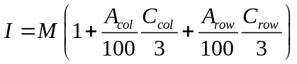 (1)

The value 3 in equation (1) is the maximum consistency score for rows (C_{row}) or columns (C_{col}). Thus, when the consistency score is maximal, the full percent adjustment (A) is added to the value in the parentheses, and lesser amounts are added for less than maximal scores. The values of 100 in equation (1) convert the adjustment percents to proportions.

It can be seen that equation (1) is the cell mean with upward adjustments for consistency within rows or columns. The user must decide what percent adjustment of the cell mean will be associated with the maximum score for both rows and columns. For example, if the user wants to emphasize consistency of toxicity across species at the same time, the user could set A_{col}=30 and A_{row}=0, which will adjust the cell mean upward by 30% for maximal within-column consistency, and ignore within-row consistency. Some example calculations with these A values are provided for below.

Example data with minimum within-column consistency might be as follows:

 | Time 1 | Time 2 | Time 3 | # hits
Species 1 | 30 | 40 | 20 | 3
Species 2 | 0 | 0 | 0 | 0
Species 3 | 0 | 0 | 0 | 0
# hits | 1 | 1 | 1

The calculations for these data with A_{col}=30 and A_{row}=0 are shown in equation (2).

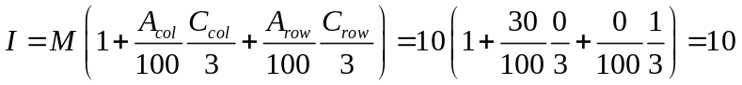 (2)

Example data with some within-column consistency might be as follows:

 | Time 1 | Time 2 | Time 3 | # hits
Species 1 | 30 | 0 | 0 | 1
Species 2 | 40 | 0 | 0 | 1
Species 3 | 20 | 0 | 0 | 1
# hits | 3+1 | 0 | 0

The calculations for these data with A_{col}=30 and A_{row}=0 are shown in equation (3).

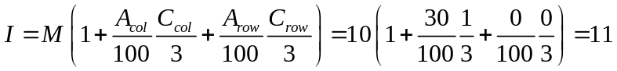 (3)

Note that the index value for the data used in equation (3) is higher than the index value for the data used in equation (2). This is because the equation (3) data have more within-column consistency and the A values were set to emphasize the within-column consistency. A more dramatic difference between the two index values would have resulted if a higher value for A_{col} was used.

It is important to stress that the intended use of the index (I) values is to help prioritize stations for follow-up TIEs. Thus, stations with higher index values would be a higher priority when allocating a fixed amount of resources for TIEs.

Appendix 2: San Diego Region Dry Weather Reconnaissance

The following material is taken from the description of the dry weather reconnaissance program developed for the San Diego region of the County. Section numbers correspond to those in the original report. However, only those tables relevant to the data analysis procedures are included (e.g., tables and figures describing site locations are not included).

3.0 Future Dry Weather Monitoring

The Permittees’ Dry Weather Monitoring Program under the San Diego Regional Water Quality Control Board’s Order No. R9-2002-0001 consists of three main elements:

- A set of randomly located stations intended to characterize the average area-wide conditions in urban runoff

- A set of rotating targeted stations intended to provide additional information about specific sites thought to have a high potential for contaminated runoff and to provide coverage of the entire MS4 system over the period of the permit term

- A set of criteria that will trigger focused IC/ID (illegal connection and illicit discharge) studies by the Permittees when the monitoring data indicate the presence of a problem.

It is important to recognize that the Permittees’ overall Stormwater Management Program includes a wide range of elements that involve activities such as public education, inspections, and a variety of best management practices (BMPs). The Dry Weather Monitoring Program described in this section will provide important feedback on the ultimate effects of such actions on stormdrain water quality. Combined with special studies and focused BMP evaluations, the Dry Weather Monitoring Program will enhance the Program’s ability to continually adapt its management approach as knowledge improves.

3.1 Objectives and Program Overview

The objectives of the Dry Weather Monitoring Program, as stated in the permit, are to:

- Assess compliance with Order No. R9-2002-0001

- Detect and eliminate illicit discharges and illegal connections to the MS4 system (by identifying sites that will be the subject of follow-up source identification investigations conducted by the Permittees)

- Characterize urban runoff within the MS4 system with respect to water quality constituents that may cause or contribute to exceedances of receiving water quality objectives when discharged to receiving waters.

These objectives translate into six fundamental questions that form the basis for specific design elements of the Dry Weather Monitoring Program:

- What are the average background characteristics of urban dry weather runoff in the region?

- What are the trends in these background characteristics over time?

- What are the characteristics of urban dry weather runoff at specific locations that may present higher risk?

- What are the trends in runoff characteristics at these locations?

- Which sites exceed the overall regional average by a substantial amount in one or more constituents?

- Which sites exhibit substantial changes in their characteristics over time that could be indicative of worsening or improving conditions?

The randomly located sites will address Questions 1 and 2. The targeted sites will address Questions 3 and 4. Data from all sites will be used to address Questions 5 and 6, using the criteria established to trigger follow-up IC/ID studies by the Permittees. The goal of these studies will be to seek out reasons for exceedances and, if feasible, correct the problems. Data from the IC/ID studies can be combined with monitoring data to help link particular land uses to specific patterns of contamination. Figures 3-1 and 3-2 present maps of the random and targeted station locations, respectively. Figures 3-1 and 3-2 also demonstrate that each Permittee has at least one site in each major drainage area in its jurisdiction (major drainage areas are defined as the major watersheds listed in Table 3-1), in accordance with permit section E.4.b.2.

Three aspects of the dry weather program deserve to be emphasized:

- First, the initial year of monitoring will have a stronger emphasis on characterizing average background conditions through the use of the random sites. As the estimates of background conditions stabilize, some of this monitoring effort may be shifted to targeted sampling focused on specific potential problems.

- Second, the list of targeted sites will be updated each year as potential problems are identified and/or resolved. This will enable the Permittees to meet the permit requirement to “provide adequate coverage of the entire MS4 system” (E.4.b.3) over the course of the full permit term.

- Third, monitoring data will be evaluated from a variety of perspectives (see Section 3.3) and decisions about whether to initiate follow-up investigations will be based on professional judgment. Thus, there are no automatic triggers built into the program.

3.2 Dry Weather Monitoring Program Elements

The dry weather monitoring program will address the six questions listed above with a two-part sampling design. The first part consists of 30 randomly selected sites intended to address questions about regional background conditions (Questions 1 and 2). The second part consists of 24 non-random, targeted sites intended to address questions about specific locations (Questions 3 and 4). Data from both sets of sites will be used to address questions about which sites should be evaluated more extensively by the Permittees because they exhibit higher values of pollutants or substantial changes in such values over time (Questions 5 and 6). The set of targeted sites will be updated each year to ensure that monitoring results in the coverage of the entire MS4 system over the course of the permit period.

The Dry Weather Monitoring Program will sample each of the 30 random sites three times and each of the 24 targeted sites five times during the five-month dry season. Laboratory analyses for metals, coliforms, pesticides, and oil and grease will be carried out for all samples, in addition to the on-site analyses conducted at each site. While this level of sampling and laboratory analysis exceeds the permit requirements, we believe it is warranted for three reasons:

- First, past experience has shown that problematic discharges can be intermittent in nature and there is a much greater likelihood of identifying such discharges if sampling occurs at a greater frequency

- Second, not all potential problems can be identified by the set of on-site analyses; thus, performing laboratory analyses at each site at each sampling event will maximize the program’s ability to detect potential problems

- Third, interpreting monitoring results, putting them into context, and assessing their relative severity can be more effectively accomplished with this more intensive sampling and analysis approach.

Thus, the monitoring design described below reflects the fundamental philosophy that the program will produce more usable information by concentrating monitoring resources on a given set of sites, and sampling and analyzing them more intensively, than would be achieved by monitoring a larger number of sites less intensively. We also emphasize that the cumulative number of sites monitored will increase each year as effort is shifted from random to targeted sites and as monitoring rotates to new sets of targeted sites each year.

3.2.1 Random Site Sampling

The goal of the random sampling element is to characterize concentrations and trends in the average conditions of urban runoff. A related goal is to help identify those sites that are candidates for follow-up source identification efforts. This section describes the site selection protocol, identifies the sites chosen for random sampling, and describes field sampling and laboratory analysis.

3.2.1.1 Random Site Selection

Figure 3-3 outlines the steps involved in selecting sites for the random sampling element of the Program.

There are two primary considerations in selecting sites for the random element of the program. The first is defining the pool of potential sites to be drawn from and the second is ensuring that the random selection is not overly weighted toward one geographic area at the expense of others. These two issues are discussed more fully in the following paragraphs.

The primary goal of the Dry Weather Monitoring Program is to provide focus and support to an illicit connection and illegal discharge (IC/ID) effort, which means that the program should concentrate on urban runoff to the greatest extent possible. This can best be achieved by attempting to remove extraneous influences by including only enclosed pipes in the pool of potential sites. Open channels run the risk of including fecal contamination from birds and other wildlife, while enclosed pipes are more likely to reflect the influence of urban runoff. In addition, including only pipes that collect runoff from predominantly urbanized land uses (as opposed to open space areas) will also help ensure that monitoring focuses on the impacts of urban runoff. However, in order to achieve the most efficient “coverage” with the least number of tests, it may be necessary to occasionally collect some samples from open channels.

The County’s database of facilities contains 148 major named drains in the south County that are designated as enclosed pipes draining urbanized land uses. Of these, 64 pipes discharge either to an open channel or to the ocean where sampling is more feasible. However, it is known that not all stormwater pipes are included in the County’s database. This does not represent a problem for the random site selection if the undocumented pipes are spread throughout the study area and are not significantly different in character from the documented pipes. We have no reason to believe that the undocumented pipes fail these two criteria.

The other major consideration in selecting sites is to avoid a geographic overweighting of random sites in a small portion of the study area. This was achieved by creating geographic strata based on watersheds (Figure 3-1) and allocating random sites to each stratum based on their relative proportions of urbanized land. Urbanized land uses included:

- Commercial
- Education and religion
- Industrial
- Recreational
- Residential
- Transportation, communication, utility.

More specifically, strata were defined based on watershed boundaries (see Table 3-1 for a list of watersheds and Figure 3-1 for their locations). The area of total urbanized land uses in each watershed was then calculated based on GIS maps produced by the County’s Geomatics Division. The relative proportion of the total urbanized land uses appearing in each stratum was then used to divide the total pool of 30 random sites among the strata (see Table 3-1 for the number of random sites per watershed). For example, if a stratum contained 10% of the study area’s total area of urbanized land uses, it would be allocated 10%, or 3, of the sites. Once the proportional allocation was determined, the specified number of random sites per stratum was selected from the pool of potential sites. One additional site was selected per watershed as an alternate site to be used when a primary site is found to be dry, with the exception of watersheds H (Los Trancos) and I (Laguna Canyon), which had only one suitable pipe apiece. Table 3-2 lists the random sites and Figure 3-1 illustrates their distribution throughout the study area.

One adjustment was made to this randomization scheme. The number of sites in the Salt Creek watershed (K) was increased from two to four, and the number of sites in the San Juan Creek watershed (L) was reduced from 15 to 13. This adjusment was made to ensure a more complete geographic coverage of the study area.

3.2.1.2 Random Sampling and Laboratory Analysis

Monitoring will be conducted three times during the dry season (May through September) at each site. Monitoring will begin in May and subsequent monitoring carried out in July and September, depending on logistical constraints that may shift the monitoring time somewhat. Monitoring at each site will consist of:

- Field observations
- Field screening analyses
- Analytical laboratory analyses.

If flow or ponded runoff is observed at a site and there have been at least seventy-two (72) hours of dry weather, field observations will include general information such as time since last rain, quantity of last rain, site descriptions (i.e., conveyance type, dominant watershed land uses), temperature (air and water), and visual observations (e.g., odor, color, clarity, floatables, deposits/stains, vegetation condition, structural condition, and biology). Flow estimates will be made at each site where there is flowing water, based on the width of the water surface, the approximate depth of water, and the approximate flow velocity. The flow measurements may contribute to pollutant mass loading estimates and to identifying substantial changes in discharge that bear further investigation. Digital photographs may be taken to document unusual conditions that may have a bearing on the interpretation of the other monitoring data.

If flow or ponded runoff is observed at a site and there have been at least seventy-two (72) hours of dry weather, a grab sample will collected for an on-site analysis (field screening) of the parameters specified in permit Section E.4.d.1.d:

- Turbidity
- pH, specific conductance, dissolved oxygen, water temperature
- Reactive Phosphorous
- Nitrate Nitrogen
- Ammonia Nitrogen
- Phenol
- Surfactants (MBAS)
- Total hardness (from Section e.4.d.1.e).

If flow or ponded runoff is observed at a site and there have been at least seventy-two (72) hours of dry weather, a grab sample will be collected for laboratory analysis of the parameters specified in permit Section E.4.d.1.e:

- Oil and grease
- Diazinon and chlorpyrifos
- Cadmium (dissolved)
- Copper (dissolved)
- Lead (dissolved)
- Zinc (dissolved)
- Fecal coliform bacteria
- Enterococcus bacteria
- Total coliform bacteria
- Total suspended solids (TSS)
- Total chlorine (not specified in permit).

If a designated site is dry (i.e., no flowing water or ponded runoff), then all applicable observations will be recorded and sampling will be attempted at the alternate site for that watershed. Table 3-3 lists the analytical methods that will be used for each parameter.

In accordance with permit Section E.4.d.6, monitoring staff will use a global positioning system (GPS) unit to record the coordinates of each site on the first sampling event. These coordinates will then be compared to those in the County’s GIS system to verify the accuracy of the database and update it if necessary.

3.2.1.3. Random Data Analysis

There are three components to the analysis of data from the random sites. These are intended to help provide the basis for determining which sites are candidates for follow-up source identification studies to be carried out by the Permittees (see Section 3.3). These include:

- Calculation of a regional tolerance interval based on data from all 30 random sites, which will help answer Question 5: Which sites exceed the overall regional average by a substantial amount in one or more constituents?

- Comparison of each site’s data values with relevant guidance levels (Table 3-4), which will help answer Question 3: What are the characteristics of urban dry weather runoff at specific locations that may present higher risk?

- Calculation of a site-specific control chart for each individual random site, which will help answer Question 6: Which sites exhibit substantial changes in their characteristics over time that could be indicative of worsening or improving conditions?

Tolerance intervals are a quantitative, rigorous method for incorporating and addressing the presence of variability in background conditions when a monitoring program searches for data values that are significantly different from background (see Appendix 2 for technical detail). A tolerance interval bound is simply the upper or lower confidence-interval bound of a quantile of the background data distribution (see Figure 3-4). Tolerance intervals will be calculated as described in the technical appendix and applied as described in Section 3.3 to help identify candidate sites for further follow-up investigations by the Permittees. The tolerance interval will be derived after the first sampling period and will then be recalculated each time the random sites are sampled throughout the duration of the program, in order to ensure that decisions are being made with the best data possible. As additional data lead to better estimates of variance, the tolerance interval will continue to become more precise over time. We investigated the possibility of accelerating this process by developing a regional tolerance interval with existing data, but found this was not feasible because existing data were not collected with a random sampling design.

Where guidelines and/or standards are available, data will be compared to these (Table 3-4), although it should be noted that any standards in Table 3-4 have been developed for receiving waters and not for the storm drain system. Information about the degree and persistence of exceedances will be used to help identify which sites are candidates for follow-up source identification efforts (see Section 3.3).

Control charts provide a means of tracking data at each individual site and identifying when new data values deviate substantially (either upward or downward) from previous experience (see Appendix 2 for technical detail). A control chart can be used to establish a bound or threshold, based on previous monitoring data, as illustrated in Figure 3-5. Control charts will be calculated as described in Appendix 2 and applied as described in Section 3.3 to help identify candidate sites for further follow-up investigations by the Permittees. The site-by-site control charts will be recalculated each time the random sites are sampled throughout the duration of the program in order to ensure that decisions are being made with the best data possible. As additional data lead to better estimates of variance, the control charts will continue to become more reliable over time. We investigated the possibility of accelerating this process by developing site-specific control charts with existing data, but found this was not feasible because appropriate grab sampling data were not available from these sites.

The results of these three analyses will be combined with professional judgment to identify those sites that are candidates for further source identification efforts by the Permittees (see Section 3.3 for more detail).

3.2.2 Targeted Site Sampling

The primary goals of the targeted sampling element are to, first, characterize concentrations and trends at particular sites that are thought to have a high potential for polluted runoff and receiving water impacts, and, second, help provide coverage of the entire MS4 system. A related goal is to help identify those sites that are candidates for follow-up IC/ID efforts. This section describes the site selection protocol, identifies the sites chosen for targeted sampling, and describes field sampling and laboratory analysis.

3.2.2.1 Targeted Site Selection

Sites for the targeted, or non-random, portion of the Dry Weather Monitoring Program were selected by combining information from two primary sources:

- County staff’s knowledge about the sorts of locations and land uses with a high potential for polluted runoff

- Input from the Permittees.

County staff have noted that concrete companies, chemical supply houses, waste transfer stations, food warehouses where transfer operations take place, and concentrations of automobile repair facilities are sometimes correlated with elevated pollutant levels. We used an Internet search engine to identify locations where concentrations of such industrial/commercial activities occurred, and then discussed these potential sites with knowledgeable City staff. In addition, the Permittees provided suggestions about sites they felt were areas of particular concern, based on inspections, spills, land use type, and other past experience.

Table 3-5 presents the final list of the targeted sites and Figure 3-2 illustrates their distribution throughout the study area.

As discussed in more detail below (Section 3.2.3), the list of targeted sites will be updated each year, with the twin goals of addressing high-priority potential problems first and achieving coverage of the entire MS4 system over the course of the full permit term.

3.2.2.2 Targeted Sampling and Laboratory Analysis

Sampling and laboratory analysis will be conducted as described for the random sites (see Section 3.2.1.2).

3.2.2.3 Targeted Data Analysis

There are three components to the analysis of data from the targeted sites. As with the random sites, these are intended primarily to help provide the basis for determining which sites are candidates for follow-up source identification studies to be carried out by the Permittees (see Section 3.3). These include:

- Comparison of each site’s data values with the regional tolerance interval calculated from the random sites, which will help answer Question 5: Which sites exceed the overall regional average by a substantial amount in one or more constituents?

- Comparison of each site’s data values with relevant guidance levels, which will help answer Question 3: What are the characteristics of urban dry weather runoff at specific locations that may present higher risk?

- Calculation of a site-specific control chart for each individual targeted site, which will help answer Question 6: Which sites exhibit substantial changes in their characteristics over time that could be indicative of worsening or improving conditions?

Methods for comparing data values to guidelines and/or standards, and for constructing control charts, are the same as described above (Section 3.2.1.3) for the random site data analysis.

The results of these three analyses will be combined with professional judgment to identify those sites that are candidates for further source identification efforts by the Permittees (see Section 3.3 for more detail).

3.2.3 Periodic reevaluation

Each year’s monitoring results will be used to reevaluate the two main aspects of the Program’s design, the random and the targeted monitoring elements.

First, the first year’s data from the random sites will be used to assess the need for continued measurement of background conditions at the original level of sampling intensity. If the tolerance interval bounds are effective and stable, then it may be feasible to reduce the random sampling effort and allocate these monitoring resources to higher-priority issues. Any decision to cut back the random, or background, portion of the Program must take into account the need to monitor for longer-term trends in background conditions. Once the current background conditions are established, one sampling event per year may serve to track trends, especially if the south County data can be combined with data from the remainder of Orange County and from other Counties as part of any Stormwater Monitoring Coalition (SMC) regional monitoring effort.

The Southern California Stormwater Monitoring Coalition (SMC) is a partnership of the lead municipal stormwater Permittees and RWQCBs in southern California, and the Southern California Coastal Water Research Project (SCCWRP). The SMC has endorsed regional cooperation and has agreed to collaboratively fund research that will improve stormwater monitoring efforts. The SMC has developed a research agenda to direct its activities and more information on both the SMC and the research agenda can be found at: ftp://ftp.sccwrp.org/pub/download/PDFs/358_stormwater_workplan.pdf.

Second, the list of targeted sites will be reevaluated each year to determine whether an individual site requires further monitoring by the County or whether monitoring can be shifted to another targeted site that has yet to be monitored. Monitoring will be discontinued at a particular site when:

- Multiple sampling events find no evidence of elevated values compared to the regional tolerance interval

- An IC/ID effort, led by the relevant Permittee, is underway and does not require further County monitoring data from the targeted site

- An IC/ID effort has found the source of elevated values.

In such cases, the Program will identify additional priority sites and shift monitoring effort to those.

3.3 Criteria for Source Identification Studies

When sampling data from the County’s routine dry weather program exceed certain criteria, then this will trigger a consideration of whether follow-up investigations by the Permittees are warranted, in accordance with permit conditions E.4.d.4 and E.4.d.5. These criteria are designed to identify sites that:

- Exceed the overall regional average by a substantial amount in one or more constituents

- Exhibit substantial changes in their characteristics over time that could be indicative of worsening or improving conditions. (It may be informative to continue monitoring where conditions are improving in order to gain information that could be useful elsewhere.)

These criteria correspond to questions 5 and 6 in Section 3.1 and will help to focus follow-up investigations on those sites that may pose the greatest potential risk to receiving waters. Because the Dry Weather Monitoring Program’s primary focus is prioritizing IC/ID detection and elimination studies, the threshold levels for the tolerance intervals and the control charts will be set at levels that will be high enough to focus follow-up sampling on those instances that are clearly beyond average conditions and therefore represent the highest-priority problems.

The tolerance interval will initially be set at the 90th percentile (or the .90 quantile), with allowance made for sampling variability around that estimate (see Appendix 2).

The control chart threshold will be set at 3.9 standard deviations beyond the mean. Given the large number of comparisons to be performed each year (approximately 1000, resulting from the large number of parameters being measured at all 60 sites), false positives will unavoidably occur. As Appendix 2 explains, numerical simulations estimate that the false positive rate at this threshold will be 0.05, which is equivalent to about 50 false positive results per year. While this appears to be a substantial number, it represents a reasonable starting point for three reasons:

- It is analogous to setting the α level at 0.05, a common procedure in statistical tests

- A single exceedance of the threshold by a single parameter will not necessarily trigger a follow-up IC/ID investigation. With the exception of values that are clearly extreme, the guidance levels will be considered in the context of the tolerance level and control chart results, and then assessed with professional judgment.

- The control chart results will not be used in isolation to initiate a follow-up investigation; they will be combined with results of comparisons to the regional tolerance interval and to any relevant guidance levels, and then assessed with professional judgment.

The flowchart in Figure 3-6 illustrates the steps involved in establishing the criteria that would trigger a consideration of follow-up investigations:

- The random sites will be used to establish a tolerance interval for each monitored pollutant. The tolerance interval will be applied to data from the entire region and will be used to identify sites that exceed the overall regional average for a particular pollutant.

- Data from all sites (both random and targeted) will be used to establish site-specific control charts for each pollutant. The control charts will be applied to data on a site by site basis to identify sites whose characteristics change substantially over time.

- Data that exceed either a tolerance interval or a control chart bound will be confirmed with data from the next sampling event. If this second sample does not confirm the exceedance, then routine sampling will continue.

- If exceedances of either tolerance intervals or control chart bounds are confirmed, then these data will be further evaluated by comparison to guidance levels and with professional judgment. Only after passing through these two additional steps will follow-up source identification efforts be initiated.

- Professional judgment will be based on knowledge of and past experience with past contamination patterns. For example, extreme pH values are evidence of a problem, as are oil sheens and the presence of dead animals, and a dissolved oxygen value of < 1 ppm on a sunny day. In addition, elevated nutrients can be evidence of agricultural activity, high pH values of concrete waste, and extremely turbid water of a grading violation. A finding of elevated copper levels is indicative of printed circuit board operations, especially when combined with low pH and the presence of soluble cyanide. Elevated bacteria levels, combined with ammonia, MBAS, COD, BOD, turbidity, and odor suggest a sewage spill. The findings of the IC/ID studies will be used to refine the screening process as the program develops.

- At any time, if extreme data values warrant it, the tolerance interval and control chart steps may be bypassed to consider whether source identification studies should be initiated as soon as is feasible.

When the County has identified a site that meets the criteria in Figure 3-6, it will notify the appropriate City representative that follow-up IC/ID efforts should be initiated. However, if the monitoring program finds extreme conditions that represent a clear and immediate risk to human health or receiving water quality, or that provide unambiguous evidence of a substantial upstream problem, then this routine procedure will be bypassed and the relevant inspector for that City notified immediately. In both kinds of instances, if the monitored site is near a jurisdictional boundary and the upstream drainage network for the site extends into a neighboring jurisdiction, both the jurisdiction containing the site as well as the jurisdiction containing the upstream portion of the drainage network will be notified.

The County plans to deliver monitoring data to the cities as soon as reliable data are available:

- Visual observations of obviously extreme conditions will be reported to the relevant city immediately
- Data from the field screening samples should be available within a few days at the most
- Bacteria data should be available from the laboratory within one to two weeks
- Preliminary results of the dissolved metals analyses should be available from the Program’s laboratory within one week
- Other analytical chemistry results will be forwarded to the cities as soon as it is received from the contract laboratory and processed through a set of quality control checks. In most cases, this will be accomplished within 45 days of the sampling data.

In addition, the County will carry out the procedure described in Section 3.3 after each sampling event and notify the relevant city of any sites that require follow-up IC/ID investigations within 21 days of receipt of the data from the laboratory.
Table 3-3 Analytical Methods Used for Field Screening and Laboratory Analyses.

Parameter | Method | HACH Method | Standard Method | EPA Method

Field screening analyses
Turbidity | Turbidimeter - Nephelometric
pH, specific conductance, dissolved oxygen and water | Multi-parameter probe
Reactive Phosphorous |  | 8048 - Ascorbic Acid
Nitrate Nitrogen |  | 8039 - Cadmium Reduction
Ammonia Nitrogen |  | 10031 - Salicylate
Phenol |  | 8047 - 4-Aminoantipyrine
Surfactants (MBAS) |  | 8028 - Crystal Violet
Total hardness |  | 8213 - Digital Titrator with EDTA
Laboratory analyses
Oil and grease |  |  | 5520B | 1664
Diazinon and chlorpyrifos (GCMS) |  |  |  | 525.2
Cadmium (dissolved) |  |  | 3125B | 200.8
Copper (dissolved) |  | 8506 - Bicinchoninate Method | 3125B | 200.8
Lead (dissolved) |  |  | 3125B | 200.8
Zinc (dissolved) |  |  | 3125B | 200.8
Fecal coliform bacteria |  |  | 9222D
Enterococcus bacteria |  |  | 9230C
Total coliform bacteria |  |  | 9222B | 9132
Total chlorine |  | 8167 - DPD Method
Total suspended solids (TSS) |  |  | 2540D | 160.2

Table 3-4 Guidance Levels for Field Screening and Laboratory Analytical Parameters.

Analyte | Guidance Levels | Source / Notes

Field screening
Turbidity (NTU) | Best professional judgment | WQOs relevant to inland surface waters are not available. Base judgment on channel type and bottom, time since last rain, background levels, and visual observation (e.g. unusual colors).
pH | <6.5 or >9.0 | Basin Plan, w/ allowance for elevated pH due to excessive photosynthesis. Elevated pH is especially problematic in combination with high ammonia
Conductivity (μmhos/cm) or TDS (mg/L) | 5000 μmhos/ cm conductivity or ~3500 mg/L TDS | Professional judgment. EC may be highly elevated in some regions due to high-TDS groundwater exfiltration to surface water, mineral dissolution and seawater intrusion. Normal source ID and discharge elimination work is not effective in these situations. Conversion factor for EC to TDS is approximately 0.7.
Temperature (F or C) | Best professional judgment | Base judgment on season, air temperature, channel type, shade, etc.
Reactive Phosphorous (orthophosphate-P) (mg/L) | 2.0 | USEPA Multi-sector General Permit
Nitrate-Nitrogen (mg/L) | 10.0 | Basin Plan, and drinking water standards
Ammonia-Nitrogen (mg/L) | 1.0 | Staff and Permittee experience, may also consider unionized ammonia fraction.
Phenol | Any occurrence | Found only very rarely during field screening program. Any occurrence would be unusual.
Surfactants (MBAS) (mg/L) | 1.0 | Basin Plan, w/ allowance based on relevant field experience and possible field reagent interferences.

Laboratory
Oil and Grease (mg/L) | 15 | USEPA Multi-sector General Permit. If a petroleum sheen is observed, the sample should be collected from the water surface.
Diazinon (nμg/L) | 500 | Acute LC50 for aquatic invertebrates range from 200 nμg/L for Gammarus fasciatus to 4000 nμg/L for Hyallela azteca
Chlorpyrifos (nμg/L) | 500 | Acute LC50 is 9000 nμg/L rainbow trout, higher for other fish, decreased survival and growth for fathead minnow at 30-day chronic exposure of 2000nμg/L.
Dissolved cadmium, copper, lead, zinc | California Toxics Rule | Use CTR table, 1-hour criteria, adjusted for hardness, to determine appropriate action level for individual samples.
Fecal Coliform (MPN or CFU/ 100 mls) | 31,000 MPN or CFU/100 mls | The 75th percentile of all data collected during the Aliso directive monitoring program between May 1 and September 30, 2001 and 2002.
Enterococcus (MPN or CFU/ 100 mls) | 20,000 CFU/100 mls | The 75th percentile of all data collected during the Aliso directive monitoring program between May 1 and September 30, 2001 and 2002.
Total Coliform (MPN or CFU/ 100 mls) | 160,000 MPN or CFU/100 mls | The 75th percentile of all data collected during the Aliso directive monitoring program between May 1 and September 30, 2001 and 2002. However, this is an underestimate because the upper detection limit was 160,000 and many values were above the detection limit.
Total suspended solids (mg/L) | 50 | Region 9 groundwater dewatering permit for construction projects

Appendix 3: San Diego Region Dry Weather Analysis Methods

A.0 Technical Appendix: Data Analysis Methods

A.1 Tolerance Intervals – Comparing Parameter Levels With Background

It will be useful to find unusual parameter measurements indicating potential problems at a location. Before we can define “unusual,” we need to know what constitutes “usual” or background parameter levels. Thirty sites have been randomly selected for the purpose of defining the County background, or reference, distribution of parameter values for the County as a whole. Measurements taken at other selected locations can then be compared to these background levels, and measurements with a relatively low probability of being part of the reference population distribution will be flagged for further study.

The reference parameter measurements will cover a range of values, and some sort of comparison with this range is appropriate. Direct comparison with the maximum or minimum reference measurement does not take into account the uncertainty from sampling error. A better comparison would be with a quantile toward the tail of the reference distribution (Splitstone 1991,Kilgour & Somers 1998). A quantile of a distribution is the measurement value that exceeds a selected proportion of the data. Instead of directly estimating a quantile, we can take into account sampling error by instead using the confidence interval bound of the quantile. The 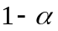 confidence interval of the p^{th} quantile of a distribution is called a p, α tolerance interval (Hahn & Meeker 1991,Vardeman 1992). Given the definition of a confidence interval, a computed tolerance interval bound is expected to cover the true quantile of the population distribution proportion of the time.

The choice of p to use for the tolerance intervals depends on the desired sensitivity of the comparison with background levels. If one wants to flag only the very worst measurements, the p=0.95 or p=0.99 could be used (for parameters problematic at high values). The resulting quantiles will be toward the extreme edge of the reference distribution. On the other hand, if one wants to be more cautious and flag more values that might potentially be a problem, then lower values of p could be used. The value chosen for the tolerance interval 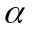 can also affect the sensitivity of the comparison with reference. However, it is more convenient to keep constant at 0.05 and vary p to obtain the desired level of sensitivity.

The choice of computational method for tolerance intervals depends on the sampling design and whether parametric assumptions can be met. The most common type of tolerance interval assumes that the data observations are independent and are normally distributed. Here, an upper p, α tolerance interval bound (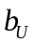) is computed as

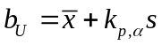,

and a lower bound (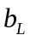) is computed as

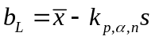.

The is the estimated parameter mean, s is the estimated standard deviation, and 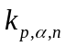 is a factor that depends on the chosen p,α, and sample size n. The values can be obtained from tables in Hahn & Meeker ( 1991) and Gilbert ( 1987), or can be directly computed as follows (Portugal 1992).

The upper bound will be used when the parameter of interest is problematic at higher values, e.g., metals or bacterial concentrations. On the other hand, would be used for parameters potentially harmful at lower concentrations, for example, pH and dissolved oxygen. In practice, if the concentration of a parameter harmful at high levels exceeds the computed for that parameter, then the parameter would be flagged as being high compared with the background levels in the County. Similarly, parameters harmful at lower levels will be flagged when measurements are below.

If the data do not appear to originate from a normal distribution (and cannot be transformed to normality), non-parametric tolerance intervals can be computed (Woodward & Frawley 1980,Hahn & Meeker 1991). The non-parametric methods still assume that the observations are independent.

The assumption of independence will only hold when computing tolerance intervals from a single survey. When more than one survey within a year is used, the replicate values at a location will tend to be correlated, and when more than one year is used, the data from the same location will be correlated over time, and the data within each year will tend to be correlated.

The lack of independence among the observations will provide tolerance interval bounds that cover the true quantile of the reference distribution at a lower rate than that specified by the chosen nominal value. At this point, there are two options, which are:

- Compute tolerance interval bounds only for single surveys, where the data are independent. These bounds would be compared to the parameter values from the same survey only.

- Use all the data and choose a suitable method of computation. Since the same 30 locations are revisited each year, the statistical model will correspond to a crossed year by location ANOVA model. If there is a year-to-year trend in the data, then years can be considered a covariate and the mixed ANOVA method proposed by Vangel ( 1994) can be used. If there is no year-to-year trend in the data, the random crossed model developed by Smith ( 2001) can be used. An advantage of the Smith ( 2001) method is that the computed bounds can be applied to surveys and years where no random data are available.

The second option has the advantage of being based on more data, which in turn may provide better estimates of tolerance interval bounds. However, the simplicity of the first option is attractive. Another advantage of the first option is the availability of nonparametric methods for this situation. The methods in the second option are parametric, assuming the data within the years are from a normal distribution. Nonparametric analogues for these statistical model have not been developed at this time. At the very least, the first option will be used for the first survey in the first year. This will allow for immediate identification of outlier locations.

If after multiple years of monitoring, it becomes evident that the parameter levels at the randomly chosen locations are not trending over time, then sampling of the random locations can be discontinued or performed less frequently. In this case, the Smith ( 2001) method can be used to compute tolerance interval bounds that can be applied to years and surveys where no random samples are taken.

A.2 Control Charts – Detecting Parameter Changes Over Time at a Location

Measurements will also be obtained at the targeted sites, which are fixed locations of interest because of their elevated potential for contamination. It will be useful to observe the parameter values over time at both these targeted sites and the random sites and detect when significant changes from previously observed parameter levels have taken place. Such information will be useful for detecting the presence of new or slowly increasing inputs. For this purpose, Shewart and CUSUM control charts will be used to monitor each location over time.

A.2.1 Shewart control charts

A Shewart control chart (Shewart 1931,Gibbons 1994) is simply a plot of time (x-axis) vs. the concentration of a parameter of interest (y-axis). On the plot, a horizontal line is drawn at the control limit set at 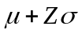, where  is the mean and is the standard deviation of the parameter. Z is a quantile from the standard normal distribution, used to control the sensitivity of the chart to outlier values and to control the rate of false positive indications of outlier status. Values above the horizontal line will be flagged as unusually high values deserving of further attention. Figure A-1 shows an example of a Shewart control chart with Z=4.5, which means that data values more than 4.5 standard deviations above the mean will be flagged. If we are concerned with low values of a parameter, the control limit of the control chart can be set at 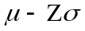 and measurements below this limit will be flagged.

Figure A1. Example of a Shewart control chart. 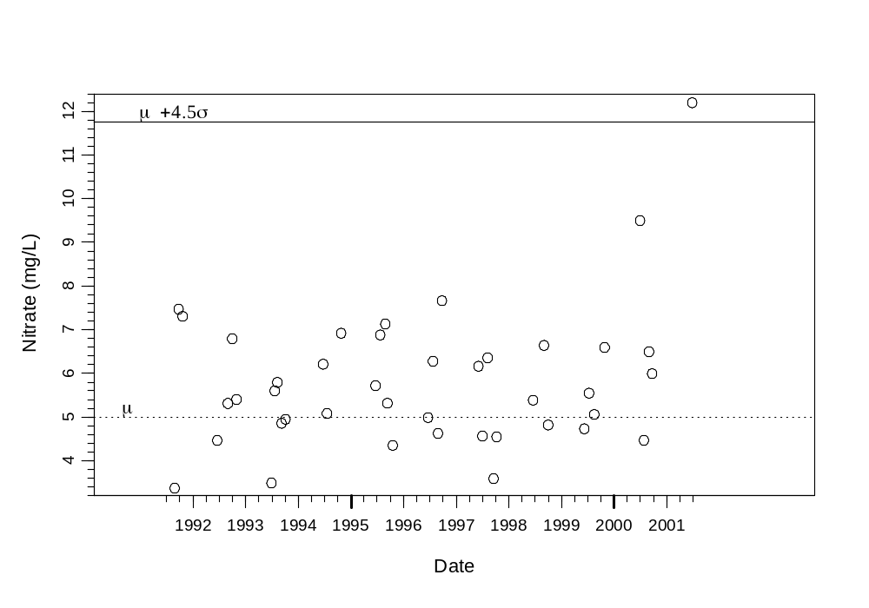
Points occurring above the solid horizontal line (the control limit) are considered outliers of concern. The point on the last date would be flagged as an outlier. In this example, the mean () is 5.0 and the standard deviation () is 1.5.

The and values are usually estimated from historical data. The locations in the present monitoring design lack such historical data. Thus, the data from the first year will be used to compute initial estimates of and, and control charts will not be used until the second year of monitoring. Subsequent observations will be compared with the control limit and then be used to re-estimate the means and standard deviations and update the control limit for future observations.

The more measurements compared with the control limit, the higher the probability that some data values might occur outside the control limit by chance alone (false positives). To adjust for the multiple tests, a higher value of Z is used. However, if too high a Z value is used, the rate of finding the true outliers (false negatives) becomes too low. To provide balanced rates of false positives and false negatives, confirmation samples will be obtained and analyzed when a value is found outside the control limit. If the confirmation sample measurement is also outside the control limit, then the value is considered outside the control limit (Gibbons 1994). The confirmation samples should be obtained on a sampling date after the date of the original sample.

Simulations were performed to estimate appropriate Z values for the Shewart charts with the proposed design.

Table A-1. Recommended Z values for dry weather monitoring.

Time Period | # Tests/Facility | False Positive Rate | Z
After first year | 4800 | 0.05 | 3.9
 |  | 0.01 | 5.0

Table A-1 provides Z values to use for the control charts. Z values for two false positive rates are given. Using the higher false positive rate (0.05) will make for more sensitive tests, but require more confirmation samples. If time or monetary resources for large numbers of confirmation samples are limited, the lower false positive rate (0.01) should be used.

The total numbers of tests were computed as follows. A monitoring program of five years is assumed. There will be no tests the first year as data are gathered to estimate μ and σ. Thirty random locations will be sampled three times a year and thirty targeted locations will be sampled five times per year, and 17 parameters will be measured. Some of the measured parameters will correlated, so 5 sets of intercorrelated variables are assumed. These five sets are treated as five independent variables since the computations assume that the parameters are independent. Given these numbers, there will be (4 years of tests) x [(5 observations/year for targeted locations) x (30 targeted locations) + (3 observations/year for random locations)] x (30 random locations)] x (5 parameter sets) = 4800 separate tests.

A.2.2 CUSUM control charts

CUSUM control charts are charts with time on the x-axis and standardized parameter measurements on the y-axis. An index summarizing cumulative inputs above a chosen level is superimposed in the chart. CUSUM control charts are sensitive to smaller, gradual changes in parameter values at a single location (Gibbons 1994). At a location, for each sampling period, the cumulative sum S_{i} is computed as

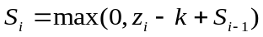,

where i is the index of the current time period, k is a factor selected to be approximately one half the size of a difference worth detecting, and

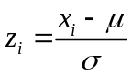.

In , x_{i} is the parameter measurement at time i, μ is the presumed mean and σ is the presumed standard deviation of the population of parameter values over time at the location. The μ and σ will need to be estimated from the first year’s data and the estimates updated as more values become available. Formula pertains to parameters that are harmful as values increase. When harm is associated with decreasing values, instead use

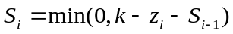.

When S_{i} reaches a preset value h, the parameter is considered outside the CUSUM control limit, and flagged as a parameter that has changing over time. When using the CUSUM control charts, the recommended values are h=5 and k=1 (Gibbons 1994).

Figure A-2 shows an example of a CUSUM control chart.

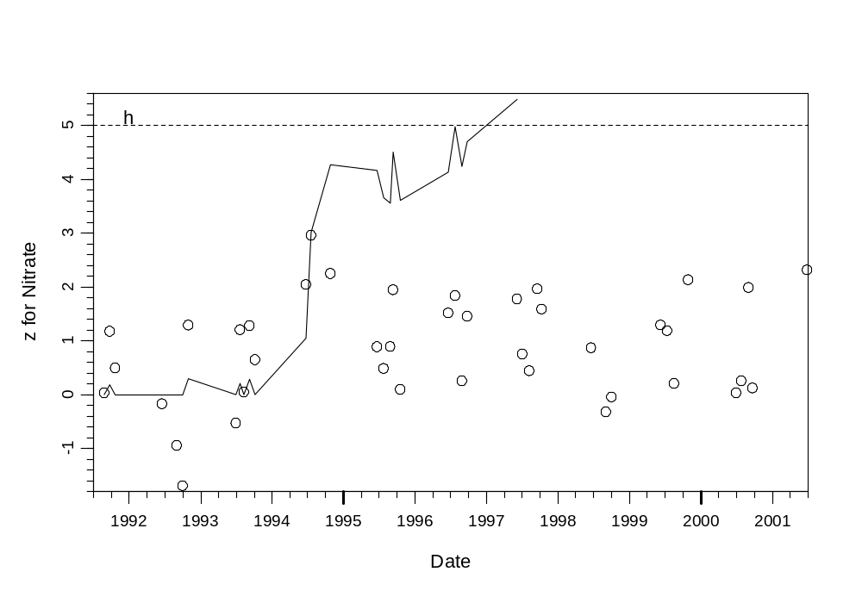
Figure A-2. Example of a CUSUM control chart. The solid line is S_{i} in . The example is based on a simulation where k=1 and the mean value of Nitrate increased by 1.08 standard deviations in 1994.

Using both Shewart and CUSUM control charts allows for more comprehensive monitoring where sudden changes are detected with the Shewart chart and cumulative smaller changes are detected with the CUSUM chart. Both control charts could be expressed in a single plot, but would require that the y axis of both charts be converted to either the z_{i} or the original measurement scale.

Control chart issues

Both methods assume the data are normally distributed. If the raw data measurements do not appear to be normally distributed, then the data should be transformed to approximate normality if possible. Most often, this can be accomplished with a log or square root transform with the present type of data. The method of Box and Cox ( 1964) is helpful in finding a suitable transformation.

Since historical data are not available at the sampling locations, the required means and standard deviations need to be estimated as data become available from the monitoring program. Outlier data points should not be included in the mean and standard deviation estimates, since the outliers can inflate the standard deviation and decrease sensitivity for detecting future outliers. The parameter values outside the Shewart control limit are obviously outliers, but outlier detection methods could also be used, e.g., Dixon ( 1953), Davies and Gather ( 1993).

The methods also assume there is no trend over time in the parameter data used to estimate the mean and standard deviation. When a linear trend is found, the data can be detrended first as (Gibbons 1994)

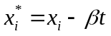,

where 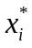 is the detrended value, x_{i} is the original parameter value, t is the year index (starting with 1,2, ..) and β is the slope from a linear regression of x_{i} vs. year index. The mean and standard deviations are computed from x*, but the original x values are compared with the resulting control limits.

The estimates of mean and standard deviation also assume that the data measurements are independent with a fixed underlying mean and variance. This assumption will not strictly be met where the underlying parameter mean varies from year to year. The effect of this violation of assumptions will cause the variance to be underestimated, which in turn leads to more conservative control limits (in the direction of greater environmental protection).

Intercorrelated subsets of the measured parameters will tend to occur outside the control limits at the same time. When this happens, it may not be necessary to make confirmatory measurements for all the measured parameters in the subset. If it is confirmed that the one of the parameters is outside the control limit, it would reasonable to assume that the other parameters in the subset are also outside the control limit. This approach could reduce the number of confirmatory reanalyses required.

References

Box, G. E. P., and D. R. Cox. 1964. An analysis of transformations. Journal of the Royal Statistical Society, Series B 26:211-252.
Davies, L., and U. Gathers. 1993. The identification of multiple outliers. Journal of the American Statistical Association 88:782-792.
Dixon, W. J. 1953. Processing data for outliers. Biometrics 9:74-89.
Gibbons R. D. 1994. Statistical Methods for Groundwater Monitoring. John Wiley & Sons, New York.
Gilbert R. O. 1987. Statistical Methods for Environmental Pollution Monitoring. Van Nostrand Reinhold Co., New York.
Hahn G. J., and W. Q. Meeker. 1991. Statistical Intervals. A Guide for Practitioners. John Wiley & Sons, New York.
Kilgour, B. W., and K. M. Somers. 1998. The statistics of testing generic biological criteria. SETAC News 18:20-22.
Portugal, S. 1992. A SAS program to compute factors for one-sided tolerance limits for a normal distribution. Pages 1231-1234 in Proceedings of the 17th Annual SAS Users' Group International Conference.
Shewart W. A. 1931. Economic Control of Quality of Manufactured Product. Van Nostrand, Princeton, NJ.
Smith, R. W. 2001. The use of random-model tolerance intervals in environmental monitoring and regulation. Journal of Agricultural, Biological, and Environmental Statistics 7:74-94.
Splitstone, D. E. 1991. How clean is clean, statistically? Pollution Engineering 90-96.
Vangel, M. G. 1994. One-sided b-content tolerance intervals for mixed models. Pages 200-206 in American Statistical Association 1994 Proceedings of the Section on Physical and Engineering Sciences.
Vardeman, S. 1992. What about the other intervals? The American Statistician 46:193-197.
Woodward, W. A., and W. H. Frawley. 1980. One-sided tolerance intervals for a broad class of lifetime distributions. Journal of Quality Technology 12:130-137.

Table 2-1 Distribution of Monitoring Types Across Program Elements

Program Element | Core Monitoring | Regional Monitoring | Special Studies
Mass Loading | Chemical and flow monitoring  Toxicity testing with marine or freshwater organisms  Dry-weather sediment monitoring | Share stations with Nutrient and Toxics TMDLs  Participation in the San Gabriel River watershed monitoring program | Toxicity tests at higher dilutions  TIEs  Upstream source identification  Sediment / pollutant links  Legacy pollutants  Monitoring design evaluation
Estuary Wetlands | Chemical, biological, toxicity monitoring | Application of regional BRI to benthic infauna results  Participation in Bight ’03 estuaries assessment | Toxicity tests at higher dilutions  TIEs  Seasonal sediment patterns  Marina impacts  Rhine Channel study  Legacy pollutants  Upstream source identification  Upland contamination  Tissue monitoring program design  Monitoring design evaluation
Bacterial / Pathogen | Bacterial indicators in inland channels  Adaptive design for coastal stormdrains | Participation in Bight ’03 stormwater plume tracking study  Participation in the SMC regional model monitoring design | Reprioritization of design and source tracking  Stormdrain / surfzone correlations  Assessment of improved indicators
Bioassessment | Bioassessment monitoring with DFG methods  Chemical monitoring  Toxicity testing with freshwater organisms | Application of regional IBI (when available)  Participation in the SMC regional model monitoring design | Toxicity tests at higher dilutions  TIEs  Upstream source identification  Participation in the SMC regional model monitoring design  Participation in SMC development of regional IBI
Reconnaissance | Monitoring at targeted sites to identify potential IC/IDs | Participation in the SMC regional model monitoring design | Upstream source identification (Seal Beach only)
Land-use | Monitor water and sediment quality before and after land use changes |  | Other studies suggested by monitoring results
Nutrient TMDL | Monitor compliance with regional TMDL targets | Monitor compliance with regional TMDL targets | Develop and implement new and/or additional studies as 303(d) information is updated
Toxics TMDL | Track long-term trends in loads of key toxic constituents  Track patterns and trends in toxicity | Monitor compliance with regional TMDL targets (when established) | Additions to mass emissions & estuary wetlands components  Others to be part of Newport watershed effort

Table 2-2 Summary Monitoring Program Overview

Program Element | Targeted Areas | # Sites | Frequency/Yr | Monitoring Parameters | Additional Studies
Mass Emissions | Huntington Harbour/Anaheim Bay  Coastline between Huntington Harbor and Newport Bay  Upper/LowerNewport Bay  North Orange County | 12 | 3 storm events  4 dry weather  Phase in 3 N. County sites over 3 yrs | Nutrients, OP & OC pesticides, PCBs, metals, bacti, dissolved organic carbon (DOC), toxicity (2 storms/4 dry weather), herbicide | Toxicity tests at higher dilutions  TIEs  Upstream source ID  Sediment / pollutant links
Estuary / Wetlands | Estuaries (Talbert Marsh, Upper Newport Bay, Huntington Harbour/Bolsa Bay)  Related channels (Talbert Channel, San Diego Creek, Santa Ana Delhi Channel, Costa Mesa Channel, East Garden Grove Wintersburg Channel) | 12  6 | 2 storm events  2 dry weather  UNB monthly  UNB toxicity only at UNBJAM, UNBSDC  See Mass Emissions | Nutrients, OP pesticides, metals, bacti, DOC, aqueous toxicity, sediment toxicity, TOC & particle size (sed), benthic infaunal analysis | Toxicity tests at higher dilutions  TIEs  Upstream source ID  Bight ’03 link  Marina impacts  Rhine Channel  Upland contamination (scoping)  Tissue monitoring design
Bacteriological | Inland creeks/channels  Coastal drains not monitored by HCA or OCSD | 6  TBD | Weekly in dry weather | Total coliform, fecal coliform, Enterococcus | Reprioritization  Upstream source ID  Drain/surfzone correlations  Assess improved indicators
Bioassessmnet | To be determined with RB8 and SCCWRP assistance | 11 | (dry-weather May and October) | Bioassessment, nutrients, metals, OP pesticides, toxicity testing | Additional chemistry Toxicity tests at higher dilutions  TIEs  Upstream source ID
Reconnaissance | Commercial/industrial, new development | 30 | 5 dry weather | DO, pH, EC, T, OP pesticides, dissolved metals, O&G or TPH, MBAS, bacteria, TSS | Source ID (by cities)
Land Use Correlations | Newport Bay watershed | 2 areas  ? sites / area | ? storm events  ? dry weather | Same as mass emissions | TBD
Nutrient TMDL | Newport Bay watershed  Upper Newport Bay | 9 channel  5 UNB  9 UNB | Biweekly  Monthly  9/yr | Nutrients  Nutrients  Algal biomass | TBD
Toxics TMDL | Newport Bay watershed | TBD | TBD | TBD | TBD

Table 2-3 Relationship of Permit Objectives to Monitoring Program Elements

Permit Objectives | Mass Emissions | Estuary / Wetlands | Bacterial / Pathogen | Bioassessment | Recon-  naissance | Land-use Correlations | Nutrient TMDL | Toxics TMDL
1. Effective runoff & source control program
2. Define status, trends, & impacts | X | X | X | X | X | X | X | X
3. ID pollutants & assess land-use effects | X | X | X |  | X | X
4. ID significant problems | X | X | X | X | X | X | X | X
5. ID other sources of pollutants
6. ID & prohibit illegal discharges |  |  |  |  | X
7. ID sensitive waters |  | X |  | X |  |  |  | X
8. Evaluate municipal programs | X | X | X | X | X | X | X | X
9. Evaluate costs & benefits of municipal programs

Table 2-4 Specific Monitoring Objectives of the Program Elements

 | Mass Emissions | Estuary / Wetlands | Bacterial / Pathogen | Bioassessment | Reconnaissance | Land-use Correlations | Nutrient TMDL | Toxics TMDL
Management goal(s) | Steady im-provement | Describe impacts | Prioritize problem areas | Describe conditions / impacts  Describe relationship to runoff | Identify potential IC/IDs | Describe consequences of change | Steady im-provement | Steady im-provement
Monitoring strategy | Measure actual targets at individual sites | Assessment | Measure suite of indicators across the region | Measure suite of indicators | Measure suite of pollutants at specific sites | Before-after experimental design | Measure actual targets at individual sites | Measure actual targets at individual sites
Certainty / precision | Moderate | Moderate | Moderate | Moderate | Moderate | Moderate | Moderate | Moderate
Reference condition | Historical data | Historical data  Ecological theory  Empirical expectations | Standards  Internal comparisons | Reference watersheds  Regional IBI | Historical data  Regional background | Before condition | TMDL tar-gets | TMDL targets
Spatial scale | Site specific | Individual system | Site-specific  Regional | Site specific  Regional | Site-specific | Site-specific  Regional | Site-specific  Regional | Site-specific  Regional
Temporal scale | Years to decades | Annual to years | Weekly to seasonal | Year-to-year | Seasonal to years | Years | Years | Years

Table 3-1 Decision Framework for Interpreting Triad Results

Chemistry | Toxicity | Benthic Alteration | Possible Conclusion(s) | Possible Actions or Decisions
Exceedance of water quality objectives | Evidence of toxicity * | Indications of alteration | Strong evidence of pollution-induced degradation | Use TIE to identify contaminants of concern
No persistent exceedances of water quality objectives | No evid-ence of toxicity | No indications of alteration | No evidence of pollution-induced degradataion | No action necessary
Exceedance of water quality objectives | No evid-ence of toxicity | No indications of alteration | Contaminants are not bioavailable | - TIE would not provide useful information if there is no evidence of toxicity  - Continue monitoring and attempt to identify source(s) of chemical(s) exceeding water quality objectives
No persistent exceedances of water quality objectives | Evidence of toxicity * | No indications of alteration | Unmeasured contaminant(s) or conditions have the potential to cause degradation | - Recheck chemical analyses; verify toxicity test results  - Consider additional advanced chemical analyses  - Use TIE to identify contaminants of concern
No persistent exceedances of water quality objectives | No evid-ence of toxicity | Indications of alteration | Alteration is probably not due to toxic contamination | No action necessary due to toxic chemicals (action be necessary for other reasons, e.g., physical habitat changes)
Exceedance of water quality objectives | Evidence of toxicity * | No indications of alteration | Toxic contaminants are bioavailalbe, but in situ effects are not demonstrable | - Determine if chemical and toxicity tests indicate persistent degradation  - Recheck results from benthic analyses, consider additional data analyses  - If recheck indicates benthic alteration, perform TIE to identify contaminant(s) of concern  - If recheck shows no effect, use TIE to identify contaminant(s) of concern
No persistent exceedances of water quality objectives | Evidence of toxicity * | Indications of alteration | Unmeasured toxic contaminants are causing degradation | - Recheck chemical analyses and consider additional advanced analyses  - Use Tie to identify contaminants of concern
Exceedance of water quality objectives | No evid-ence of toxicity | Indications of alteration | Inconclusive | - TIE would not provide useful information if there is no evidence of toxicity  - Continue monitoring and attempt to identify source(s) of chemical(s) exceeding water quality objectives

* Toxicity defined as in Section 3.1.3
Table 3-2 Dry-Weather Targeted Reconnaissance Sites

Jurisdiction | Map No. | Site No. | Targeted Sites
Anaheim | 1 | ANAE12@E01 | Large drain discharging to Santa Ana River just north of Chapman Avenue: South East Anaheim Channel E12
 | 2 | ANACIT@B01 | Box culvert discharging to Carbon Creek near La Palma Avenue and Citron Street
 | 3 | ANAHGC03 | Outlet into Anaheim Barber Channel on S. side of Ball Road between Hampstead Street and Gilbuck Drive
Brea | 4 | BRRC@I-90 | Randolph Channel at south end of Randolph Avenue and Imperial Highway, south of Imperial
Buena Park | 5 | BPDSA01 | Drain and open channel at end of Dodd Circle, off of Stage Road, drains to Coyote Creek
 | 6 | BPARA01 | Catch basin on Arturo and Regio, drains to Coyote Creek
Costa Mesa | 7 | CM15NB | Just S. of 15th and Newport Blvd, looks closed, needs recon
 | 8 | CMG02P02 | Irvine Ave. and 17th St. (share w/Newport Beach), G02P02 at G02
 | 9 | CMG02P01 | 19th St. and Dover (share w/Newport Beach) G02P01
Cypress | 10 | CYPXXX | Currently being located
Fountain Valley | 11 | FVES@D05 | Fountain Valley Ch (D05) at Euclid and Southpark
Fullerton | 12 | FULB01@SCO | Carbon Creek Channel at St. College and Orangethorpe
 | 13 | FULA03S05 | Discharge of Kimberly Creek Channel (A03S05) into Fullerton Creek Channel (A03) just W. of Raymond, between Lemon and Raymond
Garden Grove | 14 | GGKHC02S01 | Discharge of 72” drain that comes into C02S01 from south, Knott and C02S01
 | 15 | GGHKWC02S01 | Discharge of 39” drain into C02S01, just east of Hardee Way and west of Western, and south of Katella
 | 16 | GGKNOTT@BEL | Discharge of 54” drain into channel at Knott and Belgrave
Huntington Beach | 17 | HBMC@C05 | Murdy Channel at C05 and SE corner of Murdy Park; W of Gothard. Drains a mixed use industrial area.
 | 18 | HBPSPSC05 | Slater Pump Station, right before the C05 channel, past the W end of Slater Ave and SW of the end of Glenstone
 | 19 | HBBA@C02 | Discharge of 69” drain that discharges into C02 channel at Bolsa Ave.
Irvine | 20 | IRVF06P06 | Construction Circle Drain (F06P06) at F06
 | 21 | IRVF06S03 | Como Channel (F06S03) at Culver Blvd. Discharge of pump station.
La Habra | 22 | LHA01P10 | A01P10 at A01, E of Euclid and S of La Habra Blvd.
 | 23 | LHRPLP | 30” pipe under railroad tracks just west of Lambert and Palm
La Palma |  |  | Nothing suitable
Laguna Hills | 24 | LGHF23@MP | F23 at Moulton Parkway
Laguna Woods | 25 | LWMPET1 | Catch basin at NW side of intersection of Moulton and El Toro
 | 26 | LWMPET2 | Catch basin at NE side of intersection of Moulton and El Toro
Lake Forest | 27 | LFDIM@LFD | Upper end of F19, end of 72” inch pipe discharging into F19, N of intersection of Dimension and Lake Forest Dr. Pipe is W of Lake Forest Dr.
 | 28 | LFF19S02 | Intersection of F19P11 and F19S02, just S of intersection of Dimension Dr. and Commercentre Drive
Los Alamitos | 29 | LAFPS@A01 | Fenley Pump Station at W end of Fenley Drive at A01, S of Ball
Newport Beach | 8 | NBG02P02 | G02P02 at G02, Irvine Ave. and 17th St. (share w/Costa Mesa)
 | 9 | NBG02P01 | G02P01, 19th St. and Dover (share w/Costa Mesa)
Orange | 30 | ORGKAT@E07 | Pipe discharge at E07 and Katella
 | 31 | ORGBGE07S03 | Discharge into Collins Channel (E07S03) of 48” drain between Blueridge Ave. and Glassell St.
Placentia | 32 | PLSPR@YLR | Sao Paolo and Rose, S of Yorba Linda and Rose
Santa Ana | 33 | SACC@F01 | Southeast corner of Santa Ana Country Club at intersection Red Hill/Santa Ana Blvd. and Bristol St.
Seal Beach | 34 | SB1EA | (2) 6x3 boxes discharging into San Gabriel River at 1st St. and extension of Electric Ave northwestward.
 | 35 | SBMD@C01 | Discharge of 24”drain into San Gabriel River at end of Marina Dr.
Stanton | 36 | STBB@PAC | SW corner of Beach Blvd. and Pacific
Tustin | 37 | TTF07P01 | F07P01 at F07
 | 38 | TTF10P01 | F10P01 at F10
Villa Park | 39 | VPED@CD | 48” drain that discharges onto Estates near Canyon Dr.
Westminster | 40 | WMXXX | Map sent
Yorba Linda | 41 | YLXXX | Currently being located

¹ Site locations use County drainage facility numeric designations wherever possible. Location descriptions may be refined further before Program description is finalized.

Table 3-3 Dry-Weather Random Reconnaissance Sites

Map No. | Site No. | Random Sites
42 | CYB00P01 | B00P01, Lincoln Stormdrain, end of Lincoln at Coyote Creek
43 | CHF13P02 | F13P12, Rockhurst and Newport Blvd.
44 | IRVF08P10 | F08P10, Main and MacArthur
45 | IRVF05P07 | F05P07, Canada Stormdrain, end of Whatney W of Rockfield
46 | GGC04P12 | C04P12, Taft Stormdrain, Taft and Trask
47 | IRVF09P03 | F09P03, off the end of Cartwright
48 | LPB02P04 | B02P04, La Palma W of Valley View
49 | LWF23P04  LGHF23P04 | F23P04, Veeh Stormdrain, Ridgeroute and Peralta
50 | IRVF08P01 | F08P01, Von Karnann at 405 Fwy
51 | TTF07P04 | F07P04, Red Hill at Old Irvine

Figure 2-1 Role of Monitoring in the Program’s Decision Making

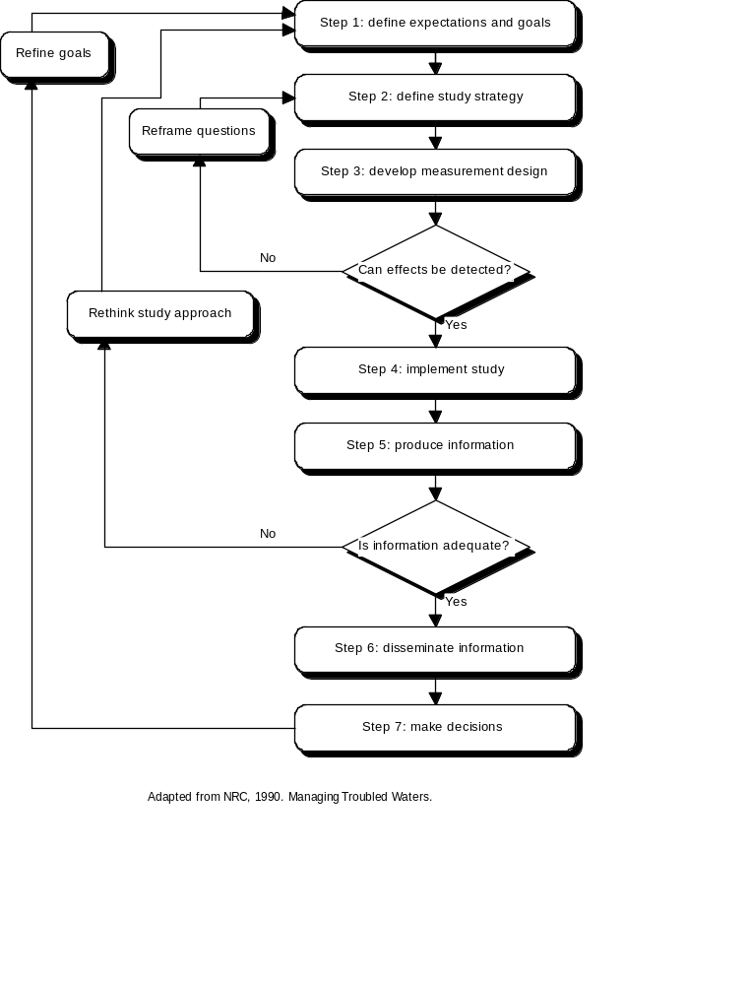
Figure 3-1 Relationship of Mass Emissions Monitoring to Other Management Efforts

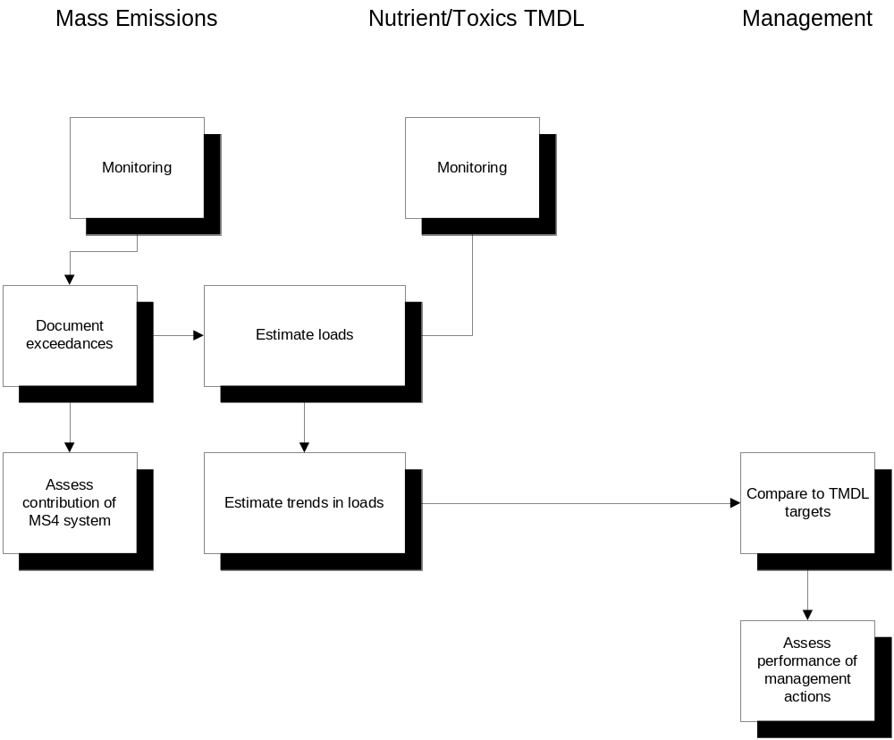
Figure 3-2 Mass Emissions Monitoring Sites

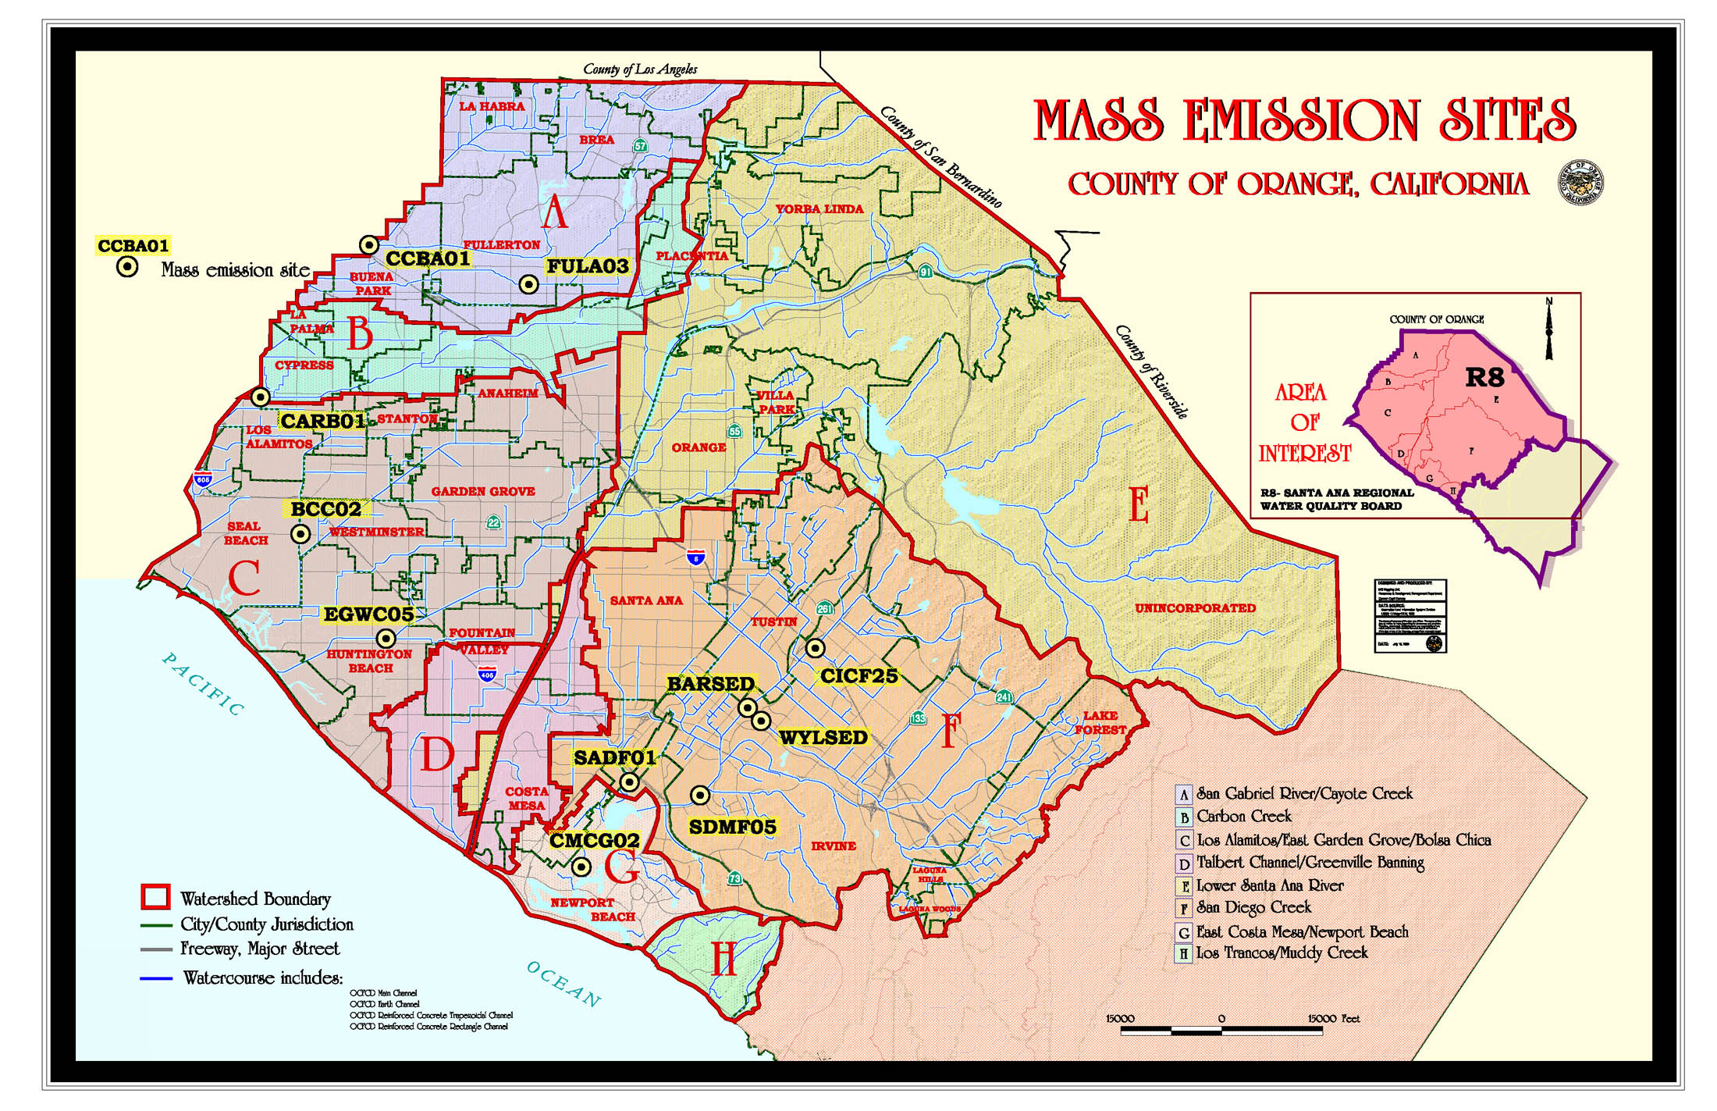
Figure 3-3 Adaptive Toxicity Testing Protocol

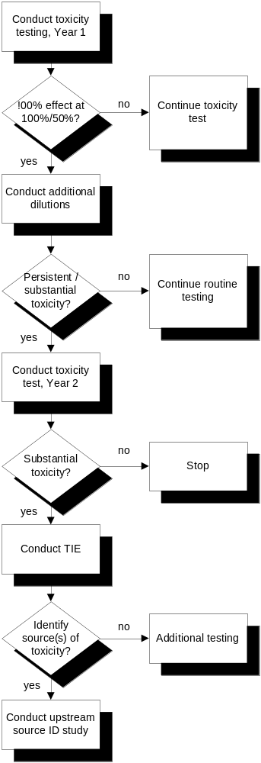
Figure 3-4 Estuary / Wetlands Monitoring Sites

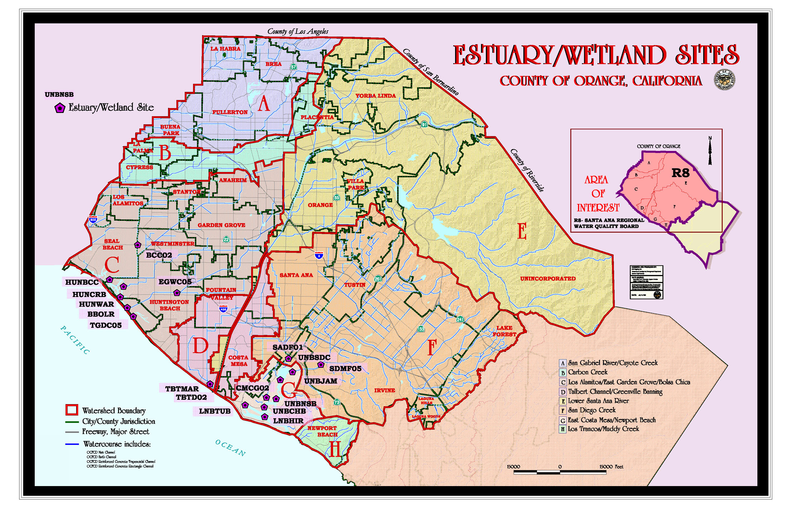
Figure 3-5 Conceptual Model Underlying Estuary / Wetlands Assessment

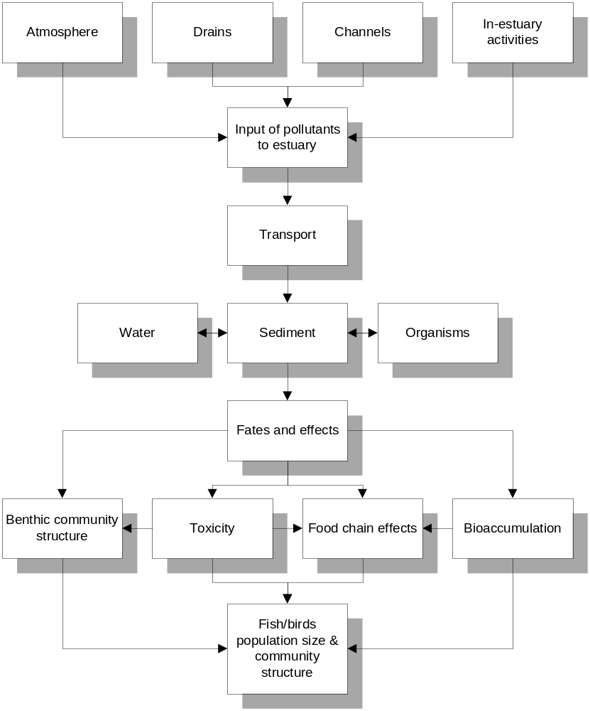

Figure 3-6 Stormdrain Prioritization Framework

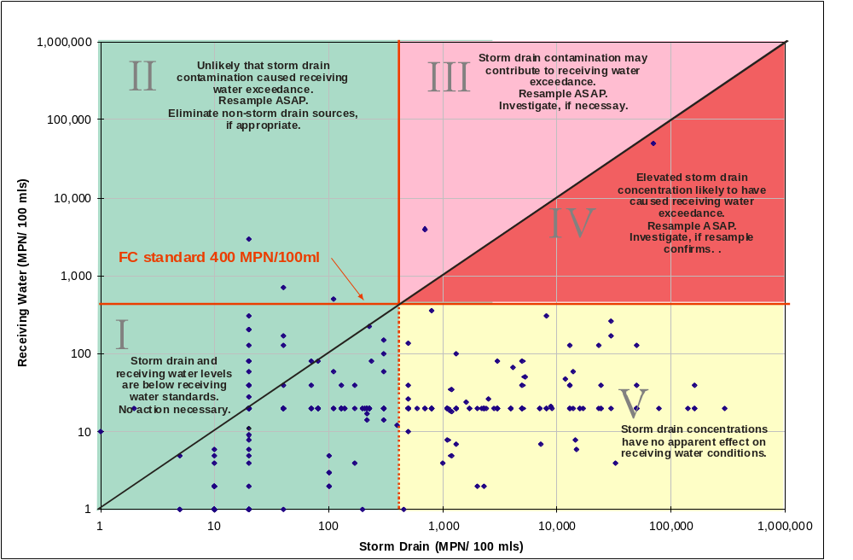

Figure 3-7 Coastal Storm Drain Site Selection Process

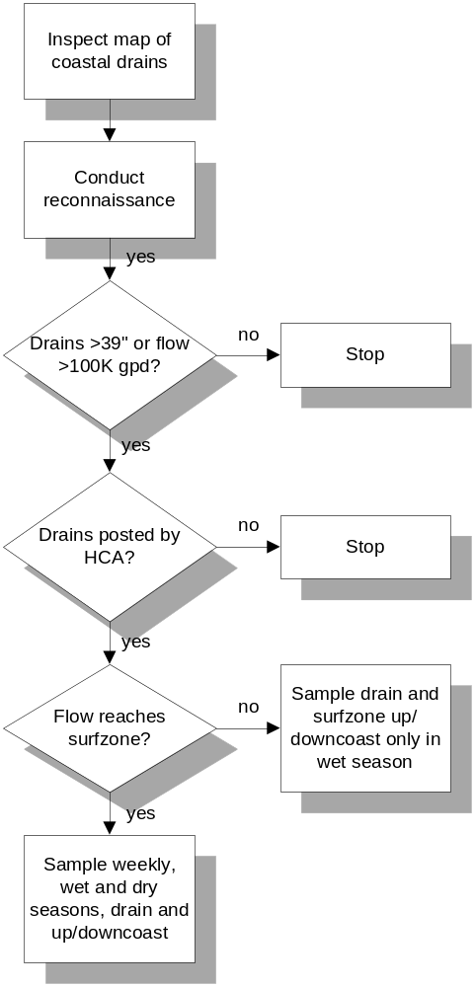

Figure 3-8 Bacteriology / Pathogen Monitoring Sites

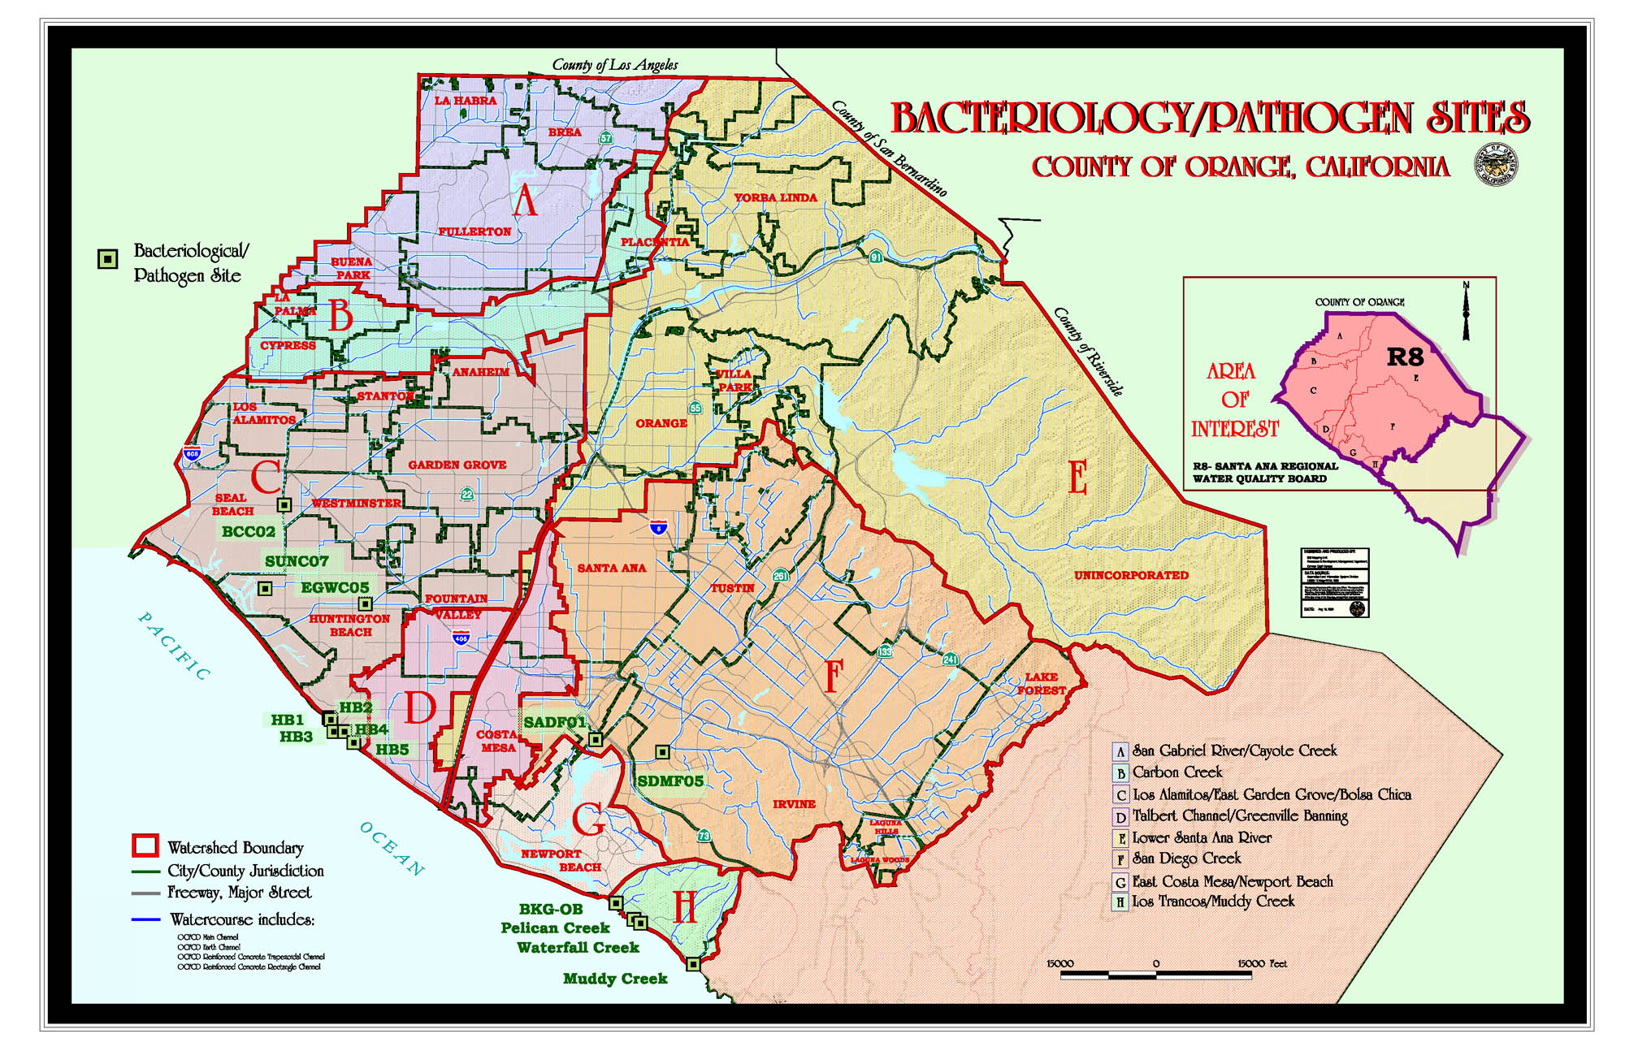
Figure 3-9 Structure of the “Triad” Approach to Bioassessment

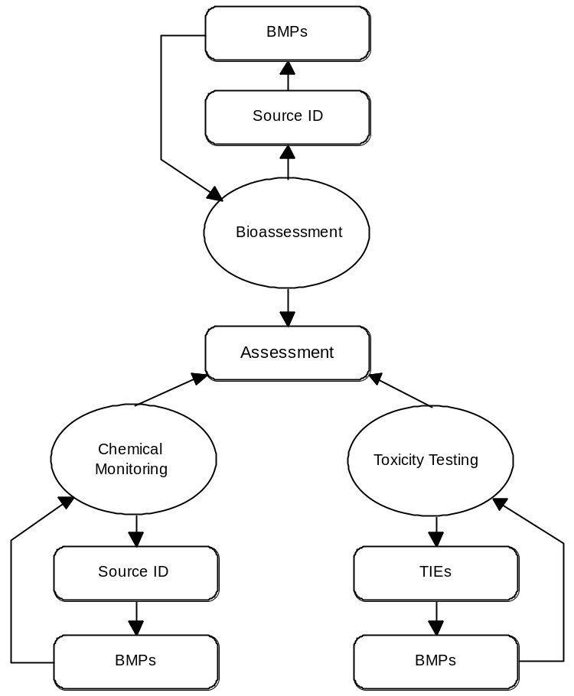

Figure 3-10 Bioassessment Monitoring Sites

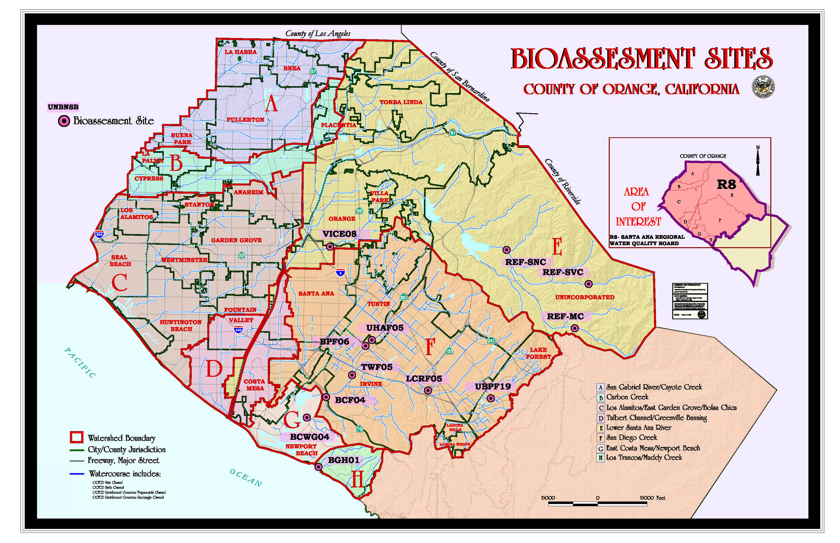
Figure 3-11 Reconnaissance Monitoring Sites (see Tables 3-3 and 3-4 for descriptions of site locations)

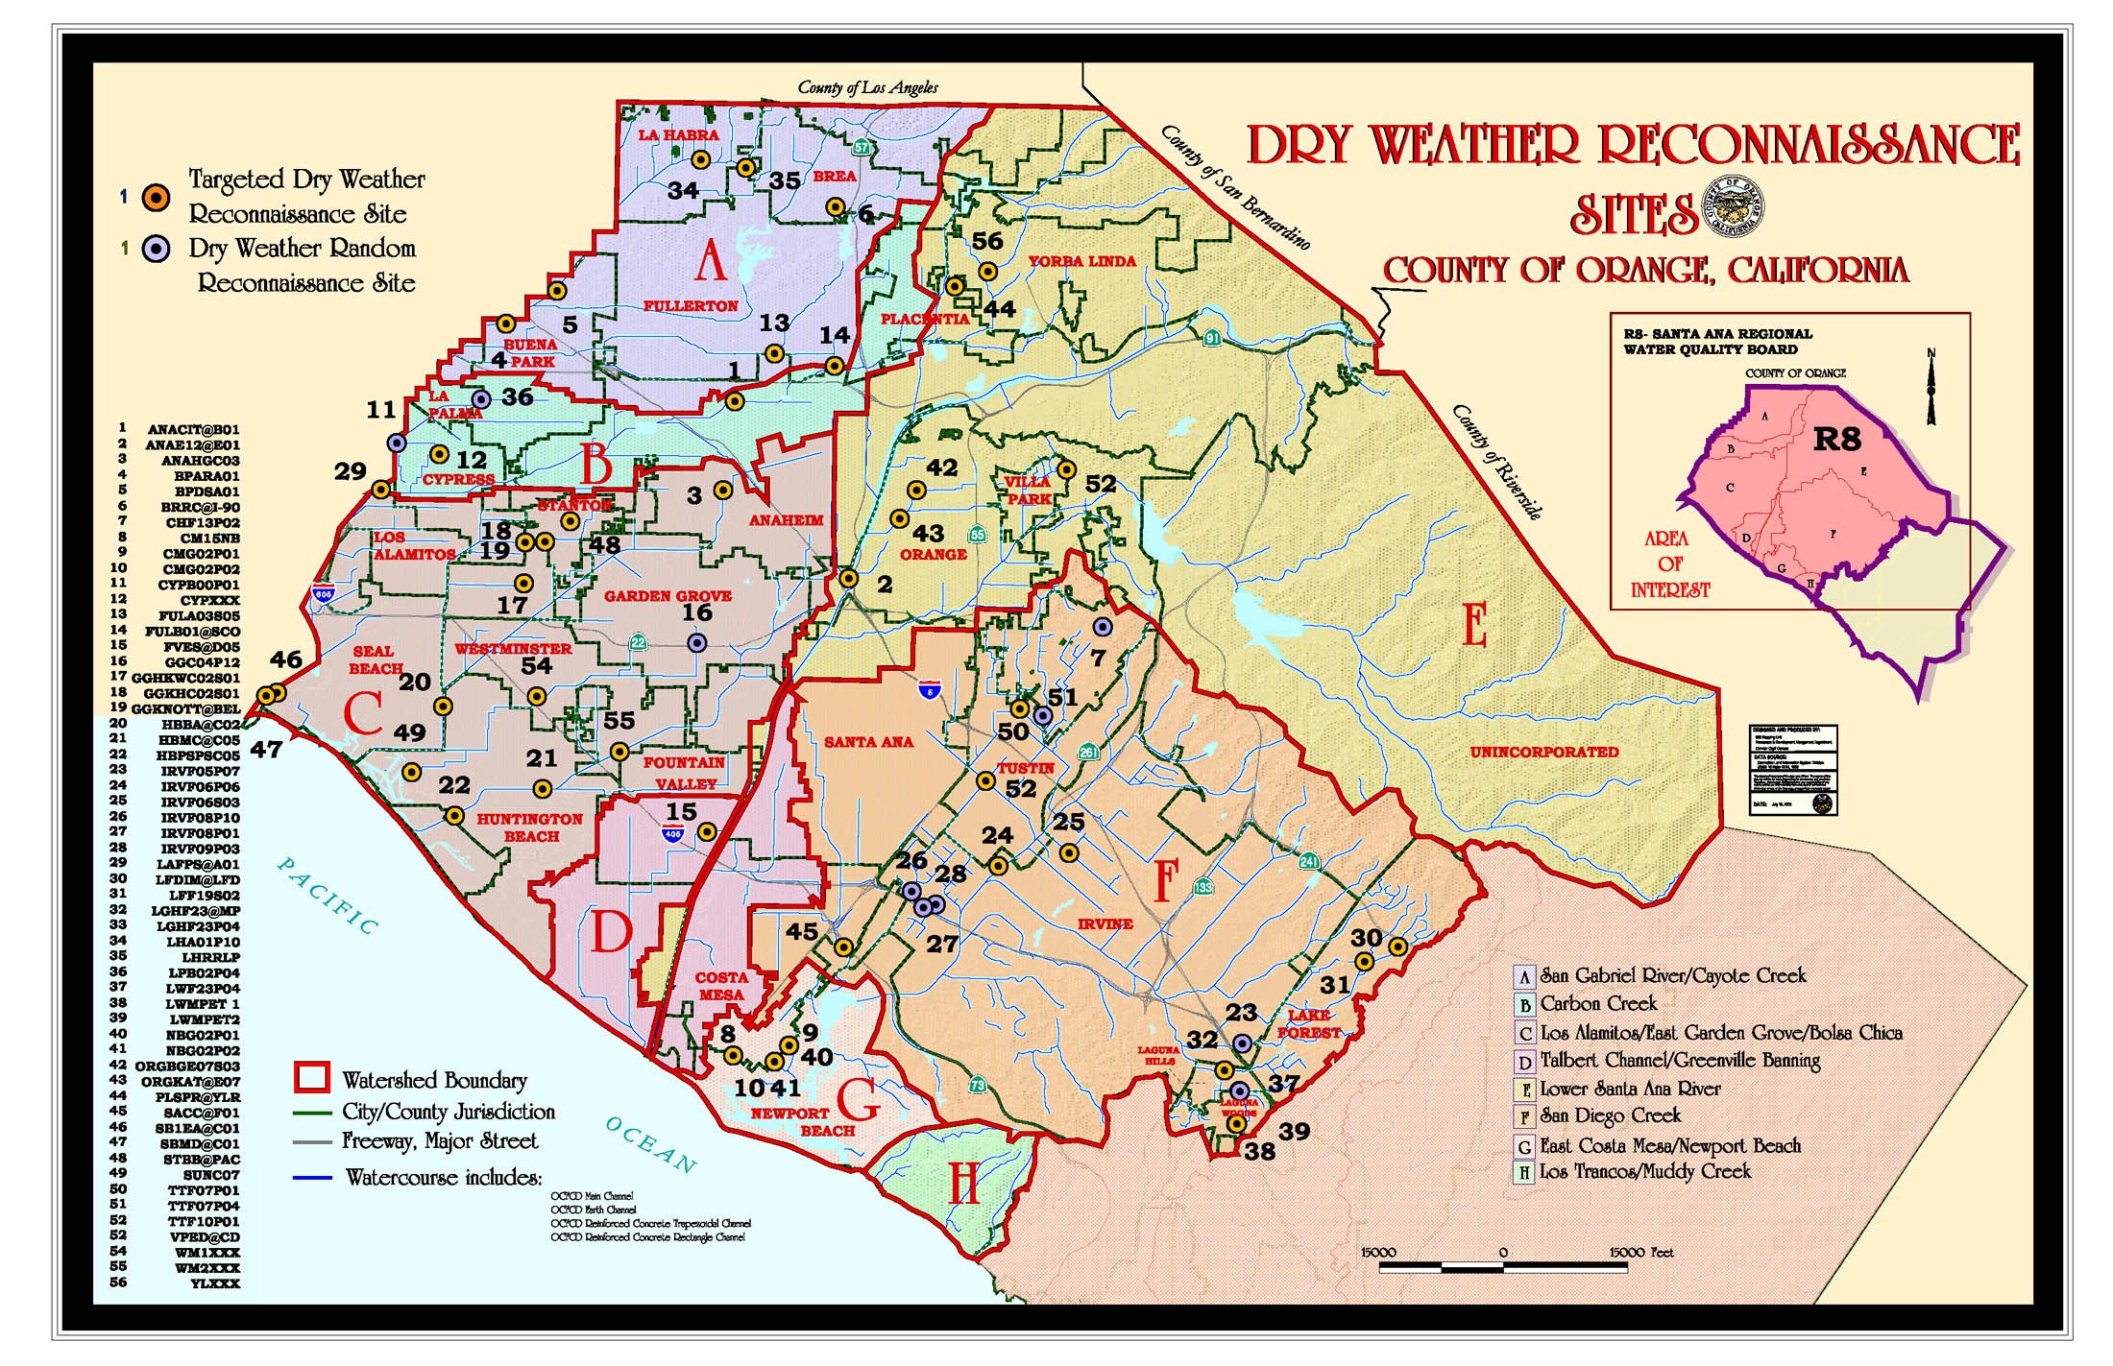
Figure 3-12 Process for Determining Basis of Comparison for Reconnaissance Sites

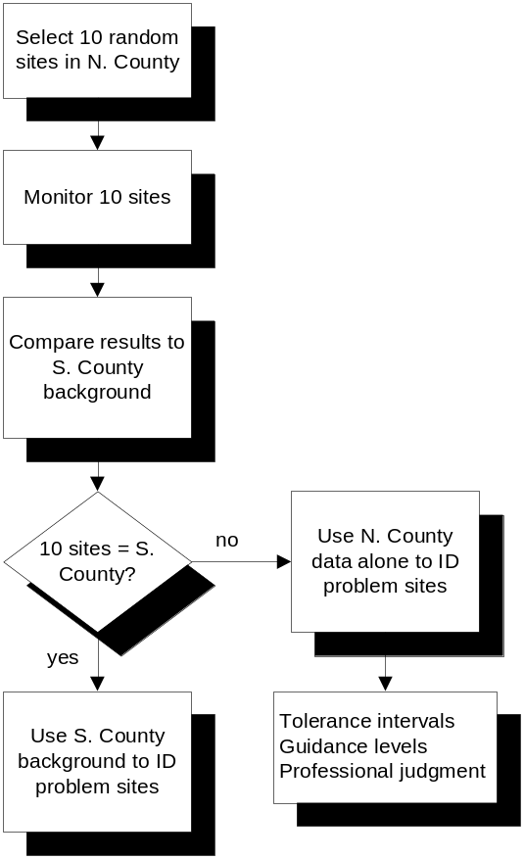
Figure 3-13 Land Use Correlations Monitoring Sites
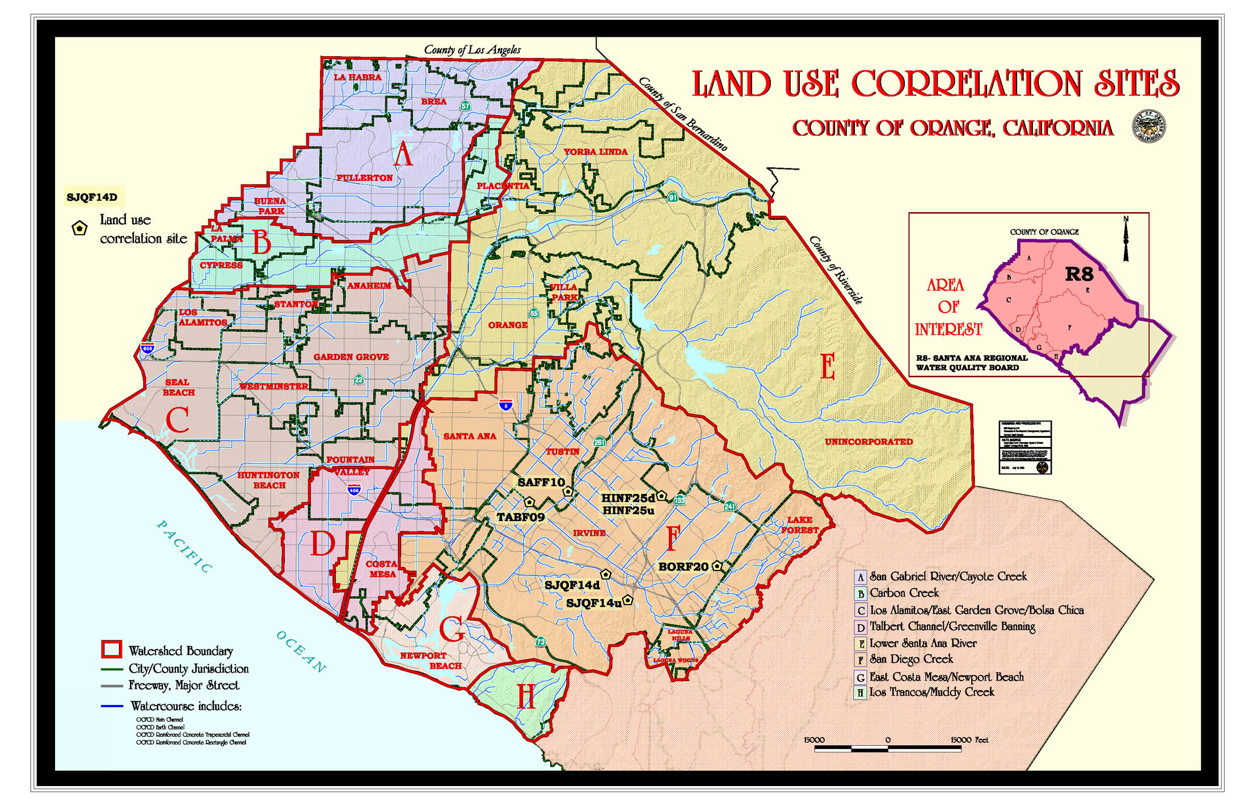
Figure 3-14 Monitoring Design for Land Use Correlations

 | Grassland | Agriculture | Base | Reference
Before conversion | Monitoring event B1 *  Monitoring event B2 | Monitoring event B1  Monitoring event B2 | Monitoring event B1  Monitoring event B2 | Monitoring event B1  Monitoring event B2
After conversion | Monitoring event A1 *  Monitoring event A2 | Monitoring event A1  Monitoring event A2 | Monitoring event A1  Monitoring event A2 | Monitoring event A1  Monitoring event A2

* “B” refers to the Before condition, and “A” to the After condition.

Figure 4-1 Receiving Waters Monitoring Program Evolution

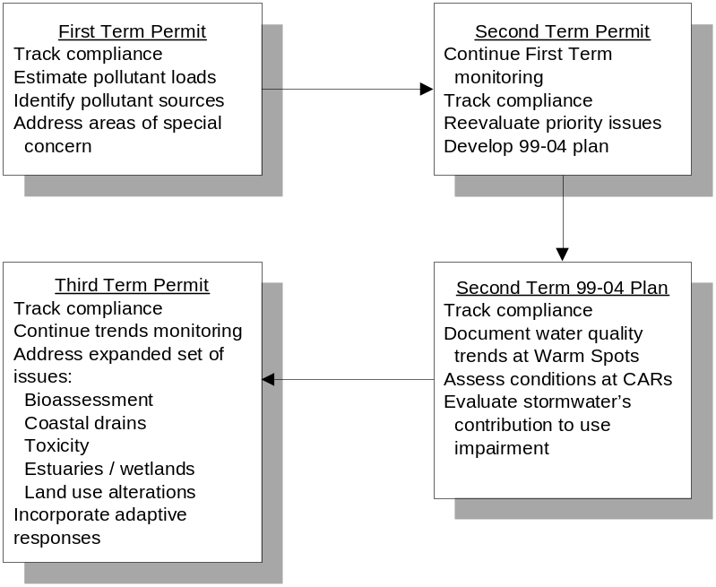

“Warm spots” refer to sites with pollutant levels that are elevated relative to the long-term County average
“CARs” refers to critical aquatic resources, sites with greater beneficial use potential

