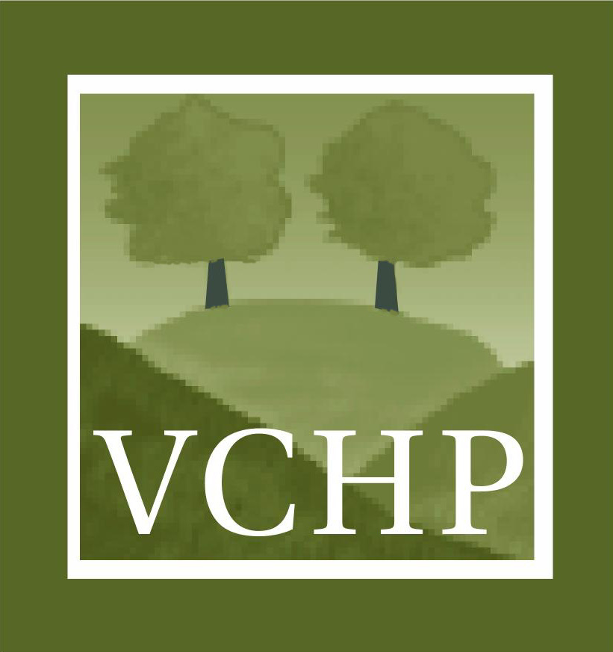
Ventura Citizens for Hillside Preservation
P. O. Box 1575 · Ventura, CA 93002 · www.vchp.org · 805.644.9247

May 27, 2010
Executive Officers

Diane Underhill
President

Claudia Armann
Vice President

Will Thompson
Secretary

Hugh Oliver
Treasurer

Board of Directors

Kathy Bremer

Matt Byrne

Norene Charnofsky

Jim Hines

Carol Lindberg

Charlie Hoppin, Chair and Board Members
State Water Resources Control Board
1001 I Street
Sacramento, CA 95814
Via Electronic Mail: commentletters@waterboards.ca.gov

RE: State Water Board’s Proposed 2010 California 305(b)/303(d) Integrated Report

Dear State Water Resources Control Board,

On behalf of the Ventura Citizens for Hillside Preservation (VCHP), which represents thousands of local Ventura area citizens, I am pleased to send the following comments on the State Water Board’s Proposed 2010 California 305(b)/303(d) Integrated Report. I should pause here and note that it is VCHP's mission to preserve Ventura's hillsides, open space, Ventura River watershed, and quality of life by actively participating in the public planning process through public education campaigns as well as supporting like-minded organizations, public officials, political candidates, and ballot measures. For more information visit: www.vchp.org

VCHP commends the efforts put forth by the State and Regional Water Board staff while updating California’s 303(d) list. VCHP strongly supports the 1,464 new impaired water body-pollutant combinations proposed for addition to the 303(d) list in the 2010 Integrated Report. Identifying these new water body-pollutant combinations is a notable achievement by State and Regional Water Board staff and demonstrates careful review of the available data.

Almost forty years after Congress passed the Clean Water Act, promising waterways that would be safe to fish and drink, the 2010 Integrated Report enumerates the severe impairment of more than 1,700 of our waterways. This represents over 3,500 303(d) listings. These impairments are a shocking reminder to Californians of the extent to which water pollution prevents the enjoyment of beneficial uses that our State's waterways once provided.

These impairments demonstrate how we need to double and triple efforts to achieve the goals of the Clean Water Act. In light of the tremendous work needed to achieve the Clean Water Act goals, VCHP strongly encourages the State Water Board to adopt all of the 1,464 new 303(d) listings proposed in the 2010 Integrated Report. VCHP also urges the State and Regional Water Board staff to immediately begin implementation of enforceable strategies to clean up the state’s waters.

California's people, wildlife, and unique habitats all deserve clean, thriving, flowing waterways-- both now and in the future. We urge the State Board’s adoption of the recommended additions to the 2010 303(d) list. Thank you for your attention.

Sincerely,

Diane Underhill
President, Ventura Citizens for Hillside Preservation

