


State Water Resources Control Board
Division
of Water Rights

Water Rights Information Management System Replacement (e-WRIMS)

Feasibility Study Report

Revised per DOF December 22, 2005

State of California
State Water Resources Control Board
Office of Information Technology
1001 I Street 8th Floor
Sacramento, CA 95814

Document control

Date | Version | Summary of Revisions
May 9, 2005 | 1.0 | Draft document for SWRCB Review
May 16, 2005 | 1.6 | Draft with comments from John Hagan incorporated in Section 3, Bus. Case
June 3, 2005 | 5.0 | Near-final draft incorporating comments from Nancy Miller and Vicky Whitney on key sections
June 21, 2005 | 6.3 | Final draft incorporating further comments from Vicky Whitney, Nancy Miller, Patrice Norris, Rebecca Lee, Steve Herrera, Ming-shyong Yang,and others
Dec. 22, 2005 | 7.0 | Final incorporating two changes requested by DOF: clarification of project management costs being part of vendor team costs, and inclusion of interest on 5-year-loan to cover e-WRIMS costs up-front.
January 6, 2006 | 7.1 | One further change required by DOF. Moved funding plan amounts from 2007/2008 and 2008/2009 into 2006/2007 to show a single-year funding strategy, as per the BCP for the funding plan.

Table of Contents

1. Executive Project Approval Transmittal 1-4
2. Project Summary Package 2-1
3. Business Case 3-1
3.1. Division of Water Rights Program Background 3-1
3.2. Water Rights Business Processes 3-4
3.3. The Appropriative Water Rights Process 3-11
3.4. Water Rights Systems Supporting the Business Processes 3-13
3.5. Business Problems and Impacts 3-16
3.6. Business Objectives 3-24
3.7. Business Problems – Objectives Traceability Matrix 3-26
3.8. Time Savings Benefits to Be Realized 3-28
3.9. Business Functional Requirements 3-33
4. Baseline Analysis 4-1
4.1. Current Method 4-1
4.2. Existing Technical Environment 4-18
4.3. Technical Requirements and Standards 4-22
5. Proposed Solution 5-1
5.1. Overview 5-1
5.2. Solution Description 5-6
5.3. Rationale for Selection and Alternatives Considered 5-19
6. Project Management Plan 6-1
6.1 Project Manager Qualifications 6-1
6.2 Project Management Methodology 6-2
6.3 Project Organization 6-3
6.4 Project Priorities 6-6
6.5 Project Plan 6-6
6.6 Project Monitoring 6-20
6.7 Project Quality 6-21
6.8 Change Management 6-22
6.9 Authorization Required 6-23
7. Risk Management Plan 7-1
7.1 Risk Management Approach 7-1
7.2. Risk Management Worksheet 7-5
7.3. Risk Tracking and Control 7-12
8. Economic Analysis Worksheets (EAWs) 8-1
8.1. Existing System Cost Worksheet 8-1
8.2. Proposed Alternative Cost Worksheet 8-2
8.3. Economic Analysis Summary Worksheet 8-4
8.4. Project Funding Plan Worksheet 8-5

Appendix A. Acronym List

List of Tables

Table 3-1. Current Water Rights Systems and Databases 3-13
Table 3-2. Business Problems-Objectives Matrix 3-26
Table 3-3. Time Saving Anticipated 3-28
Table 3-4. Business Functional Requirements for the Water Rights Division 3-33
Table 4-1. Current Systems Supporting DWR Business Processes 4-11
Table 5-1. e-WRIMS Hardware 5-6
Table 5-2. e-WRIMS Resource Requirements 5-13
Table 5-3. Implement an Existing System from another State 5-20
Table 5-4. COTS Packages in Use by Other State Water Rights Organizations 5-21
Table 5-5. Implement COTS Components from Various States/Vendors 5-22
Table 5-6. Upgrade the Existing IT Infrastructure 5-22
Table 5-7. Apply Additional Staff Resources 5-24
Table 6-1. e-WRIMS Project Trade-Off Matrix 6-6
Table 6-2. e-WRIMS Rating for Oversight 6-10
Table 6-3. e-WRIMS Project Team Roles and Responsibilities 6-11
Table 6-4. e-WRIMS Project Phases, Schedule, and Deliverables 6-17
Table 7-1. Risk Priority Matrix 7-3
Table 7-2. Risk Management Worksheet 7-5
Table 8-1 - Other IT Costs 8-1
Table 8-2 - Estimated Contractor Rates 8-2

List of Figures

Figure 3-1. Overall Process of Obtaining a Water Right 3-5
Figure 3-2. Applying for a Water Right 3-6
Figure 3-3. CEQA Process 3-7
Figure 3-4. Process for Obtaining a Licensed Water Right 3-8
Figure 3-5. Process for Obtaining a Hearing 3-9
Figure 3-6. Process for Enforcing Water Rights 3-10
Figure 4-1. Current Architecture (Servers are Compaq Proliant 3000) 4-6
Figure 4-2 - WAN Topology 4-20
Figure 5-1. Proposed e-WRIMS Solution Architecture 5-5
Figure 5-2. Water Board’s Enterprise Technical Architecture 5-8
Figure 6-1. e-WRIMS Project Organization Chart 6-4
Figure 6-2. Water Board Office of Information Technology Organization Chart 6-5
Figure 8-1 - Baseline WRIMS Costs 8-6
Figure 8-2 - e-WRIMS Proposed Alternative Costs 8-7
Figure 8-3 – e-WRIMS Economic Analysis Summary Worksheet 8-8
Figure 8-4 - Project Funding Costs 8-9

Executive Project Approval Transmittal

Information Technology Project Request  Feasibility Study Report  Executive Approval Transmittal |  | 
Department Name
State Water Resources Control Board
Project Title (maximum of 75 characters)
Water Rights Information Management System (e-WRIMS) Replacement
Project Acronym | Department Priority |  | Agency Priority
e-WRIMS | 1 |  | 1
Approval Signatures
I am submitting the attached Feasibility Study Report (FSR) in support of our request for the Department of Finance’s approval to undertake this project. I certify that the FSR was prepared in accordance with State Administrative Manual Sections 4920-4930.1 and that the proposed project is consistent with our information technology strategy as expressed in our current Agency Information Management Strategy (AIMS).
I have reviewed and agree with the information in the attached Feasibility Study Report.
Chief Information Officer |  |  | Date Signed
Printed name: | Nancy Miller
Budget Officer |  |  | Date Signed
Printed name: | Bill Damian
Department Director (or designee) |  |  | Date Signed
Printed name: | Celeste Cantú
Agency Secretary |  |  | Date Signed
Printed name: | Dr. Alan C. Lloyd, Ph.D.

Project Summary Package

- Section A: Executive Summary
- Section B: Project Contacts
- Section C: Project Relevance to State and/or Department/Agency Plans
- Section D: Budget Information
- Section E: Vendor Project Budget
- Section F: Risk Assessment Information

1. | Submittal Date |  | June 30, 2005
 |  |  | FSR | SPR | PSP Only | Other:
2. | Type of Document |  | ✓
 | Project Number |  |  |  | 115
 |  |  |  |  |  |  |  |  | Estimated Project Dates
3. | Project Title |  | Water Rights Information Management System Replacement (e-WRIMS) |  |  |  |  |  | Start | End
 | Project Acronym |  | e-WRIMS |  |  |  |  |  | 7/03/06 | 9/07/07
4. | Submitting Department |  | State Water Resources Control Board
5. | Project Objectives
- Provide a timely response to the public’s need for water rights information as required by legislative mandate.
- Provide services on-line to the public as required by legislative mandate.
- Integrate water rights processes and information.
- Improve the ability to manage and collect water rights fees, track payment, and coordinate fee-related activities.
- Increase the reliability and quality of water rights data.
- Integrate accurate GIS data to enable more complete understanding of water availability and compliance
based on current law, regulations and policy.
- Provide reporting tools to properly allocate resources and track ongoing Division of Water Rights (Division) activities and assignments.
6. | Proposed Solution
 | The proposed solution is a replacement of the current Water Rights Information Management System (WRIMS) with an integrated, enhanced new version, e-WRIMS, to support the administration of California water rights and integrate with the Water Board’s existing California Integrated Water Quality System (CIWQS), to support and improve core business functions and comply with new legislative mandates.

7. | Major Milestones | Estimated Completion Date
 | Vendor selection (Process Analysis, Implementation and Training Vendor; Core System Design and Implementation Vendor; Data Integration Vendor; GIS Development Vendor, and IPOC Vendor) | 3/31/06
 | Contract approval | 5/12/06
 | Task 1: Project initiation | 7/31/06
 | Task 2: Planning and scoping | 9/29/06
 | Task 3: Design and documentation | 12/18/06
 | Task 4: Development (Build) | 3/08/07
 | Task 5: Data conversion and cleanup | 5/07//07
 | Task 6: Testing | 7/06/07
 | Task 7: Training and outreach | 9/07/07
 | Task 8: Implementation | 9/07/07 in parallel w/Task 7
 | Task 9: Closeout | 10/03/07
 | Key Deliverables | Estimated Delivery Date
 | 1: Project charter, schedule and detailed workplan | 7/31/06
 | 2: Detailed functional requirements, assumptions and constraints | 9/29/06
 | 3: Technology architecture plan, software design specifications, system design, logical and physical data model; data dictionary and data migration plan | 12/18/06
 | 4: Develop screens and reports; physical database enhancements; configuration of system, network architecture and development environment; install and configure database; application installation and configuration | 3/08/07
 | 5: Data conversion plan; data mapping, data conversion software, successful data conversion | 5/07/07
 | 6: Test cases, test plans and test results for system integration, interfaces, network performance tests; user acceptance test plan, scripts and retesting | 7/06/07
 | 7: Training and outreach materials, training sessions, and system documentation | 9/07/07
 | 8: Implementation plan, final data migration, production application | 9/07/07
 | 9: Final project documentation and technical knowledge transfer | 9/07/07in parallel w/Task 7

Executive Contacts
 | First Name | Last Name | Area  Code | Phone # | Ext. | Area  Code | Fax # | E-mail
Agency Secretary | Dr. Alan C. | Lloyd | 916 | 323-2514 |  |  |  | alloyd@calepa.ca.gov
Dept. Director | Celeste | Cantú | 916 | 341-5615 |  | 916 | 341-5621 | ccantu@waterboards.ca.gov
Budget Officer | Bill | Damian | 916 | 341-5144 |  | 916 | 341-5147 | damib@waterboards.ca.gov
CIO | Nancy | Miller | 916 | 341-5220 |  | 916 | 341-5203 | nmiller@waterboards.ca.gov
Proj. Sponsor | Victoria | Whitney | 916 | 341-5302 |  | 916 | 341-5400 | vwhitney@waterboards.ca.gov

Direct Contacts
 | First Name | Last Name | Area  Code | Phone # | Ext. | Area  Code | Fax # | E-mail
Doc. prepared by | Renee | Taylor | 530 | 692-2000 |  | 530 | 692-2011 | expert@rt-consulting.com
Primary contact | Nancy | Miller | 916 | 341-5220 |  | 916 | 341-5203 | nmiller@waterboards.ca.gov
Project Manager | Nancy | Miller | 916 | 341-5220 |  | 916 | 341-5203 | nmiller@waterboards.ca.gov

 | What is the date of your current Operational Recovery Plan (ORP)? |  |  | Jan. 6, 2004 |  | Project # | 115
 | What is the date of your current Agency Information Management Strategy (AIMS)? |  |  | March 2004 |  | Doc. Type | FSR
 | For the proposed project, provide the page reference in your current AIMS and/or strategic business plan. |  |  | IMS  Section 10
 |  |  |  | 29
 |  |  |  |  |  | Yes | No
 | Is the project reportable to control agencies? |  |  |  |  | 
 | If YES, CHECK all that apply:
 | X | - The project involves a budget action.
 | X | - A new system development or acquisition that is specifically required by legislative mandate or is subject to special legislative review as specified in budget control language or other legislation.
 |  | - The project involves the acquisition of microcomputer commodities and the agency does not have an approved Workgroup Computing Policy.
 | X | - The estimated total development and acquisition cost exceeds the departmental cost threshold.
 |  | - The project meets a condition previously imposed by Finance.

 |  |  |  |  |  |  |  |  |  |  |  |  |  |  |  | Project # |  |  | 115
 |  |  |  |  |  |  |  |  |  |  |  |  |  |  |  | Doc. Type |  |  | FSR
Budget Augmentation Required?
 | No
 | Yes |  | If YES, indicate fiscal year(s) and associated amount:
 |  |  | FY | 2005-06 |  |  |  | 2006-07 |  | FY | 2007-08 | FY | 2008-09
 |  |  | $ 19,980 |  |  |  | $1,957,470 |  |  | $281,580 |  | $ 31,060 |  | 0 |  |  | 0

PROJECT COSTS
 | Fiscal Year | 2005/06 | 2006/07 | 2007/08 | 2008/09 | TOTAL
 | One-Time Cost | $19,980 | $2,477,330 | $529,620 | $140,000 | $3,166,930
 | Continuing Costs | 0 | 31,060 | $314,445 | $374,556 | 720,061
 | TOTAL PROJECT BUDGET | $19,980 | 2,508,390 | $844,065 | $514,556 | $3,886,991

SOURCES OF FUNDING
 | General Fund | 0 | 0 | 0 | 0 | 0
 | Redirection | $19,980 | $330,920 | $342,485 | $343,496 | $1,036,881
 | Reimbursements (loan interest, to be repaid by fees) | 0 | $580,000 | 0 | 0 | 580,000
 | Federal Funds | 0 | 0 | 0 | 0 | 0
 | Special Funds | 0 | $2,270,110 | 0 | 0 | $2,270,110
 | Grant Funds | 0 | 0 | 0 | 0 | 0
 | Other Funds | 0 | 0 | 0 | 0 | 0
 | PROJECT BUDGET | $19,980 | $3,181,030 | $342,485 | $343,496 | $3,886,991

PROJECT FINANCIAL BENEFITS
 | Cost Savings/Avoidances |  |  |  |  | No net cost
 | Revenue Increase |  |  |  |  | or increase
Note: The totals in Item 4 and Item 12 must have the same cost estimate.

 |  |  |  |  |  |  |  | Project # | 115
 | Vendor Cost for FSR Development (if applicable) |  |  |  |  |  |  | Doc. Type | FSR
 |  | Vendor Name | Renee Taylor Consulting, Inc.

VENDOR PROJECT BUDGET
 | Fiscal Year | 2006-2007 | 2007-2008 | TOTAL
 | Vendor Budget | $1,453,360 | $220,520 | $1,673,880
 | Independent Oversight Budget | $147,500 | $30,000 | $177,500
 | Other Contract Services | $30,000 |  | $30,000
 | Procurement Vendor
 | TOTAL VENDOR BUDGET | $1,630,860 | $250,520 | 1,881,380

RISK ASSESSMENT
 | Yes | No
Has a Risk Management Plan been developed for this project? | 
General Comment(s)
In order to manage and reduce the overall risk of the e-WRIMS Project, the Water Board has developed a e-WRIMS Replacement Risk Management Plan in Section 7 of this document. This Plan includes the risk management worksheet, risk assessment and identification, risk prioritization, and risk tracking and control.

Business Case

Division of Water Rights Program Background
Governor Schwarzenegger’s “Action Plan for California’s Environment” includes protection for California’s water supply and water quality through water resource management efforts that foster accountability and action.

The State Water Resources Control Board (Water Board) is the State agency responsible for administering water rights and is required to maximize the beneficial uses of California’s water resources and to protect public trust uses.

Authority of the Water Board over Water Rights
The Water Board’s water rights authority is defined primarily by the California Water Code (Wat. Code) and the California Code of Regulations (Cal. Code Regs., or CCR). The Water Board has sole administrative authority over surface and some ground water appropriations initiated after 1914. The Water Board also has jurisdiction to enforce provisions of the California Constitution and the Water Code relating to the prohibition against the waste or unreasonable use of water. The Water Board has authority to enforce the permits and licenses it issues. The Water Board’s Division of Water Rights (Division) is tasked with initial review of these issues, and the Division Chief is delegated authority to make day-to-day decisions on most of these issues.

A water right is acquired through a three-step process: the filing of an application, the issuing of a permit that specifies the conditions under which an entity may develop a water supply project, and finally, the issuing of a license confirming the right, which also specifies the conditions under which it may be exercised. The Division also issues registrations for small domestic use and livestock stockpond uses, water right appropriations which are allowed under limited circumstances.

Other records maintained by the Division include “Statements of Water Diversion and Use” for claimed riparian or pre-1914 appropriative rights, notices of groundwater extraction (a.k.a. “groundwater recordations”) for some over-drafted groundwater basins in Southern California, federal reserved rights, and stockpond certificates, which are similar to livestock pond registrations, but available only for livestock ponds constructed prior to 1969. Livestock Certificates are no longer being issued, but existing certificates are still valid and are still maintained by the Division.

The Water Rights Division was historically funded almost exclusively by the General Fund. However, effective January 2004, the program became almost exclusively fee supported. Water Code Section 1525 et seq. establishes the authority of the Water Board to collect water rights fees for the Water Rights Fund. The Water Rights Fund is established by Section 1550 of the Water Code.

Mission and Responsibilities of the Division of Water Rights
The mission of the Division of Water Rights is to maintain a stable system of water rights in California that best develops, conserves and utilizes in the public interest the water resources of the State, while protecting vested rights, water quality, and the environment.

The Division’s programs are administered in accordance with Cal/EPA’s strategic goals of (1) having “rivers, lakes, estuaries, and marine waters that are fishable, swimmable, support healthy ecosystems, and other beneficial uses” and
(2) “ensuring the efficient use of natural resources.”

The State’s appropriative right system was established to eliminate uncertainty associated with water supply for purposes of encouraging and maintaining economic development in the State. The Water Board, through the Division, administers that system (Wat. Code, § 1225). Other responsibilities of the Division include:
- Ensuring that all water in California is used reasonably and beneficially
(California Constitution, Article X, Section 2; Wat. Code, §§ 100 and 275)
- Preventing the illegal or unauthorized diversion of water. (Wat. Code, § 1052)
- Preparing and periodically reviewing (and revising, if necessary) the State Policy for Water Quality Control for the San Francisco Bay/Sacramento-San Joaquin Delta Estuary (Bay-Delta). This policy contains streamflow and flow-dependent objectives, which protect the beneficial uses of the Bay-Delta, a drinking water source for two-thirds of the State’s population. Because the objectives affect flow, they are primarily implemented through water rights actions.
- Implementing section 410 of the federal Clean Water Act as it relates to hydropower and other water diversion projects, through the issuance of Water Quality Certifications, to ensure that federal agency approvals for these projects comply with State water quality objectives.

By statute, the Division is required to maintain records of all post-1914 appropriative water rights applications, permits, licenses, certificates and registrations. Overall, the Division maintains about 35,000 records of the above post-1914 appropriative rights and other surface water rights diverted under riparian or pre-1914 appropriative water right claims, and of groundwater diversions in certain southern California counties. These records are stored and processed using the Water Rights Information Management System (WRIMS), deployed in 1994.

The Division is organized by function into three sections: (1) the Permitting Section, which processes water right applications and petitions to change existing permit and license conditions, administers the small domestic use and stockpond registration program, and manages the ground water extraction and Statement of Water Diversion and Use recordation programs; (2) the Enforcement Section, which conducts licensing, compliance, and complaint inspections, and initiates and prosecutes enforcement actions; and (3) the Hearings and Special Projects Section which assists the Water Board and the courts in the conduct of water rights-related hearings, assists the Water Board in the preparation of the Bay-Delta Water Quality Control Plan, prepares certain Water Quality Certifications, and provides administrative support to the Division. All three sections also prepare and review any environmental documentation required by the California Environmental Quality Act (CEQA).

The Division is supported almost entirely by regulatory fees. The Division works with the State Board of Equalization (BOE) to bill and collect some of those fees.

New Legislative Mandates Concerning Water Rights
Effective January 2005, new mandates for customer service and reporting requirements have been legislated, including enabling the public to track on-line the status of water right applications and permits, and providing real-time water rights information to the public.

Other new legislation, effective January 2004, changed Division funding to be fee-based for nearly all program activities. This change was made in response to a recommendation by the Legislative Analyst’s Office, which found that the Division’s programs directly benefit water right holders, who should pay for the program. Under the legislation, referred to as SB 1049, the Water Board is required to annually adopt a fee schedule to generate revenues for the water rights program consistent with the annual Budget Act. The Budget Act specifies the budget each fiscal year for the water rights program, which comes primarily from water rights fees deposited into the Water Rights Fund. These fees account for about 95 percent of the Division’s budget. Water Code section 1552 limits the activities the Water Rights Fund can support to those programs administered by the Division. The Water Board also receives a budget allocation for its water quality programs. Because the Water Board’s allocations are from special funding sources that are not, with very limited exceptions, fungible, other funding provided to the Water Board is not available to support the Division of Water Rights’ programs. Additionally, most of the budget allocation from the Water Rights Fund is for personal services. The budget for the water rights program contains only minimal contract funds, which are used primarily to contract for student assistants.

Water Rights Business Processes
The Water Code and Regulations specify procedures that the Water Board must follow when the Division administers programs related to the following processes:
- Processing water right applications and petitions for the protection of vested water right holders, public trust resources, the environment and the public interest;
- Investigating water rights complaints filed by water right holders or environmental groups;
- Conducting compliance inspections of existing diversion facilities;
- Processing petitions to amend permit or license conditions;
- Conducting field inspections of permitted diversion projects to establish maximum beneficial use of water for licensing purposes;
- Providing notification to existing water right holders of new applications to appropriate water;
- Resolving protests filed by those water right holders; and
- Initiating formal enforcement actions against illegal or unauthorized diversions.
The Water Code and Regulations also specify procedures related to the Division’s water quality functions associated with the Bay-Delta Plan and hydropower facilities.
The water rights process is defined in the Water Code, the Water Board regulations, Water Board orders and numerous court decisions. The Water Board must also comply with the requirements of CEQA and the California Endangered Species Act (CESA).
Some of the major processes of the Water Rights Division are shown below, including the overall process (Figure 3-1), the application process (Figure 3-2), the CEQA process (Figure 3-3), the licensing process (Figure 3-4), the hearings process (Figure 3-5) and the enforcement process (Figure 3-6).

Figure 3-1 illustrates the overall process for obtaining a water right:

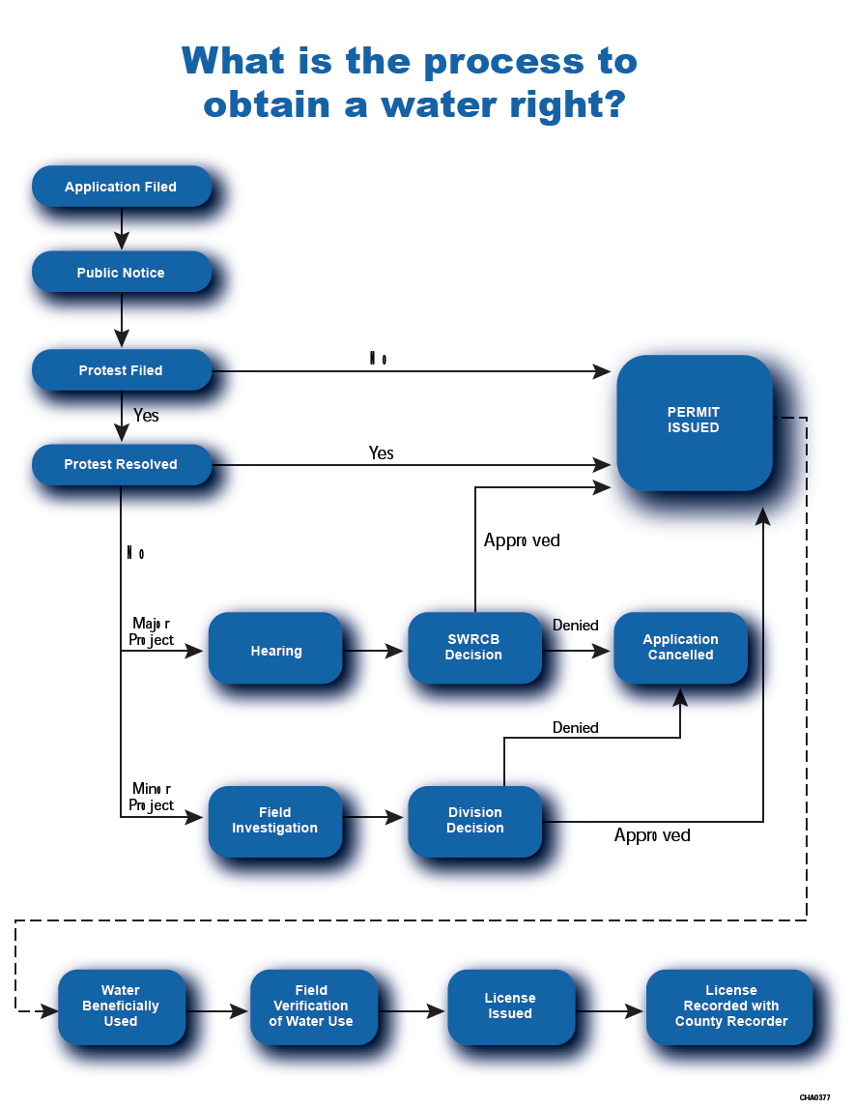
Figure 3-1. Overall Process of Obtaining a Water Right
Figure 3-2 illustrates the process for applying for a water right. This process culminates in a permit being issued unless the application is canceled.

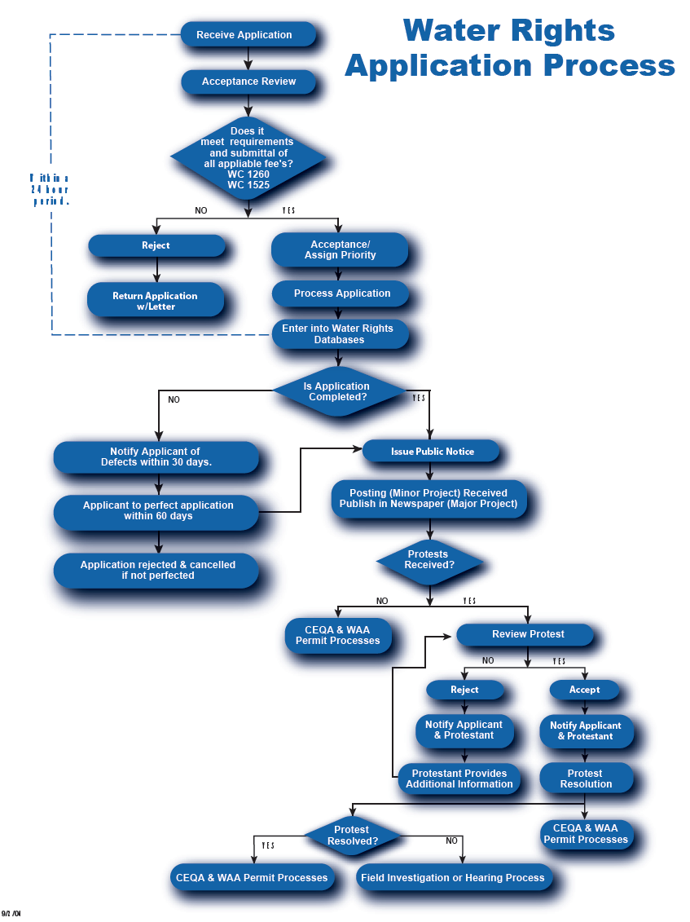
Figure 3-2. Applying for a Water Right

Figure 3-3 illustrates the process for evaluation of a water right project based on the California Environmental Quality Act (CEQA). The CEQA process is performed prior to taking any action to approve a project.
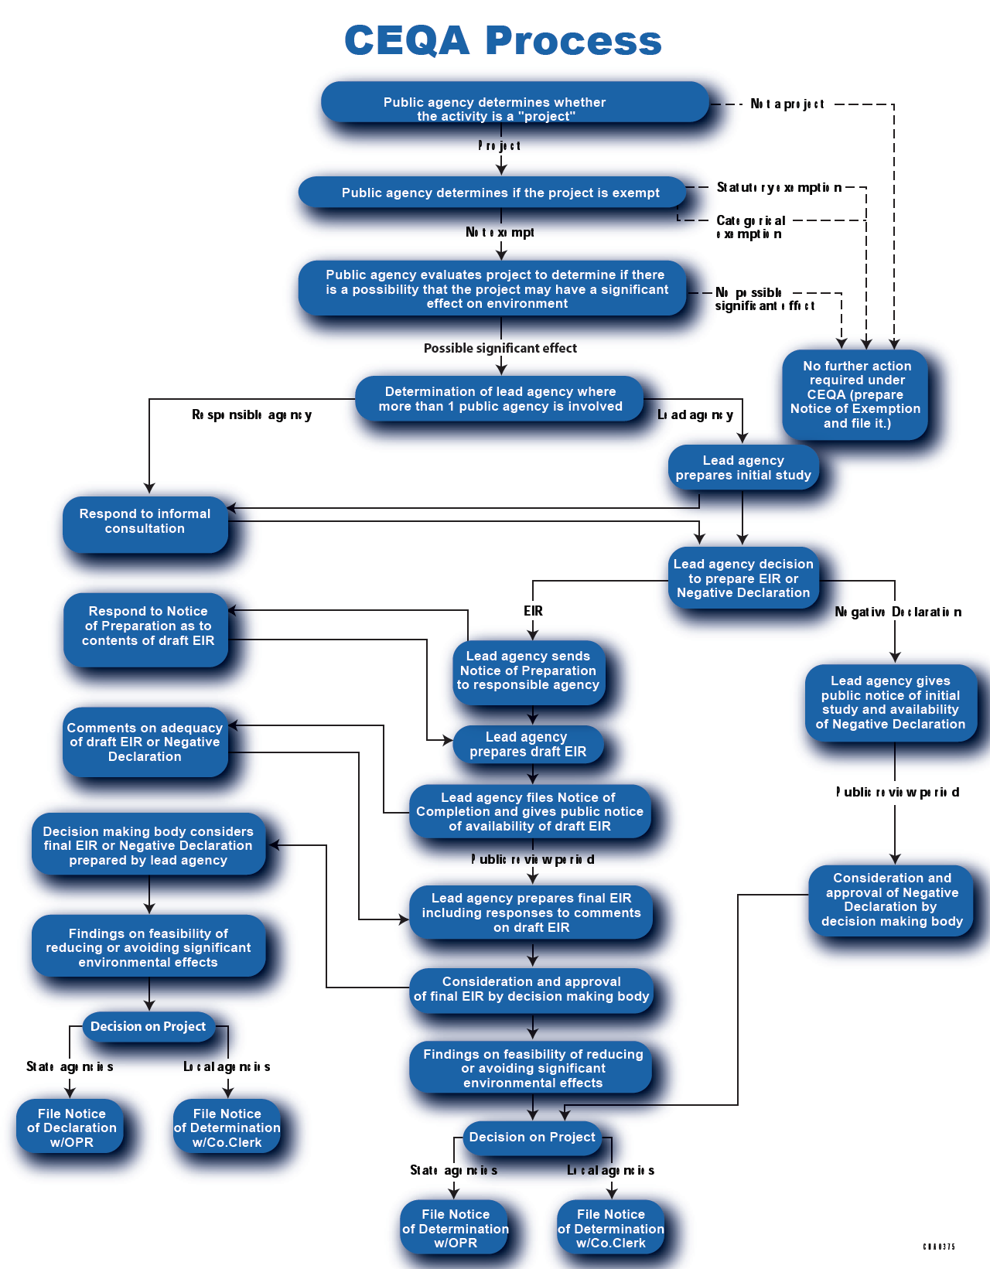
Figure 3-3. CEQA Process
Figure 3-4 illustrates the general process for obtaining a licensed water right.
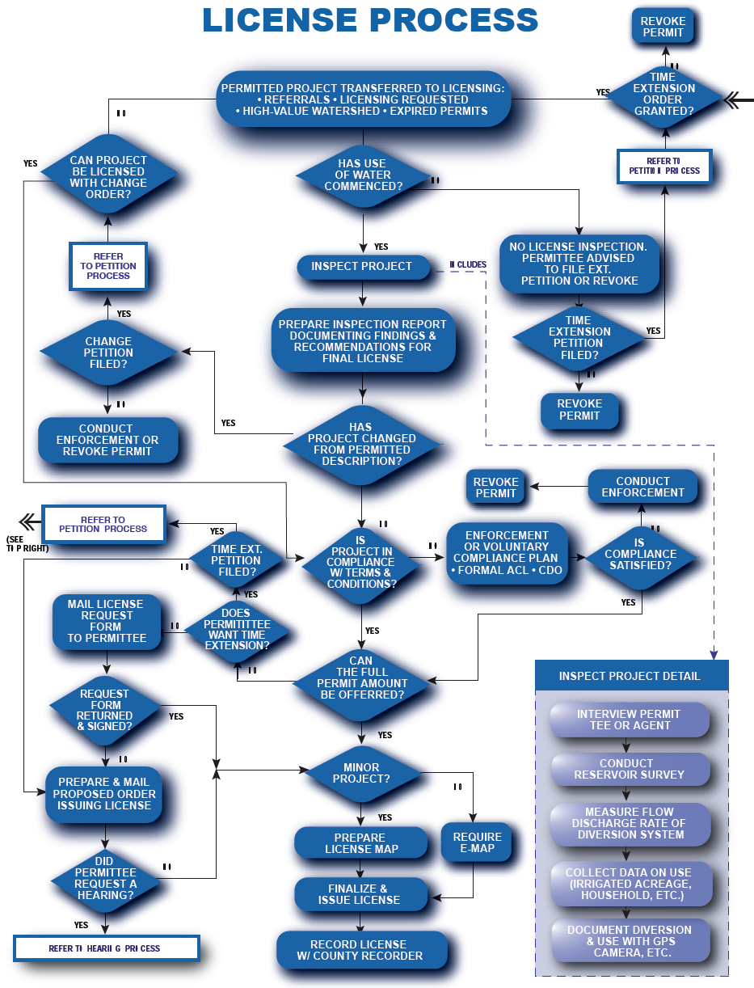
Figure 3-4. Process for Obtaining a Licensed Water Right
Figure 3-5 illustrates the process for obtaining a hearing.
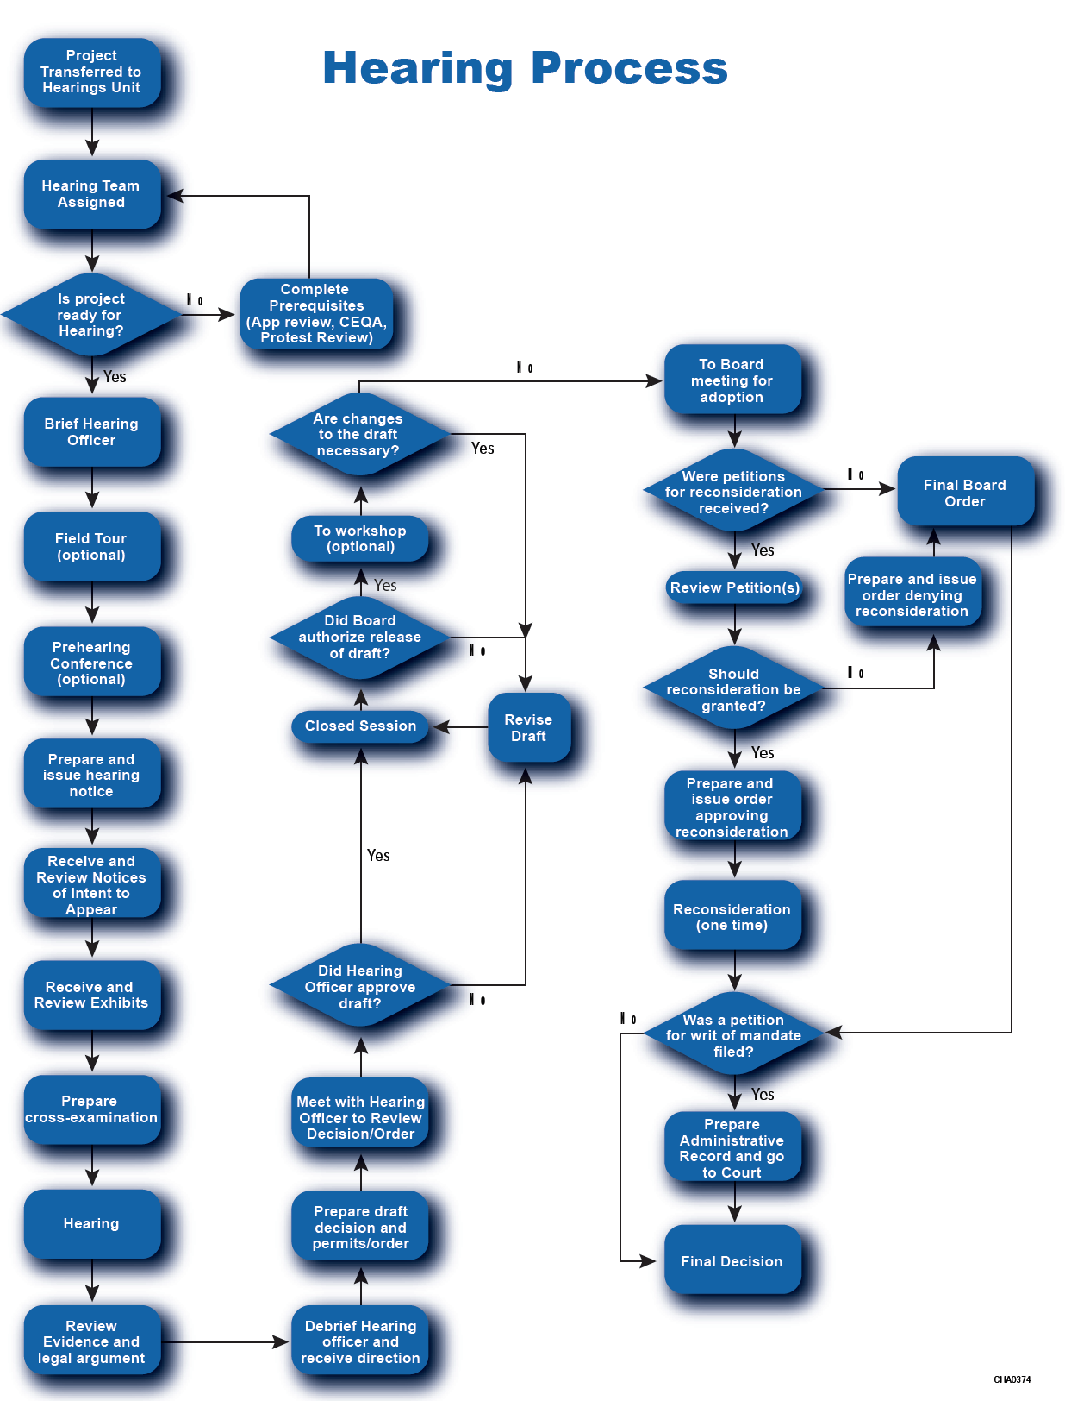
Figure 3-5. Process for Obtaining a Hearing
Figure 3-6 illustrates the process for enforcing water rights.
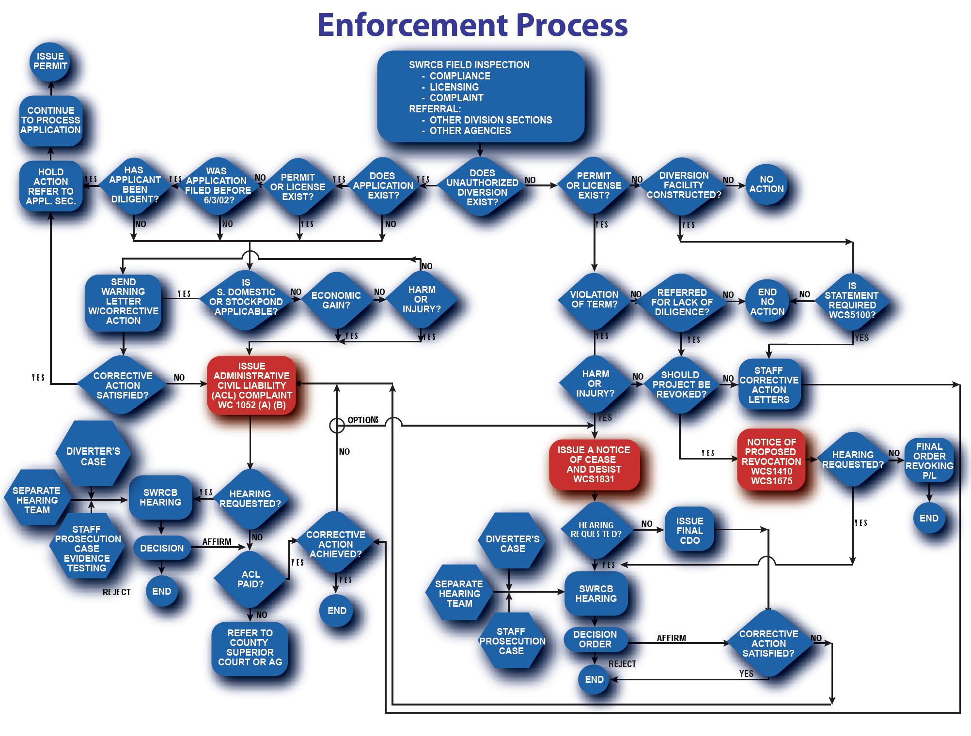
Figure 3-6. Process for Enforcing Water Rights

The Appropriative Water Rights Process
An appropriative water right can be acquired for water flowing in a natural watercourse if the right to the use of that water is not already held by other senior water users. The Legislature specifies a three-step appropriative system: (1) application, (2) permitting, and (3) licensing. Since 1914, the exclusive method of appropriation in the State of California is the three-step system described in the Water Code. That process requires the prospective diverter to submit an application to the Water Board. The Water Board processes the application in accordance with provisions of the Water Code, State regulations and Water Board policies. Before issuing a permit, the Water Board must find that water is available for the proposed appropriation, and that the proposed appropriation is in the public interest. The Water Board must also consider whether the proposed appropriation will unreasonably affect the public trust or water quality.

After making the necessary findings, the Water Board issues a permit with conditions that specify: (1) the amount of water that may be diverted and used, (2) the period of time during each year when the diversion can be made (a.k.a. the “season”), (3) the purpose and place of use of the water, (4) the point of diversion, and (5) a development schedule by which the water must be put to beneficial use. Permits also contain terms notifying the permittee of the Water Board’s continuing authority to protect the public trust and to impose terms to meet water quality objectives. Lastly, permits may contain terms to protect:
(1) prior water right holders, (2) the public interest, (3) the public trust, and
(4) the environment, including conditions necessary to mitigate potential significant environmental impacts identified through the CEQA process and to carry out water quality control plans.

To preserve water for future use and development consistent with a coordinated plan such as the State’s Water Plan or a County General Plan, the State Department of Finance previously filed water right applications. These “State Filings” were subsequently assigned to the Water Board, which holds them in trust for the people of the State. Parties who desire to develop water supply projects consistent with the coordinated plan may petition the Water Board to assign all or part of the State Filed application to them. If approved, this action gives the petitioner a water right priority based on the date that the State filed the water right application.

The Water Code requires that a permittee proceed with diligence in completing the proposed project and putting the water to full beneficial use. The permittee is required to submit progress reports annually to the Water Board. If the permittee reports that full beneficial use of the water has been made, or if the project development schedule specified in the permit has expired, the Water Board must conduct a pre-license inspection of the project. Provided that the permittee has complied with all of the terms and conditions specified in the permit, the Water Board can issue a license. The amount of water that the Water Board authorizes to be diverted under the license is limited to the maximum amount of water beneficially used during the permit period, as determined during the pre-license inspection. If the Water Board intends to issue a license for less than the permitted amount of water, the State Water Board must: (1) obtain the consent of the permittee, (2) afford him an opportunity to show cause why the amount or season should not be reduced or (3) afford him the opportunity to submit a petition with the Water Board to extend the development schedule specified in the permit.

If Water Board staff determines during the pre-license inspection that the permittee has not complied with all of the conditions required by the permit, the Water Board may revoke the permit or, at its discretion, allow the permittee a reasonable time to correct any discrepancies. If the permittee wishes to use water for a different purpose or at a different place than the permit allows, the permittee can petition the Water Board to change the permit to reflect the actual use. The permittee can also petition the Water Board to change the point of diversion, provided that the new diversion is not on a different water source.

If the permittee petitions the Water Board to extend the development schedule, the Water Board must determine that there is good cause to extend the schedule before granting the petition. If there is no basis for granting an extension, the Water Board may revoke the permit after providing the permittee a hearing opportunity. Good cause includes obstacles that could not reasonably have been avoided, but does not include lack of finances, occupation with other work, physical disability or other conditions incident to the person rather than the enterprise.

The Water Board provides notice to affected parties of the applications and petitions that it receives. Those parties have an opportunity to protest the application or petition. Protests can be filed against applications based on alleged injury to prior vested water rights, adverse environmental effects, and public interest concerns. Protests can be filed against petitions for the same reasons. A change cannot adversely affect another legal water user, even if the user is junior in priority to the water right holder proposing the change. The Water Board encourages parties to negotiate mutually agreeable resolutions to protests. If this is not possible, the Water Board will resolve the dispute through its adjudicative authorities. Adjudicative hearings are conducted as required by the Administrative Procedures Act of the Government Code. After the Water Board issues a decision, any interested party may petition the Water Board to reconsider its decision if: (1) there was an error in the proceedings, (2) the Water Board made an error in law, (3) the decision is not based on substantial evidence, or (4) there is new evidence that was not previously available for the Water Board to consider. Parties may ultimately seek to have Board actions reviewed by the courts.

Under certain conditions, parties may file an application or petition requesting urgent action by the Water Board. These actions are subject to an expedited review process due to the urgent nature of the action. In general urgency applications and petitions may only be filed in order to allow the filer to respond to an emergency or unforeseen situation. In addition, parties may file for temporary permits or change petitions seeking authorization for an action which is only expected to last for a limited time period. Sometimes these temporary approvals are requested to allow the water right holder to transfer water to another water user.
Lastly, the Water Code requires that wastewater treatment plant operators who discharge treated wastewater to a stream or river petition the Water Board for and receive approval to change their points of discharge. Downstream parties may be entitled to discharged wastewater, and these changes may have an impact on water rights. These petitions are referred to as “Wastewater Change Petitions.”

Water Rights Systems Supporting the Business Processes
Table 3-1 summarizes the different computer systems and databases used to support Divisional processes. In Baseline Analysis, Section 4, further details of these systems are given, including the programming language and purpose of each element.
Table 3-1. Current Water Rights Systems and Databases
WRIMS "Current Baseline" of IT System Components | Description
WR Permitting Section's Database Systems
Current WRIMS
Groundwater Recordation | Store Groundwater extraction data.
Statements of Diversion and Use | Store statement of water diversion and uses data.
Livestock Pond Registrations | Store Livestock Pond Registration data for stock ponds less than 10 acre-feet. The Registration program was initiated after the original Stockpond Certificate program expired. This is a registration process and does not require approval. Nevertheless, the Water Board by practice issues a document to confirm the registration. The registrations expire after five years and require renewal.
Livestock Pond Certificates | Store Livestock Pond Certificates data for stock ponds less than 10 acre-feet. This is an program has sunseted. Like Livestock Pond registrations, these rights does not require approval. Owners applied for and received a certificate issued by the Water Board. They do not have to renew the certificate.
Small Domestic Use Registrations | Store Small Domestic Use Registration data. Like Livestock Pond Registrations, these rights exist by operation of law, but are confirmed by the Water Board when a document is issued. The registration will expire and requires renewal.
Petitions for Change | Store only data for the approved changes instead of all of the data from the original petition.
Petitions for Extension of Time | Store Petition for Time Extension data.
Petitions for Assignment of State Filings | Store Petitions for Assignment of State filing data as though they were regular water rights filings.
WR Permitting Section's Tracking Database | Description
Applications | Store Application Process Tracking data
Petitions | Store Petition Process Tracking data. These petitions generally request approval to change the purpose of use, place of use or point of diversion authorized by a permit or license or requested in a pending application.
Temp Urgency Applications | Store Temporary Urgency Application Process Tracking data.
Wastewater Change Petitions | Store Wastewater Change Petition Process Tracking data.
Water Transfers | Store Water Transfer Application Process Tracking data.
Permit and License Revocations | Store Tracking data associated with voluntary or involuntary revocations of water right permits or licenses. Permits and licenses may be revoked if a water right is forfeited after five years of non-use or if a water right is abandoned.
Application Cancellations | Store Application Cancellation Process Tracking data.
Environmental Review | Store Environmental Review (CEQA) Process Tracking data.
Environmental Review of Petitions | Store Petition Environmental Review (CEQA) Process Tracking data.
WR Permitting Section's Independent Databases | Description
Application fees charged and payment received | Store Application and other Filing Fees (Small Domestic Registration, Livestock Pond Registration, Livestock Pond Certificate, Groundwater Recordation, other one time fees etc) payment data. This database generates a Fee report to be submitted to the Water Board’s Division of Administrative Services.
WR Permitting Section's Monthly Reports | Description
Applications (Monthly Reports) | The report is generated from Application Process Tracking database.
Petitions (Monthly Reports) | The report is generated from Petition Process Tracking database.
Environmental Review (Monthly Reports) | The report is generated from Environmental Review Process Tracking database.
Strategic Plan Compliance (Monthly Reports) | The data comes from various tracking databases.
Other Databases or "Systems" | Description
WR Web GIS | Water right Internet (Web) GIS has four databases:  - Water right GIS spatial data database stores Point of Diversion coordinates and water right application ID in SDE / Oracle database.  - Water right Information database stores water rights data (a replica of WRIMS database) in Oracle database.  - Water right QUAD map database stores USGS 100K and 24K USGS QUAD maps.  - Internet GIS Application Server stores and processes Internet GIS application programs
01-02 Online P/L Reports | Stores annual reporting data of water use by permittees and triennial reports of water user filed by licensees filed online by water right holders for 2001 and 2002 in Lotus Domino database. Separate sets of Water Uses Annual Reports in PDF format for 2001 and 2002 are stored in computer system which is used by DWR staff to print individual report on request.
03 P/L Reports | Store Water Uses Annual Reports in PDF format for 2003 in computer which is used by DWR staff to print individual report on request
04 P/L Reports | Store Water Uses Annual Reports in PDF format for 2004 in computer which is used by DWR staff to print individual report on request.
Hearings Database | Stores data related to the hearings process. Hearings may be held on water right applications and petitions, proposed enforcement actions, fee-related actions, water quality certifications, Bay-Delta activities, proposed rulemaking activities, and for informational purposes.
Water Hearing Information Management Program | An Access database that stores information related to adjudicatory actions. The database allows for tracking numerous comments submitted by parties on proposed actions. It has been used to manage Bay-Delta environmental document preparation as well as activities being managed by the San Diego Regional Water Quality Control Board.
Fee Questions | No database
OA Assignment Form | This is an owner assignment request form.
BOE Action Form | This is a form to request BOE to take certain action related annual fee registration and billing. There is a tracking database.
Fee Petitions | There is an annual fee petition tracking database.
ParcelQuest | This is a paid online parcel number search service subscription. No in house database.
Phone Book | A list of telephone contacts.
Fee Accounts Receivable | Water right annual fee payment report in Excel format. This is provided by BOE weekly or bi-weekly. DWR also converts it to Approach database.
Fee Registration | Water right annual fee payee registration data, provided by BOE in Excel format. DWR also converts it to Approach database.
Revocation | An Excel spreadsheet contains list of revocation permits or licenses.
Other Databases/Spreadsheets
Mail Tracking Database | Tracking of incoming and outgoing Water Rights Division mail.
License Tracking | Tracking of Licenses in process.
Initial Compliance | Stores information on permit conditions that require the submittal of studies and reports. Used to generate “tickler” reports or other documentation. If the study has not been submitted, staff writes a letter to the permittee telling them to send it.
Compliance Tracking | Tracking of Compliances in process.
Complaint Tracking | Tracking of Complaints in process.
Pending Applications Unit Assignments Spreadsheet | Current assignments for Pending Applications spreadsheets
Pending Petitions with Petition_ID Spreadsheet | Current assignments for Pending Petitions spreadsheets
401 Certifications Database | Tracking of 401 Certifications in process.
Other Sections’ Monthly Reports
Licensing | Reports monthly information on Licenses issued and on intermediate steps related to license issuance. This report is generated from the License Tracking Spreadsheet
Compliance | Reports monthly information related to compliance and enforcement actions, including number of inspections conducted, number of inspection reports prepared, number of enforcement orders issued and approved, and amount of administrative monetary penalties collected. This report is generated from the Compliance Spreadsheet.
Complaints | Reports monthly information on number of complaints received and investigated. This report is generated from the Complaints database.
FERC Monthly report | Reports monthly information on number of Water Quality Certifications issued. This report is generated from the 401 Certification spreadsheet
Hearings | Reports on the number of Water Board decisions and orders issued, the number of petitions for reconsideration received and processed, and the number of administrative records produced for pending legislative actions. The report is generated from the Hearings database.

Business Problems and Impacts
Significant issues with the current system impede the ability of the Water Board to meet its goals and objectives. This section describes the Division’s business problems and their impacts on the Division’s ability to meet legislative mandates, provide customer service, and fulfill its mission of protecting vested rights, water quality and the environment.

Non-Compliance with Recent Legislation

The Division cannot comply with two recent laws concerning California water rights due to existing systems inadequacies and constraints:
  - Water Code § 1259.2 (aka AB 2121 [Statutes 2004, Chapter 943]) requires water rights process accountability, reporting of real-time water rights information, and tracking of application status on-line.
  - Water Code §§ 1525 and 1552 (aka SB1049 [Statutes 2003, Chapter 741]) makes the Division fee-based for all program activities.
The current WRIMS does not provide the capability to effectively comply with legislative and program mandates to protect California’s water supply. As a result, numerous “stand alone” systems have been developed by staff, as shown in Table 3-1. Because these systems are not integrated and often require duplicate data entry to information that is already in WRIMS, the processing of information is not as effective and the data is not as accurate as it would be with an integrated database that meets the Division’s business needs.

Non-Accessible Information on Water Availability and Permit Status

The public cannot investigate water availability or check the status of applications and permits on-line. Before issuing a permit for a new diversion of water, the Water Code requires the applicant to demonstrate, and the Water Board to find, that water is available for appropriation. This is done by comparing the amount of water that is usually available as a result of precipitation and groundwater accretions to a stream to the amount of water being diverted from the stream by other water users and to the amount of water needed to protect the environment. Applicants cannot obtain the water rights information they need to conduct the required water availability analysis on-line from the Division.

Because applicants cannot ensure the accuracy of their water availability assumptions, Division staff must manually check assumptions on water availability, increasing the potential either for inappropriate approval where water supply is inadequate or cancellation of applications based on insufficient systems information. Inappropriate approval of a water right application may result in over allocation of a stream or other water course, causing environmental degradation, water quality impairments, groundwater overdraft, or inadequate supplies for downstream water users.

Inappropriate denial of applications based on inadequate systems information leads to unnecessary litigation, and create an adverse economic impact to the State. Inappropriate acceptance of applications and petitions based on inadequate systems information causes unnecessary protests, which are time-consuming to process and often increase the time it takes the Division to issue a permit or change order.

Staff are unable to provide a timely response to queries on application and permit status. Staff frequently need to access more than one system, and must conduct more than one query or search paper records before providing an answer. This further slows the dissemination of information on water rights and water availability.

Lack of public on-line tracking of application and permit status impacts the Division’s ability to provide mandated customer service.

No On-Line Services for Water Rights Holders, Including Water Use Reporting Capability

Water rights users are required to report water use to the Water Board annually or triennially, to show that the water right holder is complying with the rights and that the rights have not been abandoned or forfeited through non-use. No on-line reporting service is available for this purpose. No reliable electronic method is provided to facilitate reporting water use. Staff must gather data manually from paper forms and disparate sources, resulting in poor data quality.

Hard-copy data is not readily shared by Division program areas or easily made available to other agencies, such as the Department of Water Resources (DWR) and the Department of Fish and Game (DFG), which are also interested in water use records.

On-line reporting, if done correctly, would make information considerably more usable and allow the Water Board to better manage water supply. Reporting is particularly important in that water rights not exercised for five years are subject to forfeiture.

Accurate reporting of water use is also needed to further the State's goal to employ water “in the highest possible beneficial use” in conformance with the California Constitution.

Additional on-line services would enable more up-to-date information to be directly captured into water rights systems. On-line reporting of ownership changes of water right holders, for example, would significantly help in collecting the fees necessary to support the administration of the water rights program. Use information reported online could also be compared to telemetered water flow and diversion data, allowing the Water Board to determine if fraudulent use reporting is occurring.

No Integration of Information Across Water Quality and Water Rights Program Areas or Across Other State Programs

The Water Board’s practice is to review grant and loan applications to determine in the applicant is complying with programs and regulations implemented by the Water Board. Integration with the Water Board’s Division of Financial Assistance (DFA) is especially important for pending loans and grants for local agencies having water rights. DFA must manually check with staff from the Water Resources Division as well as with the Board of Equalization (BOE) to confirm that water rights fees have been paid before authorizing a loan or grant. This lack of integration provides poor customer service and delays important local projects.

Water quality information from the Water Quality Division of the Water Board cannot be integrated or easily shared with water rights information. Staff in both programs need to know of each other’s actions and decisions concerning groundwater basins and surface water watersheds to plan and manage the beneficial use of water across the State.

Water rights information cannot be easily or effectively shared with the Regional Water Quality Control Boards. The new California Integrated Water Quality System (CIWQS) is not integrated with the current WRIMS. The Regional Boards use water rights information for many program purposes, including determining appropriate terms in National Pollution Discharge Elimination System (NPDES) permits (issued under the Clean Water Act) to protect diversions located downstream of waste discharge points. This information is also critical to determine current and future diversions and uses of water in order to conduct Total Maximum Daily Load (TMDL) analyses and allocations, and to manage the potential risk of illegal discharge activities to the beneficial uses of the State’s waters. Certain groundwaters are subject to the water rights permitting process. Integration with Geotracker would allow the Division to determine if water rights approvals are required or if water rights actions will impact water quality actions related to groundwater basins.

Water rights information also cannot be easily or effectively shared with Resources Agency departments, such as the Department of Water Resources, the Department of Fish and Game, and California Bay Delta Authority (CalFED), each of which has responsibilities that overlap or enhance the water rights program. Improved management of water rights data would:
(1) enhance opportunities for water supply transfers administered by the Water Board and implemented through facilities owned by the Department of Water Resources, (2) assist the Department of Fish and Game and the Department of Water Resources in acquiring water supplies for enhancement of instream flows for the benefit of fish and wildlife, and (3) improve opportunities for water conservation through requirements and programs implemented by the Water Board, the Department of Water Resources, and CalFED. In addition, CalFED is proposing a fee system based on annual water use from the Bay-Delta watershed. The data currently maintained in hard copy by the Division would be extremely useful to CalFED for purposes of identifying potential fee payers within the Bay-Delta if it were maintained in an electronic format that was readily accessible and easily manipulated.

The lack of integration of water rights and water quality information compromises the ability to create certainty regarding water rights.

Application and permit tracking information is not consolidated, but is held in separate databases across two Divisional sections, making it difficult to track the status of applications and permits through to the final licensing process, resulting in frustration for the public, water rights consultants and Water Board staff.

Inaccurate, Out-of-Date, and Inadequate Geographic Information System (GIS) Information Needed to Identify and Protect Water Rights

Current Geographic Information System (GIS) data held in WRIMS is not broad enough in scope to be pertinent, and frequently includes inaccurate location points on the U.S.G.S. topographical maps. Further, GIS parcel information is inadequate in its reference to 40-acre land sections rather than actual parcel coordinates. There are no statewide digitized parcel maps with owner information available. Only parcel map images with owner information are available statewide. (Only a few counties have digitized parcel maps but the owner information may not be available with the maps.) Division staff must manually check and verify geographical information using non-integrated GIS data sources in an effort to ensure that location information is correct on applications and for other workflow processes.

WRIMS lacks integrated GIS information and is unable to access digital U.S. topographical maps stored in the Water Board’s GIS data library. (WRIMS has the same digitized parcel maps available in its GIS system. Water right GIS users can not access OIT GIS library because the GIS software used is out of date.) Lacking a system in which GIS is integrated, users cannot view these maps for reference. This results in missing or inaccurate geographical data references, which in turn require additional verification processes.

GIS information held in the system today is limited to the water right holder’s (or applicant’s) name and address information, named source of water, diversion limits, diversion season, and the named purpose and place of use. No statewide ongoing water diversion and actual water use data is available. This is insufficient to effectively monitor ongoing water diversion and actual water use throughout the State.

GIS data has not been updated since January 2000 due to a lack of system capacity to handle updates and a lack of integrated GIS tools.
The GIS information needed to depict the location of water right holders on topographic maps is out of date, due to the need to manually enter this data into WRIMS. This results in erroneous assumptions for application submitters, erroneous applications and, more significantly, the potential for permit and license approval where inadequate water supply exists.

Lack of accurate, integrated GIS information also limits identification of potential illegal diversions (such as storage reservoirs) and of water right holders not in compliance with existing laws. Compliance and enforcement of water rights regulations are thus incompletely supported, as it is difficult to identify enforcement and compliance needs or to perform these activities effectively.

Current System Not Designed to Support Fee Collection

In accordance with SB1049 (Stats. 2003, ch.741), the Water Board adopted a water rights fee schedule on December 15, 2003 that includes the assessment of filing fees and an annual fee for existing water right permits and licenses. The collected fees placed in the Water Rights Fund are used to fund administration of the State’s water rights program. However, the current system does not support either new fee structures or the new fee-based budgeting and accounting process.

Fees are currently calculated based on the amount of water that a water right holder is allowed to divert. Stakeholders have suggested that the Water Board instead assess fees based on limitations that are imposed on multiple water rights held by the same owner for the same project, or alternately on actual use. The Water Board has not been able to consider whether these bases would result in a more widely embraced fee schedule. To assess fees in such a manner without improving the current system would require individual manual calculations so time-consuming that the fees could not be assessed and collected within the fiscal year. Optimizing manual fee calculation would require significant staff augmentations or redirections.

Approximately twelve personnel years (PYs) have been required to handle litigation and on-going management related to the new fee structures instituted in FY 2003-04, and ten PYs in FY 2004-05, due to a lack of system support for these new structures. Inaccurate ownership information and a lack of integration with BOE has cost money both in re-delegation of staff and litigation and has resulted in a large water rights processing backlog than would have otherwise occurred.

As the Division sets the fees for water users and applicants, while the BOE sends out the bills and tracks payments, fee data needs to be easily shared and updated. Water rights holders’ addresses and fee information cannot be updated in a timely manner due to lack of compatibility in file formats exchanged with the BOE. Errors in billing, due to the inadequacies of manually-compiled data interfaces and the inconsistency of data held between the two organizations, significantly impact customer service and the availability of accurate accounting data in the Division.

The Division must maintain a duplicate database on fee payments to determine if money has been received to cover its program expenses. Improved integration and mechanisms for data transfer with the BOE would eliminate the need for duplication and much of the manual processing, and provide real-time information about payments, ensuring more adequate fee collection.

Fee regulations require Division staff to review each water rights file to determine whether the legislative billing criteria are being met. The billing criteria and resulting findings are not maintained in the current system, impacting staff efficiency in file reviews. Expanding the database to allow for fields that can track whether the criteria are being met will significantly reduce the amount of time required to assess annual application and petition fees. Errors that occur in manual calculation of the fees are more likely to be in the water right holder’s favor, resulting in reduced revenues to the State.

Inability of Management to Adequately Manage Workloads or Effectively Assign Staff to Priority Tasks

Cal. Code Regs. Title 23, Section 831 requires a water right owner to notify the Division of the name and address of the new owner of a property served by water rights whenever a change in ownership occurs. However, many owners fail to either inform the Division that a water right has been sold or to provide new owner information, and there is no penalty for failure to notify the Water Board. Consequently, Division staff must invest valuable time to research and determine the identity of the new owner and reassign the water right to the new owner.

Workloads associated with some administrative functions necessary to support core program areas have increased significantly since FY2002-03. For example, work associated with updating ownership records of water rights, including the identification of new owners and changes in address or contact information for existing owners has increased by about 400 percent over that period. The number of questions the Division receives from water right holders and the public regarding water rights have similarly increased. In addition, because each water right fee assessed by the Division can be appealed to the State Water Board, the number of appeals has increased from less than 10 per year to over 1000 per year. Staff has not been able to complete these tasks in a timely manner. In addition, redirection of staff to these tasks from core programs jeopardizes the Water Board’s ability to protect beneficial uses of water across the State.

Staff spend significant percentages of time in performing manual workarounds due to system constraints and gaps, and in responding to ad-hoc requests for information that cannot be found in a single source among current systems. Due to the technical nature of the program, the Division’s staff is comprised primarily of engineering and scientific personnel, and time spent on workarounds significantly diverts them from higher-priority core activities.

Staff task assignments are not tracked in any current system, making it difficult or impossible to give management valid information about assignments or their status, or to perform proper allocation of resources to tasks.

Coordination of staff activities is especially difficult to achieve between staff processing water rights actions to which fees apply and staff working on fee issues. This impacts staff efficiency and increases the potential for inaccurate decision-making, as well as protests and potential litigation.

Current WRIMS Platforms Out-Of-Date and Unsupported

The current WRIMS system was built on a Novell Netware server operating system which is no longer supported by Oracle, the database vendor.

GIS client software is operating on an out-of-date ArcView 3.x platform.

GIS server software (Oracle v7) is outdated and cannot be upgraded to the newest version (10g). The data conversion involved would require serious effort because of the difference in data types supported by Oracle v10g for dates and other water rights information.

The Spatial Database Engine v3 platform is out-of-date and is no longer supported by the vendor.

The real risk of system failure causes a serious threat to the Division’s ability to perform daily operations and to provide customer service. Due to the extremely out-of-date and unsupported nature of the current platforms, a system failure would result in the need for an entire conversion of data from backup files to a new version of Oracle, new GIS client-and-server software, re-creation of the entire application suite, and data integration efforts across the existing disparate data systems as noted in Table 3-1.

System failure would also require the manual calculation of fees for approximately 20,000 fee payers, an effort requiring about 80 PYs. Staff allocations for the water right program is 82 PYs.

Business Objectives
To further the Governor’s goal of protecting California’s environment through planning, innovation, and tough enforcement of existing laws, and to comply with recent legislation for improved quality and access of water rights information, the following objectives have been identified:

Provide a Timely Response to the Public’s Need for Water Rights Information

Provide real-time information about water rights to enable outside consultants, staff, and others to track the ongoing status of applications, permits, petitions, and water availability in the State.

Fulfill new laws requiring the Division to provide real-time information on the status of application and petition processing. Enable the new system to meet the legislated requirement that the Water Board identify the last task accomplished for each filing, the next step needed to process the filing, and the estimated date that processing will be completed.

Meet increased demand for processing of water right applications for permits and other requests.

Provide Services On-Line to the Public, Including Water Rights Reporting

Provide on-line forms for applications and other processes.

Provide the ability to report annual water use information on-line.

Provide the ability to change water right ownership information on-line, and other services appropriate to on-line facilitation.

Ensure More Efficient Business Operations, and Coordination Across Water Rights and Water Quality Divisions as well as Internal Water Rights Permitting and Enforcement Units, through Integration of Water Rights Processes and Information

Facilitate multi-agency coordination in the management of the State’s water supplies.

Improve sharing and integration of water rights and water quality information between the Water Quality and Water Rights Divisions, in order to effectively manage the beneficial use of water across the State.

Improve sharing of water rights information with Regional Water Quality Control Boards, who use it for certain permitting and diversion management processes, for Total Maximum Daily Load analyses and allocations, and to monitor the potential risk of illegal discharge activities.

Improve sharing of water rights information with other Resources Agency departments, such as the Department of Water Resources, the Department of Fish and Game and CalFED, in their roles which relate to the water rights program. For example, improved management of water rights data would:
(1) enhance opportunities for water supply transfers administered by the Water Board and implemented using facilities owned by the Department of Water Resources;
(2) assist the Department of Fish and Game and the Department of Water Resources in acquiring water supplies for enhancement of instream flows for the benefits of fish and wildlife;
(3) improve opportunities for water conservation through requirements and programs implemented by the Water Board, the Department of Water Resources, and CalFED; and
(4) aid CalFed in identifying potential fee payers within the Bay-Delta.

Improve the Ability to Manage and Collect Water Rights Fees, Track Payment, and Coordinate Staff Fee-Related Activities Through Improved Integration Between the Division, BOE, and DFA

Provide Tracking and Reporting Tools to Properly Allocate Staff Resources and Track On-Going Division Activities and Staff Assignments

Increase the Reliability and Quality of Water Rights Data

Integrate Water Rights Data with GIS Information to Enable More Complete Understanding of Water Availability and Compliance

Business Problems – Objectives Traceability Matrix
The water rights business problems, which are presented above in Section 3.5, Business Problems, can be addressed if key business objectives, presented in Section 3.6, Business Objectives, are achieved.

Table 3-2 presents a matrix of the business objectives and the associated eight problems as listed in Section 3.5.
Table 3-2. Business Problems-Objectives Matrix
Objective # | Objective | Performance Metric | Associated Problems #
1 | Provide a timely response to federal, State and local governmental agencies and the public for water rights information. | - Provide timely posting of public notices: notices will be posted within 60 days of the action being accepted as complete.  - Provide timely and accurate information to the public by posting forms and updating public information, including any public hearings and enforcement actions. All forms will be posted within two business days of being approved for use. Public information regarding the conduct of hearings will be posted within one business day of the decision being made. Final actions regarding hearings or enforcement actions will be posted within three business days of final action being taken by the State Water Board. | 1, 2, 3, 4, 5
2 | Provide services on-line to the public including the reporting of water use. | - Increase percentage of on-line water use reporting to over 70 percent by 2008, reducing associated staff processing time and improving ability to verify water use data and determine if water rights violations are occurring.  - Provide on line information and e-mail contacts for processing applications, petitions, protests, and complaints. | 1, 2, 3
3 | Ensure more efficient business operations, and coordination of Division permitting and enforcement units, through integration of water rights processes and information. | - Improve efficiency for processing complaints. Increase number of complaints processed each year by at least five percent.  - Increase the number of permits issued each year by 100 percent (over FY2005-06) and reduce the permitting backlog by at least ten percent.  - Improve coordination of the permitting and enforcement program activities. This will ensure that appropriate follow-up action is taken on permitting actions that are taken on enforcement cases.  - Reduce other overlaps or unnecessary cross-checking of water rights information across business processes by 90 percent. | 2, 3, 4, 5
4 | Improve the ability to manage and collect fees, track payments, and coordinate staff fee-related activities. | - Increase ability to determine, assess and collect fees from all water right holders, reducing staff time associated with such work by about 50 percent.  - Reduce the number of petitions for reconsideration or lawsuits challenging fees due to billing address errors by 15 percent.  - Reduce the incidence of non-payment of fees as a result of improper invoicing to less than one percent, resulting in the public perception of more equitable fee collections. | 2, 3, 4, 5, 6
5 | Provide tracking and reporting tools to properly allocate staff resources and track ongoing Division activities and staff assignments. | - Increase ability to track staff assigned to water rights activities, reducing time spent trying to identify staff assignments by five percent.  - Improve tracking of applications and petitions, including applicable enforcement actions  - Improve allocation of staff resources and monitoring of project process, improving customer relations and staff morale. | 4, 5
6 | Increase the reliability and quality of water rights information. | - Improve the quality of water availability analyses and increase the number of analyses that can be done by 10 per year. This will likely result in an increase of the number of streams added each year to the Declaration of Fully-Appropriated Streams by 100 percent.  - Reduce the number of petitions for reconsideration filed regarding water rights invoices by eliminating factual errors related to fee calculations to less than 0.5 percent. | 2, 3, 4, 5, 6
7 | Integrate water rights data with up-to-date GIS to assist with water availability analysis and improve information provided to the public. | - Reduce the number of public information requests by 30 percent by providing web access to GIS information.  - Provide improved access to water rights information, reducing staff responses to governmental and public information requests by about 30 percent.  - Increase efficiency in identifying illegal or unauthorized diversions (Note the increase in civil liability assessments of about $50,000 per year). | 2, 3, 6

Time Savings Benefits to Be Realized
The Division has existing backlogs in almost all processes, due in part to staffing reductions and other budget cuts that have occurred within the past three years. The reductions totaled almost 30 percent as compared to funding in FY 2000-2001. Subsequent redirections of remaining staff to fee-related work and other Legislatively mandated programs such as (1) the required adoption and implementation of State policy for water quality control for water rights administration pertaining to five northern coastal counties and (2) the assignment of the groundwater recordation function to qualifying local agencies who desire to administer the program in their area of influence have further eroded the ability of staff to complete its core program requirements. The time saved as a result of these proposed improvements will allow staff to return to its core functions and address these backlogs. Staff has 640 applications awaiting permits, almost 700 petitions awaiting review, and 1200 permits awaiting licensing. In addition, recent compliance actions in about half of the Russian River watershed in Sonoma County have identified over 800 water diversions that have no identified basis of right. The Water Board anticipates that most of these water diverters will file an application, further increasing the backlog.

Table 3-3 shows anticipated savings of program staff time with the proposed solution, an enhanced, integrated e-WRIMS. Estimated PY savings achieved through the effort to redevelop the existing WRIMS (12.2 PYs) will be redirected to reduce work backlogs of water rights program staff (in performing their core scientific and engineering duties) and to achieve the goal of providing real-time information about water rights, as required by legislative mandate.
Table 3-3. Time Saving Anticipated
 |  | Time Savings
Task | Section/Unit | Staff hrs per Staff per Month | No. of Staff | Hours per Year | PYs | Description
Annual Reports | Permitting |  | 2 | 60.00 | .34 | The Permitting Section manually compiles a mass notification for over 8500 records each year. Update and automation of recording information will reduce staff time by 80 percent.
Annual Reports | Enforcement |  |  |  | 0.65 | The Enforcement Section mails over 5,000 permit and licensee water use reports each year and reviews returned reports to confirm ownership and overall compliance status. Following the review process, the forms are filed in the water rights file. Automation of this existing reporting process to an online reporting process will save about 15 minutes per report or 0.65 PY (5,000 x 15 minutes/60 min/hr /1776). The proposed solution will provide an online reporting process to produce an annual report reducing the current time staff spends developing this report manually by 50 percent.
Bar-coding | Hearings/Files | 4.33 | 1 | 52.00 | 0.03 | Input application information into WRIMS for generating barcode labels. This process requires input into four separate WRIMS screens that are confusing and not user-friendly. Often staff need to seek assistance from more experienced WRIMS staff to complete this work.
Bay-Delta | Hearings/Bay-Delta | 3.33 | 4 | 160.00 | 0.09 | A centralized database would help link applications to the Bay-Delta projects for use in the triennial review and Term 91 compliance. Currently each section tracks their information.
Bay-Delta: Term 91&93 | Enforcement |  |  |  | 0.02 | Certain permits and licenses are subject to curtailment of diversions in order to protect Central Valley Project (CVP) diversion priorities or Sacramento-San Joaquin water quality objectives. When initiating these curtailment programs, Division staff reviews CVP operational data available on the USBR website to identify curtailment periods. Enforcement staff manually query existing WRIMS database to “flag” the permits and licenses that need to be notified of the curtailment. A notice of curtailment is prepared and mailed to the affected parties. Automating the internet review, manual queries, and mailing of notices, will result in a savings.
Caseload Manage-ment | Permitting/WU2 |  |  | 177.60 | 0.10
Database Manage-ment | Permitting/  WR Processing |  |  | 1,998.00 | 1.13 | The automated system will increase the availability of staff time by 100 percent to more efficiently process and accurately track water right permits.
Database Manage-ment | Permitting/  WU1, WU2, WU3 |  |  | 1,385.00 | 0.78 | Upgraded databases will reduce redundant data entry in multiple databases. The new  e-WRIMS will include several new data fields requiring additional data entry that will only slightly offset any time savings from consolidation of databases. The main benefit will be in data validation at data entry time, eliminating the need for a separate process for data edit and clean-up.
Enhanced GIS: Integrate  e-WRIMS GIS with other GIS data | Enforcement | 4 | 10 | 445 | 0.25 | The WRIMS upgrade (e-WRIMS) will provide enhanced Geographic Information System (GIS) integration of water rights data with other GIS information, including county parcel and aerial photographic data. Using the GIS data with the e-WRIMS database (including GIS upgrade) should result in increased administrative civil liability collections. A field presence will also be re-established to reduce any incentives for illegal diversions. An estimated $30,000 increase in assessed liability is expected, or an equivalent PY savings of 0.25 PY ($30,000 / $120,000 per PY). The automated system will result in increased administrative civil liability collections by a minimum of $30,000 annually and allowing staff to spend more time conducting field investigations and enforcement actions.
Enhanced GIS: Integrate  e-WRIMS GIS with other GIS data | Permitting/WU1, WU 2, WU3 |  |  | 1414.80 | 0.80 | Currently staff must manually research individual folders and spot maps to determine project locations and basic water rights information. e-WRIMS and GIS upgrades will assist Permitting Section staff to prepare water availability analysis and CEQA documents by linking e-WRIMS and GIS.
Fees: Coordina-tion w/BOE | Hearings | 4.00 | 5 | 240.00 | 0.14 | Often fee questions or petitions include information that is tracked by BOE. With a centralized database, staff could respond to questions about whether fees have been paid without having to call BOE and then call the person back. Staff could track down fee payment information when responding to fee letters and avoid using outdated information or having to contact BOE.
Fees: Fee Related Work | Permitting |  |  | 338.00 | 0.19 | Supervisory queries of the current WRIMS database are required to make staff assignments for Permitting fee-related tasks. These queries would not be needed if the database included fee information.
Fees: Fees/ Ownership Assign-ments/ Phone Duty | Enforcement | 40 | 8 | 3840 | 2.00 | The improved e-WRIMS database system is expected to be integrated with the BOE data and to be accessible by the Division of Financial Assistance. Data sharing by these agencies will eliminate many inter-agency communications.
Fees: Petitions/ Fee Phone Duty | Hearings | 40.00 | 4 | 1,920.00 | 1.08 | Different units are working on different aspects of the fee program. They are each tracking how and when the fees are applied. When Division staff receives a phone call or letter complaining about the fees, it is often time consuming to figure out why the person was sent a bill and how the fee was determined. With a centralized database, staff could respond to questions about how fees were calculated and why certain types of fees were charged (e.g. petition fees, etc.) or check the status or timing of a revocation to see if fee should have been charged for that fiscal year. The automated system will support an increase of 100 percent, the ability for staff to respond to questions about how fees are calculated and why certain types of fees are charged, in addition to validating if fees are charged during a current fiscal year.
FERC | Hearings/  Water Quality Certification Unit | 3.33 | 1 | 40.00 | 0.02 | It would help the water rights permitting staff to coordinate with Water Quality Certification Unit staff when application is accepted to make them aware of the project. Also, it is imperative that Water Rights Division staff be part of the check-off prior to permit issuance. There have been problems in the past where permits were issued without containing information that Water Quality Certification Unit staff had been negotiating, causing additional work to rectify the problem.
Phone Duty: File Tracking | Permitting |  | 23 | 3864.00 | 2.18 | Reduces staff time spent manually researching Division records for stakeholder inquiries.
Fees: File Tracking | Permitting |  | 23 | 1656 | 0.93 | Will reduce staff time spent manually researching files to address fee inquiries.
Hearings | Hearings | 8.00 | 5 | 480.00 | 0.27 | Staff need to determine the status of the application, protests, environment review, compliance issues, enforcement issues, etc., when determining if a project is ready for hearing, when preparing hearing notices, and when preparing to brief the Board. This information is contained in various databases throughout the Division. Staff must check several databases and often need help from other staff to access information. A centralized database would save research time and avoid making a mistake that takes more staff time to rectify. Staff could quickly track the status of any outstanding protests, enforcements, compliance issues, petition status, etc.
Monthly Report | Enforcement | 1.50 | 3 | 54.00 | 0.03 | Currently, each unit supervisor submits a monthly report to management of the unit workflow production. Preparation of these reports requires manual search of existing records to obtain the necessary monthly counts. Functionality will be greatly enhanced by automatic flags and insertion into a Division-wide monthly management report. It is estimated that the three unit supervisors would save approximately 1.5 hours per month if the monthly reports were automatically generated. Estimated savings is 0.03 PY (3 x (1.5 hrs/month)/ 1776)
Monthly Report | Hearings | 2.00 | 1 | 24.00 | 0.01 | Instead of staff tracking down information for the monthly report, if the system were integrated, the computer would generate the number
Monthly Report | Permitting |  |  | 264.00 | 0.15 | Monthly data is currently obtained from multiple databases and WRIMS. The e-WRIMS integrated database will save time now spent in manually combining data in spreadsheets and manipulating the data until it is in the proper format.
Phone Duty | Hearings | 4.00 | 5.5 | 264.00 | 0.15 | In order to answer questions about water rights and the status of applications, protests, etc., staff must check several databases and often need help from other staff to access information. Staff also need to take the elevator to the second floor several times during the day to search for files, licenses, permits, etc. A centralized database would save research time and avoid duplicating work of other staff or making a mistake that takes more staff time to rectify.
Project Tracking | Enforcement | 2.5 | 3 | 90.00 | 0.05 | Unit supervisors maintain isolated databases in Lotus Approach or Microsoft Access to monitor project and staff workload status, by manually entering required data in unlinked spreadsheets. Tracking information is not available via internet for the public or other staff. Most telephone calls concerning project status could be eliminated with the improved system. File staff workload in making copies of requested complaint, license, and enforcement information would also be reduced. Upgrading the water rights system with Division-wide tracking integration and providing public access will save unnecessary duplication of records.
Project Tracking | Hearings | 1.00 | 11 | 132.00 | 0.07 | Currently there is one system to track files and several databases that track the work various sections are doing with the files. Often files aren't scanned correctly and it takes a lot of searching to figure out who has the file. With a centralized database, staff could determine who is actively working on the file and more quickly track it down.
Project Tracking | Permitting/Supv. |  |  | 600.00 | 0.34 | Consolidation of multiple databases will reduce the need for redundant data entries and correcting of inconsistent data.
WAA review | Permitting/WU2 |  |  | 532.80 | 0.30 | Consolidation of multiple databases will reduce the need for redundant data entries and correction of inconsistent data.
WRIMS update/ Phone Duty /Control Tags, etc. | Permitting/WU1 | 2.96 | 5 | 177.60 | 0.10
Total |  |  |  |  | 12.2

Business Functional Requirements
Table 3-4 is a compilation of requirements to satisfy both current and mandated water rights program activities. It shows which business functions are now supported by automated WRIMS screens or reports and for functions that are not currently supported by WRIMS, whether the current WRIMS database holds the information necessary to help support the function. All of these business functions are “in scope” to be provided with automated support by the new e-WRIMS.
Note: A “Partial” indicates partial support, while “YES” indicates full support, and “NO”, no support.
Table 3-4. Business Functional Requirements for the Water Rights Division
e-WRIMS Business Functional Requirements | Fully automated today in WRIMS? | Data exists in current WRMS to support this? | GIS com-ponent required? | New e-WRIMS - In Scope ?
I. Manage water rights information.
A. Enter and update water rights information. | NO | YES | YES | YES
B. Perform quality analysis and quality control on water rights information. | NO | Partial | YES | YES
C. Provide water rights program management information. | NO | Partial | YES | YES
D. Manage water rights incoming and outgoing mail. | NO | Partial | NO | YES
- Manage incoming mail: track mail, establish due date and assigned staff, monitor due date, and notify when overdue. |  | Partial |  | YES
- Manage outgoing mail: track mail, record any returned receipt or returned mail, etc. |  |  |  | YES
- Manage files and records concerning water rights (bar code reader system, folder tracking system/database, etc.). |  | Partial |  | YES
E. Manage GIS and imaging data and quality assurance of that data for water rights program. | NO | Partial | YES | YES
- Perform imaging of water rights information as needed and update image data as needed. |  | Partial |  | YES
- Maintain application, permit, and license image query capability. |  | Partial | YES | YES
- Manage GIS data concerning water rights information: |  | Partial | YES | YES
- Update and maintain GIS information in WR systems. |  |  | YES | YES
- Update and maintain GIS layer in intranet GIS systems for WR data. |  |  | YES | YES
- Update and maintain GIS layer in Internet GIS systems for WR data—needed to generate coordinates data (State plane, latitude, longitude & Albers data). |  |  | YES | YES
- Enable application, permit and license image retrieval using GIS interface for public information in both intranet and internet systems. |  | Partial | YES | YES
II. Manage permitting and licensing of water rights |  |  |  | YES
A. Receive application for a water right (in both paper and electronic form). | NO | Partial | YES | YES
B. Review application or change request and maintain standards for review. | NO | NO | YES | YES
- Review completeness of application. |  |  |  | YES
- Review reasonable needs. |  |  | YES | YES
- Review and verify assumptions of water availability. |  |  | YES | YES
- Review application for small domestic use and stockpond registrations (WC 1228.3) requirements. |  |  |  | YES
- Review environmental impacts of water rights requests. |  |  | YES | YES
- Provide watershed-based information for both upstream and downstream. |  | Partial | YES | YES
- Maintain standard criteria for review and acceptance of applications (WC 1260). |  |  |  | YES
C. Determine whether to accept application. | NO | Partial | YES | YES
- Analyze and document status of completeness to application. |  |  |  | YES
- Reject and return application if incomplete or not meeting requirements. |  |  |  | YES
- Respond to applicant on status of acceptance or incompleteness. |  |  |  | YES
- Process accepted application. |  | Partial | YES | YES
- Track status of application fees received, refunds processed, and initial review fees. |  |  |  | YES
D. Issue public notice and track public notice review period. | NO | Partial | YES | YES
E. Review and resolve protest. | NO | Partial | YES | YES
- Review protest and reject or accept it based on requirements. |  |  |  | YES
- Notify applicant and protestant(s) of status of protest and next steps. |  |  |  | YES
- Advise parties to negotiate towards a resolution of the protest. |  |  |  | YES
- If negotiated, include in draft permit/order needed terms and conditions. |  |  |  | YES
- If not resolved, schedule field investigation (2.7) or refer to hearing unit. |  |  |  | YES
F. Perform environmental review process (CEQA required). | NO | NO | YES | YES
- Determine whether project requires CEQA review. |  |  |  | YES
- Determine lead agency for CEQA compliance. |  |  |  | YES
- Execute and track MOU for preparation of CEQA documentation. |  |  |  | YES
- Prepare CEQA document, as an e-WRIMS report, including mitigation terms. |  |  |  | YES
- Document type of CEQA documents prepared, public review period and final determination. |  |  |  | YES
- Document final approval and Notice of Determination submitted to State Clearing House. |  |  |  | YES
- Use GIS to provide environmental information for impact analysis during review. |  |  | YES | YES
G. Conduct investigation—for "minor" projects. | NO | NO | YES | YES
- Request relevant compliance or protest information prior to investigation. |  |  |  | YES
- Issue notice of investigation 20 days prior to field investigation. |  |  |  | YES
- Conduct field investigation. |  |  | YES | YES
- Issue a decision/order addressing all protests. |  |  |  | YES
- If petition is filed, accept or reject any petition for reconsideration. |  |  |  | YES
- Approve application and issue permit, or else deny application, based on result. |  |  |  | YES
H. Conduct hearing on water rights - for "major" projects. | NO | NO | YES | YES
- Perform pre-hearing business preparation: |  |  |  | YES
- Assign hearing team. |  |  |  | YES
- Complete prerequisites (application review, CEQA, protest review). |  |  |  | YES
- Brief hearing officer with report of hearing preparation. |  |  |  | YES
- Perform (optional) field tour and record results. |  |  |  | YES
- Conduct (optional) pre-hearing conference and record details. |  |  |  | YES
- Issue hearing notice and post publicly (onto website). |  |  |  | YES
- Collect hearing exhibits and testimony: |  |  |  | YES
- Receive and review notices of intent to appear. |  |  |  | YES
- Receive and review exhibits. |  |  |  | YES
- Scan and post public exhibits (onto website). |  |  |  | YES
- Prepare cross-examination. |  |  |  | YES
- Conduct hearing and record results. |  |  |  | YES
- Review evidence and make decision: |  |  |  | YES
- Review evidence and legal argument. |  |  |  | YES
- Debrief Hearing officer and receive (and record) direction. |  |  |  | YES
- Prepare draft decision and permits/order and record decision. |  |  |  | YES
- Meet with Hearing officer to review decision/order. |  |  |  | YES
- Revise draft decision if required. |  |  |  | YES
- Release draft decision or further revision. |  |  |  | YES
- Receive, review and record comments on reconsideration if applicable. |  |  |  | YES
- Issue Board decision. |  |  |  | YES
- Receive and review petitions for appeal/reconsideration if applicable. |  |  |  | YES
- Prepare and issue decision denying reconsideration if applicable. |  |  |  | YES
- Prepare and issue decision approving reconsideration if applicable. |  |  |  | YES
- If petition filed for writ of mandate, prepare administrative record and go to court. |  |  |  | YES
- Collect, query and report on documentation for inclusion in administrative record. |  |  |  | YES
- Eliminate documents not needed for administrative record. |  |  |  | YES
- Prepare and organize administrative record material, including index. |  |  |  | YES
- Scan administrative record (currently outsourced). |  |  |  | YES
- Obtain and record order or final decision (denied or approved) and cancel application if applicable. |  |  |  | YES
I. Issue water right permit. | NO | Partial | YES | YES
- Verify unappropriated water is available to supply the permit application. |  | Partial | YES | YES
- Verify intended water use is beneficial. |  |  |  | YES
- Develop terms and conditions to protect vested water rights, public trust resources and full and beneficial use of water. |  |  | YES | YES
- Verify all fees have been paid including all fees for CEQA review. |  |  |  | YES
- Prepare permit as an e-WRIMS report. |  |  |  | YES
- Issue permit and update project status with permit issuance data. |  |  |  | YES
J. Issue water right license. | NO | Partial | YES | YES
- Confirm permittee desires licensing and check whether permit time has already expired. |  |  |  | YES
- Revoke permit if time expires prior to licensing, if project not built, or water not in use. |  |  |  | YES
- Perform field inspection and determine beneficial use of water. |  |  | YES | YES
- Prepare request for license: |  |  |  | YES
- Verify timeframe valid for licensing. |  |  |  | YES
- Verify valid timeframe (including any extensions) for completing water use on a permitted project. |  |  |  | YES
- Verify commencement of water use. |  |  |  | YES
- File extension petition and refer to petition process if no water use has commenced. |  |  |  | YES
- Revoke permit if time extension not filed, and if project not built and water not in use. |  |  |  | YES
- Issue license for less than full permit amount if time extension not filed but project built and water use has started. |  |  |  | YES
- Verify compliance (refer to compliance process). |  |  |  | YES
- Manage and record any change from permitted description prior to licensing. |  |  |  | YES
- If changed from permit, refer to petition process (if change filed). |  |  |  | YES
- If change not filed, refer to enforcement process or revoke permit. |  |  |  | YES
- If not changed, verify compliance with terms and conditions of permit. |  |  |  | YES
- Revoke permit if not in compliance with terms and conditions. |  |  |  | YES
- License water right if conditions met. |  |  |  | YES
- If the full permit amount can be offered, finalize license for issuing. |  |  |  | YES
- Create license map/e-map. |  |  | YES | YES
- Otherwise, if permittee requires time extension, file extension and refer to petition process. |  |  |  | YES
- If permittee does not require extension, send and obtain signature on license request form and mail proposed order issuing license. |  |  |  | YES
- If permittee requests a hearing, refer to hearing process. If not, prepare license as an e-WRIMS report and issue final license. |  |  |  | YES
- Record license with county recorder. |  |  |  | YES
K. Process petitions for change or time extension. |  |  |  | YES
1. Review petition for acceptability. |  |  |  | YES
2. Provide notice of petition, if necessary. |  |  |  | YES
3. Investigate and verify permit change request will not initiate new water rights or injure any other  legal user of water, or cause adverse impacts to public trust resources. |  |  |  | YES
4. Perform environmental review process as in application process. |  |  |  | YES
5. Resolve protests as in application process. |  |  |  | YES
6. Issue order approving or denying change petition. |  |  |  | YES
III. Monitor and enforce water rights |  |  |  | YES
A. Identify high-resource value watersheds for proactive compliance investigations.  Select major water rights projects for inspection or those having complaints. | NO | Partial | YES | YES
- Field inspect projects: | NO | Partial | YES | YES
- Interview water right holders, complainants, or their agents. |  |  |  | YES
- Make necessary stream flow diversion measurements and determine reservoir capacity (if applicable). |  |  | YES | YES
- Collect data on use (irrigated acreage, household, etc.). |  |  | YES | YES
- Document diversion and use with GPS camera, etc. |  |  | YES | YES
- Perform preliminary check of field survey results, e.g. calculate reservoir capacity, render shape of the surveyed reservoir or place of use, calculate size of place of use, etc. |  |  | YES | YES
- Exchange field inspection data with the office. This is needed to avoid data loss caused by equipment malfunctions and obtain needed data from the field without returning to the office to eliminate need for redundant field trip. |  |  |  | YES
- Document findings and recommendations. |  |  | YES | YES
B. Prepare analysis on water rights compliance or complaint, and make recommendations. | NO | Partial | YES | YES
C. If in compliance, or complaint groundless, and no corrections or adjustments are required, close out. |  |  |  | YES
D. If in compliance and corrections/adjustments required, if change or petition required, prepare and issue orders and amended licenses when appropriate. |  |  |  | YES
E. If not in compliance, refer to enforcement process if needed; issue Term 91 and Term 93 notices of curtailment, and conduct field investigation for compliance monitoring. |  |  |  | YES
F. Perform action to enforce water rights: | NO | NO |  | YES
- Issue administrative civil liability (ACL) complaint. |  |  |  | YES
- Issue Notice to Cease and Desist. |  |  |  | YES
- Issue Notice of Proposed License Revocation. |  |  |  | YES
- Prosecute enforcement actions at hearings. |  |  |  | YES
IV. Track and evaluate water rights program performance |  |  |  | YES
A. Track water rights processing statistics. | NO | Partial |  | YES
e.g. track the number of urgent vs. normal change petitions regarding water rights |  |  |  | YES
B. Evaluate water rights program performance. | NO | Partial |  | YES
C. Manage program workload. | NO | Partial |  | YES
V. Manage water rights fee and billing processes |  |  |  | YES
A. Maintain and bill for annual water rights fees. | NO | Partial |  | YES
- Maintain water rights fee information for annual reporting purposes: |  |  |  | YES
- Maintain Board of Equalization registration information for all years. |  |  |  | YES
- Maintain Board of Equalization billing information for all years. |  |  |  | YES
- Maintain USBR contractors and fee allocation information. |  |  |  | YES
- Maintain FERC project owner and fee allocation information. |  |  |  | YES
- Maintain pending application and fee allocation information. |  |  |  | YES
- Maintain pending petition and fee allocation information. |  |  |  | YES
- Maintain other annual fee filing and fee allocation information as needed. |  |  |  | YES
- Share and synchronize information with BOE and other parties as required on water right ownership, owners, agents and their contact information. |  | Partial |  | YES
- Submit billing information to the Board of Equalization for invoicing: |  | Partial |  | YES
- Determine fee structure, I.e., base use allocation, base fee, incremental fee rate, discount criteria, and discount rates, etc., for billing. |  |  |  | YES
- Prepare and share billing information for permits and licenses. |  |  |  | YES
- Prepare and share billing information for USBR contracts. |  |  |  | YES
- Prepare and share billing information for FERC projects . |  |  |  | YES
- Prepare and share billing information for pending applications. |  |  |  | YES
- Prepare and share billing information for pending petitions. |  |  |  | YES
- Manage annual fee billing and collection: |  |  |  | YES
- Obtain BOE billing and collection status information. |  |  |  | YES
- Update and maintain WR annual fee billing and collection information. |  |  |  | YES
- Manage annual fee petitions and challenging fee bills: |  |  |  | YES
- Accept annual fee petition and record its information. |  |  |  | YES
- Accept or reject petitions/challenges and notify initiator/petitioners. |  |  |  | YES
- Process fee challenge or petition; determine if wrong owner, wrong amount, etc. and correct the situation. |  |  |  | YES
B. Maintain, bill, and collect for water rights filing fees and other fees. | NO | Partial |  | YES
- Establish various fee requirements (I.e. application fee, petition fee, small domestic use registration and renewal fee, groundwater extraction fee, etc.) and maintain fee structures. |  |  |  | YES
- Publish and communicate updates to fee structures. |  |  |  | YES
- Bill and collect fees as appropriate (e.g. when application is filed): |  |  |  | YES
- Test and verify fee calculation. |  |  |  | YES
- Produce fee invoices. |  |  |  | YES
- Process returned invoices. |  |  |  | YES
- Track fee collection. |  |  |  | YES
- Manage fee petitions. |  |  |  | YES
- Respond to objections to determination of expenses. |  |  |  | YES
- Notify cases of non-collection of fees (e.g. can result in cancellation). |  |  |  | YES
- Provide fees appropriate other party (DFG, etc.). |  |  |  | YES
- Provide fee collection report. |  |  |  | YES
- Maintain and update fee collection information. |  |  |  | YES
VI. Support other programs. |  |  |  | YES
A. Process adjudications referred by the courts. | NO | Partial | YES | YES
- Accept and track court orders referring litigation regarding water rights to the State Water Board. |  |  |  | YES
- Request that a program task code be assigned for the project. |  |  |  | YES
- Estimate costs of conducting the adjudication and required payment of estimated costs by parties. |  |  |  | YES
- Conduct an investigation and prepare draft report of referee containing findings of fact or findings of law or both. |  |  |  | YES
- Release draft report of referee to parties for comment. |  |  |  | YES
6. Consider objections to the draft report of referee and hold hearing if necessary. |  |  |  | YES
7. Release final report of referee and file it with the court. |  |  |  | YES
8. Provide notice of filing to the affected parties. |  |  |  | YES
9. Assist the court in its review of any exceptions filed to the report by the parties. |  |  |  | YES
10. Compare final cost accounting to pre-payment and draft order for cost allocation for the court’s consideration. |  |  |  | YES
11. After the court issues its judgment regarding cost allocation, request that invoices or refunds be processed. |  |  |  | YES
B. Process adjudications related to stream system. |  |  |  | YES
- Consider petition filed by parties requesting adjudication and determine whether or not it is in the public interest. |  |  |  | YES
- Prepare order granting or denying petition. |  |  |  | YES
- Identify all potential water right holders on the stream system. |  |  |  | YES
4. Prepare notice of the proceedings and direct parties to notify the Water Board if they intend to claim a right. |  |  |  | YES
5. Publish a public notice of the proceedings. |  |  |  | YES
6. Conduct stream system investigation. |  |  |  | YES
a. Review notices of intent to claim forms filed by the affected parties. |  |  |  | YES
b. Provide notice to all potential claimants of field investigation by Division staff. |  |  |  | YES
c. Conduct field investigation to determine use of water, acreage under irrigation, place and purpose of use, the location and capacity of the diversion works, the amount of water diverted and necessary to satisfy the uses being made for each potential claimant. |  |  |  | YES
d. Provide each potential claimant with a copy of the results of the field investigation and a “Proof of Claim” form. |  |  |  | YES
e. Conduct field investigation of all known water users who did not file an intent to claim a water right. |  |  |  | YES
f. Provide these users with a copy of their inspection report and “Proof of Claim” form. |  |  |  | YES
7. Receive and review filed “proofs of claim.” |  |  |  | YES
8. Prepare findings report and preliminary “Order of Determination.” |  |  |  | YES
9. Send a copy of report to each claimant and identified water users with notice for filing objections. |  |  |  | YES
10. Receive and process report objections. |  |  |  | YES
11. Holding hearing(s) on report objections. |  |  |  | YES
12. Adopt Order of Determination. |  |  |  | YES
13. Mail Order of Determination to all parties. |  |  |  | YES
14. Receive requests for determination an issue order on reconsideration. |  |  |  | YES
15. File Order of Determination with the Superior Court in the appropriate county. |  |  |  | YES
16. Hold court hearing on Order of Determination and Appeals. |  |  |  | YES
17. Court enters a Decree. |  |  |  | YES
18. Furnish all claimants with a copy of the Decree. |  |  |  | YES
19. Determine and assess fees to all parties. |  |  |  | YES
20. Collect adjudication fees. |  |  |  | YES
C. Process Ground Water Adjudications. |  |  |  | YES
1. Receive and review information from any governmental agency regarding ground water quality. |  |  |  | YES
2. Hold a public hearing to consider actions necessary to protect ground water quality. |  |  |  | YES
a. Mail Notice of ground water pumpers at least 15 days prior to a hearing. |  |  |  | YES
b. Hold hearing and determine if action is necessary. |  |  |  | YES
3. If adjudication is necessary, determine if a local agency will undertake the adjudication. |  |  |  | YES
4. If no local agency takes an action, file an action in Superior Court to protect the ground water quality. |  |  |  | YES
D. Conduct Water Quality Control Planning associated with water rights administration. |  |  |  | YES
1. Notice and conduct scoping meetings/workshops. |  |  |  | YES
2. Receive information at public workshops for Plan Amendments. |  |  |  | YES
3. Prepare draft plan and draft environmental documents. |  |  |  | YES
4. Conduct initial public review. |  |  |  | YES
a. Solicit comments on draft documents. |  |  |  | YES
b. Evaluate comments and prepare a response to comments. |  |  |  | YES
c. Prepare peer review package. |  |  |  | YES
5. Conduct Peer Review. |  |  |  | YES
a. Select peer review panel/submit package. |  |  |  | YES
b. Evaluate peer review comments and prepare a response to comments. |  |  |  | YES
c. If necessary, revise plan/environmental document. |  |  |  | YES
6. Conduct final public review. |  |  |  | YES
a. Circulate revised plan/environmental document. |  |  |  | YES
b. Review and evaluate public comments. |  |  |  | YES
c. Prepare response to comments. |  |  |  | YES
d. Prepare final plan/environmental document. |  |  |  | YES
7. State Water Board Consideration. |  |  |  | YES
a. Hold State Water Board workshops. |  |  |  | YES
b. Provide 60-day notice to Regional Boards. |  |  |  | YES
c. Schedule Water Board meeting to consider adoption of draft water quality control plan. |  |  |  | YES
E. Process FERC 401 water quality compliance and manage 401 fees. |  |  |  | YES
1. Track status of 401 water quality certification requests. |  |  |  | YES
2. Issue or deny 401 water quality certification including any issuance conditions required. |  |  |  | YES
3. Bill staff costs (expenses) to new FERC project. |  |  |  | YES
a. Record staff time for FERC 401 work. |  |  |  | YES
b. Calculate monthly total hours and staff costs for FERC work. |  |  |  | YES
c. Compile all staff costs and submit bill for hours for new FERC project annual fee billing (annual basis). |  |  |  | YES
4. Manage FERC 401 annual fees according to fee schedules. |  |  |  | YES
VII. Provide information to and exchange information with the public and other agencies. |  |  |  | YES
A. Provide internal information exchange. | NO | Partial | YES | YES
- Provide water rights and water use information to DWQ for water rights compliance, basin planning (water quality and basin plan development and update), etc. |  |  |  | YES
- Provide water rights information to DFA for compliance with water rights requirements etc. |  |  |  | YES
B. Provide external information exchange. | NO | Partial | YES | YES
- Provide water rights and water use information to the public on-line. |  |  | YES | YES
- Provide water rights and water use information to State agencies, e.g., DFG for fish and wildlife protection and management; to DWR for water resource planning, etc. |  |  | YES | YES
- Provide water rights and water use information to local agencies for water resource planning etc. |  |  | YES | YES
- Provide water rights information to federal agencies for water resource planning, land management, fish and wildlife protection and management, etc. |  |  | YES | YES
VIII. Provide notices and reports on water rights information. |  |  |  | YES
A. Water rights notices – Generate water right application, petition notices etc. using data from WRIMS and user input data. |  | Partial | YES | YES
B. Water rights permits – Generate water right permit using data from WRIMS and user input data (water right data and permit terms). |  | Partial |  | YES
C. Water rights licenses - Generate water right licenses using data from WRIMS and user input data (water rights data and license terms). |  | Partial |  | YES
D. Water rights orders and decisions - Generate part of the data for water rights orders and decisions using data from WRIMS and user input data. |  | Partial |  | YES
E. Water rights public information reports – Generate structured reports in interpreted plain English for public information use. |  | Partial | YES | YES
F. Water rights research data report – Generate structured reports for water rights information for research uses, generatable from ad hoc queries by data category (watershed, county, etc.). |  | Partial | YES | YES
G. Watershed water use reports – Generate watershed reports containing water rights information and cumulative water use data under various months and periods. Enable the watershed area to be selected by ad-hoc query and pointing. |  | Partial | YES | YES
H. Downstream water rights reports – Generate reports for downstream water rights and downstream water rights mailing labels. The downstream point can be selected by ad hoc pointing. |  |  | YES | YES
I. Field investigation reports – Generate reports for field investigation. |  |  |  | YES
J. Bypass requirement reports – Generate reports for bypass requirements for ad hoc selected stream segment. |  |  | YES | YES
K. Water rights compliance reports – Generate reports for water right permit and license compliance actions and automatically notify Division staff of action(s) scheduled, etc. |  |  | YES | YES
L. Environmental resource reports – Generate reports on rare and endangered species and other critical natural resources. |  |  | YES | YES
M. Generate fully appropriated stream system reports. |  |  | YES | YES
N. Provide annual reporting of water rights information. |  | Partial |  | YES
- Provide annual electronic reports on permits, licenses, statements and groundwater recordation. |  |  |  | YES
- Establish user ID and passwords for electronic filing of annual report information. |  |  |  | YES
- Distribute annual report of water use information and communicate with annual report clients. |  |  |  | YES
- Receive, track, and process incoming annual reporting information. |  |  |  | YES
- Determine if a water right change action is required for ownership changes, etc.. |  |  |  | YES
O. Provide management reports with online reporting capability. |  |  |  | YES
- Provide status tracking reports. |  |  |  | YES
- Provide workload management reports. |  |  |  | YES
- Provide water rights process statistic reports. |  |  |  | YES
- Provide water rights status reports for Internet publication. |  |  |  | YES
P. Provide ad-hoc query and online reporting for water rights information above. |  |  |  | YES
IX. Provide flexible report generation and document template functionality. |  |  |  | YES
A. Provide flexible generation of ad-hoc query reports. | NO | Partial | YES | YES
- Generate flexible reports for users based on ad-hoc queries. |  |  |  | YES
- Enable users to define ad hoc and saved queries and reports on any combination of data elements or fields contained in the database. |  |  |  | YES
- Provide legislative-mandated reporting. |  |  |  | YES
B. Provide notifications and outgoing documents. | NO | NO |  | YES
- Maintain document template: |  |  |  | YES
- Enable users to create and maintain document templates for commonly used documents (preferably using an application like MS Word), and to specify any rules governing the delivery method and the recipients for a template. |  |  |  | YES
- Enable users to define paragraphs for use in document templates. Examples include covenants and acceptable means to fulfill a requirement. |  |  |  | YES
- Merge specific information into document template: |  |  |  | YES
- Automatically populate data fields identified in a document template. |  |  |  | YES
- Enable user to edit, reformat, or cancel documents after a merge. |  |  |  | YES
- Enable user to save merged and edited document. |  |  |  | YES
- Provide a template with pull-down menu of available programs and other frequently used data. |  |  |  | YES
X. Manage system security and access. |  |  |  | YES
A. Manage user access and system security. | NO | Partial |  | YES
- Provide secure access which limits access to authorized users (define). |  |  |  | YES
- Provide "lock down" feature—once data is approved, it cannot be changed by other users. |  |  |  | YES
- Provide "firewall" security to limit access to the database to selected users, such as users outside the Water Board. |  |  |  | YES

Baseline Analysis

Current Method
The current method of automating the Water Rights Division’s business process flow is a legacy collection of Oracle, Microsoft Access, and Lotus Approach databases, supplemented by numerous Excel spreadsheets. This configuration requires an extensive amount of manual data manipulation and the results are unreliable and inconsistent. Further complicating the Division’s process is the recent transition to fee-based funding. Delays and inaccuracies in fee data, or in assessing or collecting fees, put the Division's operational ability at risk.

Objectives and Background of the Current System
The Water Rights Information Management System (WRIMS) was originally developed in 1992 to capture water rights data from the Teale Mainframe system. It was deployed in 1994 and based on Oracle (Version 6) database and Novell Netware architecture. The current Oracle database version is 8.1.5, running on a non-Oracle-supported Novell Netware 5.1 server. The primary application server also is utilizing Novell Netware 5.1 and running the application software including Oracle Forms 6.0, Lotus Reports 6.0 and Lotus Approach 9.5. WRIMS was expanded to include Geographic Information Systems (GIS) services. The current GIS system configuration is composed of Windows 2000, Oracle 8.0, SDE 3.1 on Windows NT, Java platform, and Java Program. This system is available via the Internet and intranet.

Program staff use the system to:

- Process and query water right applications, permits, and licenses
- Process and query petitions to change applications, permits and licenses
- Process and query applications for temporary changes and long and short-term transfers
- Process and query small domestic use and livestock stockpond registrations
- Process and query statements of water diversion and use (forms required to be filed by those riparian and pre-1914 claimants that are not administered by the Water Board)
- Process and query reports of ground water extractions in four southern California counties
- Process and query complaints and Water Board-initiated enforcement actions related to the illegal diversion of water, violation of permit and license conditions, and violation of the public interest and public trust.

The client (thick client) is composed of Windows 2000 running Oracle Forms and Reports. The workstations are configured to support a barcode reader (in keyboard emulation mode) to track paper-based document folders.

In addition, the BOE receives downloads and annual updates from the WRIMS data and maintains a mainframe database for annual water rights fee billing and collection processes.

Ability to Meet Current and Emerging Requirements
Since the WRIMS deployment in 1994, laws and requirements governing the accessibility and use of water rights information have been expanded and the need to automate has increased.

WRIMS was initially designed to migrate a mainframe flat file storage system into a relational database management system (RDBMS), enabling the Division to use the data stored in the mainframe system. The inability to support system maintenance, upgrade, and proper documentation over many years has deteriorated the system's functionality and usefulness. Currently, WRIMS is unable to keep up with the Division's business needs and workload in a number of critical areas. Since WRIMS’ deployment in 1994, new demands and legislative mandates have arisen for the use of water rights information, particularly information related to the diversion of water.
This information is useful for other purposes such as (1) determining the assimilative capacity of a stream, a necessary component of making Total Maximum Daily Load Allocations (TMDL) for water quality management, (2) planning studies and other actions related to the management of State supplies conducted by the DWR and CalFed, and (3) new water rights business (e.g. water rights fees and recently enacted legislation requiring the public reporting of the status of water right applications filed in certain counties).

WRIMS is unable to meet these current program/business requirements for the following reasons:
- Out-of-date and unsupported software and hardware are used to maintain WRIMS. The current software and hardware architecture is unable to adequately support the system load.
- In addition to the main Oracle database, several disparate databases exist in various database files, such as Lotus Approach, Microsoft Excel, Microsoft Access, and GIS database. These data files are not linked and require specialized programming to integrate and manipulate data outputs in order to be useful.
- Reporting tools and existing user interfaces were developed using non-standard and obsolete development tools; therefore, upgrades are unavailable.
- The current system has no automated interface with the BOE’s billing system. As a result, data exchange with the BOE requires significant data manipulation, manual intervention, and numerous manual quality assurance checks.
- The existing WRIMS is not compatible with the Water Board’s California Integrated Water Quality System (CIWQS), resulting in the inability to integrate and share water quality information across water quality programs. This is a critical factor for the Division of Financial Assistance (DFA) that must determine if an entity has paid all water rights fees before authorizing a grant and loan for the entity’s desired wastewater treatment or water supply project. Without access to the water rights fee information, DFA approval of the grants and loans is delayed while the Division and BOE manually query records to determine eligibility.
Additionally, there is an overlap of business needs between Water Quality Division functions and the Water Rights Division functions. Water quality efforts require information regarding water diversion and usage to help determine “Daily Mandatory Limits” for various streams and rivers as required by federal mandates. Water Rights staff must consider water quality impacts when reviewing applications for water rights.

User Satisfaction
The current system does not fulfill user satisfaction criteria for the following reasons:
- The data is not “user friendly.” WRIMS generates data mainly in complex code structures, and users have to look up or memorize the codes to understand the reports and screens. New data structures are needed to present the data to the users in an intuitive way. An initial effort will be required to convert the data structures into a more readable format.
- Interfaces to access and view the data are not “user friendly.” The forms are complicated and require significant training to use.
- Neither WRIMS itself nor the data it holds adequately supports the business programs. WRIMS does not take into account the workflow of various steps that the water rights activities must go through. Meanwhile, while workload statistics are required for management, WRIMS does not track or hold this information, and different users have their own methods of maintaining this information separately.
- Publicly accessible information is not integrated into the current database and requires users to go to several places to gather enough information to form conclusions and make regulatory decisions.
- The system requires extensive training to use.

Data Input and Output Characteristics
Division staff input all information into WRIMS manually, and the system cannot validate the data entered, which creates data integrity issues. Recently, the Water Board initiated an application effort to validate the integrity of water rights data, but this identifies inconsistencies with the data only after it has been entered and stored. Users must still find and modify the incorrect data. Additional data is entered into spreadsheets and not integrated with WRIMS data. This creates a problem of key information residing outside the database and being inaccessible to other users and for reporting purposes.

GIS spatial data contained within WRIMS cannot be updated due to limitations of the existing software. Since the last GIS data imported (in 1992) was inaccurate, this data within WRIMS cannot be used by the program areas.

Data output is not provided in plain English; users are required to memorize the complex codes used, as their meanings are not held within the system.

Data Characteristics
Data content in WRIMS consists of business (Water Rights) information and geographic information (GIS). The format of the data is relational in databases and flat files when held in spreadsheets. Records are updated only a few times a year. For the Division to support its mandates, the data must be accurate and of high integrity. However, WRIMS data is outdated and stored in different formats resulting in inconsistent and redundant data that is not coordinated or cannot be combined. Existing business data has become compromised because it is based on inaccurate data originating from the mainframe, while the geographic data cannot be updated because of software versions. The business impact of this issue cannot be understated, as older claims to water rights, usually prior to 1914, have legal precedence over new applications, and without accurate data, it is difficult to manage current licenses and issue new permits.

The volume of data is estimated at 500MB for business data and over 100GB for the geographic data.

Security
For intranet users, security is provided by network and Oracle authentication processes. Security access to the Internet is handled through a username and password for each user. The Internet systems are an “island,” meaning that they are isolated from the internal Water Board network. This eliminates threats of access to Water Board computers. However, this means that the data must be manually synchronized with the “production” database in the Water Board network. Currently, security access to systems does not match current US standards, including guidelines set out by homeland security.

Current Architecture
Figure 4-7 shows the current WRIMS architecture, which includes 17 servers and supports Divisional workflow and data management processes. This does not include various personal computers used for spreadsheets and Approach databases.
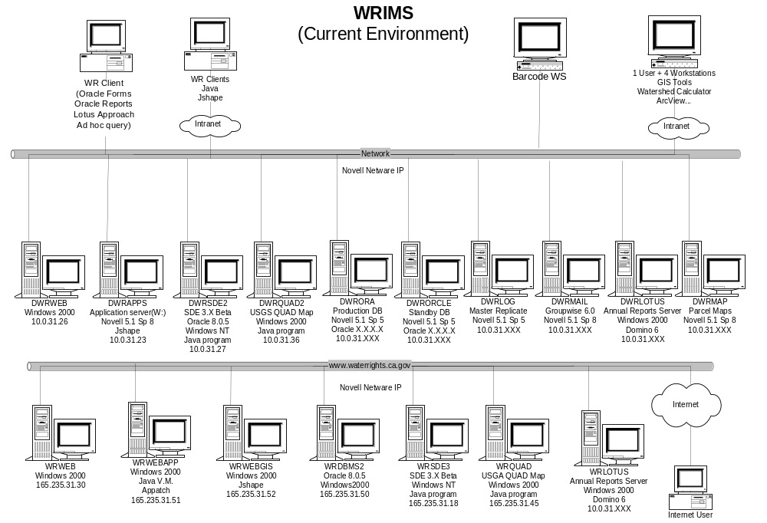
Figure 4-7. Current Architecture
(Servers are Compaq Proliant 3000)

Software Characteristics
The software used by desktop users in the Water Rights Division includes:
- Windows 2000
- Office 2000
- Lotus Approach
- MS Access
- Novell Netware
- Novell GroupWise
- Oracle Client
- Java Virtual Machine

Interfaces
The main system that interfaces with WRIMS is the BOE’s mainframe system, which transmits water-rights fee and payment information. The BOE uses this data to process water rights invoices. WRIMS interfaces to BOE’s systems by sending two data files via floppy disks. These interfaces are manually compiled and require several iterations to ensure data accuracy. The first file is “registration data” and indicates the owners of land parcels on which water rights fee billing is to be based. The second file includes the information about the fees to be billed. In turn, the BOE returns two files. The first is the verification of current “registrations.” The second is the updated billing and payment information.

Additional data from other sources are used to help determine availability and usability of water rights requests. These manual/paper based interfaces involving WRIMS from other data sources include:
- Rare and Endangered Species from the Department of Fish and Game (DFG)
- U.S. Bureau of Reclamation Contract Listings (for fee billing)
- Parcel Information (from Internet, but should be included as a GIS layer)
- Climate Data (rainfall equivalent contour data)
- Hydrology Historical Data (precipitation and stream flow)

Personnel Requirements
The total number of personnel required to manage the Division’s system is 20 personnel years (PYs). Ten of these personnel are required to manage the WRIMS systems infrastructure in the following roles:
- Data Entry: 2 PY
- Database Admin (Oracle): 1 PY
- Programmer 1 PY
- GIS-Administration (GIS): 1 PY
- Data Modules: 0.5 PY
- Network Admin: 0.5 PY
See Section 3 for details of the program staff time and effort used to manipulate data because of current WRIMS deficiencies.

System Documentation
There is no system documentation for WRIMS. The current database was developed by a contractor who delivered a working system only and did not develop system documentation. Over time, as new requirements were added, various engineer users created ad-hoc spreadsheets to provide additional information and functionality, which are also largely undocumented.

Failures of the Current System

General Weakness
- Inability to Adapt: Lack of ability to maintain the system because the network server and relational database management software is no longer supported and the original development contractor is unavailable. This exposes the Division to State sanctions from being unable to comply with new and emerging legislative mandates.
- Minimal and Complicated Web Access: Currently, there is outdated Web access to information on applications, permits or licenses on the Web for applicants or the public in general. There is also no ability to monitor petitions, hearings or legal enforcement by Water Rights Division staff via the Intranet or Internet.
- No Online Services: Water rights holders are unable to use the Internet to perform required annual water use reporting. Water usages are a critical element in the managing of water rights. Water rights are subject to forfeiture after five years of non-use. Water usages are used in determining TMDLs for water quality management; this is critical for the Water Board to meet federal mandates for water quality. In addition, the ability to pay fees online would improve the fee collection process and resulting cash flow of the Division.
- No Tracking of Field Activities There is no integrated method, electronic process or equipment to conduct or document field activities, such as investigations and surveys, required to verify and enforce regulations.
  - Field activities are currently performed using disparate systems and electronic devices (networked databases, PCs, laptops, GPS, laser range finders), and information is entered manually using various small-scale non-integrated programs.
  - Field activity data collection and reporting processes are complicated, and the lack of a unifying system for data collection results in duplication and loss of information, a lack of standard procedure, inadequate survey or investigation preparation and incomplete results.

Geographical Information System Weaknesses
- Inaccurate GIS Information: The Division uses GIS software and databases to store locations of water uses and diversions. These records are stored and processed using WRIMS. After deployment in 1994, WRIMS expanded to include GIS servers and workstations, but the data entered at the time was inaccurate. There is no ability to correct this information because the GIS software does not support it.
- Inadequate GIS Information: Division staff and the general public can access these systems. However, the web-based and desktop interfaces to access geographically referenced data are not adequate, requiring staff to manually search through paper maps to locate information.
- GIS cannot be upgraded: In addition, WRIMS uses older software that cannot be upgraded, making it impossible to maintain a reliable environment.

Baseline Weaknesses
- WRIMS uses Oracle Forms 6 and Oracle 8i. The Novell server software for WRIMS is no longer supported by Oracle’s current version (Oracle 10g).
- Currently, manual processes are undocumented while many business processes are changing.
- Existing Java applications do not support current security requirements, the Americans with Disabilities Act, or other requirements.
- Java code was developed without documentation or maintenance support.
- Business rules were hard coded, requiring changes to be re-coded by OIT staff. Currently, Division managers do not have the ability to add or modify business rules. Business rules should be supported in the data, to enable program managers with access to the data to add or modify business rules without a need for software reprogramming.
- The new system needs to be developed using the Water Board’s application language and technology standards, to enable better support from the OIT.
- The manual data synchronization process and data flow between WRIMS and other current systems is time-consuming.
- Problems with unvalidated data and data quality, due to unstructured text for data entry, impact the ability to accurately generate fees, and as a result, increased time and resources are required to manually correct and submit fees.

Lack of Integration Weakness
Gaps in current systems have resulted in disparate databases in various formats (Lotus Approach, Microsoft Excel, Microsoft Access, and the GIS database), in addition to the main Oracle WRIMS database. These are not linked or integrated, and their information requires a considerable amount of specialized review and manual processing to gather and manipulate the output needed to produce meaningful reports.

Table 4-5 demonstrates how the changing requirements over time have expanded into a myriad of systems, databases and spreadsheets in order to support the Division’s business processes.
Table 4-5. Current Systems Supporting DWR Business Processes
 |  |  | Application and Permitting Programs |  |  |  | Hearings and Special Projects Programs |  |  | Water Rights Enforcement Programs
WRIMS "Current Baseline" of IT System Components | Description | Platform | Application and Petition Programs | CEQA Certification | Water Availability Analysis | Fees Program: Filing Fees | Bay Delta Programs (Special Projects) | Water Quality Certification Program | Hearings Program | Complaints Program | Water Rights Licensing Program | Water Rights Enforcement Program | Water Transfers Program | Fees Program: Annual Fees
WR Permitting Section's Database Systems
Current WRIMS |  | Oracle | x | x | x |  | x |  | x | x | x | x | x | x
Groundwater Recordation | Store Groundwater extraction data. | Oracle | x |  |  | x
Statements of Diversion and Use | Store statement of water diversion and uses data. | Oracle | x |  | x | x | x |  |  | x |  | x
Livestock Pond Registrations | Store Livestock Pond Registration data for stock ponds less than 10 acre-feet. The Registration program was initiated after the original Stockpond Certificate program expired. This is a registration process and does not require approval. Nevertheless, the Water Board by practice issues a document to confirm the registration. The registrations expire after five years and require renewal. | Oracle | x |  | x | x | x |  |  | x |  | x
Livestock Pond Certificates | Store Livestock Pond Certificates data for stock ponds less than 10 acre-feet. This is an program has sunseted. Like Livestock Pond registrations, these rights does not require approval. Owners applied for and received a certificate issued by the Water Board. They do not have to renew the certificate. | Oracle | x |  | x | x | x |  |  | x |  | x
Small Domestic Use Registrations | Store Small Domestic Use Registration data. Like Livestock Pond Registrations, these rights exist by operation of law, but are confirmed by the Water Board when a document is issued. The registration will expire and requires renewal. | Oracle | x |  | x | x | x |  |  | x |  | x
Petitions for Change | Store only data for the approved changes instead of all of the data from the original petition. | Oracle | x | x |  | x |  |  | x |  | x |  |  | x
Petitions for Extension of Time | Store Petition for Time Extension data. | Oracle | x | x |  | x |  |  |  |  | x
Petitions for Assignment of State Filings | Store Petitions for Assignment of State filing data as though they were regular water rights filings. | Oracle | x | x | x | x |  |  |  |  | x |  |  | x
WR Permitting Section's Tracking Database
Applications | Store Application Process Tracking data | Approach | x | x | x | x |  |  | x |  |  |  |  | x
Petitions | Store Petition Process Tracking data. These petitions generally request approval to change the purpose of use, place of use or point of diversion authorized by a permit or license or requested in a pending application. | Approach | x | x |  | x |  |  | x |  |  |  |  | X
Temp Urgency Applications | Store Temporary Urgency Application Process Tracking data. | Approach | x | x | x | x |  |  |  |  |  | x |  | x
Wastewater Change Petitions | Store Wastewater Change Petition Process Tracking data. | Approach | x | x | x | x |  |  | x |  |  |  |  | x
Water Transfers | Store Water Transfer Application Process Tracking data. | Approach | x |  |  | x | x |  |  |  |  |  | x | x
Permit and License Revocations | Store Tracking data associated with voluntary or involuntary revocations of water right permits or licenses. Permits and licenses may be revoked if a water right is forfeited after five years of non-use or if a water right is abandoned. | Approach | x | x |  | x | x |  | x
Application Cancellations | Store Application Cancellation Process Tracking data. | Approach | x | x | x | x |  |  | x | x | x | x |  | x
Environmental Review | Store Environmental Review (CEQA) Process Tracking data. | Approach | x |  |  |  |  |  | x |  |  |  | x
Environmental Review of Petitions | Store Petition Environmental Review (CEQA) Process Tracking data. | Approach | x | x |  | x |  |  | x
Applications | Store Application Process Tracking data | Approach | x | x |  | x |  |  | x |  | x | x |  | x
WR Permitting Section's Independent Databases
Application fees charged and payment received | Store Application and other Filing Fees (Small Domestic Registration, Livestock Pond Registration, Livestock Pond Certificate, Groundwater Recordation, other one time fees etc) payment data. This database generates a Fee report to be submitted to the Water Board’s Division of Administrative Services. | Approach | x |  |  | x |  |  | x |  |  |  |  | x
WR Permitting Section's Monthly Reports
Applications (Monthly Reports) | The report is generated from Application Process Tracking database. |  | x
Petitions (Monthly Reports) | The report is generated from Petition Process Tracking database. |  | x |  |  |  |  |  |  |  | x
Environmental Review (Monthly Reports) | The report is generated from Environmental Review Process Tracking database. |  | x | x
Strategic Plan compliance (Monthly Reports) | The data may come from various tracking database. |  | x
Other Databases or "Systems"
WR Web GIS | Water right Internet (Web) GIS has four databases:  - Water right GIS spatial data database stores Point of Diversion coordinates and water right application ID in SDE / Oracle database.  - Water right Information database stores water rights data (a replica of WRIMS database) in Oracle database.  - Water right QUAD map database stores USGS 100K and 24K USGS QUAD maps.  - Internet GIS Application Server stores and processes Internet GIS application programs | Oracle | x | x | x |  | x |  | x | x | x | x | x
01-02 Online P/L Reports | Stores annual reporting data of water use by permittees and triennial reports of water user filed by licensees filed online by water right holders for 2001 and 2002 in Lotus Domino database. Separate sets of Water Uses Annual Reports in PDF format for 2001 and 2002 are stored in computer system which is used by DWR staff to print individual report on request. |  |  |  |  |  |  |  |  |  | x
03 P/L Reports | Store Water Uses Annual Reports in PDF format for 2003 in computer which is used by DWR staff to print individual report on request |  |  |  |  |  |  |  |  |  | x
04 P/L Reports | Store Water Uses Annual Reports in PDF format for 2004 in computer which is used by DWR staff to print individual report on request. |  |  |  |  |  |  |  |  |  | x
Fee Questions | No database |  | x |  |  | x |  |  | x |  | x |  |  | x
OA Assignment Form | This is an owner Assignment request form. There is a Petition Process Tracking database. |  | x |  |  | x |  |  |  |  | x |  |  | x
BOE Action Form | This is a form to request BOE to take certain action related annual fee registration and billing. There is a tracking database. |  | x |  |  |  |  |  | x |  | x |  |  | x
Fee Petitions | A fee petition tracking database is maintained by DWR staff. |  | x |  |  |  |  |  |  |  | x |  |  | x
ParcelQuest | This is a paid online parcel number search service subscription, a database maintained by an outside vendor, not an in-house database. It is currently used to identify current owners of property with water rights. |  | x |  |  |  |  |  |  |  | x |  |  | x
PhoneBook | A list of telephone contacts. |  | x |  |  |  |  |  |  |  | x
Fee Accounts Receivable | Water right annual fee payment report in Excel format. This is provided by BOE weekly or bi-weekly. DWR also converts it to Approach database. | Excel |  |  |  |  |  |  |  |  | x |  |  | x
Fee Registration | Water right annual fee payee registration data, provided by BOE in Excel format. DWR also converts it to Approach database. | Excel | x |  |  |  |  |  |  |  | x |  |  | x
Revocation | An Excel spreadsheet contains list of revocation permits or licenses. | Excel | x |  |  |  |  |  |  |  | x
Other Databases/Spreadsheets
License Tracking | Tracking of Licenses in process. |  |  |  |  |  |  |  |  |  | x | x
Compliance Tracking | Tracking of Compliances in process. |  |  |  |  |  |  |  |  |  | x | x
Complaint Tracking | Tracking of Complaints in process. |  |  |  |  |  |  |  |  | x | x | x
Pending Applications Unit Assignments Spreadsheet | Current assignments for Pending Applications spreadsheets |  | x | x | x | x |  |  |  |  |  |  |  | x
Pending Petitions with Petition_ID Spreadsheet | Current assignments for Pending Petitions spreadsheets |  | x | x | x | x |  |  |  |  | x |  |  | x
401 Certifications Database | Tracking of 401 Certifications in process. |  |  |  |  | x |  | x |  |  |  |  |  | x

Existing Technical Environment
This section describes the Water Board’s existing technical environment and information systems architecture that will be used to support the proposed solution.

Assumptions and Constraints
The following constraints and assumptions will affect the successful outcome of the proposed solution, a major redevelopment and integration of the current WRIMS:

Expected Operational Life
No fixed end date exists at which the proposed solution will be discontinued. The proposed solution will have to be flexible enough to accommodate unforeseen future changes, including changes in program structure, the addition of new programs and/or changes in the technology environment. A solution that is compliant with Water Board’s OIT technical standards would be expected to remain operational, assuming periodic technical upgrades, for at least ten years.

External Interfaces
The proposed solution must be compliant with the Water Board’s technical standards and integrate with CIWQS where applicable. Further, the solution must be flexible enough to share data with business partners such as the Board of Equalization, the Department of Water Resources, and the Department of Fish and Game, as well as the U.S. Geological Survey (for GIS functions).

State-Level Information Processing Policies
State-level policies do not appear to constrain the feasibility of the proposed solution.

Financial Constraints
Funding to support replacing WRIMS and integrating with CIWQS.

Legal and Public Policy Constraints
There are no known legal or public policy constraints that materially affect the makeup of this solution or the feasibility of implementing this solution. The Water Board must, however, remain apprised of future legislation, which could materially affect the business requirements of the solution.

Agency Information Management Policies and Procedures
The proposed solution will implement the strategic enterprise vision of the Water Board to successfully integrate data and applications into an effective enterprise water quality system to include comprehensive water rights information management. This proposal is cited as an “urgent” strategic initiative in the Water Boards’ current IMS, published in March 2004 (Section 10, page 29).

Anticipated Changes in Equipment, Software, and Operating System Environment
The proposed solution will utilize the Water Board’s hardware and software standards and will upgrade existing servers and integrate with the Enterprise Data Model (EDM).

Availability of Personnel Resources
It is anticipated that development of the solution resulting from this FSR will be performed by qualified systems integration, data integration and GIS vendors in collaboration with the Water Board’s OIT. It is also anticipated that OIT will provide ongoing maintenance and support for the proposed solution.

Existing Infrastructure
The following section describes the current information technology environment in use at the Water Board.

Existing Hardware Infrastructure
The Water Board’s IT hardware infrastructure for State and Regional Boards includes:
- Sun Solaris servers (database, test, internal/external DNS, Oracle and Informix application, web, FTP, mail relay)
- Novell Netware servers (electronic mail and calendaring, file, print, firewall and directory services);
- Windows and Sun Solaris Intranet web servers;
- Cisco Switches, Cisco routers, PIX Firewalls, VPN Concentrator, T3 and T1 data communication circuits; and
- MS Windows XP professional and laptop personal computers.
Desktop software standards include Windows XP, MS Office 2000, various graphics software, Geographic Information Systems (GIS) software and assorted other programming, statistical, scientific and engineering products.

Existing Network Infrastructure
OIT maintains a multi-site Ethernet wide-area network (WAN), which supports 1,700 Water Board staff working in 19 organizations located at 14 physical sites throughout the State. The following diagram, Figure 4-8, illustrates the technical topology of the WAN infrastructure. Each Regional Board administers its own Local Area Network (LAN) under functional direction from OIT.
Figure 4-8 - WAN Topology
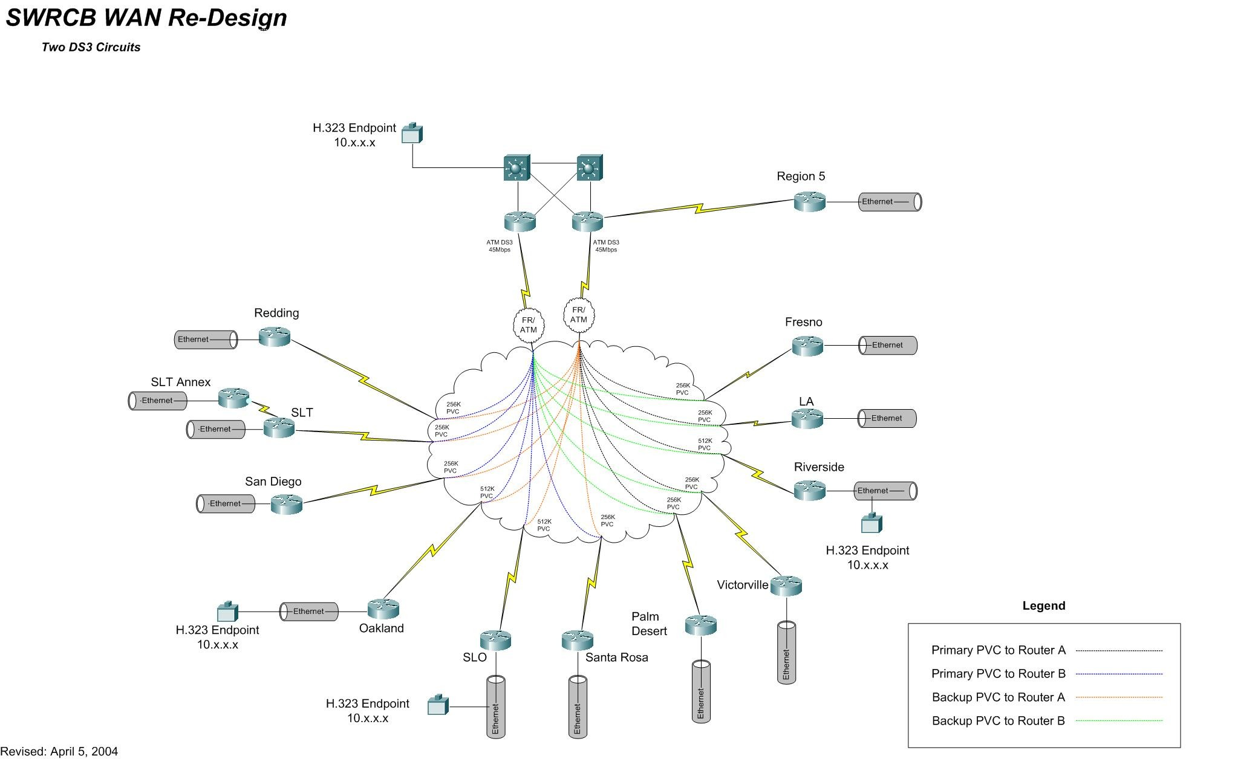

Statewide Water Board IT Policy and Operations
The Office of Information Technology (OIT) at the Water Board provides statewide information technology services for the State and Regional Boards. All Water Board IT staff (53) are in OIT and report through subordinate supervisors to the Chief of OIT (CIO). The Chief of OIT is allocated to the Career Executive Assignment level and reports to the Water Board’s Deputy Director. OIT is responsible for IT strategic planning, feasibility study preparation, new IT system development, legacy system maintenance, Internet and intranet website development and maintenance, PC help desk operations and network operations, cell phone services, and IT operational recovery operations.

OIT has statewide responsibility for promulgating IT policies and procedures and setting the full range of IT standards including hardware specifications, software utilized, configuration of workstations, servers and various network devices. In addition, procurement of all IT goods and services is centralized and administered by OIT.

Specific areas of OIT responsibility include:
- IT Strategic Planning: Development and maintenance of the Information Management Strategy (five year IT plan) and various feasibility study reports and other IT administrative documents.
- Applications Development and Maintenance: OIT is responsible for a variety of enterprise applications that support water quality, water rights or administrative programs. OIT oversees the process of system development (using OIT staff and contractors) and operation of various legacy production systems. OIT publishes standards for application development and system documentation which includes ASP and JSP application languages.
- Data Management: OIT has statewide responsibility for ensuring data standards are established and implemented including adhering to the Water Board’s enterprise data model, Oracle database design and development tool sets, assessment of program’s business requirements, product definition and delivery, and product/relationship management. OIT manages all enterprise Oracle database systems.
- Network Operations: OIT centrally procures all network hardware (servers, routers, switches etc.) and software and promulgates configuration standards for this equipment. OIT operates the Wide Area Network and provides functional direction to the regional board IT staff that operate local area networks (LAN).
- Personal Computer (PC) Support: OIT promulgates PC configuration standards that are used by State and regional board staff on all PCs. All of the workstations and peripherals in use by State and regional board staff are procured centrally by OIT. OIT develops planned replacement schedules for PCs, printers, scanners and related equipment and software.
- IT Staff Training: OIT evaluates the training needs of all IT staff statewide and develops a statewide IT training plan for both OIT and regional board IT staff each fiscal year. Funding for this training is centralized in the OIT budget.
- Internet/intranet Design and Posting Standards: OIT develops standards for all intranet sites including “look and feel” and software (DreamWeaver) used for development and maintenance. OIT sets configuration standards for the servers on which intranet content is hosted. The Water Board’s Internet sites reside on a single server maintained by OIT. Internet sites must be maintained in compliance with the Governor’s standards; OIT is already responsible to ensure this compliance.
- Geographic Information Systems (GIS): OIT is responsible for statewide GIS data and software standards. GIS software is centrally procured and renewed annually by OIT.

Technical Requirements and Standards

Water Board Enterprise Technology Standards
Pursuant to the Water Board’s Information Management Strategy (IMS) and e-Government Plan (March 2004), the Water Board’s Office of Information Technology supports enterprise systems for the Water Board and all of its divisions. Relevant Water Board enterprise technology standards include:
- Oracle 10g RDBMS
- Oracle 10g application server
- Java application development language
Consistent with State information processing system strategies, the Water Board selected Oracle as the enterprise RDBMS and application server standard. The current WRIMS application is currently based on Oracle as its RDBMS, although using an out-of-date, unsupported version. The Water Board has extensive experience with Oracle products and development tools. As a result, it will benefit from expertise gained through maintenance of the existing WRIMS, as well as the development of the Oracle-based CIWQS and other enterprise systems. Additionally, the Water Board will utilize existing Oracle database licenses obtained for CIWQS with the need for additional licenses to ensure database redundancy to support the additional data integration efforts proposed in this FSR. The Water Board will continue to adhere to the standards set forth in the IMS for hardware, software, and database management practices.

The following Technology Requirements tables detail existing technical standards in production at the Water Board and represent technical requirements within which any proposed solution must operate. While exceptions may be possible, it is expected that the proposed solution comply with these standards and requirements.

Tables 4-2, 4-3, 4-4, 4-5, and 4-6 list requirements relating to the following areas:
- Systems Requirements
- Operating Environment Requirements
- Data and Security Requirements
- Interface Requirements
- Infrastructure Requirements

Table 4-2. Systems Requirements
Standard Area | Minimum Technical Requirement
Workstations | Pentium IV CPU with 2.8 ghz  512M RAM  30G hard disk  1024x768 video card  10/100 or 10/100/1000 Mbit NIC
Transaction Rate | The proposed system will be able to support a peak average rate of 100 transactions per second
Required Up Time | 5 days a week/6am-6pm
Required Response Time | For 90% of the system transactions:  - Require no more than 10 seconds to provide initial logon to the application  - Require no more than 5 seconds to provide responses to simple database queries, complete on-line updates to the database, navigate from screen to screen

Table 4-3. Operating Environment Requirements
Standard Area | Minimum Technical Requirement
Client Operating System | Windows 2003 Professional or better, Internet Explorer 6.0+
Network Operating System | Novell Netware 6
Application Server | Microsoft IIS and Oracle 10g IAS
Application Server Operating System | Windows 2003 or Advanced Server
Application Language | Candidates include ASP, Visual Basic, JSP, Java
Data Base Management System (DBMS) | Oracle 10g
Database platform | Sun/Solaris
Data Communications | The present LAN/WAN supports network services for the Water Board and Regional Boards. Regional Board locations have adequate bandwidth to support the integrated system. This includes redundant DS3 circuits to access the Internet. T1 ATM Circuits homerun to Water Board site.
LAN Topology | Ethernet
Transport Protocols | TCP/IP
Network Management | Cisco Works Monitoring tool
Other (e.g. GIS Tools) | ESRI ArcIMS, ArcGIS, and ArcSDE, Terminal Server Software, Windows Terminal Server and Citrix

Table 4-4. Data and Security Requirements
Data Area | Minimum Technical Requirement
Data Structure | Two data types (traditional and spatial/imaging) will be employed, both of which will be stored, retrieved, updated and maintained through Oracle’s 10g RDBMS  The traditional data types will be stored in tables with defined relationships, attributes, and keys while the spatial and image data types will be stored as “objects”. Spatial data will require third party software (cited in the GIS tools section of Operating Environment Requirements table) to retrieve and format for data for use.
Data Integrity | Transaction log of changes made to high priority data fields
Data Conversion | New tables must be created and fields re-mapped to be consistent with the Water Boards Enterprise Data Model.
Integration Issues | The Water Board will comply with Oracle 10g DBMS standards so that data integration will be manageable.
Security Level | Read, write, update and delete privileges defined by user logon, workstation and/or position. Security at record level
Field Level Security | Spatial and attribute data require different access levels.

4-5. Interface Requirements
Interface Area | Minimum Requirement
User Interface | The proposed solution must have an easy to use graphical user interface, characterized by “point-and click” capabilities and compatible with CIWQS intuitive design.
System Interfaces | Board of Equalization (fee data for invoicing)  California Integrated Water Quality System (CIWQS)

Table 4-6. Infrastructure Requirements
Infrastructure | Minimum Requirement
Bandwidth | Single client connection should have minimum one connection of 1.5Mb from internal and external. A minimum of 1Mb bandwidth for a single connection to all major Tier 1 providers.
Backup system | Veritas nightly data and application backup
Firewall | Cisco PIX 525 v. 6.3(1)
Intrusion detection system | Cisco IDS
Security practice | Nightly check of applicable patches and security updates.
Operational recovery | RAID 5 drives for increased reliability and system redundancy, and clustering at the application server level.
Load balancing system | Load balancing application and provide redundancy protection
Redundant connection to ISP | Two redundant DS3 ATM Internet circuits with one T1 backup circuit.
UPS | Enterprise Liebert UPS system in Cal/EPA computer room with individual standalone UPS units connected to some servers

Application Development Methodology
A systems integration vendor will develop the system in collaboration with the Water Board’s OIT and a data integration vendor and a GIS vendor. The OIT and the vendors will share management of the project. The appropriate system development methodology will be determined through joint discussions between the OIT and the vendors. The OIT will ensure that the vendors have adequate experience in the development methodology chosen. The Project Team will develop a formal project management plan that specifies in detail the approach for designing, developing, testing, implementing and maintaining the proposed solution.

Project Management Methodology
The Water Board uses best practices for project management that include the use of the Project Management Institute’s Project Management Body of Knowledge (PMBOK) for all system development work. PMBOK provides the Water Board with an approach to successfully manage the challenges of IT system development. These management challenges arise from such factors as the complexity of the core business processes, specific customer needs, technology alternatives, and resources. The PMBOK project management phases include project initiation, planning, execution, control, and closeout. Within each phase, the organization must carefully monitor the project work plan, risk management plan, communication plan, and contracts to mitigate changes to project scope, budget, and resource requirements. Further discussions about the Water Board’s project management methodology are provided in Section 6.2 of this FSR.

Proposed Solution

Overview
The alternatives for WRIMS were evaluated based on the business objectives and functional requirements presented in Section 3, which were compiled through discussions with subject matter experts, stakeholders, and discussions with software vendors and other States. In this section, the alternatives investigated to satisfy those objectives and functional requirements are described, including:
Alternative 1. Implement Existing System from another State
Alternative 2. Implement Particular COTS Modules
Alternative 3. Upgrade Existing IT Infrastructure
Alternative 4. Allocate Additional Staff
The advantages and disadvantages of the proposed solution and other alternatives considered are presented in the following sub-sections:
5.2 Solution Description
5.3 Rationale for Selection and Alternatives Considered

Summary of Research to Determine Proposed Solution
The FSR team conducted market research to identify viable system solutions including contacting other States and software vendors. Through interviews with OIT staff, Water Rights Division personnel, and information provided by systems vendors, the e-WRIMS FSR team identified different alternatives, including custom solutions in use by other State’s water rights programs, as well as several States using a modified commercial off-the-shelf system (COTS).

The use of custom solutions developed for other States will not enable the Water Board to achieve integration with CIWQS or to achieve specific legislative mandates required by the business objectives in Section 3 above.

A COTS package is not viable to meet the needs of the Water Rights Division because a key business driver for e-WRIMS is the ability to integrate seamlessly with the functionality of CIWQS. The main functional areas of CIWQS, which must be seamlessly accessed, are its GIS components along with water right ownership information and waterbody data. Thus the proposed solution is to build customized software using CIWQS as a data foundation, and upgrade existing hardware and software to current technology standards. As discussed further in this FSR, the advantages of this approach far outweigh any disadvantages and present less risk than procuring a COTS or using another State’s system.

Scope of the Proposed Solution
The Water Board envisions a replacement of its current Water Rights Information Management System (WRIMS) with an integrated, enhanced new version, e-WRIMS, to support the administration of California water rights and integrate with CIWQS, to support the following key business functions:
- Store and maintain water rights information
- Process water right applications and issue water right permits, licenses, and registrations
- Process petitions for change to applications, permits, and licenses
- Process petitions for temporary change and long term transfers
- Process annual reports of groundwater extraction
- Monitor and enforce compliance of water rights regulations by conducting inspections, responding to complaints and performing investigations
- Provide functionality to facilitate the due process of water rights (e.g. administrative actions, conferences and hearings)
- Manage water rights business programs
- Effectively calculate and record the filing fees and fines associated with water rights
- Effectively calculate and record the annual fees assessed and collected by the BOE
- Provide information to and exchange information with the public and other government agencies, most specifically with BOE and DFG
- Provide and store information in a form compatible with CIWQS and in conformance with the Water Boards’ enterprise data model (EDM)
The proposed solution will support an integrated water rights information management system capable of Internet and Intranet on-line access that can also be used to manage the workflow of the Division. The new e-WRIMS will also monitor the Division’s workflow in processing water rights complaints, and monitoring ongoing water use (and compliance with water rights terms) for permits and licenses.

The Water Board has an enterprise GIS data library to store and access geographically referenced data. Since the current GIS infrastructure is insufficient to support the business needs of the Division of Water Rights, the proposed solution incorporates additional hardware and software into the existing GIS data library. This approach addresses the business needs of the Division’s water rights enforcement efforts by including aerial imagery in the GIS data library, expanding the public’s and Division of Water Rights’ access to GIS data, and providing the ability to collect and link geographic coordinates using Global Positioning Systems (GPS) with other associated water rights data.

Conceptual Model of the Proposed Solution
The proposed solution will be a custom developed software module that builds on the hardware, software and development standards in CIWQS. The
e-WRIMS strategy will adhere to the Water Board’s Enterprise Data Model (EDM) specified in the Water Board Information Management Strategy (IMS) document. This approach provides a single platform with a common architecture, which will significantly reduce design complications, integration issues, and maintenance complexities. The customized solution will support the business programs and functions identified in the Business Case. This approach will enable the Water Board to implement a viable system more quickly and at lower cost than the other options available, as discussed in Section 5.3.

The proposed e-WRIMS will be supported with the following hardware and software:
- For the production environment:
  - A mirrored central production database server in which all CIWQS and e-WRIMS data will reside (WATER32: ORACLE 10g server)
  - Production Oracle Application Server (Oracle 10g IAS) (WATER31) that will manage application query, reporting, and security features
  - Production Application Server for GIS online editing (FOLSOM)
  - Production Internet Web server (SWRCB2)
  - A RAID 5 File Server (proposed machine)
  - Mirrored production GIS SDE data server (SWRCB20: ORACLE 10g)
  - Two production CITRIX Terminal Servers used for GIS editing (SHASTA, TAHOE)
  - Production Veritas Backup System with Master Server and Media Server (WATER16 and proposed machine)
  - Production Net Application Device F820
- For the development, testing and training environment:
  - Test Oracle Application Server (SWRCB15: Oracle 10g IAS)
  - Test Oracle Application Server (SWRCB24: Oracle 9i IAS v2)
  - Test Oracle Database Server, Discoverer Repository, SDE (SWRCB13: Oracle 9i IAS v2)
  - Test GIS Application server (ARCTIC)
- Dedicated T-1 circuits between the State Water Board and the 9 Regional Water Boards
- Software modules that support the business functions as discussed in the Business Case

Key capabilities that e-WRIMS will provide include:
- A web-based interface permitting internal e-WRIMS users and external customers to access and use e-WRIMS from any computer with web connectivity and a browser
- The capability of receiving electronic data (applications, claims, reports of water use, etc.) from water rights customers
- Improved efficiency by streamlining and automating water rights business-critical workflow processes
- Security (passwords, authorization levels, etc.) to prevent unauthorized access or actions
- Improved data integrity and flexible reporting capabilities that will allow the Water Rights Division to meet Cal/EPA, Water Board, and public reporting needs and to analyze data with improved speed and efficiency
- Ability to meet all of the functional requirements outlined in Section 3
- Utilization of a single, integrated, industry-standard relational database management system, complying with OIT hardware, software, and database standards
- Reasonable response times even when accessed by 56K modem speed, providing minimum response times of two seconds for 95 percent of transactions
Figure 5-9 provides a graphical representation of the conceptual architecture for e-WRIMS.
Figure 5-9. Proposed e-WRIMS Solution Architecture
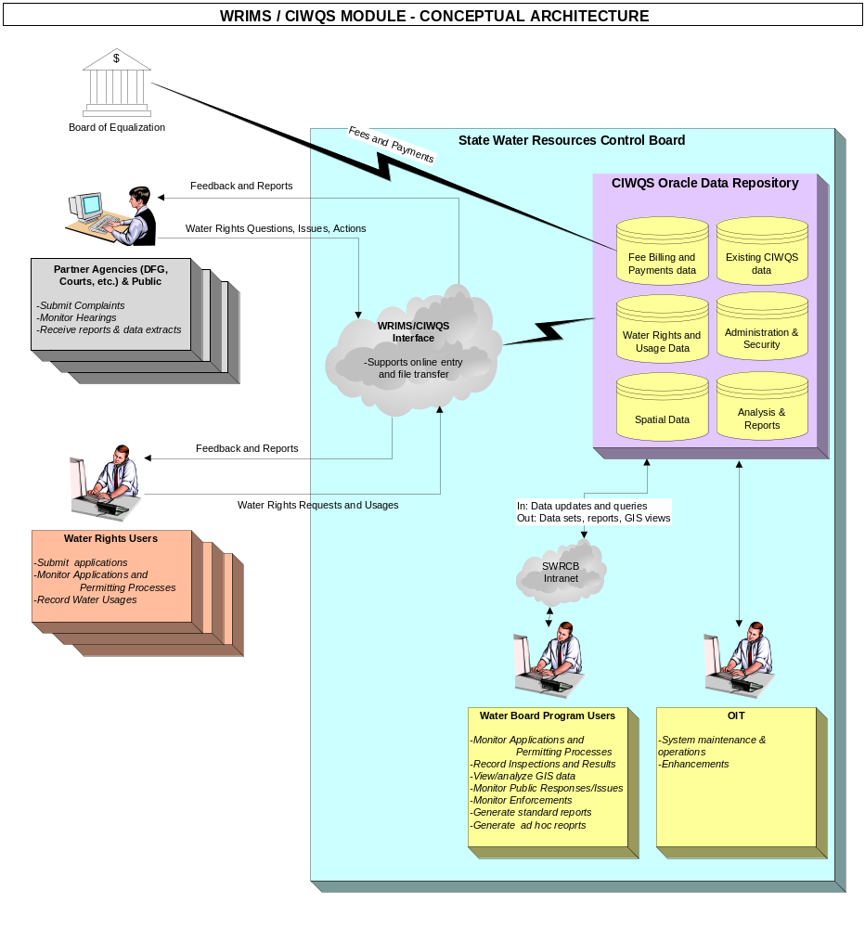

Solution Description
The remainder of this section provides additional detail about the proposed
e-WRIMS solution, including requirements for hardware and software, interfaces, testing, resources, maintenance and security, as well as the impact on end users and proposed sources of funding.

Proposed Hardware and Technical Architecture
The proposed system will require an upgrade to the existing database and application servers as well as upgrades to the GIS Spatial Database Engine (SDE) and backup system. Six additional GIS editor workstations will be required to support the users within the Division of Water Rights.

The e-WRIMS hardware architecture will conform to OIT standards as outlined in Section 4.2. Hardware to support e-WRIMS will include standard server platforms, routers, switches, and personal computers. Water Board users will have no need for additional hardware beyond standard desktop computers and an Internet Web browser. External users will require access to a computer with Internet access and a Web browser. Table 5-6 shows the servers anticipated to be required to support e-WRIMS. Figure 5-10 illustrates the plan for these upgrades in an enterprise technical architecture developed to support program activity across the Water Board.
Table 5-6. e-WRIMS Hardware
Existing Production Servers for e-WRIMS
(Housed at the Water Board)
Database, Query, and Reporting Server
Water 32
Sunfire V1280 4CPU 1200MHz, 16GB memory
Oracle 10G Database; Discoverer Repository

GIS SDE Server
SWRCB 20
Sunfire 280R
2CPU 900MHz 4GB memory, Oracle Oracle 9iv2 SDE Database
GIS Data Layers, SDE 9 Server

CITRIX Terminal Servers
TAHOE
Citrix Terminal Server for GeoWBS Editor
MS WIN 2003
Dell Poweredge 2850
4CPU 3.6 GHZ 8GB ram
SHASTA
Citrix Terminal Server for GeoWBS Editor
MS WIN 2003
Dell Poweredge 2850
4CPU 3.6 GHZ 8GB ram
Internet Application Server
Water 31
SunFire V880 four 1280MHz CPU, 4Gb memory, Solaris 9, Oracle Application Server 10g

GIS Application Server
FOLSOM
Application server GeoWS Navigator
(ArcIMS) MS WIN 2003
Dell Poweredge
2850 4CPU 3.6 GHZ 8GB ram
Microsoft IIS Server
Internet Web Server
SWRCB2
SUN E450
1 CPU 400MHz
3GB memory Solaris 9
Internet Web Server
www.waterboards.ca.gov

Test GIS Application Server
ARTIC
MS Windows 2003
Dell Power Edge 2850
1 CPU, 900 mghz, 1GB memory
Internet FTP Server
SWRCB2A
SUN E450 two cpu 480MHz 2Gb memory
FTP Server ftp://swrcb2a.waterboards.ca.gov
File Server
MS Windows 2003
Veritas Enterprise Backup System
L100
Backup Media Server
Water 16
Sunfire V240
Two 1280 MHz CPU, 2GB memory, Storedge 3310, Solaris 9, Veritas Netbackup Master Server

Figure 5-10. Water Board’s Enterprise Technical Architecture
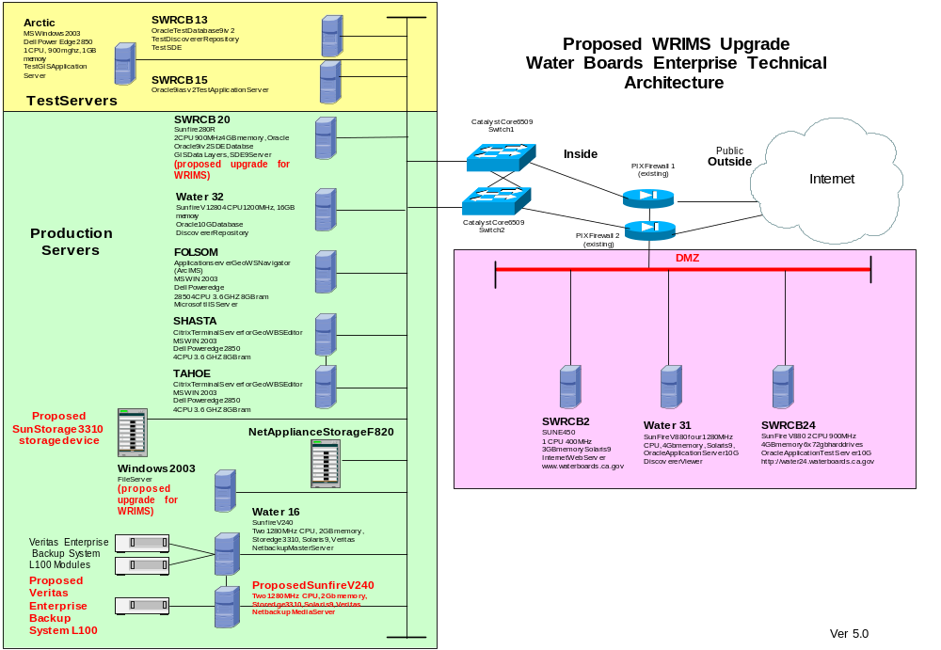

Proposed Software
The solution will be a custom developed system that will integrate with CIWQS and conform to the Water Board’s technical standards outlined in Section 4.2.

A key benefit of the proposed solution will be to take advantage of the GIS elements designed in CIWQS, leverage waterbody information for water rights, and transmit water usage information to the CIWQS system.

The proposed e-WRIMS solution will both ensure current and future compatibility with CIWQS and ensure availability of ongoing maintenance and support. These standards include formal Software Development Guidelines for application development , Oracle’s CDM toolkit, as well as software procurement standards.

In addition to the custom development effort, it is anticipated that e-WRIMS will require the installation of production standards software on the servers identified in section 5.2.1.

Proposed Technical Platform
The technical platform will include browser-based Java code running on an Oracle database and application servers with ArcIMS GIS elements supported by MS Windows 2003 systems.

The proposed solution will comply with established OIT technical standards, including Oracle application and database standards. The proposed solution’s operating system software includes Microsoft Windows Server 2003, Unix/Sun, and Oracle 10g, and Oracle 10g IAS as outlined in OIT’s technology standards.

Development Approach
Development will be performed by a combination of OIT staff and procured consulting services using an approved approach outlined in the OIT Development Standards manual.

Because the proposed solution is based on using the foundation and templates developed for the CIWQS custom-developed software, development efforts will focus on enhancing and modifying the core CIWQS to:
- Meet specific e-WRIMS functional requirements;
- Be compatible with other internal Water Board IT systems; and
- Interface efficiently with selected external systems.
Building on the CIWQS foundation significantly reduces the scope of the software development effort for certain modules, when compared with a “from scratch” custom-developed solution. The e-WRIMS workflow and tracking components will require greater levels of development. These modules can then be leveraged in CIWQS to meet additional Water Board workflow requirements.

Data Migration/Integration
A significant success measure when upgrading or replacing an information system includes the accuracy of data after migration efforts are completed. The Water Board’s historical experience in migrating existing data to CIWQS showed the effort to extract, cleanse, and load data was underestimated. In some cases, agencies have contracted out data conversion after attempting to initially perform these functions in-house. Based on both the recommendations from other agencies that have recently installed new systems and the analysis conducted by the FSR team, OIT will contract with a CMAS vendor for data conversion services using the following approach:
- Migrate customer and site information
- Migrate application data sufficient to enable on-line submittal
- Migrate GIS location data of sites and waterbodies
- Migrate additional GIS layers needed for water rights, including historical data
- Migrate historical water rights financial information to the extent required
- Consider manual conversion for low-volume data
- OIT staff will continue to build a common data architecture (EDM), for water rights data and perform data cleanup prior to the contractor migrating the data
- Evaluate the need for migrating historical financial and enforcement information
During the formation of the data migration plan, OIT will consider the following factors:
- Determine the use of the baseline system for customer, site, application, and financial data, since multiple systems exist containing the same data
- Utilize standard data definitions including format, length, and naming convention, as outlined in the Enterprise Data Model
- Determine the “cleanliness” of legacy data and assigning resources to “scrub” legacy data prior to loading
- Identify specific technical resources to develop cleanup and load programs or scripts
- Identify specific resources to implement a legacy archiving and retrieval system
- Determine the procedures and processes for documenting the data migration scripts, and for providing version history of those scripts
GIS data point corrections are not included in the proposed e-WRIMS. Corrections will need to be completed after the data has been moved to the new system.

Integration Issues
The integration with CIWQS will obviate the need for interfaces between CIWQS and the current WRIMS. With considerable overlap of data being integrated, the reliability and consistency of data will be ensured.

Interfaces with external systems will mainly consist of two-way transactions between the Board of Equalization and the Water Board. The Water Board will send data to the BOE including parties to be billed and the fee amounts. The BOE will respond with actual billings and payments to e-WRIMS customers.
Additionally, GIS layers and meta-data (e.g., rainfall, endangered species, etc.) will be imported as GIS layers for GIS analysis.

Procurement Approach
Procurement of services to design, develop, migrate data, test and implement
e-WRIMS will follow Department of General Services (DGS) procedures. The Water Board will seek vendors with particular expertise to most effectively implement the new solution, and will award contracts to those vendors who have experience in implementing and integrating systems of a similar size and scope. The vendors to be procured include a core development vendor for system development and integration, a data integration vendor, a GIS specialty vendor, a vendor to provide process analysis, process implementation and training, and a vendor to provide independent project oversight.

An invitation for proposal (IFP) will be issued to solicit vendor proposals for the e-WRIMS project. Contract services will be procured using the California Multiple Award Schedule (CMAS) to ensure alignment with current procurement guidelines. The procurement approach will be fully discussed in the e-WRIMS Information Technology Procurement Plan. The current estimated procurement schedule is outlined as part of the Project Management Plan presented in Section 6 of this FSR.

Technical Interfaces
e-WRIMS will provide an automated data flow between e-WRIMS and BOE to provide increased efficiency and accuracy of billing and invoicing services.

Testing Plan
The proposed solution testing plan is outlined in the Project Plan in Section 6.0 and is based on recent experience in testing and implementing the CIWQS application. Thorough testing of each module will be conducted prior to going into production. These tests will include:
- Interface Testing
- System Integration Testing
- Parallel Testing
- User Acceptance Testing
OIT program personnel, including subject matter experts and members of the Software Interface and Integration Team, assist in developing test scripts and participating in system integration and user acceptance testing. Customer and agency personnel who are members of the External Stakeholder Workgroup will also participate in user testing.

The Water Board OIT and the core systems integration vendor, the data integration vendor and the GIS vendor will design testing plans and conduct testing phases to ensure the accuracy, completeness, and robustness of the system. A test plan will be developed, documented and executed according to OIT’s application development approach, to include the following elements:
- Unit testing: Test that each system module performs as designed
- System testing: Test that system components work together as designed
- Migration testing: Test that data integration conforms to data elements mapped to the Enterprise Data Model
- User acceptance testing: Users test the system to ensure it meets the business functions as identified in the system requirements.
There are no significant known issues regarding the proposed testing phases for the proposed effort.
The testing plan must be developed and conform to the business requirements as defined in this FSR and any resultant IFP documents. The user-testing group will include subject matter experts from the Water Board’s Water Rights Division, as well as users from the Regional Boards and other stakeholders. The testing plan will include the following phases:

- Unit Testing Phase
The development team will test each phase of the business processes and systems functions developed for e-WRIMS. Unit testing is defined as the verification of the accuracy and completeness of the individual processes, programs, modules, objects, functions, and procedures that make up the system.
- System Testing Phase
System testing will be conducted to verify that e-WRIMS works correctly and integrates with the CIWQS.
- User Acceptance Testing Phase
User acceptance testing includes providing the user testing group access to test data to determine the usefulness and accuracy of the data entry and reporting features of the system. The users will perform their normal business using the system to identify problems that may exist during actual production execution. User acceptance testing will also help in identifying business process problems that may occur when the system is used differently than documented in the specifications.

Resource Requirements
OIT, vendor resources, program subject matter experts and other stakeholders will be required during e-WRIMS design, development, testing, implementation and training phases. Table 5-7 identifies the necessary resource requirements.
Table 5-7. e-WRIMS Resource Requirements
Water Board Resources | Vendor Resources | Customer/Agency Resources
Executive Sponsor  Management Sponsors  Project Manager  Steering Committee  Subject Matter Experts  Software Interface & Integration Team  Data Management & Integration Team  Business Implementation Team  Data Modeling | Independent Oversight  Software Interface & Integration Team  Data Modeling  Data Management & Integration Team  Implementation, Outreach & Training | External Stakeholder Workgroup
The Project Management Plan in Section 6 provides details regarding the specific responsibilities of each of the Project Teams. The e-WRIMS systems and data integration vendors will perform the majority of the required development and implementation tasks, with significant oversight and guidance from the Water Board’s e-WRIMS Project Manager. In addition, successful implementation of this project will require OIT and customer staff participation during all phases. OIT assumes that the selected vendor will provide core training and outreach.

It is not anticipated that participation in e-WRIMS will preclude OIT personnel from satisfactorily fulfilling their core (non-WRIMS) job responsibilities to the extent the proposed project resources are provided to ensure successful implementation of the solution. Cost assumptions relating to resource requirements are presented in Section 8 of this FSR.

Training Plan
The implementation of e-WRIMS will require training beyond the use of a new Web application – e-WRIMS will have significant impact on the way programs within the Water Rights Division operate, and many work processes will change as a result of the e-WRIMS implementation. Division staff are accustomed to entering and/or retrieving information from the many disparate systems that
e-WRIMS will replace, and will need to learn how to utilize e-WRIMS for these purposes. In addition, customers and agencies accustomed to submitting paper documents to program staff, and will have to learn to access e-WRIMS via the Web and submit required information on-line. The Project Management Plan in Section 6.0 outlines the training approach, tasks and deliverables. The associated costs are presented in the Economic Analysis in Section 8.0.

OIT, in collaboration with the vendor, will develop a detailed plan for training staff on the use of e-WRIMS. Individual units within the Water Rights Division will be responsible for reviewing, revising, and training their personnel on business process changes resulting from the e-WRIMS implementation. OIT will assist the vendor in providing training for customers and agencies that will use e-WRIMS. All the initial training will be a joint effort involving both OIT and vendor personnel.

Training will include the development of user documentation, and may be provided through any or all of the following methods:
- Classroom training at the Water Board
- Onsite training at statewide Water Board locations
- Computer-based online training
- Ad-hoc one-on-one training and responses to questions
- Self-directed training using hardcopy or on-line documentation
e-WRIMS will include on-line help to assist users. While training will be an important aspect of the project, the redeveloped e-WRIMS will provide a more user-friendly interface, based on the CIWQS user interface. It is expected that, in general, it will take less time to train a new employee or customer on e-WRIMS than it would on current systems and processes.

OIT plans to utilize multiple avenues to disseminate information to customers about e-WRIMS from the procurement phase through implementation. During procurement phase customer participation will ensure that the needs of customers are met when designing the solution. Post-implementation communication and outreach to customers will help ensure successful use of the new system.

Ongoing Maintenance and Operations
Initially, post-implementation of the e-WRIMS application will be the responsibility of the vendor for six months. To mitigate the risk of becoming dependent on the vendor for system support, the project approach is to include OIT technical staff during system design, documentation, testing, and deployment of the new application.
The production system will be located and supported at the Water Board. Online availability of 8:00 a.m. to 5:00 p.m. Monday through Friday will be sufficient to meet water rights business requirements. Many functions and capabilities may be available during extended hours as well. Scheduled downtime will be built into the maintenance plan to allow for routine maintenance, software updates, etc. The testing, training, and development servers will be maintained by OIT. These costs are documented and explained in Section 8.0.
As explained in Section 8.0, ongoing maintenance costs for e-WRIMS will be less than for the current systems. Resources in support of the existing systems will decline since they will be needed to maintain the existing systems for historical purposes only and be removed from the production environment once the solution is successfully implemented. Some resources will be shifted from the administration of current WRIMS systems that e-WRIMS will replace, to
e-WRIMS support. The associated costs are explained further in Section 8.0.

Information Security
The approach used for information security for this effort will be consistent with the Water Board and State of California security policies in place. CIWQS has a user authentication strategy defined and will be used for the e-WRIMS user authentication of the proposed solution. Specific security requirements for this proposal are listed in Section 3.4 above.

Confidentiality
Most of the data collected and documented within the State and Regional Boards is public information; however, some programs may require the safeguarding of data confidentiality. For this data, the system will use Secure Sockets Layer (SSL) 128-bit encryption and server validation via registered server certificates currently implemented for CIWQS.

Impact on End Users
The system will change the way the Water Rights Division manages its programs. It will automate data collection processes, replace paper and fragmented spreadsheet repositories, and reduce manual work steps. In addition, the Division will expand its use of the Internet to conduct business with stakeholders, provide higher quality information, reduce the reporting burden on customers, and provide better customer service. Specifically, this system will:
- Eliminate many manual reporting processes.
- Allow customers to submit data electronically.
- Automatically calculate fees and monitor payments and delinquencies.
- Provide customers access to their data.
- Reduce the need to refer to paper files by providing a data repository of customer, local site, claims, performance, and other data online.
- Eliminate redundant data entry and provide more accurate data to end-users.
- Allow staff within and across other Water Board divisions to share information more efficiently and effectively.
- Provide authorized Division staff with a single data repository for generating standard and ad hoc management reports to satisfy most State and Department requirements relating to the Water Board programs.
In order to support end-users (Water Rights personnel, customers, and agencies that participate in water rights programs), and during transition to e-WRIMS, implementation includes the following:
- Training, as described in Section 5.2.11 above
- User documentation
- Online help features
- A Help Desk with staff to answer questions and resolve issues

Impact on Existing System
Implementation of e-WRIMS will have the following impact to existing systems:

e-WRIMS will provide the Division with the ability to perform its mandated tasks, ensure its financial viability by accurate assessment and collection of fees, augment the functionality planned in CIWQS, and provide additional water usage information necessary for the Water Board’s mandate to determine TMDLs. In addition, it will reduce reliance on labor-intensive manual data manipulation in office automation software to perform water rights analysis.

Consistency with Overall Strategies
This proposal is consistent with the Water Board’s mission to establish and maintain a stable system of water rights in California to best develop, conserve and utilize in the public interest the water resources of the State while protecting vested rights, water quality and the environment and complying with State mandates.

To comply with these mandates, the Water Board has established the following Information Management goals:
- Business Process Automation. Implement technology solutions to automate Water Board core business processes and provide the necessary IT and information management tools.
- Technology Architecture. Adopt and promote a technology architecture that is consistent with industry standards, meets the needs of individual business units, is sustainable, supports overall enterprise needs, and increases the return on investment.
- e-Government Solutions. Provide best-in-class e-Government solutions that make it easier for customers to transact business, access information, and communicate with the Water Boards.
- Organizational Direction. Optimize the IT organizational structure and resources to improve delivery capability.
- Technology Management. Enhance the Water Board’s technology management capabilities through the full utilization of adopted best practices and processes.

Impact on Data Centers
There is no planned impact on State data centers as a result of the proposal.

Data Center Consolidation
There will be no impact on data center consolidation.

Backup and Operational Recovery
The Water Board will continue existing backup and operational recovery practices currently in place within the OIT. These practices include disk mirroring, Veritas incremental and full backups, offsite storage, and onsite magnetic media storage. In integrating the design architecture with CIWQS and providing increased performance, database and application server redundancy (“mirrored” technology) will also be added in addition to utilizing the development servers as test environments prior to migrating to the production environment.

Public Access
The public will have access to data deemed non-confidential via the Internet. Confidential data will only be available via the Wide Area Network and protected by a firewall. Data entry screens will allow online submittal of applications. GIS data views and web-based reports capabilities will also be provided to the public as part of the solution.

Costs
One-time and ongoing costs for the proposed solution are detailed in Section 8, Economic Analysis.

Benefits
The proposed solution, e-WRIMS, will resolve the business problems outlined in this FSR, meet the business needs of users and support the Water Board’s water rights and requirements by supporting mandated requirements for water rights reporting and processing. e-WRIMS will specifically benefit the Water Board by meeting the following objectives:
- Provide a timely response to the public’s need for water rights information
- Provide real-time information about water rights to enable outside consultants, staff and others to track the ongoing status of applications, permits, petitions and water availability in the State
- Meet current demand for processing of water right applications for permits and other requests
- Generate automated environmental documentation, permits and licenses from data in the database
- Provide on-line forms for applications and other processes
- Provide the ability to report annual water use information on-line
- Provide the ability to change water right ownership information on-line, and other services appropriate to on-line facilitation
- Improve sharing and integration of water rights and water quality information between the Water Quality and Water Rights Divisions, in order to effectively manage the beneficial use of water across the State
- Improve sharing of water rights information with Regional Water Quality Control Boards, who use it for certain permitting and diversion management processes, for Total Maximum Daily Load analyses and allocations, and to monitor the potential risk of illegal discharge activities
- Improve sharing of water rights information with other Resources Agency departments, such as the Department of Water Resources, the Department of Fish and Game and CalFED, in their roles which relate to the water rights program
- Improve the ability to manage and collect water rights fees, track payment and coordinate staff fee-related activities
- Provide tracking and reporting tools to properly allocate staff resources and track ongoing Division activities and staff assignments
- Increase the reliability and quality of water rights data
- Integrate water rights data with GIS information to enable more complete understanding of water availability and compliance

Sources of Funding
To cover the costs of the proposed solution, the Water Board will need to secure a low interest loan of $3.3 million from the State 's Underground Storage Tank Fund and repay that loan from the Water Right Fund annually over the next five years plus interest.

Although the Budget Authority will exist if this proposal is approved, the earliest the State Water Board may adopt emergency regulations for water right fees, get approval from Office of Administrative Law, and begin receiving payment of assessed fees for fiscal year 2006-2007 is November 2006. Between July 1 and at least November 1, the Division must operate its program using any excess funds remaining in the Water Right Fund, or secure other temporary revenue sources. The loan provides necessary security for the timely implementation of this proposal, and the continued maintenance of the Division's programs. The loan also allows the State Water Board to spread the cost of the WRIMS replacement over a five-year period so that water right fee payers are not impacted with a one-time fee increase of nearly 40 percent for fiscal year 2006-2007.

Rationale for Selection and Alternatives Considered
The proposed solution was selected based on the following rationales:
- The proposed solution solves the business problems outlined in the Business Case.
- The proposed solution meets all of the business requirements specified in the Business Case and satisfies the Water Board’s business needs and objectives.
- Development and implementation risks are lower because the solution will be based on the CIWQS foundation that is in place.
- Costs are reduced because many technology features required for the solution are already be implemented with CIWQS.
- The proposed solution complies with the Board’s technology standards and is consistent with Water Board’s technical enterprise systems and data integration and management strategy. The e-WRIMS database will continue to be developed in compliance with the Water Board’s Enterprise Data Model.
Along with the proposed solution for e-WRIMS, the following alternative solutions were considered:

Alternative 1. Implement an Existing System from another State
Alternative 2. Implement Particular COTS Modules
Alternative 3. Upgrade the IT Infrastructure
Alternative 4. Allocate Additional Staff

Alternative 1: Implement an Existing System from another State
In this scenario, the Water Board would implement water resource management software already custom developed and supported in another state. Three states were identified that developed a custom-built water rights information management system: Washington, Idaho and Wyoming.

States were selected for interviews based on their similarity with California on administering water rights programs. Directors and technology managers from three other states were interviewed to gain an understanding of their implementation experiences. These discussions assisted in identifying viable alternatives for OIT.

State staff shared their custom development implementation experiences and provided knowledge of other states’ best practices. Each state official provided functional and technical descriptions of their solution and answered questions on the features and functionality as part of the informal market research conducted for e-WRIMS.
Table 5-8 summarizes the advantages and disadvantages of implementing one of these systems.
Table 5-8. Implement an Existing System from another State
Advantages | Disadvantages
- Application proven in another state with possibly similar operations to California.  - Initial cost to develop is avoided. Primary costs result from integration vendor customization and implementation efforts.  - Highly automated, web-based application. | - Database platforms (MS SQL 2000)  not compatible with Water Board standards (Oracle).  - Requires rewrite and significant additional customization for California prior to implementation.  - Requires excellent documentation and knowledgeable application resources to decipher and modify the system.  - Without vendor support, requires Division staff to make future modifications.  - Contracting with the systems integrator in lieu of using staff to enhance and maintain the system could cost more than redeveloping WRIMS.
Recommendation: Implementation of another state’s automated system is a potentially more expensive solution than redeveloping WRIMS. Implementation costs would be a major consideration, as well as the ongoing maintenance and support costs for a systems integrator required to perform major revisions of another state’s system in order to meet the requirements of the California water rights program.

Alternative 2: Implement Particular COTS Modules
The use of COTS software to support water rights programs, particularly for the GIS component, is on the rise in other states, and the Department of Finance for the State of California is encouraging the use of COTS solutions. Using COTS in place at other states rather than undertaking a custom development effort would mean implementing numerous separate software programs to achieve a viable solution. However, implementing pre-existing individual COTS components would not address the automation and integration needs of the Water Board, due to unconnected “islands” of data and redundant functionality that would be created using this approach. Further, implementing individual software components would not provide electronic sharing of data easily both on the Internet and across program areas, which is a critical business requirement.

Software vendors who specialize in water rights software typically customize and maintain the product based on the specific needs of the state and the water rights program administered by each state client. When these applications were first implemented, they were modified due to:
- Variations in the way different states administer the program;
- Differences in state technology standards;
- Different state populations and program participation;
- The unique functional and business requirements of each state; and
- Different state systems with which the applications must interface.
The FSR team investigated two water resources management COTS solutions to determine product features and functionality.

Table 5-9shows the summary information of COTS evaluated for this project.
Table 5-9. COTS Packages in Use by Other State Water Rights Organizations
COTS Name | Organization Using COTS | Description and Water Rights  Program Areas Covered
1. National Resources Information System (ArcView) | U.S.D.A. Forest Service, Corvallis, WA | GIS component solution only.  Provides mapping and coordinates for water events; creates water events and displays them with GIS  Does not support water rights program areas per se (application, permit, license, hearing, fee processes)
2. Earthwon | Canadian  government agencies | Offers only two modules, to support water structure management (dams, bridges), no in-ground water resource management or water rights processing.

Table 5-10 shows the benefits and risks of incorporating COTS components to support areas of water rights systems requirements.
Table 5-10. Implement COTS Components from Various States/Vendors
Advantages | Disadvantages
- Shorter implementation timeline.  - Proven success of prior COTS solutions.  - Cost is known in advanced and minimized. Primary costs resulting from customization, integration, and implementation.  - California can select the product that best meets the need of the particular program.  - Provides proven web-based solutions. | - Would create silos of data and potential for redundant functionality.  - Some level of customization still required for California prior to implementation.  - Does not address the need to minimize multiple disparate systems.  - Introduces complexities to on-going maintenance and support.  - Non-integrated application environment makes any subsequent integration far more complex.  - May not meet all the needs of water rights programs.
Recommendation: Implementing individual components from other States would eliminate at least some of the multiple stand-alone systems currently in use in California for a given program area. However, this approach fails to provide an integrated solution that allows sharing data across programs. It also introduces the need for a potentially significant integration effort for the Water Board. Based on the inherent system integration and data sharing issues associated with this approach, this alternative is not recommended.

Alternative 3: Upgrade the Existing IT Infrastructure
In this scenario, the Water Board would continue to use the current disparate applications but would upgrade to more recent versions of technology platforms, where possible. This scenario does not include functional improvements, redesign of interfaces or integration with CIWQS.

Table 5-11 summarizes the advantages and disadvantages of this approach.
Table 5-11. Upgrade the Existing IT Infrastructure
Advantages | Disadvantages
- Avoids disruption of tasks involved in new system testing and implementation.  - Avoids re-training of users. | - Migration to newer platform may not be seamless – change to Oracle 10g alone will require significant application rewriting to accommodate a newer database platform. Additional data migration efforts will be required to move to newer operating system.  - Tasks would still be disrupted during interface redesign, data migration and conversion and testing phases required for the Oracle database upgrade.  - Does not eliminate existence of 30+ non-integrated “systems” and manual processes used to manage Water Board’s programs.  - Propagates reliance on out-dated platforms and technology.  - Propagates inefficient program workflow processes.

Recommendation: Although upgrading the current technology infrastructure avoids some of the challenges that accompany other alternatives evaluated, such as a procurement, this option meets very few of the functional and technical requirements required to meet the Water Board’s objectives and legal mandates. The database upgrade will involve necessary data redesign, migration and conversion tasks similar to a more complete software integration effort envisioned by the proposed solution. Consequently, the option of only upgrading the technology supporting the existing system should not be pursued.

Alternative 4: Apply Additional Staff Resources Only
With approval, the Water Board could hire additional staff resources to address some of the previously identified business needs and requirements rather than redevelop WRIMS. The initial automation of WRIMS’ major work processes was accomplished 12 years ago. In recent years, the Water Rights Division has taken on additional programs and responsibilities. These typically required new business and reporting processes. Because the original WRIMS cannot be easily modified, many additional systems have been developed over the years to support these new programs and processes. The level of “automation” provided by these additional systems is limited. Many are basic Microsoft Access databases or Microsoft Excel worksheets used on standalone personal computers (PCs) by one or a few users.

The effect of these new business requirements is a highly manual, paper-intensive processes supported by “systems” that provide a place to store data electronically with little real process automation. There is minimal data sharing between these applications, and minimal logic built into them to automate functions, verify data, check for errors, or reconcile information. These PC-based tools support manual processes and are not true automated systems. It is not uncommon to have similar data (such as water right holder/owner information) manually keyed into as many as seven different standalone systems. When the data change, there is no automated process for updating all these systems, or even communicating to those responsible for updating the various systems that a change has been made. This results in poor data quality and the inability of staff to track current and accurate information.

Table 5-12 outlines the advantages and disadvantages of allocating additional resources to address the problems identified in the Business Case, Section 3:
Table 5-12. Apply Additional Staff Resources
Advantages | Disadvantages
- Avoids many of the technology and project risks and disruptions associated with implementing new systems (conversion, training, etc.).  - Can be implemented incrementally with minimal impact to ongoing operations.  - Provides a way of accomplishing some of the objectives of  e-WRIMS. | - Many of the current standalone systems are not designed for access by multiple users, making it difficult for staff to get the information they need in a timely manner. Allocating additional people to processes that rely on these systems will require significant modifications to facilitate multi-user access. For example, incorporating a record locking feature (to prevent multiple users from attempting to simultaneously modify the same record).  - Many of the current systems were developed by  end-users themselves. They have little or no documentation, no on-line help, and were not developed using application design standards. They may be difficult for new users to learn, and have few built-in safeguards to protect against unintentional duplication, modification or deletion of records.  - The number of errors currently introduced because of all the paper-based manual processes and re-keying of data will increase if more people are involved in the processes.  - Training of additional new staff in system and processes would be required.  - Does not address the long-term need for redefining program workflow processes or improving the quality of data, or the need to integrate water quality information with water rights program information.  - Current business processes are inefficient due to lack of adequate system support. Adding staff without significantly upgrading systems will further reduce efficiency.  - Allocating additional personnel is significantly more costly than implementing the recommended solution.  - This approach fails to address many of the specific shortcomings of the current systems that are driving the need for e-WRIMS, including:  - Current systems do not adequately support the need for accurate, complete, readily accessible data, including GIS data.  - Current systems do not meet current Water Board technology standards, which means technical support will become ever more costly and difficult to obtain. In several cases, the Division is already highly reliant on only one person (who is retiring in 2005) to support critical systems.  - Current systems lack adequate security and disaster recovery safeguards.  - The current systems prevent public users throughout the State from accessing information they need resulting in requests to headquarters staff to mail and fax forms and other documents.

Recommendation: Given the current technical environment and challenges faced by the Water Board, allocating additional staff will only compound the problem, by increasing the risk of poor data introduced to the system. Due to the number of data owners and limited ability in the current system to provide data quality control or quality assurance, this alternative would meet hardly any of the objectives and functional requirements, and is therefore not recommended.

To summarize, there is no compelling reason to consider other states’ solutions, since the solutions found run on incompatible technology platforms. Nor would implementing modules from multiple vendors be appropriate, since no vendor is exceptionally strong in one or more key functional areas. Addressing only the underlying technical infrastructure is not possible, as several key platforms are out-of-date and no longer supported by the vendors. Applying additional human resources rather than improving WRIMS will only add to the handoffs and complexities of the current process, doing nothing to improve data access, integrity, reliability, and timeliness.

The proposed solution will utilize the Water Board’s Enterprise Data Model and integrate with the newly developed Water Board system, CWIQS, and will benefit from using the systems design architecture developed and implemented for CIWQS.

Project Management Plan
The Water Board recognizes that a structured approach to managing the e-WRIMS Project is critical to ensuring its success. To this end, it has developed the Project Management Plan outlined in this section of the FSR. This plan complies with Department of Finance’s Information Technology Project Management Methodology.

Project Manager Qualifications
The Water Board will assign a staff e-WRIMS Project Manager and collaborate with the selected contractors’ project team leads to perform the project management duties involved in ensuring the success of the e-WRIMS Project. The e-WRIMS Project Manager possesses the following qualifications:
- Knowledge of IT project management and execution methodologies such as the Project Management Institute’s (PMI) Project Management Body of Knowledge (PMBOK)
- Completion of a project management certification program
- Team leadership experience
- Previous experience developing IT project plans
- Skilled in the use of project scheduling tools, system modeling tools, and IT application strategies and methodologies
- Knowledge of project management concepts and techniques, including team leadership, and change, issue, risk, quality, schedule, vendor, and budget management
- Able to coordinate and motivate the work of a variety of individuals, groups, and organizations both internal and external to the Water Board in order to accomplish project goals
- Experienced in working with and managing an outside application vendor
- Knowledge of and experience with data conversion, system security, web-based systems, and reporting systems
- Experienced in performing conflict resolution with stakeholders, vendors and staff
- Technical knowledge of and familiarity with the Water Board’s information technology environment
- Knowledge of the Water Board’s programs and issues related to water rights and information sharing between Water Boards stakeholders and the public
- A thorough understanding of the challenges involved in developing e-WRIMS Project components

Project Management Methodology
The Water Board’s Project Management Methodology is based on the use of the Project Management Institute’s Project Management Body of Knowledge (PMBOK) and the Department of Finance’s Information Technology Project Management Methodology as outlined in the Statewide Information Management Manual (SIMM), Section 200.

PMBOK provides the Water Board with an approach to successfully manage the challenges of IT system development. These management challenges arise from such factors as the complexity of the core business, specific customer needs, technology alternatives, and scarce resources. The PMBOK project management phases include project initiation, planning, execution, control, and closeout. Within each phase, the organization must carefully monitor the project work plan, risk management plan, communication plan, and contracts to mitigate changes to project scope, budget, and resource requirements.

Adhering to a sound project management methodology at each stage of an IT project—from planning to evaluation—ensures that the Water Boards’ projects will achieve desired business outcomes, meet end-user expectations, and will be completed on schedule and within budget. The Water Boards will utilize this methodology to successfully implement the e-WRIMS requirements. The e-WRIMS Project Manager will use Microsoft Project to develop a detailed Project Plan and schedule, and will provide written status reports on a regular basis.

The e-WRIMS project management activities include:
- Development of a project charter defining the project and roles and responsibilities
- Defining activities and their sequence
- Development of a project schedule and budget
- Resource, quality, and configuration planning
- Development of business and technical requirements
- Risk and change management
- Ongoing performance review, corrective actions, and project plan updates
- Monitoring planned versus actual performance, schedule, and budget
- Ongoing quality assurance and documentation
- User review and acceptance
- Post-implementation evaluation
Additional project management activities are detailed below under Roles and Responsibilities.

Project Organization
The proposed e-WRIMS Project organization is illustrated in Figure 6-11. Additional information on the roles and responsibilities of the various components is provided in Roles and Responsibilities 10.
Figure 6-11. e-WRIMS Project Organization Chart
The following figure displays the current organizational structure of the Office of Information Technology. The Water Rights Division organizational structure is depicted in Section 3.1 of this document.
Process Analysis, Implementation, and Training Team

Data Integration Team

GIS
Development Team

WRIMS Core Development Team

SWRCB
Project Sponsors

Harry Schuller
Executive Sponsor
Nancy Miller
Office of Information
Technology
Vicky Whitney
Division of Water Rights
External
Stakeholders

e-WRIMS
Project Manager

IPOC
Vendor

Project
Steering
Committee
Oracle DBA Lead
Systems Architect Lead
Application Manager
Application Developer
WRIMS Vendor Lead and Staff

GIS Developer
GEOWBS Application Developers
GIS Vendor Lead and Staff

Data Modeler
Data Conversion Analyst
Data Integration Vendor Lead and Staff
Vendor Lead and Staff
Permitting Product Manager
Enforcement Product Manager
Hearings Product Manager
Training Rep
Outreach Rep

SWRCB Staff
Vendor Staff
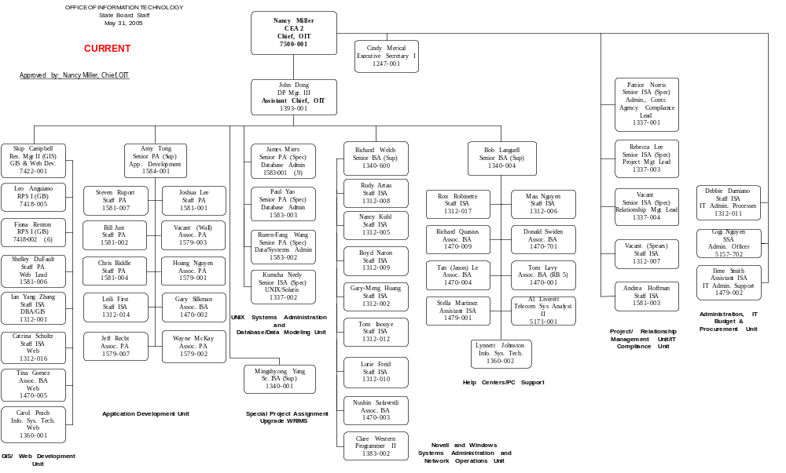
Figure 6-12. Water Board Office of Information Technology Organization Chart

Project Priorities
All projects have three core components that must be managed:
- Schedule
- Scope
- Resources
Each of these is interrelated—a change in any one factor will almost certainly impact the others. Prior to beginning the project, it is important to determine the relative importance and flexibility of each. For e-WRIMS, this trade-off is documented in Table 6-13.
Table 6-13. e-WRIMS Project Trade-Off Matrix
Schedule | Scope | Resources
Improved  (Can be adjusted) | Constrained  (Cannot be changed) | Accepted  (Is somewhat flexible)

The project schedule is flexible and may be adjusted to achieve the defined scope with available resources.

Resources are somewhat flexible, in terms of business and technical experts who can assist in the design, development, and implementation of the project.

The scope for the e-WRIMS is constrained, in order to meet the business needs of the Division of Water Rights and replace obsolete existing systems.

Project Plan
Project planning defines the project goals and objectives, the activities that will be required to accomplish them, how these will be performed, and the resources that will be required to accomplish them. The project plan defines each major task, estimates the time and resources required to accomplish it, and provides a framework for management review and control. Project planning activities include defining the following:
- Project scope
- Project assumptions
- Project phasing
- Project team roles and responsibilities
- Project schedule
The following sections will briefly define and discuss each of these project-planning components.

Project Scope
The e-WRIMS Project seeks to implement a system to support the administration of the Water Board’s Water Rights programs, including:
- Permitting
- Licensing
- Enforcement
- Hearings
- Special Projects
The new e-WRIMS will provide the functionality required to manage these programs, including the ability to:
- Store and maintain water rights information, and provide ad-hoc and standard reporting of water rights information
- Effectively process water right applications and issue and renew water right permits, licenses and registrations, including:
  - Provide on-line application submittal and status monitoring
  - Provide on-line tracking of permit and license processing
  - Provide on-line support for submittal of ownership and other change requests
- Generate final documents such as permits, licenses and some CEQA documents, as reports
- Monitor and enforce compliance of water rights regulations by conducting inspections, responding to complaints and performing investigations
- Provide functionality to facilitate the due process of water rights (e.g. administrative actions, conferences and hearings)
- Effectively calculate and record the filing fees and fines associated with water rights
- Effectively calculate and record the annual fees assessed and collected by the BOE
- Provide information to and exchange information with the public and other government agencies, most specifically with BOE and DFG
- Provide and store information in a form compatible with CIWQS and in conformance with the Water Boards’ enterprise data model (EDM)
- Provide “real-time” information for water rights activities, including enforcement and hearings

This project will consist of those activities required to accomplish the proposed solution and implement a new e-WRIMS to meet the functional requirements listed in Section 3.4 of this document. The scope includes:
- Procure vendor system integration contract services
- Perform enterprise level data modeling
- Perform data migration analysis / integration
- Develop detailed business requirements
- Develop detailed architecture, data, and application design
- Develop and build e-WRIMS code
- Perform unit, system, migration and user acceptance testing
- Perform the necessary training and knowledge transfer for users, the administrator, and maintenance support staff Develop system and user documentation
- Perform migration of existing historical data to enhanced system
- Perform implementation and production cutover
When completely implemented, e-WRIMS will replace 40 systems, including a variety of Approach and MS Access databases, and numerous MS Excel spreadsheets. The complete listing of these systems can be found in Section 4, Baseline Analysis.

Project Assumptions
Major e-WRIMS assumptions include:
- The Water Board will coordinate with the Department of General Services (DGS) to ensure that DGS can review and approve the proposed procurement approach defined in the Information Technology Procurement Plan (ITPP) for the e-WRIMS Project according to the plan outlined in Table 6-16.
- The Department of Finance (DOF) will review and approve this FSR in a timely manner.
- Project will obtain Control Agency (Department of Finance and Department of General Services) approvals.
- The e-WRIMS Project will be funded by a five-year loan from the Underground Storage Tank Fund, administered by the Water Board. The Water Board will request a budget augmentation for the Water Rights program to repay the loan.
- The Water Board will ensure that funding will be available, as planned, throughout the project’s life.
- Program requirements will not change substantially during project implementation.
- Higher priority issues will not impact the schedule or resource needs.
- Executive Sponsorship will continue through project completion.
- The Water Board’s OIT project management methodology (PMM) will be utilized.
- Negotiations with contractors will result in a budget similar to the estimates provided in this proposal.
- Vendor resources will be utilized to perform one-time application development tasks.
- Qualified Water Rights program and Office of Information Technology (OIT) technical staff will be available to participate, as needed, in design, development, testing, training, and implementation of the proposed e-WRIMS solution.
- Suppliers, vendors, consultants, and State staff will perform their assignments related to the e-WRIMS Project in a competent and timely manner.
- Partner agencies will participate and provide information as required to successfully develop and implement system interfaces and data exchange.
- Issues will be resolved and risks mitigated on a timely basis.
- All equipment and software procured will comply with the Water Board’s policies and production standards.

Project Phasing
In order to reduce project risk and stay within resource constraints, the e-WRIMS Project will be implemented in a phased approached, as described below.

Phase 1.0 FSR and ITPP Development and Approval
This phase consists of the planning and analysis done to identify the need and appropriate scope for the e-WRIMS Project. It includes the preparation of this Feasibility Study Report (FSR), as well at the Information Technology Procurement Plan (ITPP) for the project. Upon completion of this phase, the Water Board will have a thorough assessment of the impacted program areas and business functions, and define and document the major project execution activities.

Phase 2.0 IFP and System Vendor Procurement
In this phase, the Water Board/OIT will prepare the statement of work(s) for soliciting bids from vendors using the Invitation for Proposal (IFP) and CMAS contracting process for each of the modules described in Phase 3. The IFPs will be made available to potential vendors, their responses will be evaluated based on best value to the Water Board, and vendors will be selected for contract award. The independent project oversight consultant will also be selected during this phase using the same IFP process.

Based on the Department of Finance Technology Oversight Framework, e-WRIMS is a medium-criticality project based on the calculation summarized in Table 6-14.

Table 6-14. e-WRIMS Rating for Oversight
Factor | e-WRIMS Rating
1) Size | Low (1)
2) Project Manager | Medium (2)
3) Project Team | Medium (2)
4) Type | Medium (2)
Total Score | 7
Average Score | 1.75

Funding for independent project oversight is included in the EAWs.

Phase 3.0 System Design, Development, Integration and Implementation
e-WRIMS will include integration with information currently held in the Water Board’s California Integrated Water Quality System (CIWQS) and be comprised of the following four modules:
- e-WRIMS Core Development
- GIS Development
- Data Integration
- Process Analysis, Implementation, and Training

Further details of this phase and each module is provided in Section 6.5.5, the e-WRIMS Project Schedule.

The data integration of the e-WRIMS core development and GIS will enable key information to be shared between the Water Rights program and the Water Board. As noted in Section 3, the Business Case, the Water Board require water rights information for many program purposes, including determining appropriate terms in National Pollution Discharge Elimination System (NPDES) permits (issued under the Clean Water Act) to protect diversions located downstream of point discharges of waste, to determine current and future diversions and uses of water in order to conduct Total Maximum Daily Load (TMDL) analyses and allocations, and to manage the potential risk of illegal discharge activities to the beneficial uses of the State’s waters.

For additional information on each of these phases, including work to be accomplished, expected beginning and end dates, and deliverables, see Table 6-16. e-WRIMS Project Phases, Schedule, and Deliverables on 16.

Roles and Responsibilities
As illustrated in the Project Organization Chart in Section 6.3, the project participants and decision makers related to the e-WRIMS Project will include the Executive Sponsor, Management Sponsor, the SWRBC e-WRIMS Project Manager and the vendor team leads. Other members of the Project Team are critical to the project’s success. The roles and responsibilities of the various individuals and groups that make up the e-WRIMS Project Team are described in Table 6-15.
Table 6-15. e-WRIMS Project Team Roles and Responsibilities
Responsibilities | Resource Type
1. Executive Sponsor
- Serve as key business decision maker on the e-WRIMS Project.  - Provide executive level leadership and guidance of the project.  - Secure project funding and ensure the availability of project resources.  - Participate in Steering Committee meetings that address key project milestones.  - Champion support for the project and markets its benefits.  - Monitor project progress.  - Provide direction on alternative strategies to accomplish project goals if risks/issues arise. | Water Board
2. Management Sponsors (Technology and Program)
- Communicate project status to Director and internal and external stakeholders.  - Champion support for the project and markets its benefits.  - Monitor project progress.  - Resolve significant issues and make scope change decisions that cannot be resolved by the e-WRIMS Project Management Team.  - Approve chosen vendors retained throughout the e-WRIMS Project.  - Help coordinate work efforts that impact the project.  - Resolve significant project issues.  - Attend e-WRIMS Project Management Team meetings.  - Facilitate Steering Committee meetings.  - Approve project deliverables. | Water Board
3. Steering Committee
- Sponsor the development and implementation of needed business process changes and IT systems.  - Guide the overall effort towards the achievement of its objectives.  - Confirm project goals and scope.  - Assist in the resolution of project issues.  - Attend and actively participate in Steering Committee meetings.  - Communicate project objectives and status to peers, colleagues, and staff.  - Provide direction and guidance to the development process.  - Provide input on development progress.  - Set priorities of recommendations.  - Address cross-division policy issues.  - Address barriers to project success. | Water Board
4. SWRCB e-WRIMS Project Manager and Vendor Team Leads
- Participate in the procurement processes to secure IFP development, software integration, data management and integration, implementation and outreach and independent project oversight services.  - Approve the project scope and approach from a technical IT perspective.  - Assure project technical feasibility, adherence to standards and appropriateness to the overall information technology strategy.  - Check plans and estimates and coordinate IT resources.  - Monitor the development of and adherence to the project management plan.  - Determine the suitability and soundness of the overall technical architecture from an IT perspective.  - Elevate risks and mitigation measures to the appropriate organization level.  - Oversee the prioritization of application requirements.  - Provide oversight of technical and programmatic project activities to include database design, testing and implementation, as well as business requirements definition, user input and enrollment.  - Manage and implement the implementation work plan.  - Evaluate implementation effectiveness and communicates need for additional implementation efforts.  - Elevate budget, schedule, client, and technical issues to the Management Sponsors, as necessary.  - Regularly communicate with the Vendor Project Team Leads to address project management, development, and implementation issues.  - Maintain Issues Database or Log and Change Management Database or Log.  - Develop and maintain the Risk Management Plan, together with the Vendor Project Team Leads. Develop mitigation strategies and contingency plans and monitor project risks.  - Communicate project status to stakeholders as needed.  - Track the project budget and review vendor invoices.  - Maintain the project schedule and risk management plan.  - Maintain information on contracted costs vs. actual costs.  - Manage contract change requests and addendums. | Water Board Project Manager  (with support from  Vendor Team Leads)
5. Independent Project Oversight Consultant (IPOC)
- Serve as an independent expert that provides technical assistance in all activities that are critical to the project’s success.  - Evaluate the project to ensure that it is following a structured and defined approach.  - Review deliverables to ensure that they are aligned with defined standards, needs, and contractual requirements.  - Prepare periodic project assessments and develop monthly DOF/OTROS progress reports in coordination with e-WRIMS Project management.  - Oversee the project in accordance with the Department of Finance IT Project Oversight Framework by performing the following tasks:  - Produce and deliver work products (e.g., Project Risk Lists, Project Risk Management Forms) required by the Information Technology Project Oversight Framework for the SWRCB, Cal/EPA and the Department of Finance.  - Review and make recommendations for improvements to the project plan and associated project management documents and processes.  - Assess whether project goals are being achieved. | Vendor
- Ensure project reviews are held and documented.
- Review project Status Reports.
- Review project on a regular basis for conformance with project management plans and processes.
- Assist with the identification and resolution of problems and issues, including follow-up audits.
- Participate in review of key project milestone deliverables.
- Participate in Project Management Team meetings, as needed.
6. Systems Architecture Lead
- Coordinate and oversee the establishment and operation of the Project’s technological environment including servers, workstations, network connectivity, development software, and database environments.  - Participate in the determination of technology architecture required to support system interfaces.  - Participate in the procurement processes to secure systems integration and oversight services.  - Attend e-WRIMS Project Management Team meetings. | Water Board  Vendor
7. Subject Matter Experts
- Provide candid input to business needs assessments, evaluations, and the selected solution.  - Assist in the definition of business processes and business rules.  - Assist in the identification of potential new policies and procedures.  - Participate in interviews and working sessions with the e-WRIMS Project Team.  - Communicate project status to internal stakeholders, as needed.  - Participate in system integration and user acceptance testing. | Water Board
8. e-WRIMS Software Design and Implementation Team
- Design and develop the e-WRIMS environment, as defined by the functional requirements and business needs.  - Conduct prototyping sessions with internal and external stakeholders.  - Conduct system design and development walkthrough sessions.  - Conduct unit tests.  - Develop test scripts for user acceptance testing.  - Facilitate user acceptance testing.  - Develop system documentation.  - Coordinate with representatives from other internal and external systems with which e-WRIMS will interface.  - Work with the implementation and training teams to develop user manuals, address user questions and issues, develop training manuals, and conduct training sessions. | Vendor  Water Board
9. GIS Development Team
- Design and develop e-WRIMS GIS environment, as defined by the functional requirements and business needs.  - Conduct prototyping sessions with internal and external stakeholders.  - Conduct system design and development walkthrough sessions.  - Conduct unit tests.  - Develop test scripts for user acceptance testing.  - Facilitate user acceptance testing.  - Develop system documentation.  - Coordinate with representatives from other internal and external systems with which e-WRIMS will interface.  - Work with the Process Analysis, Implementation, and Training Team to develop user manuals, address user questions and issues (e.g., help desk), develop training manuals, and conduct training sessions. | Vendor  Water Board
10. Data Management & Integration Team
- Define current and future data elements, relationships, and definitions in conjunction with use of the Water Board’s Enterprise Data Model (EDM).  - Work with the Project Team to design the logical data model and develop the data dictionary.  - Conduct data model walkthrough sessions.  - Coordinate data cleanup.  - Confirm data conversion approach.  - Develop automated data conversion tools.  - Coordinate data conversion resources.  - Conduct integration testing  - Develop and implement system interfaces | Vendor  Water Board
11. Process Analysis, Implementation, and Training
- Identify business requirements  - Define and implement new business processes.  - Assess organizational impact and determine optimal organizational structure, skills, and operation processes.  - Design business processes and transaction steps.  - Document new business processes.  - Document and provide training on new business processes.  - Develop and deliver training for users.  - Participate in outreach and communication prior to and during implementation. | Vendor  Water Board

Project Schedule
The proposed e-WRIMS Project Schedule is outlined in Table 6-16. e-WRIMS Project Phases, Schedule, and Deliverables.
Table 6-16. e-WRIMS Project Phases, Schedule, and Deliverables
Project Phases & Stages | Estimated Start | Estimated End | Deliverables
Phase 1.0 FSR and ITPP Development and Approval
Stage 1: Feasibility Study Report | 04/15/05 | 7/08/05 | - FSR  - ITPP  - Approval from DOF of FSR  - Approval from DGS of ITPP
Stage 2: Information Technology Procurement Plan | 8/01/05 | 8/31/05
Stage 3: Control Agency Review and Approval | 7/11/05 | 11/30/05
Phase 2.0 Vendor Procurements
Stage 1: Procurement Vendor Preparations | 1/02/06 | 2/03/06 | - Statements of Work completed and approved  - Vendors selected and contracted
Stage 2: Vendor(s) Solicitation and Selection | 2/06/06 | 3/31/06
Stage 3: Independent Oversight Vendor Solicitation and Selection | 1/02/06 | 2/03/06 | - Oversight consultant selected and contracted  - Contracts approved
Stage 4: Contract Approval | 4/03/06 | 05/12/06
Phase 3.0 System Development, Integration, and Implementation
Project Management | 7/03/06 | 9/07/07 | - Project charter  - Detailed work plan  - Project schedule  - Project closeout documentation
Module 1: e-WRIMS Core Development | 7/03/06 | 9/07/07 | - Detailed functional requirements  - Technology architecture plan  - Physical Data Models  - Software design specifications  - System design (hardware and software) document  - Screens developed  - Physical database enhancements  - Configuration of systems & network architecture and development environment  - e-WRIMS database installed and configured  - Test plan developed  - Systems interface test cases  - Systems interface test plans and results  - System integration plans and test results  - System documentation  - Network performance test plans and results  - User acceptance testing plan, scripts, environment and results  - Maintenance and support procedures  - Vendor contract closeout
Module 2: GIS Development | 7/24/06 | 9/07/07 | - Detailed functional requirements  - Technology architecture plan  - Physical Data Models  - Software design specifications  - System design (hardware and software) document  - Configuration of systems & network architecture and development environment  - Network performance test plans and results  - Maintenance and support procedures  - Vendor contract closeout
Module 3: Data Integration | 7/24/06 | 9/07/07 | - Data dictionary  - Data migration plan  - Logical data model  - Data conversion plan  - Data mapping  - Data conversion software  - Converted test data  - Data migration results report  - Data successfully converted  - Final data migration
Module 4: Process Analysis, Implementation, Training, and Change Management | 7/03/06 | 9/07/07 | - Workflow diagrams  - Change control procedures  - New process implementation plan  - Training materials  - Product outreach communications  - End-user training  - Public outreach/ communications  - Vendor contract closeout

Project Monitoring
The project will be monitored in accordance with the Water Board Project Management Policy. The e-WRIMS Project Management Team will work closely with the individual Project Teams in order to monitor project progress and effectively manage the project work plan. Using industry-accepted methodology and project management tools (e.g., Microsoft Access, Excel, Project), the Project Management Team will document and track project phases and activities, as well as project timelines and associated milestones. In addition, the Project Oversight vendor will monitor the project status to ensure that project decisions are appropriate and cost-effective, and will report these findings to the Product Manager and Executive Sponsor regularly. By combining staff expertise with effective project management, the Water Board can monitor the project while ensuring effective communication and contractor knowledge transfer to OIT staff.

The e-WRIMS Project Manager, together with the vendor team leads and the Management Sponsors, will monitor project progress. Key components of this monitoring will include:
- Weekly Project Team Meetings and Monthly Project Management Meetings. These will include discussions of the project schedule, deliverable status, upcoming meetings, risks, and issues.
- Weekly Project Status Reports. These will be distributed to the Project Manager and Project Sponsor. The report will include the activities performed by all Project Team members during the previous week, including: accomplishments, activities in progress, upcoming activities, issues, and deliverable status.
- Monthly Project Status Reports. The Project Team will also prepare monthly progress reports and submit them to the project manager. These reports will establish a formal record of project status, including: project work plan updates, progress of work performed, and unanticipated tasks.
- Oversight provided by an independent project oversight consultant (IPOC) and by the Water Board’s e-WRIMS Project Manager .

Project Quality
A structured approach to quality assurance is necessary to ensure that the e-WRIMS Project is successful in meeting the Water Board’s goals and objectives for it. The first step in ensuring project quality is developing clearly defined functional and technical requirements. They provide the benchmarks against which quality can be evaluated. Through assessment, validation, and testing, project results will then be measured against these requirements in order to ensure quality.

Project quality management will be performed in accordance with the Quality Management section of Water Board’s Project Management Policy. This includes the specification and monitoring of project quality standards and performing mid-project adjustments/corrections as necessary to ensure that the project will meet its stated objectives. As prescribed by the PMBOK, quality management will be performed across two dimensions:
- Quality Control—Quality control (QC) involves monitoring specific project results to determine if they comply with relevant quality standards, and identifying ways to eliminate causes of unsatisfactory results. Specific activities related to project results will include:
  - Review and acceptance of formal deliverables
  - Review of project management performance indicators (e.g., schedule and budget) and overall project status
- Quality Assurance—Quality assurance (QA) includes all the activities necessary to provide confidence that the project will satisfy the relevant quality standards. In short, this includes employment of the repeatable processes and procedures employed by Water Board to ensure that projects have the appropriate quality standards, and that they are consistently followed. This includes testing processes, verification and validation, and other audit-related activities.

Quality assurance also relies upon the use of effective policies and standards.
The Water Board has established information technology standards for computers, networks as well as other infrastructure components, web development, GIS, etc.

The e-WRIMS Project Team will adhere to these production standards wherever they are applicable for the use of technology on this and other projects, as follows:
- Password Policy
- Internet Equipment Policy
- Router Security Policy
- Virtual Private Network Policy
- Wireless Communications Policy
- Enterprise Data Model Standards

The Water Board requires that project work products and deliverables satisfy project requirements and objectives with minimal errors and defects. In order to minimize the risk of receiving an unsatisfactory deliverable, a Deliverable Expectations Document (DED) will be prepared prior to the start of any major deliverable. The DED will ensure that all parties have a clear understanding of what is expected from the deliverable before work commences on it. The DED will contain the following about the deliverable:
- Name
- Description
- Outline
- Due Date
- Reviewers
- Sign-off Sheet

Upon their completion, the e-WRIMS Project Manager will conduct a walkthrough of each deliverable with appropriate members of the Project Team and Water Board management. Designated managers will be allowed a reasonable time to review each deliverable and either request changes or sign-off on them indicating that they are acceptable.

The Water Board’s Database Administrator and Data Modeling Lead will assist the e-WRIMS Project Team during the planning, analysis, and development activities in order to ensure that e-WRIMS collects and stores data according to the Water Board’s Enterprise Data Model (EDM).

Change Management
The project management process will follow a three-step approach designed to accommodate reasonable variations from the original work plan and will identify and manage proposed changes to the project’s scope, schedule, or resource requirements.

These steps are:
- Submission of Change Requests—Changes in this project will require submission of a change request that documents the nature of the change, the reason, impact of the change on the project budget, impact on the project schedule, and the impact of not incorporating the change.
- Review and Discuss with the Project Team—The Water Board Project Manager will review the change request with the appropriate Project Team to determine the impact of incorporating or not incorporating the change. The change request is evaluated based on its cost and benefit, as well as its relevance to the original scope of the project. Complex requests will be elevated to the Product Manager and, if necessary, to the Executive Sponsor.
- Approval or Denial—In order to be implemented, the request must be approved by the Water Board Project Manager, and, if the change is substantial, by the Executive Sponsor and Steering Committee as well. Without consent of the majority, the request will be denied. When a change is approved, the requirements matrix will be updated accordingly.

Authorization Required
In addition to Water Board and Cal/EPA approval, prerequisite control agency approvals from Department of Finance and Department of General Services must be obtained for expenditures on this project.

Risk Management Plan

Project risks are factors that jeopardize the successful accomplishment of project goals. Risk management is the systematic process of identifying, analyzing, and responding to project risks. This Risk Management Plan will help to minimize the risks associated with the e-WRIMS Project. It is presented in the following sections:
7.1 Risk Management Approach
7.2 Risk Management Worksheet
7.3 Risk Tracking and Control

Risk Management Approach
The Water Board’s approach to risk management on the e-WRIMS Project will include:
- Identification of potential project issues and risks by the Project Team, e-WRIMS vendors and Water Board management;
- Development of preventative risk mitigation strategies and contingency measures to avoid or minimize the impact of these potential issues and risks; and
- Continuous monitoring of identified issues and risks through on-going communications and reporting mechanisms.

The Water Board’s risk management processes will comply with the Department of Finance’s Information Technology Project Management Methodology. This approach is based on early detection, swift response, close monitoring, impact minimization, and thorough recovery. The costs of managing risks on the e-WRIMS Project are included in the Economic Analysis Worksheets presented in Section 8 of this Feasibility Study Report.

The Water Board’s e-WRIMS Project Manager will have overall responsibility for risk management on the project, and will be supported in this responsibility by the e-WRIMS Project Team. The Project Manager and team members will have experience with the various water rights programs, and will receive assistance and technical advice from the management sponsors. This role will be to work with the Project Team to identify, monitor, mitigate, and report project risk without conflicting interests.

The e-WRIMS Project Team will include the following key individuals:
- Water Board e-WRIMS Project Manager (Technical) – Has overall responsibility for the e-WRIMS Project. The Project Manager will help identify project risks, review and approve the Risk Management Plan, regularly review the Project Issues Log, and meet regularly with the Project Team and independent oversight consultant.
- Vendor Project Team Leads – Will develop and maintain the Risk Management Plan and the Issues Log. The vendor team leads will assist the Water Board Project Manager in monitoring project risks, developing risk mitigation strategies and contingency plans, and ensuring that these are implemented appropriately.
- Independent Project Oversight Consultant – Responsible for providing project oversight. The Oversight Consultant will meet with the Project Manager on a bi-monthly basis to discuss the status of the project, including project risks. The Oversight Consultant may assist the Project Manager in identifying project risks and developing risk mitigation strategies and contingency plans.

Risk Assessment
The e-WRIMS Project Manager, with support from the Project Team, will be responsible for risk assessment. This consists of identifying, analyzing, quantifying, and prioritizing project risks. The Project Manager will determine the probability that specific risks will occur, and evaluate their potential impact. This will be an ongoing process throughout the life of the project. The three steps in Risk Assessment are: (1) risk identification, (2) risk analysis and confirmation, and (3) risk prioritization. Each of these is briefly discussed below.

Risk Identification
Risk identification is the first step in risk assessment. It is the responsibility of all members of the Project Team, and consists of foreseeing potential risks as early as possible in the project. Initially, this will be based on an understanding and analysis of project requirements and challenges, in light of previous experience with similar projects. As the project progresses, and more specific experience is gained with the people, organizations, technologies, and the business environment associated with e-WRIMS, additional risks will be identified, and the probability estimates of others may be changed.

Crucial to risk identification will be the input of Project Team members and other stakeholders who will be encouraged to recognize and report risks as soon as possible. This will occur through formal means, such as status reports and team meetings, as well as by less formal communications such as telephone calls and e-mail messages. The e-WRIMS Project Manager will document and evaluate risks identified by these Project Team members and stakeholders.

Risk Analysis and Quantification
Once a risk is identified, the e-WRIMS Project Manager, in consultation with the Project Team, will evaluate the likelihood of the risk event occurring, and the probable outcomes associated with the risk event, in order to determine its probable impact on the success of the project.

Setting Risk Priorities
Setting risk priorities is the final step in risk assessment. Based on the analysis of risk event likelihood and impact, the e-WRIMS Project Manager will analyze the risks and set priorities so that attention and resources are applied to reducing the likelihood and/or minimizing the impact of the highest priority risks. Risks that are less likely to occur and/or will have relatively low impact if they do occur, will be assigned a lower priority. They will be monitored, but fewer resources will be applied to addressing them unless circumstances change their likelihood of occurrence or probable impact.

Some risks may cease to require attention because one or more of the following occurs:
- Their likelihood of occurrence drops to zero percent;
- Their impact is determined to be negligible; or
- They have already occurred, successful contingency measures have been implemented, and there is little risk of recurrence.

These are the lowest priority risks. They will be removed from the list of open risk issues and will no longer be actively managed by the Project Manager or Project Team. Nevertheless, a record will be maintained of these items, their impact (if any), and how they were addressed.

A Risk Priority Matrix as shown in Table 7-17, in conjunction with the impact and probability estimates documented in the Risk Management Worksheet, will be used to prioritize risks. The probability of occurrence within the impact category determines whether the risk is a high, medium or low priority.
Table 7-17. Risk Priority Matrix
Impact on Project Goals and Objectives | Probability of Occurrence | Risk Priority
High | 80%-100% | High
High | 20%-79% | High
High | 0%-19% | Medium
Medium | 80%-100% | Medium
Medium | 20%-79% | Medium
Medium | 0%-19% | Low
Low | 80%-100% | Low
Low | 20%-79% | Low
Low | 0%-19% | Low

Risk Response
This refers to the actions taken to manage risks. They include risk avoidance, acceptance, mitigation, and sharing. Each of these is discussed briefly below. In general, risk mitigation actions will be undertaken for all high impact/high probability risks that cannot reasonably be avoided. When risk events do occur, the Water Board will have contingency plans in place to address them and minimize their negative impact on the project.

Risk Avoidance
This refers to eliminating the cause of the risk by modifying or selecting an alternate approach, technology, vendor, timeframe, or method that does not include the risk. Risk avoidance is often a key factor in initially selecting the proposed solution, but once a solution is selected, the risks inherent in it cannot usually be avoided without sacrificing important benefits. When planning the
e-WRIMS implementation, the Project Manager and Project Team will weigh the risks associated with all key project decisions (vendors, technology, schedule, etc.) in order to avoid or minimize risks whenever possible.

Risk Acceptance
Risk acceptance involves an organizational decision to accept a certain degree of risk, usually for technical or cost reasons. The e-WRIMS Project Manager and Project Team will evaluate the costs and benefits associated with all key project decisions in order to determine which risks should reasonably be accepted. For example, in addressing a particular risk they may have to weigh the probable impact of a particular risk event occurring against the cost of shifting some portion of the risk to a vendor, in order to determine how much of the risk the Water Board should accept.

Risk Mitigation
In the context of this e-WRIMS Risk Management Plan, risk mitigation refers to actions taken to minimize the probability of a risk event occurring (in contrast to contingency plans, which attempt to minimize the negative impact of risk events that do occur). The Risk Management Worksheet in Section 7.2 lists both risk mitigation actions and contingency plans.

Risk Sharing
Risk sharing involves shifting some of the risk to other stakeholders (such as vendors). This is often possible, but can result in increasing the project cost. For example, a risk may be that the Board of Equalization alters the structure of the fee information required for invoice processing. The Water Board may elect to accept this risk (and perhaps shift additional internal resources to support the change involved, or to share this risk by contracting with the vendor to handle it.

Risk Management Worksheet
The Risk Management Worksheet (Table 7-18) will be a key tool in tracking, managing, and reporting on project risks. It lists the major risks associated with the e-WRIMS Project, and groups them into the following categories:
- Resources
- Schedule
- Scope
- Stakeholders
- Product
- Organization

It also includes an estimate of the likely impact on project success of each risk event, the estimated probability of occurrence, and a priority rating based on the Risk Priority Matrix (Table 7-17 above). In addition, the areas impacted are identified (schedule, cost, functionality, and/or operations). Finally, specific strategies to reduce the likelihood or impact of each risk event are identified. Within each category, risks are sorted according to their priority. The content of this table will be updated regularly throughout the project.
Table 7-18. Risk Management Worksheet
ID | Risk  Category or Event | Impact & Probability | Affected Area(s) | Preventive Strategies and  Contingency Measures
1.0 Resources
1.1 | Departure or reassignment of e-WRIMS Project staff, management, and/or subject matter experts could delay project implementation. | Impact: Med.  Prob: 50%  Priority: Med. | Schedule | - Define roles and responsibilities for team members and identify backup staff members.  - Ensure knowledge transfer and clear documentation between team members, subject matter experts, and their backups.
1.2 | The Water Boards’ OIT technical personnel may lack skills required to support the  e-WRIMS implementation. | Impact: Low  Prob: 20%  Priority: Low | Schedule  Operations | - Ensure that the e-WRIMS solution selected is based on the Water Boards’ technology standards (operating system, database management system, hardware, etc.).  - Assign OIT technical staff possessing appropriate skills to support e-WRIMS.  - Ensure that e-WRIMS core systems integration vendor provides ongoing technical support for at least two years following the e-WRIMS implementation (with assistance from the Water Board).  - If necessary, recruit additional limited term technical personnel or contractors to support e-WRIMS.
2.0 Schedule
2.1 | External organizations whose systems (BOE, etc.) will need to interface with e-WRIMS may be unable or unwilling to provide interfaces to e-WRIMS or the support needed to implement them in a timely manner. | Impact: High  Prob: 60%  Priority: High | Schedule  Functionality | - Begin working with these organizations early and obtain commitments from their management to support e-WRIMS.  - Provide them with the required interface documentation.  - Identify alternative sources of data or functionality if possible.
2.2 | The e-WRIMS core systems integration vendor or data integration vendor may fail to complete required customization and enhancements on schedule. | Impact: High  Prob: 30%  Priority: High | Schedule  Functionality  Operations | - Provide the vendors with very clear, complete, and specific requirements.  - Incorporate financial penalties into the contract for failure of the vendors to perform as agreed.  - Ensure the vendors have timely and appropriate access to all required Water Board systems, personnel, and information.
2.3 | OIT personnel and program staff with the required business and technical expertise may not have sufficient time available to support the e-WRIMS implementation. | Impact: High  Prob: 90%  Priority: High | Schedule  Functionality | - Request funding and limited term position authority to backfill for the assigned project resources.  - Identify key human resources and potential backups early in the process and obtain commitments from them and their management.  - Provide realistic estimates of the time they will be required to dedicate to e-WRIMS, and remind them in advance as the need for their services approaches.  - Do not schedule e-WRIMS implementation to coincide with other major projects or resource demands.
2.4 | Delivery of required hardware may be delayed. | Impact: High  Prob: 20%  Priority: High | Schedule  Cost | - Identify required equipment early and order with sufficient lead-time.  - Order equipment from the Water Board’s established vendors.  - Identify potential temporary backup hardware to use in the interim if equipment delivery is delayed.
2.6 | The Water Board design review process may jeopardize the project schedule due to time required to complete reviews, agree on system characteristics, and approve design decisions. | Impact: Med.  Prob: 50%  Priority: Med. | Schedule | - Establish review procedures that include clear timeframes for review completion.  - Establish issue resolution processes within Water Board to quickly resolve disagreements on e-WRIMS functionality or other project characteristics.  - Plan for the vendors to proceed with selected components of the project if Water Board takes longer than agreed to review the design or other documentation.
2.7 | Managing this project may be particularly challenging due to the many water rights programs and functions involved and data migration efforts required. This may result in project planning, scheduling, and coordination issues delaying project progress. | Impact: Med.  Prob: 25%  Priority: Med. | Schedule  Cost | - Develop a detailed and realistic Project Plan and ensure that all participants know and accept their responsibilities.  - Establish clear project phases and milestones and carefully monitor their timely completion/ accomplishment.  - Ensure that the Water Board management and Project Team members are committed to the project and work closely with each other.  - Ensure that vendors dedicate appropriate resources to the project and plan to spend sufficient time on-site.  - Communicate regularly with all key parties.
3.0 Scope
3.1 | Scope creep or changing requirements may delay project implementation. | Impact: High  Prob: 60%  Priority: High | Schedule  Cost | - Ensure that the Water Board and the e-WRIMS vendors work together on finalization of system requirements and design.  - Agree on and incorporate a structured change management process.
3.2 | Sponsor may request functionality different from what will be provided by e-WRIMS. | Impact: High  Prob: 15%  Priority: Med. | Functionality  Operations | - Identify external organizations that will be impacted by e-WRIMS and work with them early in the process to develop agreement on functionality, and support for e-WRIMS.
3.3 | Due to California’s size, e-WRIMS will likely be the largest and most complex implementation of a fully integrated water rights information management system. This may bring to light unexpected scalability, volume-related, or functionality issues with the system selected. | Impact: Med.  Prob: 30%  Priority: Med. | Schedule  Functionality | - Provide volume information (water users, records, locations, etc.) to the e-WRIMS vendors during the procurement phase.  - Ensure that the system architecture purchased is sufficient to handle the expected demands, and scalable for future expansion.  - Utilize pilots and/or phasing to initially roll out sub-sets of e-WRIMS functionality to limited user groups in order to test functionality, system capacity, and performance.
4.0 Stakeholders
4.1 | The public may resist submitting applications, extensions, claims, and other data via the Internet. | Impact: Low  Prob: 100%  Priority: Low | Operations | - Communicate well in advance with public regarding new features of  e- WRIMS. Explain how  e-WRIMS will impact them, and highlight its advantages to them.  - Ensure that the interface to e-WRIMS is user-friendly.  - Provide training and documentation.  - Have the e-WRIMS vendor provide a telephone and email help-line to respond to questions and problems for at least the first six months.
4.2 | Some stakeholders may not have ready access to the internet for submitting information via e-WRIMS. | Impact: Low  Prob: 10%  Priority: Low | Operations  Functionality | - Ensure that e-WRIMS provides adequate performance for users with dial-up (56K modem) connections to their Internet Service Provider.
5.0 Product
5.1 | Developing interfaces between e-WRIMS and external systems may present unforeseen technical difficulties. | Impact: High  Prob: 75%  Priority: High | Schedule  Functionality | - Work early and closely with owners of external systems with which e-WRIMS will need to interface.  - Develop clear documentation of the interface requirements.
5.2 | The Water Board does not have control over interfacing with external systems that may be affected or upgraded. | Impact: High  Prob: 25%  Priority: High | Schedule  Functionality  Cost | - Establish e-WRIMS workgroup to determine if existing external systems plan to be upgraded or replaced.  - Obtain interface requirements early in the external system replacement effort.
5.2 | Incomplete functional requirements may create the risk that a vendor may underestimate some required functionality. | Impact: High  Prob: 30%  Priority: High | Functionality  Schedule  Cost | - Thoroughly document functional requirements in the IFP.  - Select vendors experienced with water rights programs, if any (who would be less likely to omit or misunderstand a core requirement).  - Involve Water Board subject matter experts throughout the process. Provide opportunities for them to review the system design, in detail, early on, in order to verify that required functionality is included.
5.3 | An e-WRIMS vendor and/or hardware or software component may be procured that ultimately fails to meet the requirements and expectations in key areas (functionality, performance, support, etc.). | Impact: High  Prob: 20%  Priority: High | Functionality  Cost  Operations | - Gather as much information as possible from other States regarding their experiences with the products and vendors under consideration.  - Obtain demonstrations and hands-on experience, if possible, with the systems under consideration.  - Ensure that key Water Board technical and business personnel have the opportunity to meet with and question vendors. Obtain and carefully consider their concerns and impressions.  - Ensure that vendor compensation is clearly tied to delivering a functioning and usable system that meets documented requirements.
5.4 | Technical issues may arise with the conversion of electronic data from existing systems to e-WRIMS. | Impact: Med.  Prob: 25%  Priority: Med. | Schedule  Operations | - If possible, schedule cutover of modules/functions to e-WRIMS to coincide with program timelines.  - Develop a Data Conversion Plan to identify what data to convert, and how to perform the conversion (manually or through automated processes).  - Maintain read-only access to data on existing systems for a specific period of time following the e-WRIMS implementation.

6.0 Organization
6.1 | Critical water rights business processes may be disrupted due to unforeseen problems experienced during the transition to e-WRIMS. | Impact: Med.  Prob: 30%  Priority: Med. | Operations | - Implement pilot groups within program areas.  - Conduct parallel system testing during pilots.  - Continue to support and run existing systems and processes until cutover to  e-WRIMS.  - Cut over to e-WRIMS in phases to limit the impact of any problems.
6.2 | Current water rights or OIT personnel may resist or have difficulty adapting to the new systems and resulting changes in work processes. | Impact: Med.  Prob: 20%  Priority: Med. | Operations | - Develop and provide training specific to e-WRIMS users.  - Ensure that training covers both changes in business processes, and how to use e-WRIMS.  - Develop clear and concise user documentation.
6.3 | Because current systems store copies of similar data, conflicts may arise among users in determining which source is most accurate. | Impact: Low  Prob: 70%  Priority: Low | Schedule  Functionality | - Establish teams of data owners to work carefully through the details of what data to include, what sources to use.  - Ensure that decisions are clearly documented and circulated to all interested parties.

Risk Tracking and Control
This involves maintaining up-to-date risk status information. It is continuous throughout the project. The e-WRIMS Project Manager will track and control project risk using the Risk Management Worksheet, which may be expanded to include:
- Date the risk was identified
- Person/organization that identified the risk
- Timeframe (Short/Medium/Long)
- Priority
- Mitigation actions taken
- Contingency plans implemented
- Current status

Risk Tracking
Risk tracking involves monitoring risks and the progress toward risk event resolution. It includes providing accurate and timely information to the Project Team, and keeping the Risk Management Worksheet updated as new risk-related information becomes available and risks are addressed. Risks will be discussed in project staff meetings in order to identify new risks, plan risk mitigation strategies and contingency plans, and monitor the impact of risk events that have occurred. This information is tracked by the e-WRIMS Project Manager. Risk tracking and control information will be included in Project Status Reports.

Risk Control
Risk control is necessary to ensure that the risk management plan is executed and risk events are addressed in a timely manner. The focus is on risk response actions. As risk events occur, the Project Team will implement the appropriate contingency plans as outlined in the Risk Management Worksheet, which is, in turn, updated with the results of these actions and other relevant information. While the Project Manager will take the lead in this, both the Oversight Consultant and the e-WRIMS Vendors have important roles in providing timely support and oversight of the risk control function.

Economic Analysis Worksheets (EAWs)

The worksheets included in this section provide a comprehensive analysis of the costs associated with the proposed solution for implementation of e-WRIMS. Instructions for the Economic Analysis Worksheets (EAWs) require full analysis of those alternatives that “satisfactorily meet the objectives and functional requirements.”

As identified in Section 5, none of the other alternatives could meet the minimum requirements is the proposed solution.

The EAWs present estimated PYs and costs for State Fiscal Years (FYs) 2006-07 through 2008-09, representing the first full year of maintenance and operations (M&O) for e-WRIMS.

This section presents the assumptions made to prepare the cost sheets pursuant to the EAW Package Guidelines. The EA Worksheets are presented in Figures 8-1 through 8-4 and described in the following sections:

1. Existing System/Baseline Cost Worksheet
2. Proposed Alternative: Integrate with CIWQS
3. Economic Analysis Summary
4. Project Funding Plan

Existing System Cost Worksheet
All existing costs are based on actual staffing allocations for the Division, plus OIT staff required and dollars budgeted for the current WRIMS. This worksheet is shown below in Figure 8-13.

Information Technology Costs
The costs in this category are comprised of salaries and benefits for 4 PYs. These staff provide support to the existing systems. Other costs as shown in Table 8-19 include the following:
Table 8-19 - Other IT Costs
Other IT Cost Category | Cost
Hardware Maintenance | $20,842.
Software Licenses | $54,327.
Total | $75,169.

Program (Division) Costs
These costs, which total $7,488,188, include the funds budgeted for the Division of Water Rights. The costs, associated with the 76.8 PYs allocated to the Division, include benefits and overhead.

Proposed Alternative Cost Worksheet
The proposed solution’s cost worksheet is shown in Figure 8-14.

One-Time IT Project Costs
Total one-time costs for the e-WRIMS solution are estimated at $3,186,930, following the assumptions outlined below.

One-Time Project Staff Costs
The Water Board estimated the level of staff effort from project initiation to implementation. These project staff would be involved within the project structure outlined in Chapter 6. The dollars and PYs were estimated based on hourly costs associated with a given classification (including benefits). The PY costs were calculated assuming 1,776 hours per year.

One-Time Project Contract Services
The contractor costs will be incurred based on the schedule outlined in Section 6. The estimated hourly contractor costs used for this worksheet are shown in Table 8-20 - Estimated Contractor Rates:
Table 8-20 - Estimated Contractor Rates
Contractor Staff Classification | Hours | Hourly Rate
Systems Architect | 1924 | $100
Software Integrator/Implementer | 4588 | $100
Data Manager/Implementer | 3478 | $100
Business Analyst | 888 | $100
Project Oversight Vendor | 1420 | $125
Vendor project team lead costs have been included in the vendor cost line in the EAWs, as these services will be bundled with software development and other services in the vendor contracts.

Other One-Time Project Costs
Other one-time project costs include:
- Repayment of the $580,000 loan interest amount (over three years).
- Hardware for the production system, development, and testing servers.
- Software licenses for all servers as described in Section 5.1.

Continuing IT Project Costs
Total ongoing costs for the solution are estimated at $374,556 per year following the assumptions outlined below.

e-WRIMS Support and Maintenance

Application Support and Maintenance
Post-implementation support of the e-WRIMS application will be the responsibility of the vendor for the first 6 months. The cost of this support is estimated at $88,800, comprised of one vendor staff at 148 hours per month at the rate of $100. After the first six months, the system will be supported by redirected OIT staff. The cost of this support is estimated at $374,556, and is comprised of five OIT staff (4 total PYs). The proposed e-WRIMS will be supported by OIT staff responsible for the following areas:
- Database Administrator (1 PYs)
- Data Modeler (0.5 PY)
- Programmer (1 PY)
- GIS Administrator (1 PY)
- Network Administrator (0.5 PY)

Help Desk and Network Support and Maintenance
Post-implementation network and help desk support will be the responsibility of the e-WRIMS vendor for the first six months. The cost of this support is included in the $88,800 shown above. After the first six months, OIT staff referenced above will support the network and technical help desk for internal and external users. The following describes the staff responsibilities:
- Help Desk: Order, install, and configure hardware and software (including peripheral devices such as printers and storage media). Assist customers with technology issues by means of telephone, onsite and remote support. Maintain hardware and software inventories, and create deploy software upgrades and patches.
- Network Support & Maintenance: Plan, coordinate and design telecommunications, hardware and software infrastructure. Install, configure, and maintain security components, upgrades, and new hardware and software into existing infrastructure. Provide access, authentication, patching, backups and recovery of systems. Manage and monitor data storage and overall system performance. Work with vendors to resolve complex communications, hardware, and software issues, when necessary. Provide router and firewall support.

Telecommunications Support
The e-WRIMS application will utilize existing telecommunication infrastructure.

Continuing Existing IT Costs

Continuing Existing IT Staff
It is expected that after e-WRIMS implementation the IT staff supporting the current systems can be redirected to support e-WRIMS. This assumption is reflected in the proposed solution worksheet.

Other Continuing Existing IT Costs
This cost category will be eliminated after implementation of e-WRIMS.

Continuing Existing Program Costs

Continuing Existing Program Staff
The current WRIMS application requires extensive manual data manipulation. Chapter 3 of the FSR describes the cost savings associated with the e-WRIMS application. The cost savings created by the e-WRIMS application will allow staff to be redirected to core business functions.

Other Existing Program Costs
There are no other existing program costs.

Economic Analysis Summary Worksheet
The summary worksheet shown in Figure 8-15 summarizes both the existing system/baseline and proposed alternative costs.

Project Funding Plan Worksheet
The project funding worksheet shown in Figure 8-16 summarizes the costs, redirections, and existing system cost savings previously discussed and summarizes the funding plan for e-WRIMS.

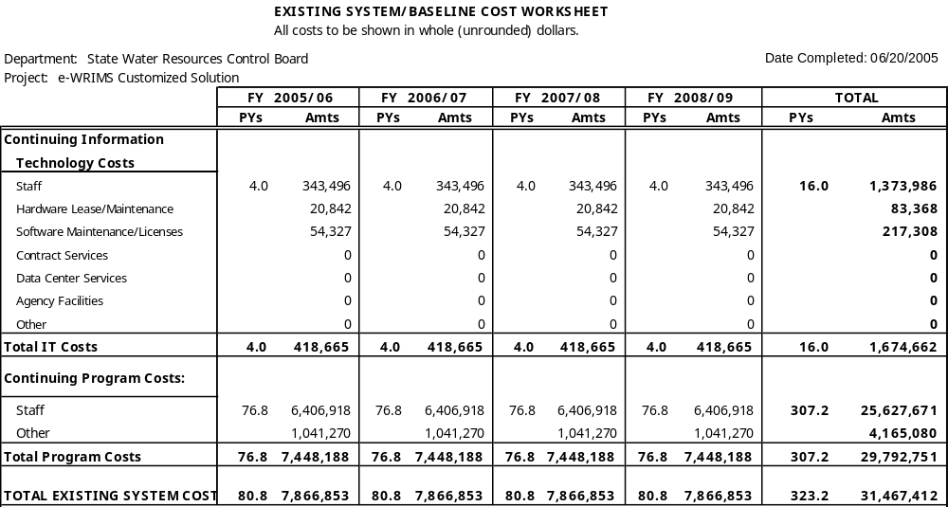
Figure 8-13 - Baseline WRIMS Costs
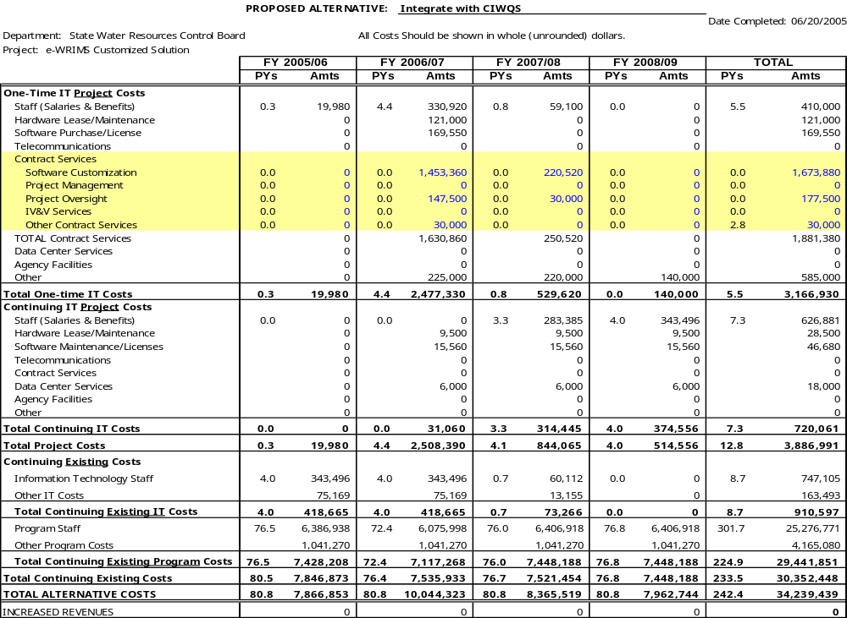
Figure 8-14 - e-WRIMS Proposed Alternative Costs
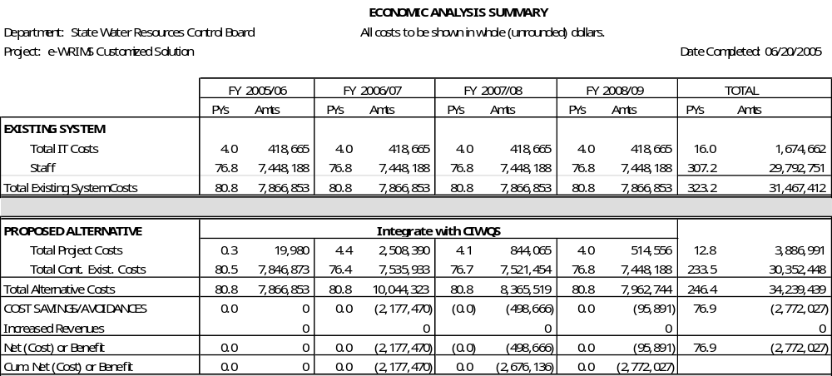
Figure 8-15 – e-WRIMS Economic Analysis Summary Worksheet
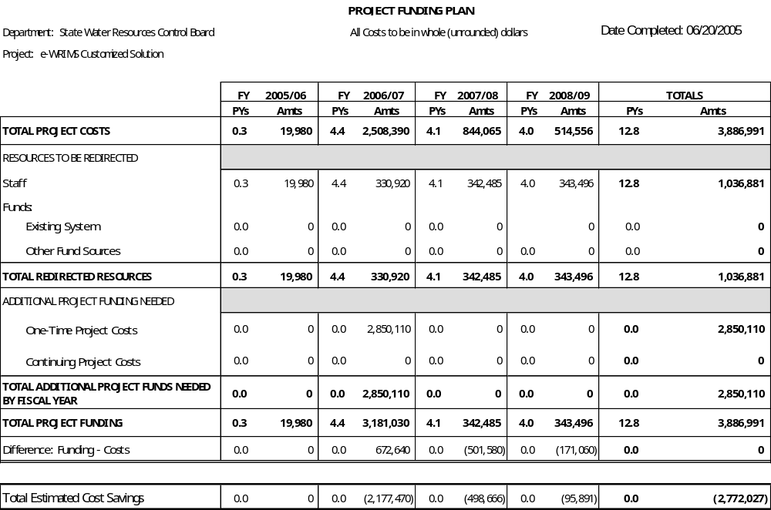
Figure 8-16 - Project Funding Costs

Appendix A. Acronym List
CD-ROM | Compact Disc Read Only Memory
COTS | Commercial Off The Shelf (Generally refers to a non-custom-developed software application)
DGS | California Department of General Services
DOF | California Department of Finance
DWR | Department of Water Rights
EAWs | Economic Analysis Worksheets
e-WRIMS | Electronic Water Rights Information Management System
FSR | Feasibility Study Report
GB | Gigabyte
GHz | Gigahertz
IP | Internet Protocol
ITPP | Information Technology Procurement Plan
J2EE | Java 2 Platform, Enterprise Edition (programming software for building web-based applications)
KB | Kilobytes
LAN | Local Area Network
MB | Megabyte
Mbps | Million bytes per second
MHz | Megahertz
MS Access | Microsoft database management and reporting application.
MOTS | Modified Off The Shelf (COTS software that is customized to meet customer requirements).
MS | Microsoft
NOS | Network Operating System
NTFS | Microsoft Windows NT File System
PC | Personal Computer
PMO | Project Management Office
RAM | Random Access Memory
RDBMS | Relational Database Management System
RFP | Request for Proposals
SAE | State Administrative Expenditures
SAM | State Administrative Manual
SCO | State Controller’s Office
SIMM | Statewide Information Management Manual
SNA | System Network Architecture
SSL | Secure Sockets Layer
SVGA | Super Video Graphics Array
SWRCB | State Water Resources Control Board
T-1 | Trunk Level 1 (1.544 Mbps)
TCP/IP | Transmission Control Protocol/Internet Protocol
TDC | Teale Data Center
WAN | Wide Area Network
WRIMS | Water Rights Information Management System

Riparian and pre-1914 appropriative rights predate the Water Commission act which set forth the state’s water right permitting system. Therefore entities who hold these rights are not required to obtain a permit from the Water Board. Parties may file “Statements” to put the Water Board on notice that they claim a riparian or pre-1914 right; however these types of rights can only be confirmed by the courts.
The federal government claims sovereign immunity and will not pay regulatory fees. The Legislature authorized the Water Board to pass unpaid federal water right fees on to the water right holders’ water supply contractors. The U.S. Bureau of Reclamation holds rights to about 30 percent of the water currently under permit or license. Fees assessed to the U.S. Bureau of Reclamation constitute a significant sources of potential revenue to the State Water Board. These unpaid fees are prorated among the U.S. Bureau of Reclamation’s contractors, based on each contractor’s contract entitlements to water.

